Range-Wide Status of Yellowstone Cutthroat Trout (Oncorhynchus clarki bouvieri): 2001

Bruce E. May
USDA Forest Service
Bozeman, Montana

Wendi Urie
U.S.D.A. Forest Service
Bozeman, Montana

Bradley B. Shepard
Montana, Fish, Wildlife and Parks
And
Montana Cooperative Fishery Research Unit
Bozeman, Montana

This status update was developed and completed under the oversight of a Yellowstone cutthroat interagency coordination group that, in addition to the primary authors, contributed information and editorial oversight necessary to the completion of this status report. Members of that coordination team included the individuals listed below. New members of the coordination group are Chip Corsi, Idaho Department of Fish and Game, Boise, Idaho, Bob Snyder, Montana Fish, Wildlife and Parks, and Kate Walker, USDA Forest Service, Missoula, Montana

Steve Yundt and Chip Corsi
Idaho Department of Fish and Game
Boise, Idaho

Ken McDonald and Bob Snyder
Montana Fish, Wildlife and Parks
Helena, Montana

Steve Yekel
Wyoming Game and Fish Department
Cody, Wyoming

Kate Walker
USDA Forest Service
Missoula, Montana

March 2003

Executive Summary

The distribution and abundance of Yellowstone cutthroat trout (Oncorhynchus clarki bouvieri; YCT) have declined from historical levels over part or all of their l range. For this YCT assessment we used existing information provided by 43 fisheries professionals applied through a consistent methodology to assess the extent of YCT historical range, their current distribution, including genetic status, and evaluated the foreseeable risks to 195 populations designated as “conservation populations” by management agencies.

We estimated that YCT historically occupied about 17,397 miles of habitat in the western U.S. YCT currently occupy an estimated 7,528 miles of historical habitats (43%). Genetic testing has been completed across about 1,880 miles of habitat (25% of occupied habitats), but sample sizes were variable and sample sizes of 25 fish or more (a sample size that likely would detect as little as 1% introgression at alpha = 0.05) made up 27% of the samples. YCT with no evidence of genetic introgression currently occupy about 1,300 stream miles (17%) of habitat. Another 105 miles of currently occupied habitats (1%) contained YCT that were identified as part of a mixed stock where the YCT were not introgressed. We suggest that even though genetic sampling was nonrandom because sampling likely occurred more frequently in YCT populations that appeared non-introgressed, some, if not much, of the habitats currently occupied by YCT with no genetic testing likely support populations that are not introgressed. Approximately 3,000 miles of occupied habitat were identified as containing genetically unaltered YCT based on no record of stocking or by having no hybridizing species present. Much of the habitat currently occupied by YCT was located in designated parks (2%), wilderness areas (19%), and other road-less areas (40%), and almost 70% of habitats currently occupied lie within federally managed lands.

A total of 195 separate YCT populations currently occupying 6,346 miles of habitat were designated as “conservation populations” (84.3% of currently occupied habitat). These conservation populations were spread throughout the historical range, occuring in 35 of the 41 hydrologic units historically occupied by YCT. Most of these conservation populations were judged to be “isolets” (143 or 73%); however, meta-populations occupied much more of the habitat (5,515 miles or 73%). Of the 195 designated conservation populations, 133 (68%) had at least some component that was tested as genetically unaltered or viewed as being potentially unaltered. Thirty nine populations (20%) consisted of only tested unaltered YCT. More isolet populations were at higher risks due to temporal variability, population size, and isolation than meta-populations, but these isolets were generally at less risk from genetic and disease factors than meta-populations.

This assessment clearly shows that YCT currently occupy significant portions of, and are well distributed across, their historical range. The data suggest that genetically unaltered YCT occupy at least 17% and possibly up to 58% of currently occupied habitats (7 to 25% of historical habitats). Conservation population designations suggest that two different conservation management strategies are needed and being implemented to conserve YCT. One strategy concentrates on preventing introgression, disease and competition risks through isolation of YCT, while the other concentrates on preserving meta-population function and multiple life-history strategies by connecting occupied habitats.

Table of Contents

Executive Summary ii
Table of Contents ii
List of Tables iv
List of Figures vi
Introduction 1
Analysis Area 1
Methods 3
Geographic Information System 3
Scale issues 4
Assessment Teams and Workshops 5
Historical Range 5
Barriers to Fish Movement 6
Current distribution 6
Genetic Status 6
Abundance Relative to Habitat Potential 8
Designated “Conservation Populations” 9
Risk Classification 10
Genetic Risks 10
Population Risks 11
Conservation Activities 13
Land and Resource Management Impacts 13
Summaries from Database 13
Summaries that Linked Database to GIS Layers 13
Results 16
Historical Range 16
Current Distribution 16
Genetic Status 17
Abundance Relative to Habitat Potential 20
Occurrence in Special Land Management Areas 22
Conservation Populations 25
Ranked Risks to Conservation Populations 29
Restoration Activities Implemented for Conservation Populations 29
Land Use Impacts on Conservation Populations 35
Fine-Spotted and Large Spotted Forms 35
Discussion and Conclusions 39
Historical Range 39
Current Distribution 42
Designated Conservation Populations 43
Conclusions 45
Acknowledgements 47
References 47
Appendix A………………………………………………………………………………………50
Appendix B………………………………………………………………………………………67
Appendix C……………………………………………………………………………………70
Appendix D……………………………………………………………………………………72
Appendix E……………………………………………………………………………………77
Appendix F……………………………………………………………………………………78

List of Tables

Table 1. Genetic classes used for assessing genetic status of Yellowstone cutthroat trout in 2001. 7
Table 2. Codes and descriptions used for assessing relative abundance of Yellowstone cutthroat trout in 2001. 9
Table 3. Ranks and descriptions used for assessing genetic risks to designated conservation populations of Yellowstone cutthroat trout in 2001. Hybridizing species includes any introduced species or subspecies that could potentially hybridize with Yellowstone cutthroat trout. 11
Table 4. Ranks and descriptions of population risks to designated conservation populations of Yellowstone cutthroat trout in 2001. 12
Table 5. Codes and descriptions for conservation activities applied to designate conservation populations of Yellowstone cutthroat trout assessed in 2001. 14
Table 6. Codes and descriptions for management activities that could potentially impact designated conservation populations of Yellowstone cutthroat trout assessed in 2001. 15
Table 7. Genetic status for Yellowstone cutthroat trout (both spotting forms combined) by stream length (miles) within their historical range as of 2001. 19
Table 8. Miles of habitat currently occupied by Yellowstone cutthroat trout by genetic status and relative abundance for assessment done in 2001. 21
Table 9. Miles (%) of habitats within historical range that are currently occupied by Yellowstone cutthroat trout by relative abundance classes, data source ratings for the abundance determination, and presence of competing species (i.e. non-native trout). 21
Table 10. Miles of habitat occupied (% of occupied habitat by Federal land catagory) by Yellowstone cutthroat trout in Forest Service designated road-less areas (including wilderness), National Parks and within all federal lands combined. 22
Table 11. Miles of habitat occupied (% occupied by Federal land category) by abundance rating for Yellowstone cutthroat trout in Forest Service designated road-less areas (including wilderness), National Parks and within all federal lands. 23
Table 12. Number and miles of designated conservation populations of Yellowstone cutthroat (both spotting forms combined) along with proportions of those populations by number and miles within isolets and meta-populations. 27
Table 13. Ranked risks to designated conservation populations of Yellowstone cutthroat trout (both forms combined) that functioned as “isolets”, “meta-populations”, and combined by miles of habitat and numbers of conservation populations that conservation populations occupied by risk factor as of 2001. Bold population composite risk scores are weighted scores for temporal variability, population size, demographics, and isolation re-classified into low to high categories (see Methods for details). 30
Table 14. Number and percentage (based on the 195 conservation populations that were evaluated) of Yellowstone cutthroat trout conservation populations that have had various types of conservation, restoration, and management actions implemented to conserve them as of 2001. 34
Table 15. Number and percentage (based on the 195 conservation populations that were evaluated) of designated Yellowstone cutthroat trout conservation populations where human management activities were known or believed (possible) to have impacted the population by type of management activity. 35
Table 16. Number and miles of designated conservation populations of Yellowstone cutthroat based on spotting pattern along with proportions of those populations by number and miles within isolets and meta-populations. 38
Table 17. Ranked risks to designated conservation populations of Yellowstone cutthroat trout (represented as large spotted, fine spotted or a mixture of both) that functioned as “isolets”, “metapopulations”, and combined by number of conservation populations and miles of habitat that these conservation populations occupied by risk factor as of 2001. Bold population composite risk scores are weighted scores for temporal variability, population size, demographics, and isolation re-classified into low to high categories (see Methods for details). 40

List of Figures

Figure 1. Streams that were included (dark) as part of the historical distribution and excluded (light) from the stream layer for historically occupied watersheds. 2
Figure 2. Genetic status of Yellowstone cutthroat trout populations throughout their range. Gray lines indicate historical range. 18
Figure 3. Genetic status of Yellowstone cutthroat trout expressed as proportion of currently occupied habitats (in miles) classified within each genetic status category for assessment done in 2001. 19
Figure 4. Distribution of the number of fish sampled for genetic testing, by level of introgression detected, for assessment done in 2001. 20
Figure 5. Relative abundance related to habitat potential overlaying designated wilderness and road-less areas and national parks. 24
Figure 6. Designated conservation populations of Yellowstone cutthroat trout (colored streams) throughout their range shown overlaying their current distribution (gray streams) as of 2001. Different colors were used to distinguish between different conservation populations and have no other significance. 26
Figure 7. Frequencies of the number of miles occupied by designated conservation populations of Yellowstone cutthroat trout throughout their range. Mileage bins are uniformly assigned at 5.0 mile intervals in top graph and non-uniformly assigned in bottom graph. 28
Figure 8. Proportions of miles occupied by designated “isolet” (top) and metapopulation (bottom) Yellowstone cutthroat trout conservation populations ranked into low to high levels of risk by risk factor (vertical axes). 31
Figure 9. Proportions for numbers of designated “isolet” (top) and metapopulation (bottom) Yellowstone cutthroat trout conservation populations ranked into low to high levels of risk by risk factor (vertical axes). 32
Figure 10. Distribution of the number of designated Yellowstone cutthroat trout populations by composite population risk scores and population type (excludes genetics and disease risks). 33
Figure 11. Distribution of YCT conservation populations based on presence of the large spotted form only, the fine spotted form only and a combination of both spotting patterns. 37

Introduction

Within the last 20 years several status assessments have been conducted for Yellowstone cutthroat trout (Oncorhynchus clarki bouvieri; YCT) over part or all of their historic range (Behnke 1979: Hadley 1984; Varley and Gresswell, 1988; Thurow et al. 1988; Gresswell 1995; May 1996; Kruse et al. 2000; Meyer et al 2003). Many of these assessments were either conducted over only a portion of YCT historic range, involved only a few experts with specific detailed knowledge of the assessment area, or suffered from a lack of consistency in the sources of information used. This report updates the past assessments using a protocol that was consistently applied throughout the historical range of YCT. We assessed the historically occupied range, current distribution, general abundance and genetic status, and risks for YCT throughout their historical range. Fisheries professionals from Montana, Idaho, Wyoming, Nevada and Utah (state agencies, Park Service, USFS, BLM, tribal, private, etc.) provided the information for this assessment. State fisheries staffs identified and designated “conservation populations”, but information from many different sources was used to assess risks and threats to these populations. The information for this status update was primarily compiled during the later part of 2001. While this assessment provides consistent and relatively current information on YCT that can be used by the FWS in relation to their responsibilities under ESA, the longer-term, and probably more significant use of this assessment, is as an information base to be used by individual states and other agencies, working collaboratively, to assess, plan and prioritize their ongoing and future YCT conservation efforts.

The five states where YCT occur have the primary responsibility under their respective state laws to manage and conserve YCT. Within specific portions of YCT range, Tribal governments and the National Park Service assume managerial authority for conservation and management of YCT. The Forest Service, BLM and other federal land and resource management agencies play an essential role because of a responsibility for management of aquatic habitats on federal lands and for coordination of land uses consistent with laws, rules, and regulations. The FWS is charged with administration of the federal Endangered Species Act (ESA) and they concluded that the petition to list YCT did not contain sufficient or substantial information to indicate that a listing may be warranted. It is mutually beneficial for the above parties to work together to: further the collective knowledge, implement conservation actions, and provide the best scientific information to further YCT conservation.

Analysis Area

The analysis area included all of the known historical range of YCT within the western United States. We relied primarily on Behnke (1992) to delineate the likely historical range (Figure 1). This area includes, from east to west, the upper portions of the Yellowstone River drainage within Montana and Wyoming and the upper Snake River drainage in Idaho, Wyoming, Nevada and Utah. This assessment does not provide an assessment of YCT that have been introduced into areas outside of the historical range.
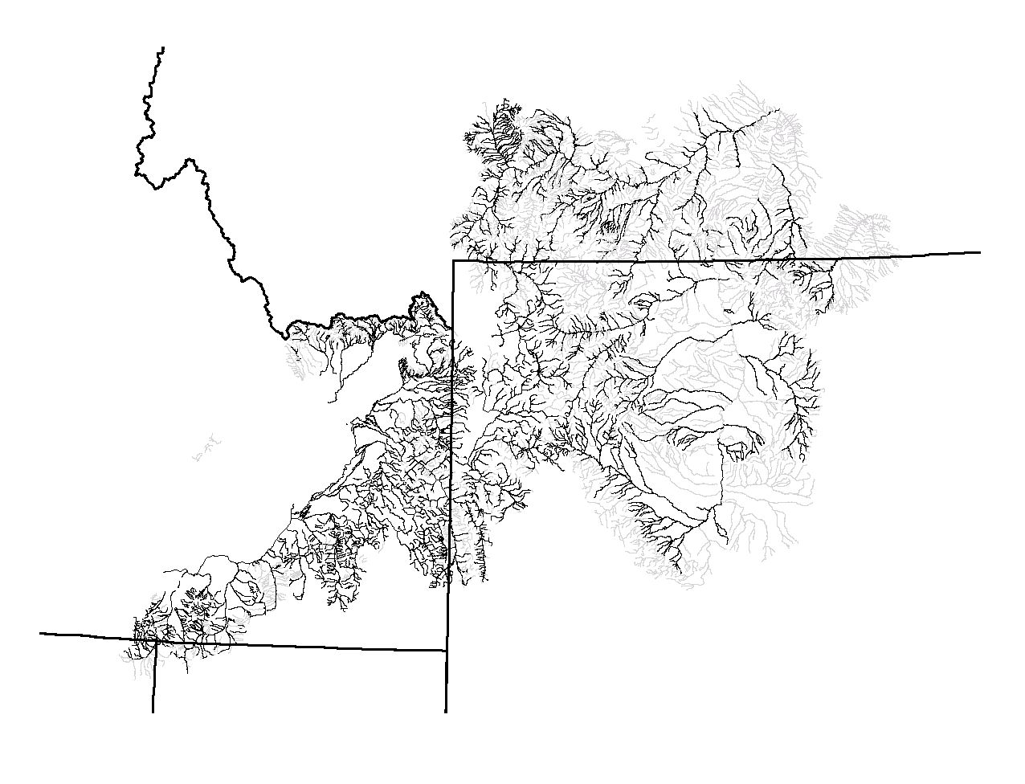
Figure 1. Streams that were included (dark) as part of the historical distribution and excluded (light) from the stream layer for historically occupied watersheds.

Within the assessment area two forms of YCT have been identified, but have not been differentiated genetically: 1. a large-spotted form that was dominant in most of the upper Yellowstone River basin and the lower Snake River basin from Palisades Reservoir downstream to Shoshone Falls; and 2. a fine-spotted form that was dominant in portions of four watersheds in the upper Snake River basin. We assessed the status of YCT from several perspectives including a broad overview of the entire assessment area, a review of the relationship of the large and fine-spotted forms, and a brief summary of specific conservation population status information.

Methods

We developed a standardized approach and consistent protocols that were used by all participants who gathered together in localized workshops (Appendices A and B). Information was gathered by the participants at each workshop and entered into a geographic information system (GIS) and relational databases. Many different sources of information were used in this assessment, but consistency was maintained by having one or two individuals attend all workshops and facilitate data entry and answer questions raised by workshop participants. Since this assessment relied upon existing information, sampling was not random, and in many cases not independent; therefore, there are undoubtedly biases associated with these data. We discuss the possible consequences of these biases when we present the results. We have attempted to qualify and disclose the nature of these data through citations and by having the people that provided information identify the primary source of information (e.g. primarily based on professional judgment, based on a minimum level of field information or linked to extensive study). Sources of information were also referenced (e.g. field notes, agency files, reports or publications)

Geographic Information System

We used the 4th code hydrologic unit code (8-digit EPA designation) as the primary unit for organizing data input from the fisheries professionals. We also summarized historical range and current status information using this stratification. The U.S. Geological Survey (USGS) created the hierarchical hydrologic unit code (HUC) system for the United States in the 1970’s. This system divides the country into 21 Regions, 222 Sub-regions, 352 Accounting Units, and 2,149 Cataloging units based on surface hydrologic features. The smallest HUC used in this study was approximately 448,000 acres (Hydrologic Units Maps of the Conterminous United States. Reston, VA. United States Geological Survey. August 2002. http://water.usgs.gov/GIS/metadata/ usgswrd/huc250k.html).

We chose to use stream and river distance as measures of YCT occupancy, both for suspected historical and known currently occupied habitats. Consequently, lake occupancy was not directly assessed; however, all lakes that were located within the stream network were included, as length values, if the stream network bisected the lake. Our assessment used GIS tools in Arcview 3.2 along with extensions created for this project (Steve Carson, Montana Fish Wildlife and Parks, Helena, Montana modified “ddeaccess.avx” and “routetool.avx” extensions that are available from ESRI at http://arcscripts.esri.com) as well as a relational database within Microsoft Access (modeled after the Montana Fish Wildlife and Parks’ MFISH database that can be found at http://nris.state.mt.us/scripts/esrimap.dll?name=MFISH&Cmd=INST) for organizing and displaying the data.

A Latitude-Longitude Identifier (LLID) 1:100,000 hydrography layer that was edge-matched across state boundaries was used as the primary base-layer. The Idaho portion of the study area was obtained from the Pacific Northwest River Reach Files. The U.S. Geological Survey (USGS) in Portland, in cooperation with Bonneville Power Administration, the Northwest Power Planning Council, and other Federal and state agencies and NW Indian Tribes produced a 1:100,000-scale River Reach data layer for the Pacific Northwest in the early 1990s. The Pacific Northwest (PNW) River Reach Files are a geo-referenced river reach data layer that encompasses the Columbia River Basin within the conterminous United States, the coasts of Oregon and Washington, Puget Sound in Washington, the Klamath and Goose Lake Basins in southern Oregon and the Bear Lake Basin in southeastern Idaho (PNW Reach File, Gladstone, Oregon: Stream Net, August 2002. http://www.streamnet.org/pnwr/pnwrhome.html). A Latitude-Longitude Identifier (LLID) 1:100,000 hydrography for the Montana portion of the study area was obtained from Montana Fish Wildlife and Parks (Streams. Helena, MT: Montana Fish Wildlife and Parks, March 2001 and are available at http://fwp.state.mt.us/insidefwp/fwplibrary/gis/). A Latitude-Longitude Identifier (LLID) 1:100,000 hydrography layer was not available for Wyoming; thus we utilized the USGS National Hydrography Dataset (National Hydrography Dataset, Reston, Virginia: United States Geological Survey, March 2001; available at http://nhd.usgs.gov). The National Hydrography Dataset (NHD) uses different stream routing methods and was not immediately compatible with the LLID stream layer. Steve Carson and Jeff Hutten, Montana Fish Wildlife and Parks, assisted in the rerouting and editing of Wyoming NHD data to create a Wyoming LLID routed stream layer. This LLID hydrography layer routes stream segments by uniquely identifying each stream. Streams missing from the LLID hydrography layer with known YCT populations were added from the unrouted NHD data. Delineating lower and upper segment boundaries as distances above each stream’s mouth identified each stream segment occupied by YCT. All known fish barriers were located as points, also using distance upstream from a stream’s mouth.

Scale issues
Using a standard 1:100,000 base-layer allowed for consistent summaries among states and other entities. However, summaries based on this scale will underestimate “true” field lengths of stream habitats due to scale-based error. There are several potential sources of bias associated with using 1:100,000 scale LLID hydrography. First, map-derived stream lengths under-estimate actual stream lengths. Firman and Jacobs (2002) found that while hip-chained measurements of Oregon coastal streams were significantly correlated to stream lengths computed using MapTech® Terrain Navigator software and 1:24,000-scale maps, map lengths needed to be multiplied by about 1.14 to estimate measured stream lengths.

Secondly, there are scale-differences between 1:100,000 and 1:24,000-scale hydrography. We evaluated the magnitude of these scale-differences during the Westslope Cutthroat Trout assessment. We compared lengths of 30 streams from three different 4th code HUC’s (10 per HUC) and found that lengths of streams derived from 1:100,000-scale hydrography were only about 1% shorter than estimates of that same stream using 1:24,000-scale hydrography (Shepard et al. 2003). However, these were small unnamed streams that are mapped at 1:24,000 scale that were not included in the 1:100,000 scale hydrography. In most cases, these small unnamed streams did not support YCT or any trout. In a few instances YCT were known to exist in unnamed streams that were mapped at the finer scale but not at the 1:100,000 scale. These YCT streams were not included in this assessment.

Assessment Teams and Workshops

A total of five workshops were held to obtain the pertinent information for this status update. One workshop was held in each of the five states that have historical habitat and current YCT populations. At each workshop a systematic application of the assessment protocol was undertaken (Appendix A) An estimated 43 fisheries professionals from 10 state, federal, and tribal agencies and private firms (Appendix B) provided the information that was used in this assessment. In addition to the fisheries professionals, 8 GIS and data management specialists also participated in these workshops to assist with data entry and display of status information for on-site editing of data. Information stored in statewide databases was available in hard copy and on computer for each of these assessment workshops in tabular and map formats. From two to five information technology and data entry personnel also attended each workshop to provide technical support and enter information into computer databases. All fishery professionals were asked to bring field data summaries and reports for their areas of responsibility so existing databases could be updated and used in this assessment. At each workshop fishery professionals who had relevant information or knowledge within each 4th code HUC worked collaboratively to fill in data forms that were immediately entered into a computer database. Often individuals worked on several 4th code HUC teams. As data were entered from paper data forms into the computerized database at least one individual from each 4th code HUC team ensured that data were entered accurately. The fisheries professionals that completed these assessments had experience levels ranging from several months to several decades. Collectively, these fishery professionals had a combined total of 862 years of professional fisheries experience, of which (650 were directly applicable to YCT. The majority of participants had Master’s of Science college degrees (31), one had a PhD degree, and all but one had at least a Bachelor of Science degree.

Historical Range

For the purposes of this assessment European “discovery” of the west was set as the benchmark time (~1800) for the historical range of YCT. While it is likely that the distribution of YCT has expanded and contracted over geological time, written documentation of historical distribution began around 1800. Behnke (1992) states (p. 89), “Yellowstone cutthroat trout had a much greater distribution before redband trout invaded the middle Columbia River basin in the late-glacial period.” Behnke (1992) viewed YCT as the original native trout to the entire Snake River system and subsequently the upper Yellowstone River drainage. Using Behnke’s (1992) delineation of historical range as a starting point, we included all streams within any 4th code HUC’s that were within the area Behnke identified as being potentially part of the historically occupied habitat. Fishery professionals were then asked to identify stream segments that should be excluded from historical range based on evidence for exclusion. Evidence for exclusion included: geological barriers with no evidence that YCT inhabited waters above the barriers; tectonic events that would have made regions uninhabitable and were likely either not colonized or ancient populations had gone extinct and not re-colonized prior to 1800; and habitat judged as unsuitable based primarily on thermal regime, stream channel gradient, and minimal stream flow (Appendix A). In a few cases entire 4th code HUC’s were excluded. Information sources that supported inclusion or exclusion of stream segments as historically occupied were noted. Important information sources included, historical journal entries, scientific reports, and evidence of basin transfers by headwater stream captures. Current occupancy of streams was also evaluated as a possible rationale for inclusion. All stream and river habitat was included within the historical range unless explicitly excluded by the fishery professionals. Our delineation of historical range refines previous assessments of historical range. The amount of historical range we estimated was then used as the baseline for comparison to the current status.

Barriers to Fish Movement

Since barriers to upstream fish movement have important implications for both historical range and current status, known barriers believed to significantly affect distribution of YCT were located and identified. Geological (i.e. bedrock waterfalls, naturally dry channel segments, etc.) and anthropogenic barriers were located and classified. Geological barriers were considered when potentially excluding lotic habitats from the historical range. Anthropogenic barriers were considered when assessing current distributions and various risks to conservation populations. Only barriers of believed significance were included; however, much of the area had not been surveyed for barriers. Significance of barriers as they related to risk and conservation of YCT was identified (Appendix A).

Current distribution

For the purposes of this assessment, all stream segments currently occupied by YCT within their historical range were included. Stream segments occupied by YCT outside historical range were not included. Stream segments where YCT populations were supported or maintained by stocking were not included in current distribution; however, stream segments that may have been stocked with YCT in the past, but currently were maintained exclusively by natural reproduction were included. All waters that supported YCT and appeared on the LLID hydrography layer, regardless of level of introgression, were included. However, the genetic status of YCT within each stream segment was classified (see below). In addition to genetic status, biologists ranked the abundance of YCT inhabiting each stream segment. Additional notations for each occupied segment included: a determination of which YCT form (i.e. large-spotted, fine-spotted or both) was present; whether competing species (principally non-native salmonids) were present; identification of restoration or conservation activities implemented within each occupied segment; and identification of land uses and fish management activities believed to be influencing YCT in the occupied segments. These results were summarized by length of habitat occupied and not by number of stream segments occupied. Number of stream segments was not a meaningful measure because this number does not equate to number of populations and lengths of stream segments varied widely. The stream segment information was aggregated within the “conservation population” assessment (see below).

Genetic Status
Six classes identifying genetic status for stream segments were applied (Table 1). Four classes were used for those stream segments that had been genetically tested and two classes for those where no genetic testing had been done (Table 1). Genetic sampling involves many complex issues that can make clear interpretation and reporting of results difficult, especially within standardized databases. We will briefly address a few of these issues here, but suggest reading Appendix D in Shepard et al. 2003 for more detail.

Table 1. Genetic classes used for assessing genetic status of Yellowstone cutthroat trout in 2001.

Code | Description | Genetic Report Code
A | Genetically unaltered (<1% introgression) - tested via electrophoresis or DNA | Tested; Unaltered
B | Introgressed 75% or less and 99% or more - tested via electrophoresis or DNA | Tested; <=25% to >=1% introgressed
C | Introgressed more than 75% - tested via electrophoresis or DNA | Tested; > 25% introgressed
H | Potentially unaltered with no record of stocking or contaminating species present | Suspected Unaltered
J | Suspected hybridized with records of contaminating species being stocked or occurring in stream | Potentially Altered
N | Hybridized and Pure populations co-exist in stream (use only if reproductive isolation is suspected and testing completed) | Mixed Stock; Altered and Unaltered co-exist

Genetic tests can detect introgression between YCT and potentially introgressing species or subspecies by finding alleles unique (“diagnostic alleles”) to that potentially introgressing species or subspecies within YCT populations. The number, and thus the proportion, of potentially introgressing species or subspecies “diagnostic” alleles within YCT populations, is used to estimate the level of introgression. One consequence of this approach is that proving a stock of YCT to be genetically pure is essentially impossible: all individuals in a population would have to be tested. Therefore, sample size must be considered when evaluating the reliability of any genetic test. Generally, sample sizes should be large enough to determine, with a pre-determined level of statistical reliability (95% has often been used), that a 1% or less level of introgression would be detected. Both the number of fish sampled and the number of alleles that are “diagnostic” between species or subspecies determine the sample size needed for a pre-determined level of statistical reliability. Thus, when genetic testing finds no evidence of introgression, sample size is very important for assessing how valid the result may be. For this assessment we reported results of all genetic testing, regardless of sample size, and then displayed and summarized sample sizes for all genetic testing.

Different genetics laboratories, and sometimes even the same lab, may report genetic results differently; consequently, it can be difficult to compare genetic results across broad geographic areas. Especially when only brief summaries of these data are stored in standardized fish resource databases. An example of where this type of problem may occur is that of a mixed stock population, where some individuals within the population may be genetically unaltered YCT and other individuals may be genetically unaltered rainbow trout (RBT). Unless either the local fisheries professional or the database indicated that non-random mating was occurring (code N; Table 1), we assumed genetic results were a function of random mating. If random matings were incorrectly assumed to be operating for the above hypothetical mixed stock population, genetic sample results would indicate introgression at levels in proportion to the proportion of RBT to YCT for this hypothetical population. Where there was evidence of non-random mating due to both the presence of some YCT individuals within the population that had no evidence of introgression and evidence that reproductive isolation was occurring, YCT in these stream segments were designated as a mixed stock that had both “genetically altered” and “unaltered” individuals. This situation usually occurred in main rivers and mainstem tributaries where it was known that YCT spawned in different tributaries or at different times than the introgressing species (i.e. rainbow trout). However, when evidence to support non-random mating was lacking, random mating was assumed. This assumption likely introduced bias toward classifying stream segments as introgressed when some may have been mixed stock populations.

The levels of introgression we assigned for genetically tested stream segments were based, in part, on the literature. For our genetically unaltered (“pure”) stream segments (code A; Table 1) we selected less than 1% introgression, based on the most commonly defined level of introgression that genetic sampling is designed to detect (Anon. 2000). The next two levels (i.e. <=25% to >=1% and >25% introgression) were assigned based on conservation planning considerations. The <=25% to >=1% classification was selected as the grouping that would include conservation populations that had specific unique attributes important for conservation. Within this grouping are the stream segments that tested 90 to 99% YCT and there are indications that meristic counts are not different between individuals from populations that are not genetically altered and those that are from populations with 10% or less introgression (Leary et al. 1996). Stream segments that tested >25% might have appeared to be cutthroat trout to the untrained eye, but they were treated as primarily having recreational value and were not carried forward as conservation populations. The class where both hybrids and pure individuals inhabit the same stream segment (code N; Table 1) indicated some reproductive isolation and were identified as a mixed stock

Genetic information was extremely limited for some large geographic areas particularly in the large tracts of wilderness, road-less, and National Park land in Montana, Idaho, and Wyoming. The genetic characterization for the occupied stream segments in these areas were primarily “suspected hybridized” or “potentially unaltered. We suspect that many of these segments actually support genetically pure YCT. This question was addressed in the westslope cutthroat status review that was completed in 2002 (Shepard et al. 2003) and we feel that a similar result could exist for YCT. In addition, recent YCT population monitoring in southeastern Idaho indicated that a high number of YCT judged to be genetically unaltered based on morphological inspection were in fact genetically unaltered based on genetic test results (Meyer et al. 2003).

Abundance Relative to Habitat Potential
In addition to classifying genetic status, relative abundance of YCT in qualitative terms (i.e. abundant, common, rare or unknown) was also specified for each stream segment. For stream segments where no quantified population determinations were available, habitat condition was used as a surrogate to provide likely abundance for each stream segment occupied by YCT (Table 2; Appendix A). Relative abundance ranks based on habitat potential were rated in two ways. First, where abundance data were available, that data was compared to all sites that had similar habitat potential and rated by comparison. Data quality for these segments was usually rated as high or good. Secondly, for those segments where no quantitative fish abundance data were available, YCT abundance was ranked solely from the condition of habitat relative to its potential. Data quality for these cases was rated as low. Thus, when quantitative fish abundance information was available both the measured abundance and habitat condition were used to rank relative abundance. When no quantitative abundance data were available only habitat condition was used to rank abundance. These results were also summarized by length of habitat occupied and not by number of stream segments occupied. Number of stream segments was not felt to be a meaningful measure because this number does not equate to number of populations and lengths of stream segments varied widely. Where field data were available, abundance was rated based on how similar the measured abundance was to measured abundances from areas of similar types of habitat that were not impacted by human activities. Where no field data were available, abundance classes were subjective and based, to a large extent, on the quality of the habitats occupied. Consequently, analyses between the relative abundance levels we assigned and land-use or other habitat-related variables were not independent.

Table 2. Codes and descriptions used for assessing relative abundance of Yellowstone cutthroat trout in 2001.

Code | Description
99 | Unknown
A | Abundant – viewed as being at site potential or in high quality habitat
C | Common – Possibly slightly below site potential or habitat less than optimal
R | Rare – Restricted by sub-optimal habitat or significantly below site potential

Designated “Conservation Populations”

YCT are considered a game fish by all state and federal agencies that manage this subspecies. Consequently, all YCT populations have sport fish value and are managed as such by the various states and national parks in which they occur, regardless of their genetic status. Many YCT are managed as “conservation populations” with additional management emphasis placed on preserving the genetic makeup and/or other important attributes of these populations. Most of the western states that have management and conservation authority for cutthroat trout participated in the development of a position paper on genetic management (Anon 2000). This position paper describes a hierarchical classification for conserving cutthroat trout that includes: 1) a core component of genetically unaltered populations or individuals; 2) designated conservation populations that may be either genetically unaltered or slightly introgressed but have attributes worthy of conservation; and 3) populations that are managed primarily for their recreational fishery value. Core populations are recognized as having important genetic value and would serve as donor sources for developing either captive brood or for re-founding additional populations. Management will emphasize conservation, including potential expansion, of both core and conservation populations.

For this assessment any stream segment that supported YCT could potentially be designated as either an individual “conservation population”, aggregated as part of a larger networked or connected “conservation population”, or be considered as having recreational fishery value, but not considered within YCT conservation. Designated “conservation populations” that occupied two or more connected stream segments were viewed as population networks (“meta-populations”) that had the potential to interact with each other (Hanski and Gilpin 1991). Populations were designated as “conservation populations” based on whether they represented a core conservation population having no genetic alteration or there were identified unique attributes such as expression of unique or multiple life-history strategies, adaptation to specific environmental or habitat conditions, and geographic location (Anon 2000; Allendorf et al. 2001).

Almost all stream segments occupied by YCT where genetic testing found no evidence of introgression were classified as “core conservation populations”. A few isolated stream segments where YCT were genetically tested and there was no evidence of introgression were not classed as conservation populations. These populations occupied very little habitat and it was not deemed effective to invest in expanding them because expanding these populations was infeasible given current restoration techniques. Some of these populations might be replicated by moving either fish or gametes in the future, but this restoration activity would be speculative at this time.

All conservation populations were classified as either “isolates” or “meta-populations” depending upon their isolation or connectivity and likely genetic exchange between stream segments. We also identified conservation populations that were considered as a "source" to other conservation populations. This information was felt to be potentially important to future conservation decisions.

We summarized information for designated conservation populations based on length of stream occupied, number of populations, and geographic distribution. Since there was a very wide range of lengths of habitats occupied by the various conservation populations we chose to present these data in terms of length occupied and number of populations.

Risk Classification
The risks identified in this assessment are potential risks that could occur in the “foreseeable future” (considered to be two to three decades). Risks were stratified into two major categories: genetic and general population-level health.

Genetic Risks

Genetic risk was defined by the risk of future introgression of YCT in a conservation population. Distance from potential sources of anthropogenic introgression and the presence of documented barriers between those sources and the conservation population were the two primary components that were assessed to determine genetic risk (Table 3). In addition, where there was documented evidence indicating that potentially introgressing species or subspecies were reproductively isolated from YCT, due to either temporal or spatial isolation during spawning, the genetic risk rating for that conservation population was reduced. Nonnative salmonids that could potentially hybridize with YCT, had been stocked, either legally or illegally and, were now reproducing naturally in the wild were considered as posing a genetic risk to YCT.

Table 3. Ranks and descriptions used for assessing genetic risks to designated conservation populations of Yellowstone cutthroat trout in 2001. Hybridizing species includes any introduced species or subspecies that could potentially hybridize with Yellowstone cutthroat trout.

Rank | Activity
1 | Hybridizing species CANNOT INTERACT with existing YCT population. Barrier provides complete blockage to upstream fish movement. No hybridizing species in close proximity to YCT population.
2 | Hybridizing species are in same stream and/or drainage FURTHER THAN 10 KM from YCT population, but not in same stream segment as YCT, or may be WITHIN 10 KM WHERE BARRIER EXISTS, BUT THE BARRIER MAY BE AT RISK OF FAILURE.
3 | Hybridizing species are in same stream and/or drainage WITHIN 10 KM of YCT population and NO BARRIER EXISTS; however, hybridizing species not yet found in same stream segment as YCT population.
4 | Hybridizing species are SYMPATRIC with YCT population in same stream segment.

Population Risks

Demographic and stochastic population risks were assessed using criteria established by Rieman et al. (1993). Four separate types of risk were considered including: temporal variability, population size, population productivity, and isolation (Table 4). These four main factors were assessed individually and then weighted and summed to derive a final composite risk factor. Weightings were assigned to each risk factor based on advice from those who developed the demographic and stochastic population risk matrix (Rieman et al. 1993; D. Lee, U.S.D.A. Forest Service, Rocky Mountain Research Station, Boise, Idaho, personal communication) as: Temporal Variability = 0.7; Population Size = 1.2; Population Productivity (Growth/Survival) = 1.6; and Isolation = 0.5. Weighted composite risk scores could potentially range from 4 to 16 and were then ranked into four low to high risk categories by placing them in four nearly equal-sized bins (4 to < 7; 7 to < 10; 10 to <13; and 13 to 16).
Table 4. Ranks and descriptions of population risks to designated conservation populations of Yellowstone cutthroat trout in 2001.

Type of Risk | Rank | Criteria
Population Productivity | 1 | Population is increasing or fluctuating around an equilibrium that fills available habitat that is near potential. No nonnative competing or predating species present.
 | 2 | Population has been reduced from potential, but is fluctuating around an equilibrium (population relatively stable and either habitat quality is less than potential, or another factor - disease, competition, etc. - is limiting the population).
 | 3 | Population has been reduced and is declining (year-class failures are periodic; competition may be reducing survival; habitat limiting population).
 | 4 | Population has been much reduced and has either been declining over a long time period or has been declining at a fast rate over a short time-period (year-class failures are common; competition or habitat dramatically reducing survival).
Temporal Variability | 1 | At least 75 km of connected habitats
 | 2 | 25-75 km of connected habitats
 | 3 | 10-25 km of connected habitats
 | 4 | < 10 km of connected habitats
Isolation | 1 | Migratory forms must be present and migration corridors are open (connectivity maintained).
 | 2 | Migratory forms are present, but connection with other migratory populations disrupted at a frequency that allows only occasional spawning.
 | 3 | Questionable whether migratory form exists within connected habitat; however, possible infrequent straying of adults from other populations into area occupied by population.
 | 4 | Population is isolated from any other population segment, usually due to barrier, but may be related to lack of movement or distance to nearest population.
Population Size | 1 | > 2,000 adults
 | 2 | 500-2,000 adults
 | 3 | 50-500 adults
 | 4 | < 50 adults

Conservation Activities
A listing of potential conservation activities was provided to workshop participants. If any conservation activity had been applied to any stream segment of a conservation population, that activity was checked and linked to the conservation population (Table 5; Appendix A). Since we did not specifically address the significance or effectiveness of various conservation activities, we summarized these data only by the number of conservation populations affected by each type of activity. For many conservation populations, especially those that occupied larger areas of habitat, conservation activities may have only affected a portion of the population.

Land and Resource Management Impacts
Fishery professionals were asked to judge whether various land, water, and/or fish management activities affected each stream segment and therefore the designated conservation population (Table 6; Appendix A). Participants were asked whether each activity resulted in a “known”, “possible”, or “no” (not checked) impact to the stream segment. Similar to the conservation activities, we did not specifically ask how many miles of habitat occupied by conservation populations each type of management activity influenced. Thus, we also summarized these data only by the number of conservation populations affected by each management activity. For many conservation populations, especially those that occupied larger areas of habitat, management activities (land uses) likely only affected a portion of the population. Participants varied in how they rated whether a stream segment was impacted by a particular activity, especially for stream segments that included relatively large areas of connected habitat and a particular activity was occurring only on a portion of the occupied segment. Thus, ratings for land management effects on larger meta-populations were inconsistently applied.

Summaries from Database

Data provided by the fishery professionals were summarized directly from the Microsoft Access database using queries within Access. Summarized data were then copied to Excel spreadsheets where these data were further reduced to produce summary tables and figures. Most summaries within this report are summarized over the entire historical range of YCT. Additional summaries by 4th code HUC and associated conservation populations are provided in appendices (Appendix F).

Summaries that Linked Database to GIS Layers

To better assess existing regulatory mechanisms associated with land management for the streams currently occupied by YCT we used Arcview to select (“clip” feature in Arcview) stream segments occupied by YCT that were within designated Forest Service wilderness areas, designated Forest Service “road-less” areas, and USDI National Parks. After clipping the stream segments occupied by YCT using the above polygon layers we computed the length of streams occupied by YCT that were within the above land management designations using a query in Arcview (“[Shape].returnlength” query).

Table 5. Codes and descriptions for conservation activities applied to designate conservation populations of Yellowstone cutthroat trout assessed in 2001.

Code | Description
3 | Water lease/In-stream enhancement
4 | Channel restoration
5 | Bank stabilization
6 | Riparian restoration
7 | Diversion modification
8 | Barrier removal
9 | Barrier construction
10 | Culvert replacement
11 | Fish screens
12 | Fish ladders
13 | Spawning habitat enhancement
14 | Woody debris
15 | Pool development
16 | Irrigation efficiency
17 | Grade control
22 | In-stream cover habitat
24 | Riparian Fencing
31 | Physical removal of competing/hybridizing species
32 | Chemical removal of competing/hybridizing species
72 | Population restoration/expansion
73 | Angling regulations
 | Public outreach
99 | Other (specify in comments)

Table 6. Codes and descriptions for management activities that could potentially impact designated conservation populations of Yellowstone cutthroat trout assessed in 2001.

Code | Activity
1 | Timber Harvest
2 | Range (livestock grazing)
3 | Mining
4 | Recreation (non-angling)
5 | Angling
6 | Roads
7 | Dewatering
8 | Fish stocking
10 | Other, specify in comments

Results

Historical Range

Based on the LLID hydrography layer, a total of about 17,407 miles of lotic habitat were identified as having been historically (circa 1800) occupied by YCT (Figure 1; Appendix E). The estimated amount of historical range in each state was about 4,049 miles in Montana (23%), 6,269 miles in Idaho (36%), 6,889 miles in Wyoming (40%), and nearly 100 miles (0.5%) in both Nevada and Utah. Historically occupied habitat included stream segments occupied by both large and fine-spotted forms of YCT, and in some instances both forms were present. We believe that fine spotted YCT occupied only those HUC’s (i.e. Snake Headwaters, Gros Ventre, Greys-Hoback, Salt and Palisades) in the upper most portion of the Snake River basin. In some instances, it was probable that both forms were present together in the same stream segments within the upper Snake River basin.

Several 4th code river basins, including the Lower Rosebud, Lower Tongue, Dry Creek, Badwater, and Muskrat in the Yellowstone River system, and the western-most watersheds in the sinks drainages in the Snake River system were excluded as historical habitats, even though previous assessments may have included some or parts of these basins within the historical range. We excluded these watersheds as historically occupied because YCT were not found during fishery surveys, either in historical or current records, in any waters within these basins; and/or we found written historical accounts that specifically stated that streams within the basin were devoid of trout.

Current Distribution

YCT currently occupy about 7,528 miles (43%) of the nearly 17,400 miles of historically occupied habitats. YCT currently occupy over 2,100 miles in Idaho (35% of historical), over 1,400 miles in Montana (35% of historical), about 3,860 miles in Wyoming (55% of historical), just over 40 miles in Nevada (45% of historical), and about 42 miles in Utah (41% of historical).

As part of the current distribution assessment an attempt was made to identify, on a stream segment basis, the presence or absence of the two forms of YCT (i.e. large spotted and fine spotted YCT). For each stream segment, reviewers were asked to identify which YCT form was dominant. In addition, many reviewers made comments suggesting that both spotting forms were present. The large spotted form of YCT were identified as being present in 6,091 miles (81% of current) of the 7,528 miles of currently occupied habitat. Of these stream miles, large spotted YCT were sympatric with fine spotted YCT in 1,084 miles, either as the dominant form (544 miles; 7.2%) or as the sub-dominant form (540 miles, 7.2%). Fine-spotted YCT were identified as being the only spotting form in 1,438 miles of stream. Due to the use of the fine-spotted form in recreational fishery management, their distribution has been enlarged to include portions of 15 HUC’s with total occupied habitat estimated at 2,522 miles (34% of current). There were no HUC’s that contained only fine-spotted YCT.

Genetic Status
Genetic testing of YCT (both spotting forms combined) across all of the currently occupied area has not been completed. Most genetic testing was not completed in random fashion. Consequently, the available genetics information does not constitute a random sample taken from the entire YCT population. Instead, there was a tendency to sample fish from populations that appeared to be phenotypical YCT. Genetic sampling has been conducted in over 1,880 miles of occupied habitats (25% of occupied habitats). No evidence of introgression was found from samples covering about 1,300 miles (69% of tested area, 17% of occupied habitats, and 7% of historical habitats; Table 7; Figures 2 and 3; Appendix F). YCT that made up part of a mixed stock population and were not introgressed occupied another 105 miles for a total of genetically tested non-introgressed YCT occupying over 19% of currently occupied habitats. YCT that inhabited over 3,018 miles (40% of occupied habitats and 17% of historical habitats) are suspected of being genetically unaltered, based on the absence of introduced hybridizing species and the lack of records that identify stocking of hybridizing species. YCT in about 2,629 miles (35% of occupied habitats and 15% of historical habitats) were identified as having the potential of being hybridized due to the presence, or past stocking, of hybridizing nonnative species or subspecies (Table 7).

To better evaluate the quality of genetic sampling, we looked at the sample sizes of genetic sampling events related to whether more or less than a 1% level of introgression was found (Figure 4). The number of fish sampled represents each sampling event and, in some cases, more than one sampling event were probably pooled, but we had no way of assessing pooled samples. Of those samples that indicated a level of introgression of 1% or less, 27% had 25 fish or more and over 48% had 20 fish or more in the sample. Most genetic testing techniques allow for a 95% confidence at detecting a 1% level of introgression with a 25 fish sample.

To provide insight into the likely genetic status of YCT within habitats classified as “Potentially Unaltered” and “Suspected Altered” we refer the reader to the recent westslope cutthroat (WCT) status review that was completed in February, 2003 (Shepard et al. 2003). For central Idaho where limited genetic testing has been conducted, the assessment team took a closer look at classification results for 10 separate 4th code HUC’s where some genetic testing had been conducted, they compared the level of introgression within tested stream segments to the classifications for stream segments where no genetic testing had been done. Seven of these ten HUC’s had the majority of the stream segments classified as “Potentially Altered”. Of these seven, genetic testing in five HUC’s found no evidence of introgression, while genetic testing in one HUC found 65% of tested stream length had no evidence of introgression and testing in another HUC found evidence of introgression in all tested samples. Conversely, some stream segments in one HUC that supported WCT classified as being primarily “Suspected Unaltered” tested as introgressed, while genetic testing in the other two HUC’s that were predominated by streams classified as “Suspected Unaltered” found no evidence of introgression. We feel the situation for YCT maybe somewhat similar to that of WCT in that the potential for introgression is highest in stream segments that are connected to waters that support nonnative species or subspecies that could interbreed with YCT. We caution against drawing specific conclusions about genetic status of YCT populations identified as potentially unaltered or suspected altered from a genetic perspective. The definitive way of determining genetic status is through formal genetic testing.
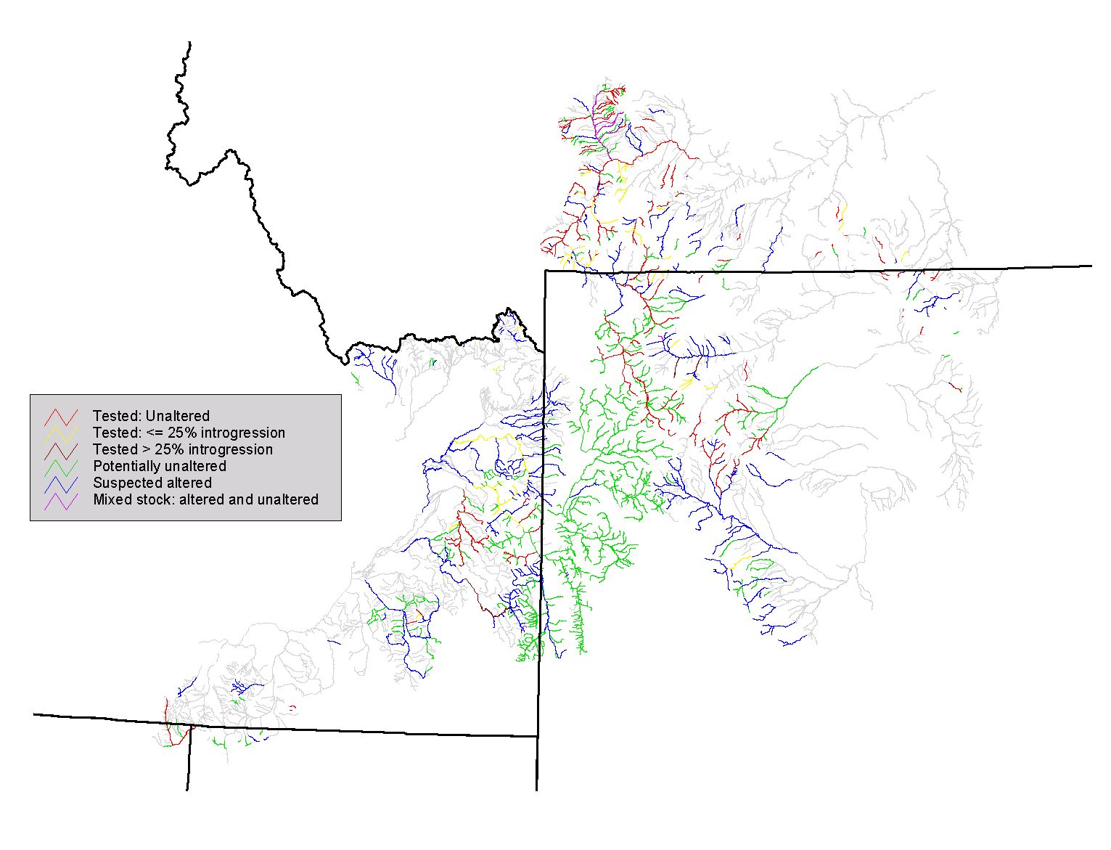
Figure 2. Genetic status of Yellowstone cutthroat trout populations throughout their range. Gray lines indicate historical range.
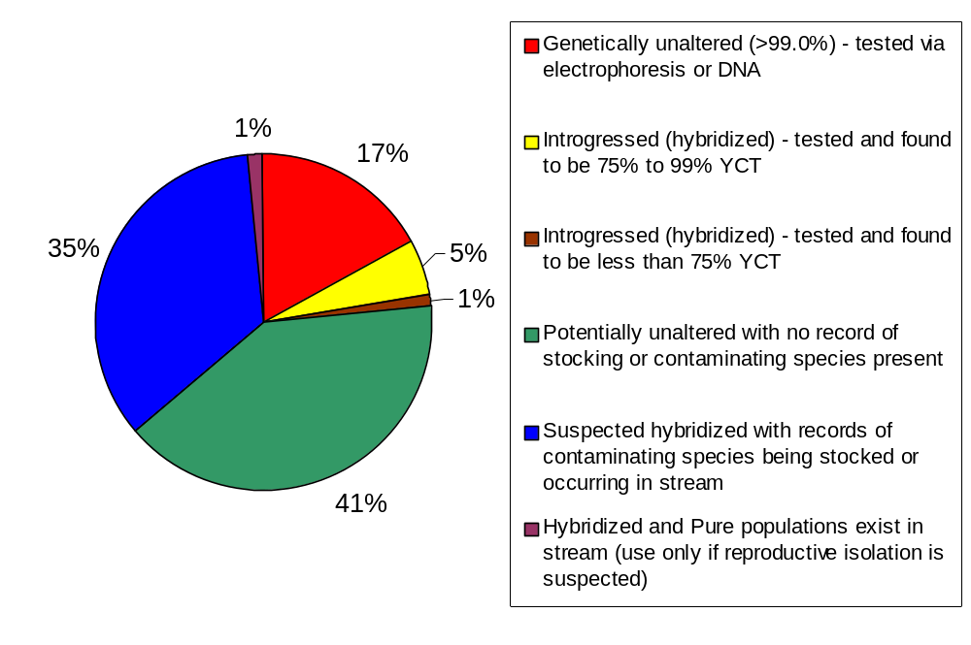
Figure 3. Genetic status of Yellowstone cutthroat trout expressed as proportion of currently occupied habitats (in miles) classified within each genetic status category for assessment done in 2001.

Table 7. Genetic status for Yellowstone cutthroat trout (both spotting forms combined) by stream length (miles) within their historical range as of 2001.

 |  | Within historical range
Genetic status |  | Miles | % of occupied | % of historical
Tested; Unaltered (<1% introgression) |  | 1301.4 | 17.3 | 7.4
Tested; <=25% to >=1% introgressed |  | 394.6 | 5.2 | 2.3
Tested; >25% introgressed |  | 79.9 | 1.1 | 0.5
Potentially Unaltered |  | 3018.5 | 40.1 | 17.2
Suspected Altered |  | 2629.6 | 34.9 | 15.0
Mixed Stock; Altered and Unaltered |  | 104.9 | 1.4 | 0.6
TOTAL |  | 7528.0 | 100.0 | 43

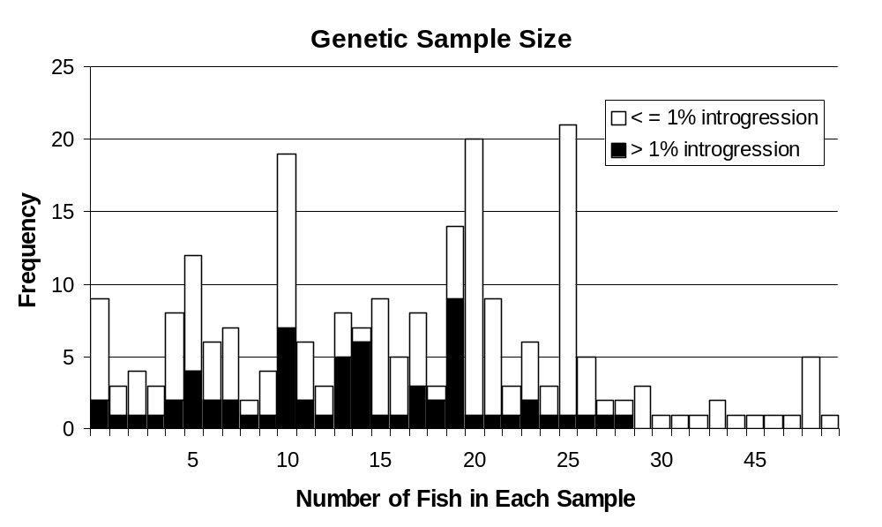
Figure 4. Distribution of the number of fish sampled for genetic testing, by level of introgression detected, for assessment done in 2001.

Abundance Relative to Habitat Potential
A total of almost 2,281 miles of occupied habitats (30% of currently occupied habitats) supported populations identified as being abundant (i.e. believed to be at or near the habitat’s potential capacity); over 3,302 miles of occupied habitat had population levels viewed as common (44% of occupied); about 1,505 miles of occupied habitat supported populations considered as rare (i.e. could be linked to habitat significantly below potential); and, 439 miles of occupied had unknown population abundance (Table 8). Of nearly 2,281 miles of habitat that had populations deemed to be abundant, a total of about 465 miles (20% of miles deemed near capacity and 6% of occupied habitats) also had no evidence of genetic introgression. Over 81% of habitats classified as abundant had field estimates to support the classification, while only 3% had data that identified professional judgment as an information source (Table 9). Approximately 525 miles of occupied habitat (40%) with abundance classified as common was associated with genetically unaltered YCT. Only 288 miles of occupied habitat (22%) supporting genetically unaltered YCT had population levels rated as rare.
Table 8. Miles of habitat currently occupied by Yellowstone cutthroat trout by genetic status and relative abundance for assessment done in 2001.

 | Abundance class
Genetic status | Abundant | Common | Rare | Unknown | Total
Tested; Unaltered | 465.3 | 524.5 | 287.9 | 23.6 | 1301.4
Tested; <=25% to>=1% introgressed | 171.4 | 199.2 | 20.9 | 3.0 | 394.6
Tested; > 25% introgressed | 51.8 | 28.1 |  |  | 79.9
Potentially Unaltered | 1002.3 | 1381.2 | 340.2 | 294.8 | 3018.58
Suspected Altered | 590.6 | 1097.2 | 834.3 | 107.4 | 2629.6
Mixed Stock; Altered and Unaltered |  | 72.4 | 22.2 | 10.3 | 104.9
TOTAL | 2281.6 | 3302.6 | 1505.6 | 439.1 | 7528.9

Table 9. Miles (%) of habitats within historical range that are currently occupied by Yellowstone cutthroat trout by relative abundance classes, data source ratings for the abundance determination, and presence of competing species (i.e. non-native trout).
 | Data source |  |  |  |  | Competing species present--
Abundance class | Judgment ----------------------- Field Data |  |  | Total | Percent | Miles | Percent
Abundant | 74.2 | 343.4 | 1863.9 | 2281.6 | 30.3% | 1356.8 | 18.0%
Common | 391.5 | 1342.4 | 1568.7 | 3302.6 | 43.9% | 1997.3 | 26.5%
Rare | 359.3 | 493.0 | 653.3 | 1505.6 | 20.0% | 99.3 | 13.3%
Unknown | 371.3 | 50.9 | 16.9 | 439.1 | 5.8% | 194.9 | 2.6%
TOTAL | 1196.3 | 2229.7 | 4102.8 | 7528.9 |  | 4548.3
Percent | 15.9% | 29.6% | 54.5% | 100% |  | 60.4%

Occurrence in Special Land Management Areas
Of over 7,528 miles of habitats currently occupied by YCT (both forms combined), approximately 4,427 miles (59% of currently occupied habitat) were associated with land administrated by specific Federal agencies. An estimated 764 miles were in designated National Parks; 1,086 miles occurred within designated Forest Service wilderness areas; and, 2,510 miles were within Forest Service road-less areas (including wilderness) (Table 10; Figure 5). Since we did not assess BLM wilderness or road-less areas in this assessment, the estimates of the proportions of habitat currently occupied by YCT within lands managed as wilderness and road-less are slight under-estimates.

The genetic status breakdown for YCT that occupy habitats on federal lands having special management focus is presented in Table 10. YCT tested as unaltered and those identified to be potentially unaltered occupied almost 2,213 miles of habitat on federal land that are managed as National Parks or Forest Service road-less, including, wilderness areas. This is about 29% of the total occupied YCT habitat. The number of miles occupied by YCT tested as unaltered and those identified to be potentially unaltered for all federal lands was 2,859 miles (38% of currently occupied habitat). Approximately 541 miles (7%) of currently occupied habitats that supported YCT with no evidence of introgression occurred within areas administered by the USDA Forest Service as road-less or by the National Park Service. The amount of occupied habitat within these special management areas with known genetic alteration was 154 miles or about 2% of currently occupied habitat.

Table 10. Miles of habitat occupied (% of occupied habitat by Federal land category) by Yellowstone cutthroat trout in Forest Service designated road-less areas (including wilderness), National Parks and within all federal lands combined.

 | National Parks |  |  | Forest Service Wilderness |  |  | Forest Service Road-less |  |  | All Federal Lands
Genetic status | Miles |  |  | Miles |  |  | Miles |  |  | Miles
Tested; Unaltered | 170.8 | (22%) |  | 206.2 | (19%) |  | 370.6 | (15%) |  | 695.6 | (16%)
Tested introgressed; 75% to 99% YCT | 20.0 | (3%) |  | 83.0 | (8%) |  | 111.4 | (4%) |  | 186.2 | (4%)
Tested; > 25% introgressed |  |  |  | 16.8 | (2%) |  | 22.5 | (1%) |  | 30.8 | (<1%)
Potentially Unaltered | 401.3 | (52%) |  | 424.0 | (39%) |  | 1270.9 | (51% |  | 2163.6 | (49%)
Suspected Altered | 172.3 | (23%) |  | 352.2 | (32%) |  | 724.2 | (29%) |  | 1336.5 | (30%)
Mixed Stock; Altered and Unaltered |  |  |  | 4.1 | (<1%) |  | 10.6 | (<1%) |  | 14.4 | (<1%)
Total | 764.4 |  |  | 1086.3 |  |  | 2510.3 |  |  | 4427

Abundance information for YCT occupying 4,427 miles of habitat on federal lands indicated that approximately 1,373 miles (31%) were rated as abundant. YCT in another 2,021 miles of occupied habitat were rated as common. YCT in approximately 697 miles of stream were rated as rare and YCT abundance was unknown in approximately 335 miles of habitat (Table 11).

The spatial arrangement of YCT whose abundance was deemed “abundant” and “common” were obviously clumped and appeared related to the presence of areas designated as wilderness, road-less, or national parks (Figure 5). About 306 miles classified as “abundant” (28% of all miles in this category) were in wilderness and about 739 miles (29% of all miles in this category) were within the road-less category that included wilderness (Table 11). Because assessments of abundance, regardless of data quality, were likely linked to quality of habitat, it is not surprising that many populations located in wilderness and road-less areas would be designated as being at or near capacity. Except where empirical observations of abundance indicated otherwise, nearly all habitats in Forest Service road-less areas (wilderness) and National Parks were presumed to have abundance levels (abundant or common) consistent with pristine conditions.

Table 11. Miles of habitat occupied (% occupied by Federal land category) by abundance rating for Yellowstone cutthroat trout in Forest Service designated road-less areas (including wilderness), National Parks and within all federal lands.

 | National Parks |  |  | Forest Service Wilderness |  |  | Forest Service Road-less |  |  | All Federal Lands
Abundance | Miles |  |  | Miles |  |  | Miles |  |  | Miles
Abundant | 297.1 | (39%) |  | 306.2 | (28%) |  | 738.6 | (29%) |  | 1373.2 | (31%)
Common | 252.1 | (33%) |  | 599.7 | (55%) |  | 1242.7 | (50%) |  | 2021.5 | (46%)
Rare | 99.3 | (13%) |  | 116.6 | (11%) |  | 348.2 | (14%) |  | 697.2 | (16%)
Unknown | 115.8 | (15%) |  | 63.9 | (6%) |  | 180.7 | (7%) |  | 335.1 | (7%)
Totals | 764.3 |  |  | 1086.3 |  |  | 2510.3 |  |  | 4427

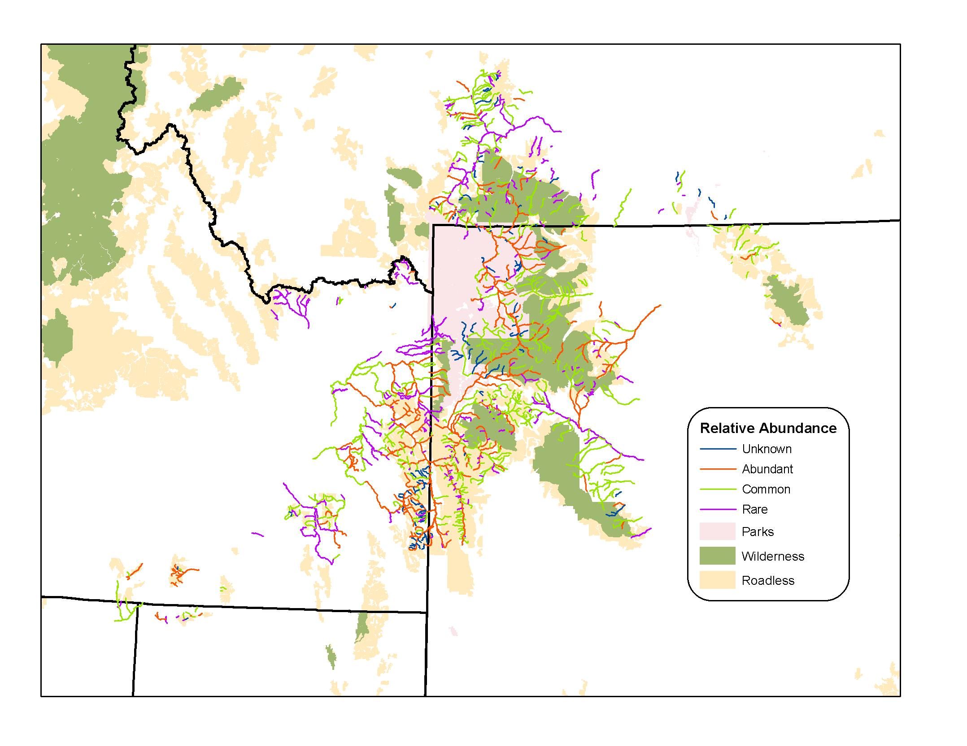

Figure 5. Relative abundance related to habitat potential overlaying designated wilderness and road-less areas and national parks.

Conservation Populations

A total of 195 populations of YCT (both spotting forms combined) occupying about 6,346 miles of habitat (over 84% of currently occupied habitats; 36% of historical range) were identified as conservation populations (Figure 6; Appendix F). These designated conservation populations were spread throughout the historical range, occurring in 35 of the 41 HUC’s historically occupied by YCT. These conservation populations were obviously more densely concentrated within the core of the historical range than near the fringes (Figure 6). Individual conservation populations occupied from 0.3 to over 1,500 miles of habitat (median = approximately 10 miles: Figure 7). The distribution of lengths of habitat occupied by conservation populations was skewed with most of the populations (126) occupying 10 miles or less. Most conservation populations were isolets (143) that occupied a total of 831 miles of habitat (Table 12). A total of 52 meta-populations occupying 5,515 miles of habitat were identified.

Of the 195 designated conservation populations, 39 (20%) were considered as “core” conservation populations having been tested and found to be genetically unaltered (Table 12). These core conservation populations occurred as 37 “isolates” and 2 meta-populations that occupied approximately 236 miles of habitat (11% of current habitat and 5% of historical habitat). There were an additional 10 conservation populations that were comprised of stream segments tested as unaltered and segments that were untested but felt to be potentially unaltered. There were also 84 populations (71 isolates and 13 meta-populations) made up solely of potentially unaltered stream segments. In combination, conservation populations that were tested unaltered with those believed to be unaltered would bring the total of “core” conservation populations to a total of 133. A total of 61 conservation populations included stream segments suspected of being altered and segments known to be introgressed based on genetic testing

The amount of habitat occupied by “core” populations known to be genetically unaltered was estimated to at 235 miles (about 3% of currently occupied habitat; slightly more than 1% of the historical habitat). There were approximately 685 stream miles (9% of current; 4% of historic) associated with conservation populations believed to be potentially unaltered and another 949 miles (13% of current; 5.4% of historic) composed of a mixture of tested unaltered and potentially unaltered. In combination, there were 133 potential “core” populations (1,870 miles; 24.8% of current and 10.7% of historic) of YCT with stream segments existing as tested unaltered, or a combination of tested and potentially unaltered or only potentially unaltered. Conservation populations composed of suspected altered stream segments and those composed of mixture of tested altered and varying combinations of altered and other genetic makeup comprised, 580 and 3,896 miles, respectively.

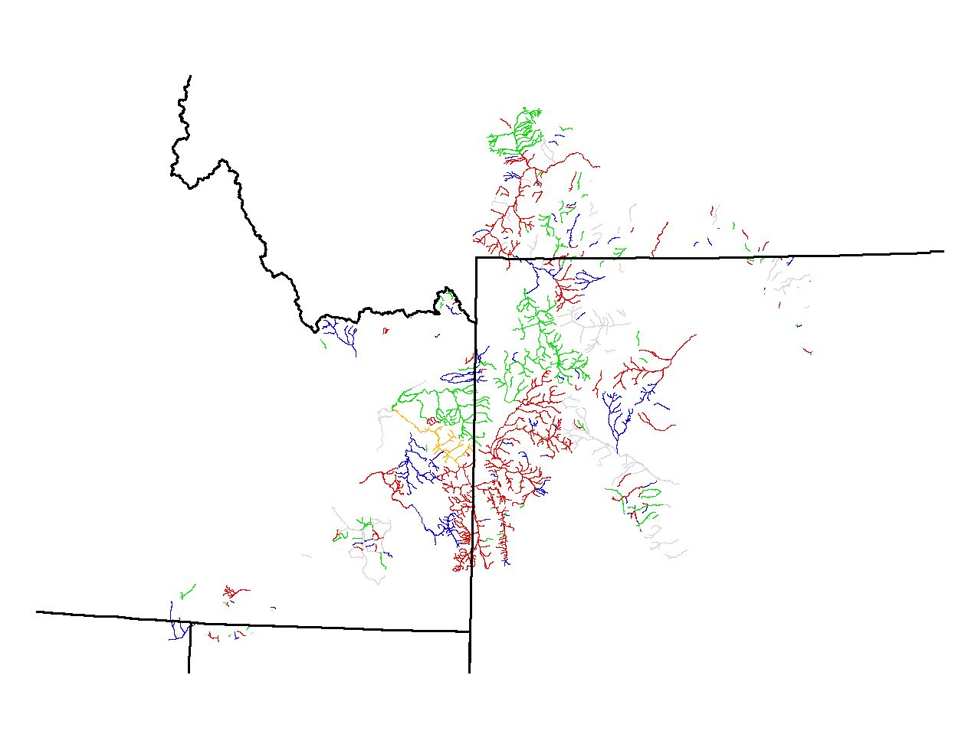
Figure 6. Designated conservation populations of Yellowstone cutthroat trout (colored streams) throughout their range shown overlaying their current distribution (gray streams) as of 2001. Different colors were used to distinguish between different conservation populations and have no other significance.

Table 12. Number and miles of designated conservation populations of Yellowstone cutthroat (both spotting forms combined) along with proportions of those populations by number and miles within isolets and meta-populations.

 |  | Isolets |  |  | Meta-populations |  |  | Total
Conservation Populations |  | Number | Miles |  | Number | Miles |  | Number | Miles
Core Conservation Populations (Tested unaltered – greater than 99% pure) |  | 37 | 199.6 |  | 2 | 35.6 |  | 39 | 235.1
Other Conservation Populations
Tested Pure w/ Potentially Unaltered |  | 3 | 26.8 |  | 7 | 921.6 |  | 10 | 948.4
Potentially Unaltered |  | 71 | 294.4 |  | 13 | 391.1 |  | 84 | 685.5
Suspected Altered |  | 21 | 209.3 |  | 11 | 371.3 |  | 32 | 580.6
Tested Altered and Combination of Above |  | 11 | 100.3 |  | 19 | 3796.0 |  | 30 | 3896.3
TOTALS |  | 143 | 830.4 |  | 52 | 5515.5 |  | 195 | 6345.8
Percent of current habitat occupied |  |  | 11.0% |  |  | 73.3% |  |  | 84.3%

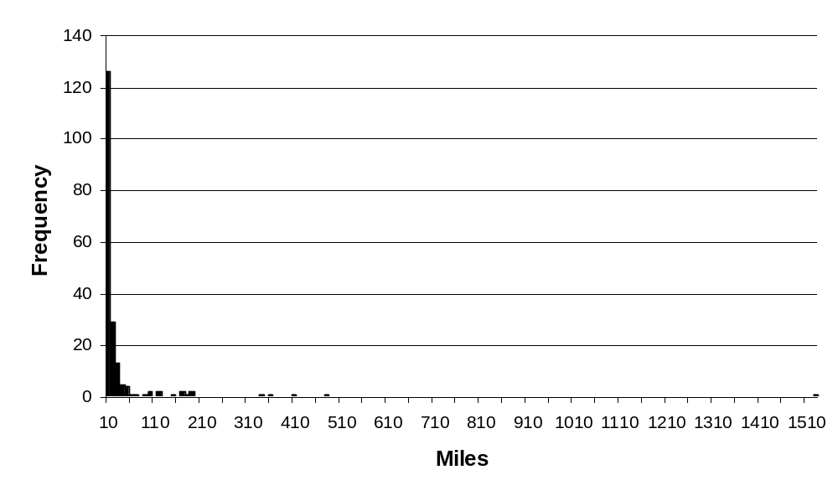
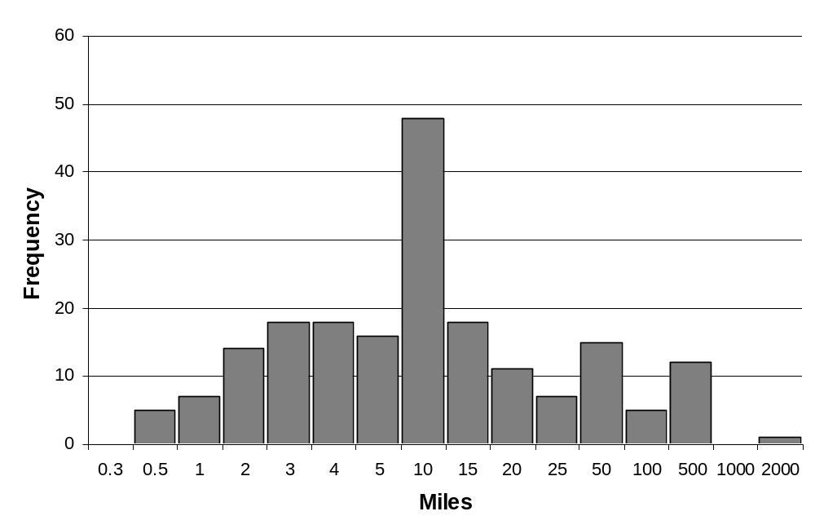
Figure 7. Frequencies of the number of miles occupied by designated conservation populations of Yellowstone cutthroat trout throughout their range. Mileage bins are uniformly assigned at 5.0 mile intervals in top graph and non-uniformly assigned in bottom graph.

Ranked Risks to Conservation Populations
We rated risks to 195 designated YCT conservation populations by miles of habitat occupied (Table 13 and Figure 8; Appendix F) and by number of populations (Table 13 and Figure 9; Appendix F). The two distinct types of conservation populations, “isolets” and “meta-populations”, were separated in the analyses. In general, isolet populations were at higher risk than due to temporal variability (amount of occupied habitat), population size, and isolation meta-populations, especially when rated by number of populations (Table 13), but isolet populations were at less risk than meta-populations due to genetic introgression. Risks associated with demographic factors were about the same for “isolates” and “meta-populations. These findings validate the fact that while smaller, isolated populations are usually much more susceptible to population level risks due to isolation, small population size, and temporal variability; their isolation makes them less susceptible to genetic introgression. Conversely, while more meta-populations (larger, connected populations) were less vulnerable to population risks such as temporal variability, isolation, and small population size, their connectedness made them more susceptible to genetic introgression risks (Table 13). Composite population risk scores ranged from a low of 4 to a high of 16 with most scores being over 10 for isolet populations and under 8 for meta-populations (Figure 10). “Isolets” were at moderately high risk based on the composite of risk characters. Meta-populations were viewed as being at moderately low risk when all, non-genetic, risk factors were considered. It is important to note that 101 YCT conservation populations (51.8%) were sympatric with competitive species of trout. By convention, the demographic risk factor associated with populations that were sympatric with competitive species had to be rated down by one to two points.

It is important to understand that population risks are presented in relative terms. Higher genetic risk ratings for meta-populations do not mean that each of these population is doomed to a fate of being genetically contaminated. Nor do high isolation risk ratings mean that all isolated populations will be eventually eliminated. The risks evaluated in this review should be viewed in relative terms and not as absolutes.

Restoration Activities Implemented for Conservation Populations
Restoration, conservation, and management activities that have been implemented to conserve designated conservation populations were evaluated for the 195 conservation populations (Table 14). Angling restrictions have been implemented on waters that affect nearly half of the designated conservation populations. Angling restrictions often consisted of “catch and release” fishing for YCT, but other restrictions such as bag and size limits and gear restrictions were also included. Restoration and enhancement activities, such as physical removal of competing and/or hybridizing species, population restoration and expansion, riparian fencing, pool development, diversion modification, riparian restoration and stream bank stabilization, have occurred for 5 to 10% of the conservation populations, respectively. In addition, a substantial number of conservation populations reside within the boundaries of lands with special management (e.g. road less, wilderness, and national parks, etc.).

Table 13. Ranked risks to designated conservation populations of Yellowstone cutthroat trout (both forms combined) that functioned as “isolets”, “meta-populations”, and combined by miles of habitat and numbers of conservation populations that conservation populations occupied by risk factor as of 2001. Bold population composite risk scores are weighted scores for temporal variability, population size, demographics, and isolation re-classified into low to high categories (see Methods for details).

 |  |  | Ranked risk by miles |  |  | Ranked risk by number of populations
 |  | Low | Med Low | Med High | High | Low | Med Low | Med High | High
Type of Population | Risk Factor | Low | -------------------------- |  | High | Low | ------------------------- |  | High
Isolets | Genetics | 465.1 | 114.0 | 174.0 | 77.2 | 99 | 16 | 22 | 6
 | Temporal Variability | 77.4 | 320.3 | 432.7 | 0.0 | 0 | 4 | 33 | 106
 | Population size | 49.2 | 204.7 | 456.1 | 120.3 | 4 | 20 | 84 | 35
 | Demographics | 297.9 | 382.6 | 114.9 | 34.9 | 49 | 73 | 15 | 6
 | Isolation | 25.3 | 15.7 | 789.3 | 0.0 | 0 | 1 | 1 | 141
 | Composite | 0.0 | 388.9 | 395.3 | 46.2 | 0 | 55 | 79 | 9
Metapopulations | Genetics | 1118.5 | 127.2 | 2063.6 | 2206.1 | 17 | 5 | 11 | 19
 | Temporal Variability | 4653.3 | 631.0 | 222.2 | 9.0 | 19 | 19 | 12 | 2
 | Population size | 4627.9 | 616.8 | 261.8 | 9.0 | 22 | 18 | 10 | 2
 | Demographics | 1031.1 | 3473.8 | 704.0 | 306.5 | 17 | 23 | 9 | 3
 | Isolation | 4001.7 | 870.5 | 490.5 | 152.7 | 23 | 7 | 14 | 8
 | Composite | 3627.3 | 1619.8 | 268.4 | 0.0 | 11 | 24 | 17 | 0
COMBINED | Genetics | 1583.7 | 241.2 | 2237.6 | 2283.3 | 116 | 21 | 33 | 25
 | Temporal Variability | 4730.7 | 951.3 | 654.8 | 9.0 | 19 | 23 | 45 | 108
 | Population size | 4677.1 | 821.5 | 717.9 | 129.3 | 26 | 38 | 94 | 37
 | Demographics | 1329.0 | 3856.5 | 819.0 | 341.4 | 66 | 96 | 24 | 9
 | Isolation | 4027.0 | 886.3 | 1279.8 | 152.7 | 23 | 8 | 15 | 149
 | Composite | 3627.3 | 2008.6 | 663.8 | 46.2 | 11 | 79 | 96 | 9

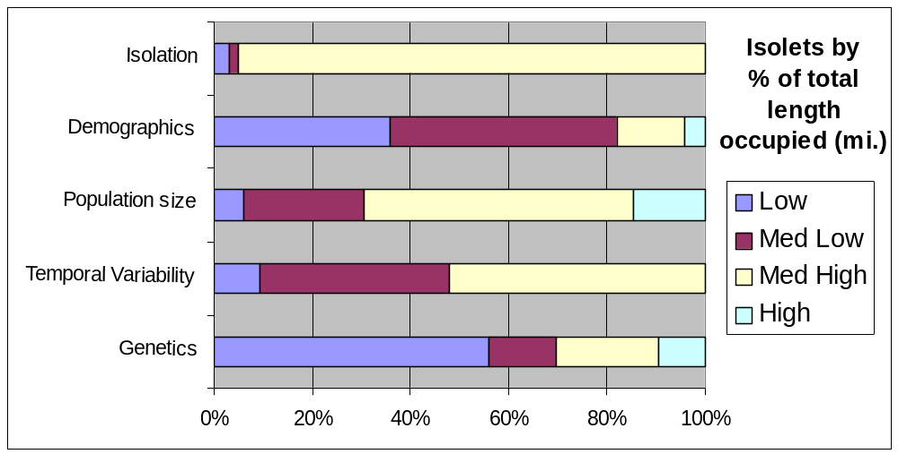
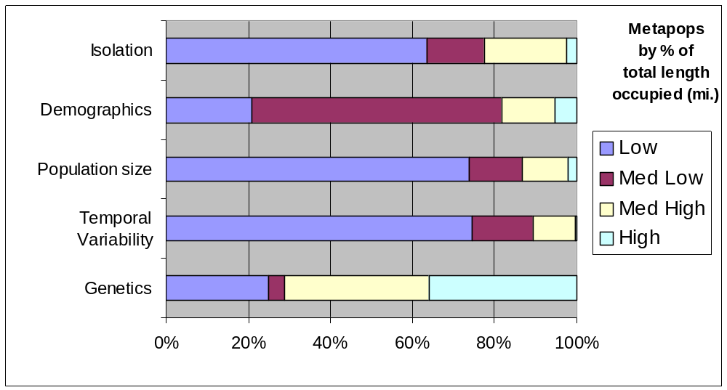

Figure 8. Proportions of miles occupied by designated “isolet” (top) and metapopulation (bottom) Yellowstone cutthroat trout conservation populations ranked into low to high levels of risk by risk factor (vertical axes).

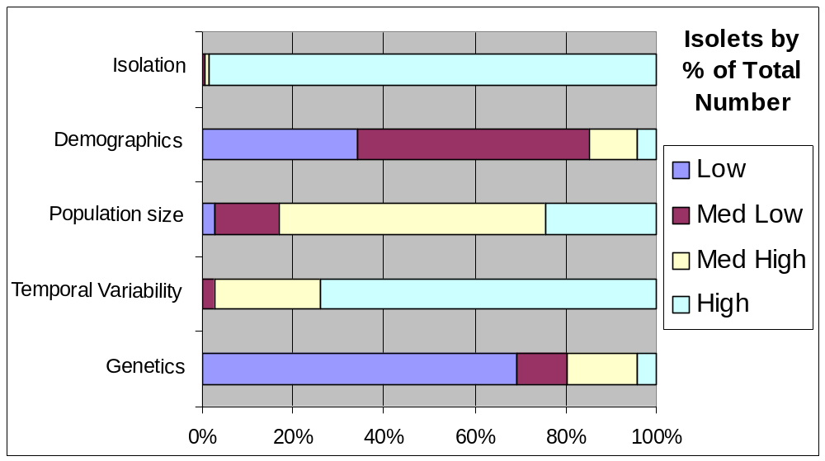

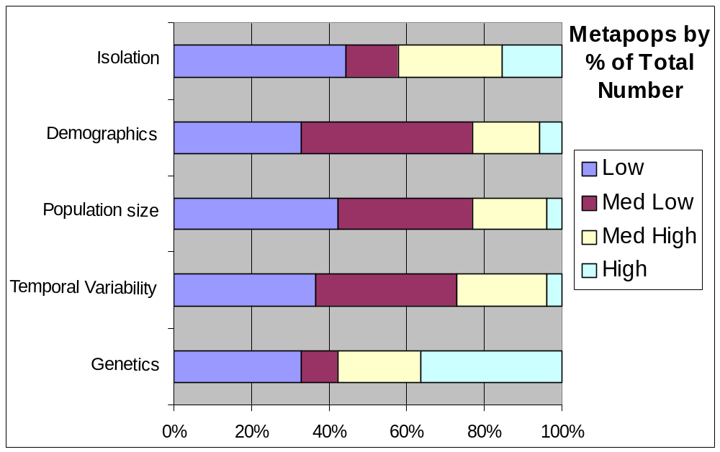

Figure 9. Proportions for numbers of designated “isolet” (top) and metapopulation (bottom) Yellowstone cutthroat trout conservation populations ranked into low to high levels of risk by risk factor (vertical axes).
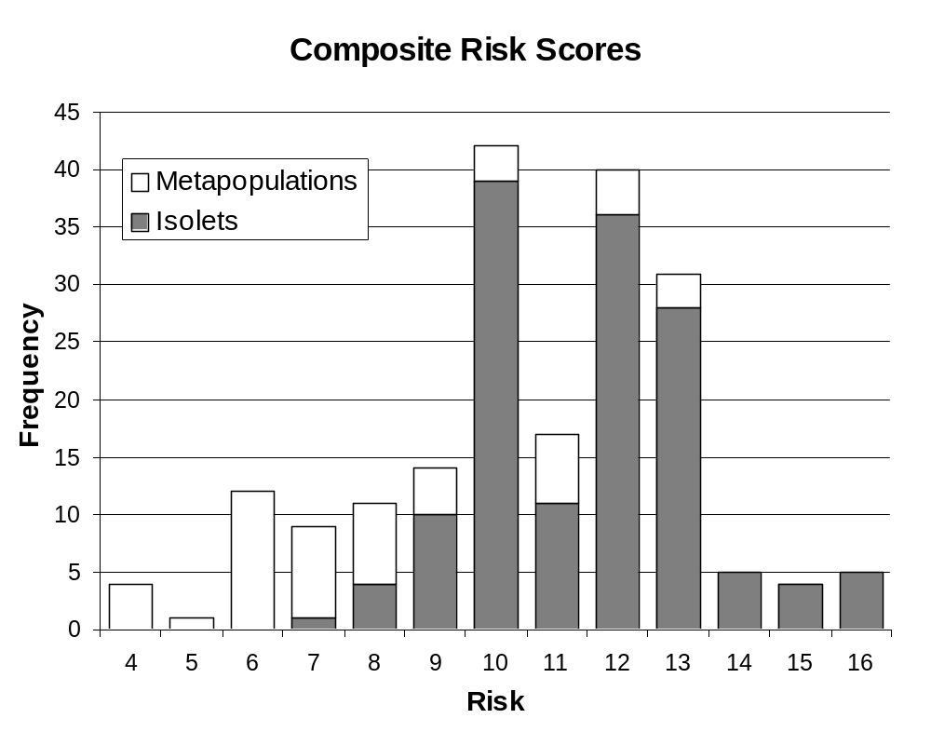

Figure 10. Distribution of the number of designated Yellowstone cutthroat trout populations by composite population risk scores and population type (excludes genetics and disease risks).

Table 14. Number and percentage (based on the 195 conservation populations that were evaluated) of Yellowstone cutthroat trout conservation populations that have had various types of conservation, restoration, and management actions implemented to conserve them as of 2001.

Type of restoration or management activity | Number of populations
Water lease/Instream enhancement | 4 | 2.1%
Channel restoration | 9 | 4.6%
Bank stabilization | 17 | 8.7%
Riparian restoration | 18 | 9.2%
Diversion modification | 9 | 4.6%
Barrier removal | 3 | 1.5%
Barrier construction | 5 | 2.6%
Culvert replacement | 7 | 3.6%
Fish screens | 2 | 1.0%
Fish ladders | 3 | 1.5%
Spawning habitat enhancement | 3 | 1.5%
Woody debris | 9 | 4.6%
Pool development | 10 | 5.1%
Irrigation efficiency | 9 | 1.7%
Grade control | 1 | 2.0%
Instream cover habitat | 6 | 3.1%
Riparian Fencing | 20 | 10.3%
Physical removal of competing/hybridizing species | 10 | 5.1%
Chemical removal of competing/hybridizing species | 3 | 1.5%
Public outreach (Interpretive site) | 8 | 4.1%
Population restoration/expansion | 13 | 6.7%
Angling regulations | 70 | 40.5%
Other | 12 | 6.2%

Land Use Impacts on Conservation Populations
The approach taken to address the influences of land uses on YCT was too qualitative to definitively link land use impacts to specific conservation populations. Information was collected for each occupied stream segment and there was a considerable amount of uncertainty associated with the influence determinations that were made. Survey groups responded to land use impact questions in different ways; some included past land uses to those currently occurring. Others only identified current land uses. It was difficult to determine if the response was related to the whole stream segment or only a portion of a segment. Because of the stated uncertainties it is suggested that future work to quantify the nature of land use impacts to YCT conservation populations be undertaken. Even with these uncertainties, the information does serve to heighten the awareness of the possible influences of land uses on YCT. Livestock grazing was ranked as having the greatest influence on YCT conservation populations. This was followed by roads, angling, timber harvest, stream de-watering and non-angling recreation as major land uses (Table 15). We encourage caution when reviewing this information. At best it provides a very qualitative picture of the nature of land uses on YCT conservation populations.

Table 15. Number and percentage (based on the 195 conservation populations that were evaluated) of designated Yellowstone cutthroat trout conservation populations where human management activities were known or believed (possible) to have impacted the population by type of management activity.

 | Known Impacts |  |  | Possible Impacts
Type of activity | Number |  |  | Number
Timber harvest | 31 | (15.9%) |  | 35 | (17.9%)
Range (livestock grazing) | 45 | (23.1%) |  | 97 | (49.7%)
Mining | 17 | (8.7%) |  | 8 | (4.1%)
Recreation (non-angling) | 34 | (17.4%) |  | 42 | (21.5%)
Angling | 54 | (27.7%) |  | 22 | (11.3%)
Roads | 33 | (16.9%) |  | 66 | (33.8%)
Dewatering | 21 | (10.8%) |  | 40 | (20.5%)
Other | 13 | (6.7%) |  | 20 | (10.3%)

Fine-Spotted and Large Spotted Forms
There are two spotting patterns displayed by YCT within their current range. This assessment made an attempt to partition the information by asking the assessment teams to identify which form was present in each stream segment. Additionally, in instances where both forms were present within a stream segment most reviewers made comments on which form was dominant.

Of the 195 conservation populations, 138 (71%) were comprised of only the large-spotted form, 39 (20%) were comprised of only the fine-spotted form and 18 (9%) represented a mixture of both spotting patterns (Figure 11; Table 16). Large-spotted YCT conservation populations were identified as being broadly distributed throughout the range. Large-spotted YCT existing without the presence of the fine-spotted form occurred in 3,888 miles of stream (61.3% of habitat occupied by conservation populations). The fine-spotted form existing without the presence of the large-spotted form occurred in 217 miles of stream (3.4%). Conservation populations having representatives of both spotting patterns occurred in 2,241 miles of stream (35.3%). Conservation populations with only fine-spotted YCT were primarily located within headwaters of the Snake River. A few fine-spotted YCT conservation populations were identified outside of the Snake River basin (Figure 11). It should be noted that the fine-spotted form had been widely used within the recreational fishery management program for Wyoming and because of this they have been introduced into many watersheds outside the initial area they occupied

Of the 138 large-spotted YCT conservation populations, 38 had sufficient genetic testing to determine that they were unaltered and could be considered as “core” populations. Another 8 conservation populations were comprised of stream segments containing both tested pure and segments viewed a potentially unaltered. Forty (40) conservation populations were treated as potentially unaltered and 25 were suspected of being genetically altered. Another 27 populations were either tested and found to be genetically altered or they existed as a mixture of altered and unaltered YCT. Seventy two percent of the large-spotted YCT populations were isolates and 28% were meta-populations.

For the conservation populations (39) having only the fine-spotted form, most (36) were identified as being potentially unaltered and three were suspected of being altered. Thirty four of these fine-spotted YCT conservation populations were isolates and five were meta-populations. A total of 18 conservation populations had both fine and large-spotted YCT present. These conservation populations were nearly equally split between isolates (56%) and meta-populations (44%). There was only one “core” conservation population identified in this mixed stock group. As more genetic testing is completed we anticipate that many of the populations having potentially unaltered stream segments will be found to be unaltered. Genetic alteration (introgression) alluded to in this assessment is between YCT, and rainbow trout or other formally recognized cutthroat subspecies (AFS 1991) with no differentiation between the spotting patterns.
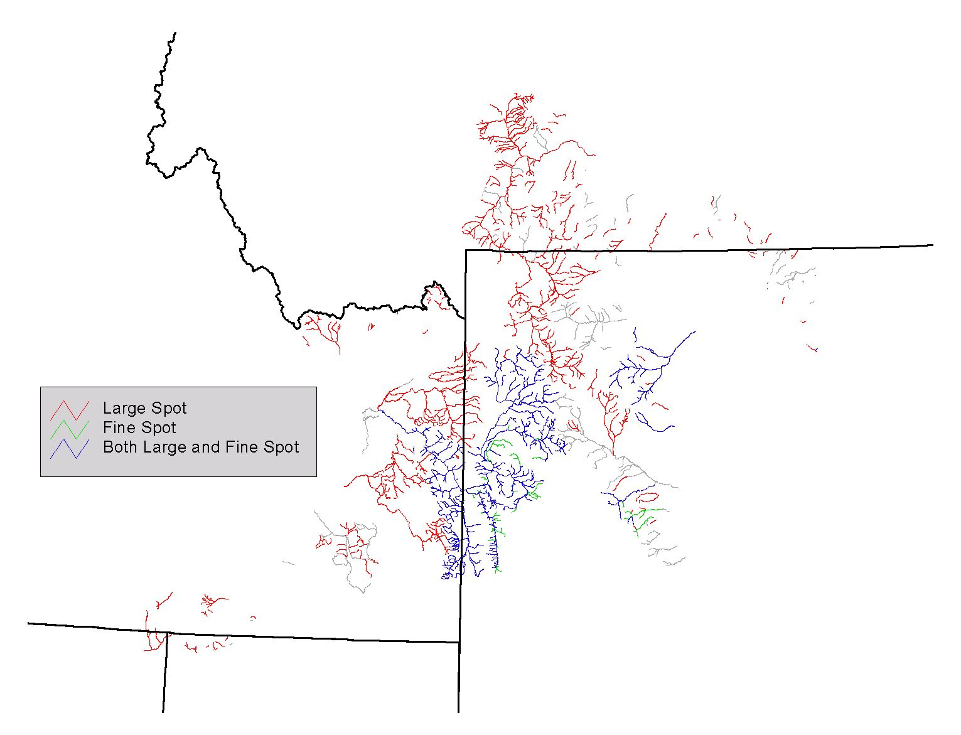
Figure 11. Distribution of YCT conservation populations based on presence of the large spotted form only, the fine spotted form only and a combination of both spotting patterns.
Table 16. Number and miles of designated conservation populations of Yellowstone cutthroat based on spotting pattern along with proportions of those populations by number and miles within isolets and meta-populations.

 |  | Isolets |  |  | Meta-populations |  |  | Total
Conservation Population |  | Number | Miles |  | Number | Miles |  | Number | Miles

Large Spotted YCT
Core Conservation Populations (Tested unaltered – greater than 99% pure) |  | 36 | 190.1 |  | 2 | 35.6 |  | 38 | 255.6
Tested Pure w/ Potentially Unaltered |  | 3 | 26.8 |  | 5 | 714.4 |  | 8 | 741.2
Potentially Genetically Unaltered |  | 34 | 176.2 |  | 6 | 104.6 |  | 40 | 280.8
Suspected Genetically Altered |  | 16 | 146.7 |  | 9 | 317.6 |  | 25 | 464.4
Tested Genetically Altered and/or a Mix |  | 10 | 72.1 |  | 17 | 2104.8 |  | 27 | 2176.8
Fine Spotted YCT
Potentially Genetically Unaltered |  | 32 | 93.7 |  | 4 | 76.3 |  | 36 | 169.9
Suspected Genetically Altered |  | 2 | 29.7 |  | 1 | 16.8 |  | 3 | 46.5

Large and Fine Spotted YCT Together
Core-Conservation Populations (Tested unaltered – greater than 99% pure) |  | 1 | 9.5 |  | -- | -- |  | 1 | 9.5
Tested Pure w/ Potentially Unaltered |  | -- | -- |  | 2 | 207.2 |  | 2 | 207.2
Potentially Genetically Unaltered |  | 5 | 24.5 |  | 3 | 210.2 |  | 8 | 234.7
Suspected Genetically Altered |  | 3 | 32.9 |  | 1 | 36.9 |  | 4 | 69.8
Tested Genetically Altered and/or a Mix |  | 1 | 28.2 |  | 2 | 1691.2 |  | 3 | 1719.4
TOTALS |  | 143 | 830.4 |  | 52 | 5515.5 |  | 195 | 6345.8

We separated the rated risks to the conservation populations based on spotting pattern by miles of habitat occupied and by number of populations (Table 17). The distinct spotting patterns were separated in the analyses. In general, spotting pattern did not appear to be related to genetic risks to the populations. The difference associated with the low genetic risk for the fine spotted populations was likely a function of the limited genetic sampling completed to date. Few clear risk differences emerged during the analysis. We believe the risks assessed for YCT in general also apply equally to the differing spotting patterns. Further comments or discussion of the two spotting patterns of YCT will not be carried forward in the discussion and conclusions section.

Discussion and Conclusions

Historical Range

The exact evolutionary (phylogenetic) origins and zoogeographical processes taken during the speciation process for the various cutthroat trout subspecies may not be known for quite some time, if ever. Numerous theories and much speculation have been tendered (Behnke 1992, Smith et al. 2002). More recent advances in genetic testing methodologies have offered new insight into the pre-historical cutthroat trout story. This status update did not attempt to address the pre-historical picture. Rather we intended to focus on a more recent historical point of reference as a way of tracking changes that could be validated through written accounts and personal observations.

Historical habitats of YCT delineated by this assessment differ from previous assessments (Henzel 1959; Behnke 1979; Hadley 1984; Behnke 1988; Varley and Gresswell 1988; Thurow et al. 1988; Behnke 1992; Gresswell 1995) for a number of reasons. A notable difference is the reference period of historical occupancy. Behnke (1979; 1992) indicated that the western extent of YCT range likely extended to portions of the Snake River, near the Idaho-Washington border. The type locality for the name bouvieri was Waha Lake in western Idaho. Behnke (1979 and 1992) states that S.c. bouvieri were the original native trout of the entire Snake River some time prior to the last glacial period (8,000 to 12,000 year ago) and replaced by redband and westslope cutthroat trout below Shoshone Falls after that time period. Behnke (1979; 1992) notes that all tributaries between Palisades Reservior and Shoshone Falls have S.c. bouvieri as the native trout. Expansion into the Yellowstone River basin is felt to be via a connection between Pacific Creek in the Snake River basin and Atlantic Creek which is a Yellowstone River tributary (Behnke 1992). Behnke (1979 and 1992) discussed eastern expansion within the Yellowstone River basin and concluded that YCT occupied the mainstem Yellowstone River and tributaries as far as the Tongue River. This eastern expansion would have occurred during the last 8,000 years. Many status reports (Hadley 1984; Varley and Gresswell 1988; Gresswell 1995) cite Behnke (1979 and 1992) as the reference source for historical distribution of YCT there by anchoring to a time period with a pre-historical perspective. A recent status review (May 1996) discussed the historical range from a more immediate perspective using European exploration of the inland portion of west (circa 1800) as a historical benchmark. While it is reasonable to assume that the pre-historical distribution of YCT likely expanded and contracted over time as environmental and climatic conditions changed, written documentation that provides a more comparative reference to current conditions began around 1800. Kruse et al. (2000) completed a recent status

Table 17. Ranked risks to designated conservation populations of Yellowstone cutthroat trout (represented as large spotted, fine spotted or a mixture of both) that functioned as “isolets”, “metapopulations”, and combined by number of conservation populations and miles of habitat that these conservation populations occupied by risk factor as of 2001. Bold population composite risk scores are weighted scores for temporal variability, population size, demographics, and isolation re-classified into low to high categories (see Methods for details).

 |  |  | Ranked risk by miles |  |  | Ranked risk by number of populations
Spotting Pattern Associated with Conservation Population | Risk Factor | Low | -------------------------- |  | High | Low | ------------------------- |  | High
Large Spotted YCT | Genetics | 930.5 | 220.3 | 679.5 | 2058.6 | 66 | 19 | 31 | 22
 | Temporal Variability | 2574.2 | 566.6 | 407.7 | 340.3 | 14 | 16 | 35 | 73
 | Population size | 2514.7 | 727.2 | 583.2 | 63.8 | 17 | 31 | 77 | 13
 | Demographics | 986.7 | 1813.6 | 747.3 | 341.4 | 48 | 60 | 21 | 9
 | Isolation | 1844.9 | 852.5 | 489.4 | 702.2 | 15 | 6 | 14 | 103
 | Composite | 1520.0 | 1729.4 | 593.4 | 46.2 | 10 | 63 | 56 | 9
Fine Spotted YCT | Genetics | 161.4 | 0 | 0 | 54.8 | 37 | 0 | 0 | 2
 | Temporal Variability | 0 | 70.1 | 69.4 | 76.8 | 0 | 3 | 6 | 30
 | Population size | 46.3 | 31.3 | 79.8 | 59.0 | 2 | 2 | 12 | 23
 | Demographics | 42.3 | 148.8 | 25.3 | 0 | 9 | 29 | 1 | 0
 | Isolation | 29.5 | 25.3 | 16.8 | 144.8 | 1 | 1 | 1 | 36
 | Composite | 16.8 | 50.2 | 149.4 | 0 | 1 | 7 | 31 | 0
Large and Fine Spotted YCT | Genetics | 491.5 | 20.9 | 1558.1 | 170.0 | 13 | 2 | 2 | 1
 | Temporal Variability | 2079.1 | 71.7 | 65.3 | 24.5 | 5 | 4 | 4 | 5
 | Population size | 2116.1 | 63.1 | 54.9 | 6.5 | 7 | 5 | 5 | 1
 | Demographics | 300.1 | 1894.1 | 46.4 | 0 | 9 | 7 | 2 | 0
 | Isolation | 2127.4 | 18.1 | 0 | 95.1 | 7 | 1 | 0 | 10
 | Composite | 2090.5 | 83.8 | 66.3 | 0 | 6 | 6 | 6 | 011

assessment of YCT in specific drainages of the Bighorn River and primarily anchored to the more recent time period (May 1996) as a historical reference period.

Another significant difference between this status assessment and many of the previous assessments is associated with the base representation of occupied habitat across the potential range. Behnke (1979, 1988 and 1992) used narratives and qualitative maps to describe the outer most boundaries of YCT historical range. These publications made reference, from field notes and observations, to specific streams but did not attempt to provide quantification of the amount of historically occupied habitat. Hadley 1984 provided a very limited qualitative reference to historical occupancy by stating: “The Yellowstone cutthroat trout in Montana was at one time abundant in most waters in the Yellowstone River basin from the Montana-Wyoming border to the Tongue River system.” Varley and Gresswell (1988) cited Behnke’s publications relative to historic range and then provided further quantitative detail. They mention that original habitat was comprised of 44,500 ha of lake habitat and 24,000 km (15,000 miles) of stream environment. Varley and Gresswell (1988) did not provide an explanation on how they obtained these historical estimates. Kruse (2000) in turn cited Varley and Gresswell (1988) when commenting on the historical distribution. In the USDA Forest Service conservation assessment for the inland cutthroat trout subspecies (May 1996) an attempt was made to quantify YCT historical range based on mapped stream miles within the geographical area believed to have been occupied in about 1800.

The generalized boundaries depicted in most assessments (e.g. Behnke 1979 and 1992) encompassed many 4th code HUC’s that we excluded (e.g. lower Tongue River, lower Rosebud within the Tongue River basin; Badwater, Muskrat, and Lower Bighorn in the Bighorn River basin; and, several watersheds on the north side of the mainstem lower Yellowstone River) based on a focused review by individuals knowledgeable about the specific geographical areas reviewed. In addition, the lack of historical quantification and site specificity in most status discussions can imply to many readers that all or most streams within the generalized boundaries depicted were occupied by YCT.

Our estimates suggest approximately 17,400 miles , located within 39 4th code HUC’s, were occupied by YCT at the time of Lewis and Clark’s “Corps of Discovery” expedition. This amount of historically occupied habitat is in contrast to the nearly 32,200 miles of stream contained in the 1:100,000 hydrography associated with these watersheds. Nearly 14,600 miles of streams were excluded from being historically occupied due to passage barriers (e.g. physical, temperature, etc.) and inadequate habitat (e.g. minimal flows, excessive gradients, intermittent or ephemeral flows, etc.). Some stream reaches were excluded because of historical references and other antidotal observations indicating that the stream was barren of fish (i.e. Jordan 1891). Habitats were included on the basis of historical journal entries, scientific reports, anecdotal information on presence, evidence of basin transfers and presence of trout when no barriers were present.

May (1996) reported that YCT historically occupied just over 16,600 miles of riverine habitat. Of that total, Wyoming had 10,949 miles (66%), Idaho had 3,587 miles (22%), Montana contained just over 1,920 miles (12%) and 210 miles (1%) were attributed to occupied habitats in Utah and Nevada combined. We estimated that about 17,400 miles of habitat were historically occupied within the historical geographical boundary (Figure 1). Of our total, Wyoming contained the most historical habitat (6,886 miles; 40%), Idaho was believed to have 6,267 miles (36%), Montana contained just over 4,040 miles (23%) , Nevada and Utah had 97 and 103 miles, respectively (0.5% each). While the total number of historically occupied miles between our status update and the status review completed in the mid-1990’s were very similar there was a marked difference in the mileages associated with Wyoming, Idaho and Montana. The difference between our estimate and that developed in the previous assessment (May 1996) was likely due to two significant factors. First, our assessment used a set 1:100,000 hydrography base layer that was attributed and queried within an ARCView platform and a standardized database. The status assessment of the mid-1990’s relied on area maps having differing scales and stream designations. Notations were made on each map and stream distances were calculation using a mileage function on a planimeter. Secondly, the mileage estimate for Wyoming in the earlier assessment was suspect due to the nature of Wyoming’s stream database at the time (May 1996).

Varley and Gresswell (1988) estimated the historically occupied habitat at 24,000 km (15,000 miles). Since Varley and Gresswell (1988) did not provide a rationale of how they derived the number of occupied stream miles, it was difficult to compare with our estimate. Their estimate of about 15,000 miles did not include mileages covered by large lakes, particularly Yellowstone Lake, and thus their total is reasonably close to the historical occupancy estimates in our status update and the status review completed by May (1996).

Current Distribution

Based on our assessment, YCT currently occupy about 7,530 miles of habitat (43% of historically occupied habitat) within the historical range (Figure 2). YCT currently occupy 3,861 miles (51%) in Wyoming, 2,174 miles (29%) in Idaho, 1,417 miles (19%) in Montana and Nevada and Utah have 44 and 42 miles, respectively (0.5% each). In contrast, the assessment reported in May 1996 reported that approximately 6,817 miles of currently occupied habitat. Of that total 1,622 (including 31 miles in the Goose Creek and Raft River drainages) were in Idaho, 4,624 were in Wyoming and 625 were in Montana. The reason for the significantly large difference in currently occupied habitat within Montana was because only those YCT that had been genetically tested were counted in the earlier assessment (May 1996). In addition, differences could be attributed to mapping and hydrography scales, differences in the individuals participating the assessments and fact that more YCT had been documented in the six year period between assessments. Varley and Gresswell (1988) estimated that YCT in their pure form occupied 38,500 ha of lake environment and 2,400 km (1,500 miles) of stream habitat. A reason for this estimate being significantly lower could be linked to the notation that only “pure” YCT were considered. Varley and Gresswell (1988) did not provide a discussion of how purity was determined to support their estimate of current distribution.

Hanzel’s (1959) work on YCT distribution in Montana was updated by Hadley (1984). Both of these efforts relied on visual observation to identify YCT. As referenced in Hadley (1984), Hanzel made YCT collections within the Yellowstone River basin in the section between Yellowstone National Park and the mouth of the Bighorn River. These collections indicated that YCT were present in the Yellowstone River from the park boundary downstream for a distance of 145 km (90 miles). Mention was also made that remnant YCT were confined to small headwater streams. Hanzel’s assessment was mostly qualitative and he made little effort to quantify numbers of streams or miles occupied. Hadley (1984) completed an assessment of YCT using Montana Fish, Wildlife and Parks’ computerized database as an information source. Use of the database allowed for a partitioning of YCT information into categories that were used to gain a better understanding of YCT populations in Montana. Hadley (1984) reported that YCT were believe to exist in 324 km (203 miles) of stream based on information contained in the database at that time. Hadley also stated that the database was likely incomplete because at the time it didn’t contain information from Federal agencies nor have all the information from department personnel. The significant difference in miles of occupied stream habitat between the assessment (203 miles) completed by Hadley (1984) and our assessment (1,417 miles) is likely do to insufficient data being available within the State’s database at the time Hadley completed her review. During the last 20 years there has been a substantial investment of time and energy to prove better information of YCT distributions within Montana. As a result, many more stream reaches have been inventoried and tested genetically. In addition, the statewide database has been updated on a regular basis of at least by-annually and included data from all sources.

Kruse et al. (2000) reported on the status of YCT within the Greybull and Shoshone River basin of northwestern Wyoming. Their assessment was very detailed and provided information on YCT distribution from 182 streams (1,705 km; 1,066 miles) within the two river basins. As part of the Wyoming workshop for our assessment, the information collected by Kruse (2000) was entered into the database which greatly strengthened the information on current YCT distributions in Wyoming. In similar fashion, the work of Mark Novak, USDA Forest Service and Wyoming Department of Game and Fish in the upper Snake River basin was included within our assessment.

Thurow et al. (1988) provided an assessment of YCT status and ecology within the Idaho portion of the native range. Their work concentrated on many of the major tributary drainages to the Snake River in Idaho (i.e. Blackfoot River, South Fork of the Snake River, Teton River and Willow Creek). Specific quantification of the amount of stream habitat occupied by YCT was not provided but there were statements indicating the YCT were present in most streams and stream reaches within these tributaries but there was a significant effort to quantify population levels for streams occupied by YCT. Meyer et al.(2003) completed a very important follow up assessment of many streams sampled in the 1980’s by Thurow et al. (1988) and others. This later sampling repeated population quantification at 77 pair sites following the same sampling protocol to the extent possible. Meyer et al. (2003) found that population abundance had remained relatively stable, at most paired sites, over the last 10-20 years. Only five of the sites sampled in the 1980’s did not contain YCT (Meyer et al.(2003). The sampling design of this recent study made it impossible to provide definitive conclusions regarding YCT distribution and population abundance outside of the study sites.

Designated Conservation Populations

There were two types of conservation strategies represented by the YCT “conservation populations” (Appendix F). One strategy was linked to conserving genetic integrity and reducing the influence of competitive species by isolating YCT populations (Kruse et al. (2001). The other strategy emphasized maintenance of connectivity among YCT populations by protecting relatively large areas of continuous habitat that allow YCT to express all life-history traits, especially migratory life histories. As shown, the type of risks inherent in the two different conservation strategies are dramatically different.

For those YCT conservation populations where genetic integrity and isolation from competing species is emphasized, risks due to isolation, small population size, and temporal variability are high, while other types of risk are relatively low. The assumption made in rating these population risks as high was that YCT populations benefit from occupancy in relatively large habitats that allow for connection among subpopulations. Some authors have indicated that cutthroat trout populations need to be supported by an effective population of 500 reproducing adults based on the 50/500 “rule” (Franklin 1980; Soulé 1980), thus they believed that most isolated small populations of cutthroat trout were at an extremely high risk of extinction (Kruse et al. 2001; Hilderbrand and Kershner 2000). Harig and Fausch (2001) found that cutthroat trout translocations were most successful when the drainage area was at least 5.6 mi.² (14.7 km²), which likely translates to inhabited stream lengths of at least 2 to 3 miles. Hilderbrand and Kershner (2000) estimated that cutthroat trout needed at least 5.7 miles (9.3 km) of habitat at moderately high densities to persist under the 500 “rule”. Rieman and Dunham (2000) provided data that indicated small, isolated populations of WCT might not be as prone to extinction as other vertebrates, and even other salmonids, based on their evaluation of the persistence of isolated headwater populations of WCT in the Coeur d’Alene basin of Idaho. Of the 195 YCT conservation populations we evaluated (Appendix F), 143 were considered as “isolates” with majority having either moderately high or low composite risk scores ( weighted toward the moderately high score). Risk factors of concern for most of the “isolates” were occupancy of relatively small stream lengths (<10 km), smaller effective population sizes (fewer spawning adults), and the potential detrimental influence of being isolated. None of the “isolate” populations had a low composite risk score. Fifty-two (52) of the 195 designated conservation populations were viewed as meta-populations consisting of several sub-populations having the opportunity to interact. Most meta-population composite risk scores were at the low end of the moderate score. The risk factor of most concern for the meta-populations was loss of genetic identity. There were 11 meta-populations that had low composite risk scores. There were a significantly higher number of “core” conservation populations that were identified as “isolates” (95%). It is anticipated that the number of “core” conservation populations will increase substantially as more genetic testing is accomplished. There could be as many as 74 additional core conservation populations dependant upon the results of the genetic testing yet to be preformed.

Since genetic introgression and nonnative competition threats probably outweigh stochastic risks over the short-term for many extant YCT populations, isolating remaining non-introgressed YCT populations may be a prudent, short-term conservation strategy. Replicating and re-founding existing isolated, non-introgressed YCT populations that may be lost due to stochastic or demographic pressures, and using humans as the dispersal agent via conservation stocking to re-found YCT populations that are lost from isolated habitats due to stochastic processes have been recognized as viable conservation strategies (e.g. Montana Fish, Wildlife and Parks 1999; Shepard et al. in press).

Land-use implications and application of actions focused on improving the conservation potential of the conservation populations is viewed was important but due to limited information and lack of consistency in the information currently available, the significance of these factors was not validated effectively in our assessment. We did make an effort to acknowledge which land uses were felt to be influencing the populations and to identify the various conservation actions that had been applied to the conservation populations.

Conclusions

This assessment clearly shows that YCT currently occupy significant portions of, and are well distributed across, their historical range. YCT currently occupy a higher proportion of their historical habitats near the core of their historical range, with sparser occupancy near range fringe areas, particularly in the Snake River system of Idaho below the Portneuf River and in the middle Yellowstone River and lower Bighorn River systems. Several studies, both theoretical and empirical, have suggested a decline in the proportion of sites occupied and in population densities from the center to the fringe of a species range for many vertebrate species (e.g. Brown 1984; Caughley et al. 1988; Lawton 1993). Meyer et al. (2003) observed that most YCT populations in southeastern Idaho had neither declined in abundance nor distribution over the last two decades.

The precise genetic status of most YCT populations is uncertain because genetic testing has not been completed for a substantial number of populations. Genetic testing is expensive and time-consuming. Efforts to gain more genetic information will continue consistent with funding and available workforce. Also, even for some populations where genetic testing has been completed, sample sizes are so small that the absence of introgression cannot be statistically inferred with any degree of confidence. Existing genetic information suggests that YCT with no evidence of introgression currently occupy 17% of the habitats where YCT are currently found (7% of historical). While it is probable that future evidence of introgression will be found in some of the populations that currently have shown no evidence of introgression, it is also likely that more of the currently untested populations of YCT will be found to have no evidence of introgression, once they are genetically tested.

In addition, we know that the data were biased because stream segments were assigned as introgressed when we could not determine from the database whether a particular sample was from a population where random or non-random mating occurred. Thus, unless a biologist or geneticist knew that non-random mating occurred, we assumed random mating had occurred for all genetic samples where introgression was detected and the level of introgression was computed based on that assumption.

We are reasonably sure that a minimum of 17% of the currently occupied habitats (7% of historical range) should be considered as supporting genetically unaltered YCT. This contention is supported both by the trends observed between assessments done over time, indicating that as more testing was conducted, more streams were found that support unaltered YCT; and by the information cited in this assessment indicating that in Idaho basins where limited genetic testing had been done, most testing found no evidence of introgression. If we assume that half of the area that we classified as supporting “Potentially Unaltered” and 20% of the areas classified as “Suspected Altered” YCT are, in fact, supporting unaltered YCT, then the total miles of likely unaltered YCT increases to over 2,234 miles (30% of currently occupied habitats and 13% of historical range). We suspect that from 17 to 30% of habitats currently occupied by YCT have not experienced genetic introgression. All of the agencies and tribes responsible for managing YCT throughout their range recognize the importance of conserving populations that have no detectable introgression, illustrated by the inclusion of almost all genetically tested and unaltered YCT populations within designated conservation populations.
A component of the current YCT conservation effort that was not specifically addressed in this status update was associated with the coordinated conservation effort that has been initiated. In 2000, the five states (Montana, Idaho, Wyoming, Nevada and Utah with YCT along with the USDA Forest Service, Yellowstone National Park and Grand Teton National Park entered into a MOU for the conservation and management of YCT. Parties to the MOU identified a common conservation goal and seven objectives that would collectively and individually guide future conservation efforts. The goal included the intent (paraphrased as) to ensure the persistence of YCT within the historic range and to preserve genetic integrity and provide adequate numbers and populations to provide for the protection and maintenance of intrinsic and recreational values of YCT. The objectives included: efforts to identify all existing populations; securing and enhancing conservation populations; restoration of populations; public outreach; data sharing; improved coordination; and, a stated intent of implement actions and activities necessary to meet the stated goal and objectives. At present Montana has developed a state level conservation plan that is consistent with the MOU. Wyoming likewise has a state level plan in place. Idaho is in the process of finalizing a similar plan and Idaho, Utah and Nevada provide for YCT conservation as part of the resident trout management plans that are in place. The Forest Service and other Federal governmental agencies are implementing conservation actions on an annual basis. Tribes with management responsibility for YCT are implementing their own management and conservation actions. Completion of this status update was viewed as a priority coordination action necessary to provide both a qualitative and quantitative basis for future conservation action. Through the coordinated conservation effort state, Federal and tribal managers will employ recreational fishery management sufficient to regulate sport fisheries on YCT populations to ensure that both harvest and incidental hooking mortality do not cause these populations to decline in a deterministic fashion. Angler-caused mortality should be low enough to ensure that each YCT population has adequate resiliency to recover rapidly from stochastic environmental events that could severely reduce that population. Agency fish managers should continue their efforts to reduce the potential for genetic introgression resulting from fish stocking practices, and aggressively manage to reduce threats from nonnative species that may hybridize or compete with YCT. Land management agencies need to conserve aquatic habitats at a habitat quality level that ensures that remaining YCT populations persist and, preferably, flourish. In particular, we recommend that existing road-less areas, parks, and wilderness areas continue to be managed so that aquatic habitats are maintained at or near their potential in these areas. Since so much of the remaining habitat occupied by YCT is located within federally managed lands, good stewardship of these lands is critical for maintaining YCT.

This assessment will serve as a baseline for measuring future conservation progress. In addition, this information will be used for prioritizing YCT conservation efforts and assist in conservation planning by the states, tribes, and others with fish management responsibility. Updating this database with data from a well-designed field-monitoring program could serve as a barometer to monitor the status of YCT over time.

Acknowledgements

We would like to thank all the fisheries biologists and data entry and geographical information technicians who provided information, entered data, and assisted with GIS applications. Their names can be found in Appendix B. Steve Carson of Montana, Fish, Wildlife and Parks provided support and applications for the GIS program Arcview. We would like to thank the Fisheries Administrators and staffs of the: states of Idaho, Montana, Wyoming, Nevada and Utah; USDA Forest Service, The National Park Service, particularly Grand Teton and Yellowstone National Parks; the Crow tribe, the tribes of the Wind River Reservation;; U.S. Fish and Wildlife Service; and U. S. Bureau of Land Management for their participation and support. Montana Fish, Wildlife and Parks and U.S.D.A. Forest Service supported the main authors’ efforts to collect and summarize status information and prepare this report. Members of the YCT interagency conservation team reviewed earlier drafts of this report and provided helpful suggestions.

References

Allendorf, F. W., R. F. Leary, P. Spruell, and J. K. Wenburg. 2001. The problems with hybrids: setting conservation guidelines. Trends in Ecology and Evolution 16:613-622.

American Fishery Society. 1991.Common and scientific names of fishes in the United States and Canada. Special Publication 20. 5th Edition. Bethesda, Maryland. 183 pp.

Anon. 2000. Cutthroat trout management: a position paper, genetic considerations associated with cutthroat trout management. Publication Number 00-26. Utah Division of Wildlife Resources, Salt Lake City, Utah.

Behnke, R. J. 1979. Monograph of the native trouts of the genus Salmo of western North America. Final report under contract to BLM, FWS, and USDA Forest Service, Region 2, Lakewood, Colorado.

Behnke, R. J. 1988. Phylogeny and classification of cutthroat trout. In: Status and Management of Interior Stocks of Cutthroat Trout. American Fisheries Society Symposium 4:1-7.

Behnke, R. J. 1992. Native trout of Western North America. American Fisheries Society, Monograph 6, Bethesda, Maryland.

Behnke, R. J. 2002. Trout and salmon of North America. The Free Press. 359 pp.

Brown, J. H. 1984. On the relationship between abundance and distribution of species. American Naturalist 124:255-279.

Caughley, G., D. Grice, R. Barker, and B. Brown. 1988. The edge of the range. Journal of Animal Ecology 57:771-785.

Firman, J. C., and S. E. Jacobs. 2001. Comparison of stream reach lengths measured in the field and from maps. North American Journal of Fisheries Management 22:1325-1328.

Franklin, I. A. 1980. Evolutionary changes in small populations. Pages 135-150 in M. Soulé, and B. A. Wilcox, editors. Conservation biology: an evolutionary-ecological perspective. Sinauer Associates, Sunderland, Massachusetts.

Gresswell, R. E. 1995. Yellowstone cutthroat trout. In: Conservation Assessment for Inland Cutthroat Trout. M.K. Young Technical Editor. USDA Forest Service RM-GTR-256. p. 36-54.

Hadley, K. 1984. Status report on the Yellowstone cutthroat trout (Salmo clarki bouveri) in Montana. Montana Department of Fish, Wildlife and Parks Report. 74 pp.

Hanksi, I., and M. Gilpin. 1991. Metapopulation dynamics: brief history and conceptual domain. Biological Journal of the Linnean Society 42:3-16.

Hanzel, D. A. 1959. The distribution of the cutthroat trout (Salmo clarki) in Montana. Proceedings of the Montana Academy of Sciences 19:32-71.

Harig, A. L., and K. D. Fausch. 2001. Minimum habitat requirements for establishing translocated cutthroat trout populations. Ecological Applications 12:535-551.

Hilderbrand, R. H., and J. L. Kershner. 2000. Conserving inland cutthroat trout in small streams: how much stream is enough? North American Journal of Fisheries Management 20:513-520.

Jordan, D. S. 1891. A reconnaissance of the streams and lakes in the Yellowstone National Park, Wyoming, in the interest of the United States Fish Commission. Bulletin U. S. Fish Commission. Vol. 41-63.

Kruse, C. G.,, W. A. Hubert, and F. J. Rahel. 2000. Status of Yellowstone cutthroat trout in Wyoming waters. North American Journal of Fisheries Management 20:693-705.

Kruse, C. G., W. A. Hubert, and F. J. Rahel. 2001. An assessment of headwater isolation as a conservation strategy for cutthroat trout in the Absaroka Mountains of Wyoming. Northwest Science 75:1-11.

Lawton, J. H. 1993. Range, population abundance and conservation. Trends in Ecology and Evolution 8:409-413.

Leary, R. F., W. R. Gould, and G. K. Sage. 1996. Success of basibranchial tgeeth in indicating pure populations of rainbow trout and failure to indicate pure populations of westslope cutthroat trout. North American Journal of Fisheries Management 16: 210-213.

May, B. E. 1996. Yellowstone cutthroat trout (Oncorhynchus clarki bouvieri). In: Conservation Assessment for Inland Cutthroat Trout. D. D. Duff Technical Editor. USDA Forest Service, Intermountain Region Report. pp. 11-34.

Montana Fish, Wildlife and Parks. 2000. Cooperative conservation agreement for Yellowstone cutthroat trout within Montana. MFWP. Helena, Montana. 57 pp.

Meyer, K.A., D. J. Schill, F. S. Elle, and W. C. Schrader. 2003. A long-term comparison of Yellowstone cutthroat trout abundance and size structure in their hishorical range in Idaho. North American Journal of Fisheries Management 23:149-162.

Rieman, B.E., and J. B. Dunham. 2000. Metapopulation and salmonids: a synthesis of life history patterns and empirical observations. Ecology of Freshwater Fish 9:51-64.

Rieman, B., D. Lee, J. McIntyre, K. Overton, and R. Thurow. 1993. Consideration of extinction risks for salmonids. FHR Currents, Fish Habitat Relationships, Technical Bulletin 14 December. USDA Forest Service, Boise, Idaho.

Shepard, B.B., B.E. May, and W. Urie. 2003. Status of westslope cutthroat trout (Oncorhynchus clarki lewisi) in the United States. Printed Agency Report. 94 pp.

Smith, G. R., T. E. Dowling, D. W. Gobalet, T. Lugaski, D. K. Shiozawa, and R. P. Evans. 2002. Biogeography and timing of evolutionary events among Great Basin fishes. In: Great Basin Aquatic History. Editors: Robert Hershler, David B. Madsen and Donald R. Currey. Smithsonian Contributions to the Earth Sciences. 33:175-234.

Soulé, M. E. 1980. Thresholds for survival: maintaining fitness and evolutionary potential. Pages 151-169 in M. E. Soulé, and B. A. Wilcox, editors. Conservation biology: an evolutionary-ecological perspective. Sinauer, Sunderland, MA.

Thurow, R. F., C. E. Corsi and V. K. Moore. 1988. Status, ecology, and management of Yellowstone cutthroat trout in the upper Snake River Drainage, Idaho. In: Status and Management of Interior Stocks of Cutthroat trout. American Fisheries Society Symposium 4:25-36.

Varley, J. D. and R. E. Gresswell. 1988. Ecology, status, and management of Yellowstone cutthroat trout. In: Status and Management of Interior Stocks of Cutthroat Trout. American Fisheries Society Symposium 4:13-24.

Appendix A. Assessment Protocol and Data Forms

Yellowstone Cutthroat Trout Range-wide Assessment
Historical Range, Current Status, and Risk
Protocols
August 6, 2001
An interstate and interagency group of fishery administrators, managers, and biologists representing the states of Idaho, Montana, Wyoming, Nevada, and Utah, Yellowstone National Park, U.S. Fish and Wildlife Service, and Forest Service met January 17-18, 2001 in Idaho Falls, Idaho to initiate a range-wide assessment for Yellowstone cutthroat trout (YCT; Oncorhynchus clarki bouveri). It was agreed at that meeting to conduct a range-wide assessment for YCT that included: 1) estimating range that was historically occupied; 2) determining current distributional and genetic status; and 3) assessing risk using a ranking system approach similar to that proposed by Rieman et al. (1993). It was recognized that this assessment would be based primarily on expert opinion and that, particularly when historically occupied range was assessed, the assessment would be qualitative. However, where field data were available these data would be used and referenced. An ad hoc committee was formed to develop a protocol for conducting this assessment. That group was charged with developing a protocol that linked information developed from this assessment with a geographic information system that would allow the information to be displayed and queried. The protocol detailed below will be used to conduct this assessment.

The first issue when conducting any large-scale assessment is determining the map scale that will be used for the assessment. It was decided that 1:100,000 scale hydrography (stream layer) would be used and that any information geo-referenced to this hydrography scale must meet the needs of the states involved and be useful for federal agencies. The USGS 1:100,000 scale hydrography that is routed using LLID identifiers and that can be transferred to NHD format was selected as the base hydrography layer. The hydrography layer will primarily include named streams. The second issue involves data quality and reliability. This assessment will use two protocols for determining data quality. First, a rating system will be used to indicate the data quality (DQI; Table 1; tables provide codes and look-up descriptors that will be used in the database). Second, an effort will be made to document source material for all information used in this assessment (Table 2) and a text field will allow entering a citation which details where the information can be found. Finally, several issues directly associated with the logistics of keeping data entry consistent and dealing with a consistent GIS database emerged. The ad hoc committee strongly recommends that only 1:100,000 stream hydrography layer be used to complete this assessment (some possible data management issues are addressed in Appendix A).

Table 1. Look-up table for data quality index (DQI) for information entered.
RatingID | Rating | GeneticValue | UseValue = Data source | PopSurveyValue
1 | Low - judgment only | 1-9 fish sample | Judgment only | Low quality
2 | Med - some observations | 10-24 fish sample | Extrapolated from surveys | Medium quality
3 | High - many observations | 25+ fish sample | Extensive samples or monitoring sections | Good quality

Table 2. Look-up table for type of source information used.
SourceCode | Description
1 | Judgment
2 | Anecdotal Information
3 | Letter
4 | News Account
5 | Data Files
6 | Agency Report
7 | Published Paper
8 | Thesis or Dissertation

This protocol is segregated into three primary components for conducting this assessment. First, the historical range that was occupied by YCT at the time of the first European exploration of the Northern Rocky Mountains will be estimated. Second, the current distribution, abundance and genetic status information for YCT will be displayed. Lastly conservation populations, either as isolated and meta-populations (networked or connected populations – e.g. interbreeding populations), will be identified and population viability risk and genetic risk assessments will be made for each of these populations. Risk will be assessed at two levels: 1) risk of genetic introgression, and 2) population level risk. Risk assessments represent relative determinations indicating a higher or lower level of concern. The mapping and risk assessments will be completed for all populations including those associated with lakes that are maintained by natural reproduction. Populations supported or augmented by stocking will not be included. Definitions of terms used for this protocol are provided in italics as they are first used.

Population mapping unit (segment) – each stream, or occupied segment of stream, will be treated as a separate population (stock) mapping unit or segment and connectivity between these segments will determine whether these segments function in terms of an isolate population or as a “metapopulation”.

Conservation Populations - those cutthroat populations existing in a genetically unaltered condition (core conservation population with genetic analysis indicating greater than 99% purity) and/or populations having unique ecological, genetic and behavioral attribute of significance that maybe genetically introgressed (See Cutthroat Trout Management: A Position Paper – Genetic Considerations Associated with Cutthroat Trout Management). Conservation populations may exist as isolates or networks of subpopulations.

Meta-population- infers that interbreeding between subpopulations (population mapping segments) can occur within a generation (3-5 years). Also referred to as a connected or networked population.

Isolated Population - Some populations occupy isolated habitat fragments (isolates) and these populations likely operate independently from connected groups of subpopulations.

Genetic Risk – risk of initial or on-going genetic introgression (hybridization).

Population Risk – risk of deterministic or stochastic declines in a population that could lead to a reduced probability of viability for that population. Linked to temporal, population size, production considerations and degree of isolation.

Genetic and abundance information will be provided for each population mapping segment. Genetic and population risk assessments will be done for each conservation population.

Historical Range

The historically occupied range of YCT will be assessed based on their believed distribution at the time Europeans first entered the Rocky Mountain West. This assessment was done at a relatively coarse level (Fourth-code level Hydrologic Unit Code; HUC) and assumed the entire hydrography within 4th code HUC was either occupied or unoccupied. While these distributions will be used as the starting point for assessing historical range, the historical range within each HUC will be refined. Fishery professionals familiar with each major drainage basin (Fourth-code HUC) will define historical range for stream mapping segments within each 4th code HUC by comparing the historical range with their personal knowledge of the area, known anecdotal information, known habitat restrictions, known geologic barriers, and historical fisheries data and reports to edit TNC YCT historical range maps at the 1:100,000 scale. YCT will be assumed to have occupied all streams within their broad known historical distribution unless information or professional judgment indicates YCT likely did not occupy a mapping segment of stream based on a documented rationale (Table 3). Data sources used to determine whether stream segments were historically occupied, or not occupied, will be provided (Table 2), along with a reference documenting why each stream segment was included or excluded, when applicable.

Table 3. Look-up table for reasons to exclude or include a stream segment as historical YCT habitat.
Description
Habitat limited - gradient, elevation, temperature
Known geologic barrier
Anecdotal information
Historical scientific survey data
Judgment only

Since barriers to upstream fish movement (either long-term geologic, natural short-term, or anthropogenic barriers) will be used to assess whether individual stream segments were likely historically occupied by YCT, or for assessing risk of genetic introgression to existing YCT populations, or whether existing YCT populations are connected with other populations; during the effort to describe the historical distribution identify those barriers that represent long-term geologic features that would serve to influence historical distributions. These barrier locations will be located (as points in ARCVIEW) on the population mapping segments. During current population distribution mapping identify other significant barrier locations (as points in ARCVIEW), including barrier type (Table 4), blockage extent (Table 5), and barrier significance (Table 6). Identify only those barriers that contribute to the maintenance of population isolation.

Table 4. Look-up table for types of barriers to fish movement upstream.
Barrier Type
Water diversion
Fish culture facility/research facility
Temperature
Bedrock
Culvert
Debris
Insufficient flow
Manmade Dam
Pollution
Beaver dams
Unknown
Velocity barrier
Waterfall

Table 5. Look-up table for extent of blockage caused by barriers.
Blockage Extent
Complete
Partial
Intermittent depending on flow
Temporary (landslide or woody debris)
N/A

Table 6. Look-up table for barrier significance.
Barrier Significance
Prevents introgression
Prevents ingress of competing species
Migration barrier
Temporary, but presently prevents introgression
N/A
Unknown

Current Distribution and Genetic Status

Lower and upper bound of all stream segments presently occupied by naturally self-sustaining populations of YCT will be located and data quality associated with the locations of these boundaries of current distribution will be rated (DQI; Tables 1 and 2). Genetic information and status will be rated for each YCT mapping unit (Tables 7 and 8) along with their DQI. For Table 7, base the category determination on information from the largest sample and/or the most recent sample. Naturally self-sustaining populations are the only ones that will be assessed in this status review. Relative abundance for each YCT mapping segment will also be rated (Table 9).

Table 7. Look-up table for genetic status of a population segment.
Genetic Status
Genetically unaltered (>99.0%) – tested via electrophoresis or DNA
Introgressed (hybridized) – tested and found to be 75% to 99% YCT
Introgressed (hybridized) – tested and found to be less than 75% YCT
Potentially unaltered with no record of stocking and contaminating species present
Suspected hybridized with records of contaminating species being stocked or occurring in stream
Hybridized and Pure populations exist in stream (use only if reproductive isolation is suspected

Table 8. Tables for genetic analyses. More than one entry can be made for a population segment.

SAMPLE_NO | COLL_DATE | COLL_ID | NO_FISH | ANAL_DATE | ANAL_TYPE | % YCT

Genetic Analysis Type
Allozymes
PINES
Microsatellites
DNA

Table 9. Look-up table for relative population abundance.

Abundance
Unknown
Abundant
Common
Rare

For each mapping segment it is important to identify those conservation actions, past or on-going, that have been intended to protect, conserve and enhance each specific population (Table 11). It is also important to identify those land-uses (Table 12) that are or maybe exerting negative impacts to the respective mapping segments and the associated habitat. The information on conservation actions and land-use influences will be important as genetic and population risks are assessed.

Table 10. Look-up table for conservation/restoration activities.
Restoration Activity
Water lease/Instream flow enhancement
Channel restoration
Bank stabilization
Riparian restoration
Diversion modification
Barrier removal
Barrier construction
Culvert replacement
Installation of fish screens to prevent loss
Fish ladders to provide access
Spawning habitat enhancement
Woody debris placement
Pool development
Increase irrigation efficiency
Grade control
Instream cover habitat
Re-founding pure population
Other
Riparian fencing
Physical removal of competing/hybridizing species
Chemical removal of competing/hybridizing species
Public outreach efforts at site (Interpretative site)
Population Restoration/Expansion
Angling Regulations

Table 11. Land-use and angling activities that might impact a population segment.
Known Impact | Possible Impact | Activity
Check box | Check box | Timber Harvest
Check box | Check box | Range (Livestock grazing)
Check box | Check box | Mining
Check box | Check box | Recreation (non-angling)
Check box | Check box | Angling
Check box | Check box | Roads
Check box | Check box | De-watering
Check box | Check box | Other

Change in Focus

At this point the assessment will change from the focus on population mapping units (segments) to a level of assessment related to populations and the risks that influence the well-being of the identified populations. At this point, a determination will be made relative to which population mapping units have a conservation objective and which will be assigned to a recreational fishery objective. Those segments identified as having a recreational objective, only, will not be carried forward in the genetic and population risk assessments. Population mapping units having a conservation objective will be further sub-divided based on connectedness or isolation into meta-populations or isolated populations (isolates). Both meta-populations and isolates can serve as conservation populations. From this point, only conservation populations will be evaluated for genetic and population risks.

Genetic Risk Assessment

A Genetic risk assessment will be made for each meta- or isolate population using a ranking of 1 to 4 to indicate low to progressively higher risk (Table 10). Take into consideration those actions and activities (Tables 10 and 11) that may have an influence on genetic risk.

Table 12. Look-up table for genetic risk ranking.
Rank | Activity
1 | Hybridizing species cannot interact with existing YCT population. Barrier provides complete blockage to upstream fish movement.
2 | Hybridizing species are in same stream and/or drainage further than 10 km from YCT population, but not in same stream segment as YCT, or within 10 km where existing barriers exist, but maybe at risk of failure.
3 | Hybridizing species are in same stream and/or drainage within 10 km of YCT population and no barriers exist between hybridizing species and YCT population. However, hybridizing species have not yet been found in same stream segment as YCT population.
4 | Hybridizing species are sympatric with YCT in same stream segment.

Population Risk Assessment

Population risk assessments will be done for each meta- or isolate population using a ranking that includes consideration of four factors. Risks will be ranked from low to high by using a 1 to 4 ranking system for four variables identified by Rieman et al. (1993) (Table 12). These four main factors will be weighted to derive a final risk factor as follows: Temporal Variability = 0.7; Population Size = 1.2; Population Productivity (Growth/Survival) = 1.6; and Isolation = 0.5.

Table 13. Ranks of various types of viability risk to populations.
Variable | Description | Rank | Criteria
Temporal Variability –  Influence of stochastic catastrophic events on a whole population | Stream length occupied will be used to index temporal variability. However, if environmental and hydrologic events are unlikely to markedly influence the entire population, then rank should be reduced by one rank^{1/}. Factors that influence ability to resist catastrophic events are groundwater systems or systems with complex and high quality habitats. | 1 | At least 75 km of connected habitats
 |  | 2 | 25 - 75 km of connected habitats
 |  | 3 | 10 - 25 km of connected habitats
 |  | 4 | < 10 km of connected habitats
Population Size –  whole population | Defined as the number of mature adults. | 1 | > 2,000
Population Size –  whole population | Defined as the number of mature adults. | 2 | 500 – 2,000
Population Size –  whole population | Defined as the number of mature adults. | 3 | 50 - 500
Population Size –  whole population | Defined as the number of mature adults. | 4 | < 50
Population Production (Growth/ Survival)  -  Influence of deterministic demographic factors on whole population | Factors that influence population production include habitat quality, disease, competition, and predation. | 1 | Population is increasing or fluctuating around an equilibrium that fills a habitat that is near potential
 |  | 2 | Population has been reduced, but is fluctuating around an equilibrium value that indicates the population is at a level that is less than its potential (i.e. habitat quality is less than potential or another factor is limiting the population – competition and/or disease)
 |  | 3 | Population has been reduced and is declining (year-class failures may be periodic; e.g. competition reducing survival and/or disease)
 |  | 4 | Population has been much reduced and declining over long-term or at a fast rate (year-class failures common; e.g. competition dramatically reducing survival)
Isolation | How isolated or connected is the conservation population from other conservation populations? | 1 | Migratory forms must be present and migration corridors must be open (connected)
Isolation |  | 2 | Migratory forms are present, but connection with migratory populations disrupted at a frequency that allows only occasional genetic exchange.
Isolation |  | 3 | Questionable whether migratory form exists within connected habitat; however, possible infrequent straying of adults into area occupied by population
Isolation |  | 4 | population is isolated from any other population segment, usually due to a barrier, but possibly due to lack of movement.

^{1/} For example, if you have a 60 km length of connected habitat that is very complex and high quality it would receive a rank of “1” (original rank of “2” due to length decreased to “1” because of high quality habitat).

Two other variables that Rieman et al. (1993) suggested evaluating were population replication and synchrony between populations. At this time we believe that these variables are somewhat less important because the majority of YCT populations occupy dispersed habitats across the range. It will likely be important to assess the variables in the future as conservation actions are taken to restore populations. Subsequent assessment of these variable could best be ranked using spatial queries within a GIS application after all other data is entered in a spatially explicit GIS database.

The ad hoc committee also discussed whether it was important to acknowledge the source/sink relationships that may exist between headwater YCT population and those YCT populations that might exist lower in a drainage, especially where barriers to upstream movement might exist. While headwater YCT populations that are isolated by impassible barriers to upstream fish movement and thus could not be re-founded if they went extinct, these headwater populations may be important sources for re-founding and augmenting lower populations. The ad hoc committee felt it was important to capture in a database where these types of relationships between populations occur. This will be handled by a simple identifier check indicating that a given population operates as a source. Any downstream population would then automatically become a “sink” recipient.
I BARRIERS
Mark Geologic Barriers on Both Maps and Give Unique Number with a square around it.
Mark all other Barriers on Current Map and Give Unique Number with a square around it.
All known geologic barriers – waterfalls- use HIGH for DQ Rating and Judgment for Source

Huc Number: ______________ Barrier Number: ______________
PositiontID
1
2
3
4
Barrier Type (Circle One) Blockage Extent (Circle One)
BarrierTYpe
Water diversion
Fish culture facility/research facility
Temperature
Bedrock
Culvert
Debris
Insufficient flow
Manmade Dam
Pollution
Beaver dams
Unknown
Velocity barrier
Waterfall
BlockageExtent
Complete
Partial
Intermittent depending on flow
Temporary (landslide; woody debris, etc.)
N/A

Barrier Significance (Circle One)
BarrSignif
Prevents introgression
Prevents ingress of competing species
Migration barrier
Temporary, but presently prevents introgression
N/A
Unknown

Data Quality Rating (Circle one) Source (Circle One)
Source
Judgment
Anecdotal Information
Letter
News Account
Data files
Agency Report
Published Paper
Thesis or Dissertation
Other
DQ Rating
Low - Judgment only
Med -Medium
High -High

II HISTORICAL DISTRIBUTION
All streams are assumed to be included by reason of “Judgment Only” to start.
Highlight all areas to exclude, label all highlighted streams with an E and a unique number
. Fill out form below.
Highlight all areas to include for reasons other than “Judgment Only”, label all highlighted streams with an I and a unique number. Fill out form below.

HUC Number:__________________
Historic Distribution Mapping Circle Number:____________
INCLUDE or EXCLUDE (Circle)

Reason (Circle) Data Quality (Circle one) Source (Circle one)
DQ Rating
Low - Judgment only
Med -Medium
High -High
Source
Judgement
Anecdotal Information
Letter
News Account
Data files
Agency Report
Published Paper
Thesis or Dissertation
Other
Reason to Include/Exclude
Habitat limited - gradient, elevation, temperature
Known geologic barrier at lower boundary
Anecdotal information
Historical scientific survey data
Judgement only

HUC Number:__________________
Historic Distribution Mapping Circle Number:____________
INCLUDE or EXCLUDE (Circle)

Reason (Circle) Data Quality (Circle one) Source (Circle one)
Source
Judgement
Anecdotal Information
Letter
News Account
Data files
Agency Report
Published Paper
Thesis or Dissertation
Other

Reason to Include/Exclude
Habitat limited - gradient, elevation, temperature
Known geologic barrier at lower boundary
Anecdotal information
Historical scientific survey data
Judgement only
DQ Rating
Low - Judgment only
Med -Medium
High -High

III CURRENT DISTRIBUTION
Highlight all stream segments currently occupied by cutthroat trout. Give each population mapping unit (segment) a unique number, circle the number and fill out form below. Also complete genetic analysis information if samples are available.

HUC Number:___________________
Population Mapping Unit (segment) Number:__________________
Species: Large Spot YCT/ Fine Spot YCT (Circle one)
Competing Species Present: Y or N

Genetic Status (Circle one)
Genetic Status
Genetically unaltered (>99.0%) - tested via electrophoresis or DNA
Introgressed (hybridized) - tested and found to be 75% to 99% YCT
Introgressed (hybridized) - tested and found to be less than 75% YCT
Potentially unaltered with no record of stocking and contaminating species present
Potentially hybridized with records of contaminating species being stocked or occurring in stream
Hybridized and Pure populations exist in stream (use only if reproductive isolation is suspected)

Genetic Analyses

Fill in form below for each sample associated with the above mapping unit:
Mark sample location on map and label with sample number.

SAMPLE_NO | COLLECTOR | COLL_DATE | NO_FISH | ANAL_DATE | ANAL_TYPE | % YCT

GenAnalType
Allozymes
PINES
Microsatellites
DNA

Abundance (Circle one) Data Quality (Circle one) Source (Circle one)
Source
Judgement
Anecdotal Information
Letter
News Account
Data files
Agency Report
Published Paper
Thesis or Dissertation
Other
Abundance
Unknown
Abundant
Common
Rare
DQ Rating
Low - Judgment only
Med -Medium
High -High

Restoration Activities (Circle all which apply and complete data quality and source using tables below)

Restoration Activity | X
Water lease/Instream enhancement
Channel restoration
Bank stabilization
Riparian restoration
Diversion modification
Barrier removal
Barrier construction
Culvert replacement
Fish screens
Fish ladders
Spawning habitat enhancement
Woody debris
Pool development
Irrigation efficiency
Grade control
Instream cover habitat
Other
Riparian Fencing
Physical removal of competing/hybridizing species
Chemical removal of competing/hybridizing species
Public outreach (Interpretive site)
Population Restoration/Expansion
Angling Regulations

Land-use activities: (Check all that apply and complete data quality rating and source information using above tables)

Land Use Activity | Known Impact X | Possible Impact X
Timber Harvest
Range (livestock grazing)
Mining
Recreation (non-angling)
Angling
Roads
Dewatering
Other, specify using comments

IV CONSERVATION POPULATION RISK ASSESSMENT
For each mapping unit managed as a conservation population determine whether it is part of a meta-population or an isolet. Draw circles around the meta-population or isolate. Give unique numbers to each circle and draw a triangle around each number. Fill out form below.
HUC Number:____________________ Meta-population/isolet unique number:_______________

Meta-Population or Isolet (Circle one)

Downstream source Y or N (Circle one)

Genetic Risk Assessment: (Circle one taking into consideration those actions and activities checked above that may influence genetic risk)

Genetic Risk
Hybridizing species CANNOT INTERACT with population. Barrier provides complete blockage to upstream fish movement.
Hybridizing species are in same stream and/or drainage FURTHER THAN 10 KM from population, but not in same stream segment as population, or WITHIN 10 KM WHERE BARRIER EXISTS, BUT MAY FAIL.
Hybridizing species are in same stream and/or drainage WITHIN 10 KM of population and NO BARRIER EXISTS; however, hybridizing species not in same area as population.
Hybridizing species are SYMPATRIC with population in same stream segment.
Circle DQ Rating for Genetic Risk
DQ Rating
Low - Judgment only
Med -Medium
High -High

Population Risk Assessment: (Circle response for each risk factor and give a data quality rating based on table below)

Variable | Description | Rank | Criteria | Data Quality
Temporal Variability –  Influence of stochastic catastrophic events on a whole population | Stream length occupied will be used to index temporal variability. However, if environmental and hydrologic events are unlikely to markedly influence the entire population, then rank should be reduced by one rank^{1/}. Factors that influence ability to resist catastrophic events are groundwater systems or systems with complex and high quality habitats. | 1 | At least 75 km of connected habitats
 |  | 2 | 25 - 75 km of connected habitats
 |  | 3 | 10 - 25 km of connected habitats
 |  | 4 | < 10 km of connected habitats
Population Size –  whole population | Defined as the number of mature adults. | 1 | > 2,000
Population Size –  whole population | Defined as the number of mature adults. | 2 | 500 – 2,000
Population Size –  whole population | Defined as the number of mature adults. | 3 | 50 - 500
Population Size –  whole population | Defined as the number of mature adults. | 4 | < 50
Population Production (Growth/ Survival)  -  Influence of deterministic demographic factors on whole population | Factors that influence population production include habitat quality, disease, competition, and predation. | 1 | Population is increasing or fluctuating around an equilibrium that fills a habitat that is near potential
 |  | 2 | Population has been reduced, but is fluctuating around an equilibrium value that indicates the population is at a level that is less than its potential (i.e. habitat quality is less than potential or another factor is limiting the population – competition and/or disease)
 |  | 3 | Population has been reduced and is declining (year-class failures may be periodic; e.g. competition reducing survival and/or disease)
 |  | 4 | Population has been much reduced and declining over long-term or at a fast rate (year-class failures common; e.g. competition dramatically reducing survival)
Isolation | How isolated or connected is the conservation population from other conservation populatons? | 1 | Migratory forms must be present and migration corridors must be open (connected)
Isolation |  | 2 | Migratory forms are present, but connection with migratory populations disrupted at a frequency that allows only occasional spawning
Isolation |  | 3 | Questionable whether migratory form exists within connected habitat; however, possible infrequent straying of adults into area occupied by population
Isolation |  | 4 | population is isolated from any other population segment, usually due to a barrier, but possibly due to lack of movement.
Source
Judgement
Anecdotal Information
Letter
News Account
Data files
Agency Report
Published Paper
Thesis or Dissertation
Other
DQ Rating
Low - Judgment only
Med -Medium
High -High

Circle dominant source of population risk data.

Appendix B. Fisheries Professionals Who Participated the YCT Assessment and their Experience Level.

Name | Affiliation | Position Title | Highest Degree | Years Experience | Years of Cutthroat Trout Mgt/Conservation Experience
Kevin Meyer | Idaho Department Fish and Game | Fishery Research Biologist | MS | 5 | 5
Fred Partridge | Idaho Department Fish and Game | Resident Fishery Mgt Asst. | MS | 30 | 30
Bill Schrader | Idaho Department Fish and Game | Fishery Research Biologist | MS | 18 | 12
Dick Skully | Idaho Department Fish and Game | Regional Fishery Manager | PhD | 25 | 25
Steve Yundt | Idaho Department Fish and Game | Fishery Research Supvr. | MS | 23 | 23
Jim Capurso | USDA Forest Service | Fishery Program Leader | BS | 20 | 17
Bill Janowski | USDA Forest Service | Fishery Biologist | MS | 8 | 2
Lee Mabey | USDA Forest Service | Fishery Biologist | MS | 12 | 12
Bart Gamett | USDA Forest Service | Fishery Biologist | MS | 12 | 7
Ted kellogg | USDA Forest Service | Fishery Technician | BS | 30 | 15
Pat Koelsch | USDI Bureau of Land Management | Fishery Biologist | MS | 25 | 25
Ken McDonald | Montana Fish, Wildlife and Parks | Special Projects Coordinator | MS | 12 | 5
Martha Mousel | USDA-Forest Service | GIS Specialist | BS | 10
Bethany Martineau | USDI-Bureau of Land Management | GIS Specialist | BS | 6
Bruce Rich | Montana Fish, Wildlife and Parks | Regional Fishery Manager | MS | 20 | 10
Joel Tohtz | Montana Fish, Wildlife and Parks | District Fishery Biologist | MS | 14 | 9
Brad Shepard | Montana Fish, Wildlife and Parks | Cutthroat Project Leader | MS | 24 | 20
Ken Frazer | Montana Fish, Wildlife and Parks | District Fishery Biologist | MS | 25 | 21
Mike Poore | Montana Fish, Wildlife and Parks | District Fishery Biologist(ret.) | MS | 33 | 33
Dave Hergenrider | Montana Fish, Wildlife and Parks | Fishery Biologist | -- | 22 | 22
Robbin Wagner | USDI Fish and Wildlife Service | Fishery Biologist | BS | 17 | 17
Wally McClure | USDA Forest Service | Fishery Biologist | MS | 12 | 12
Scot Shuler | USDA Forest Service | Fishery Biologist | MS | 15 | 11
Bruce May | USDA Forest Service | Cutthroat Conservation Coordinator | MS | 33 | 30
Steve Carson | Montana Fish, Wildlife and Parks | GIS/Data Manager | BS | 5
Wendi Urie | USDA Forest Service | GIS/Data Manager | MS | 7
Katrina Dixon | Montana Fish, Wildlife and Parks | GIS/Data Manager | BS | 2
Dan Mahony | Nationl Park Service | Fisheries Biologist | MS | 22 | 17
Carter Kruse | Turner Enterprises | Aquatic Resource Biologist | PhD | 9 | 7
David L. Skates | US Fish and Wildlife Service | Project Leader | BS | 27 | 20
Scott Roth | US Fish and Wildlife Service | Fisheries Biologist | MS | 20 | 15
Dan Scaife | US Forest Service | Fisheries Biologist | BS | 3 | 3
Dave Mandrella | US Forest Service | Fisheries Biologist | BS | 26 | 6
Joe Neal | US Forest Service | Fisheries Biologist | BS | 8 | 7
Mark Novak | US Forest Service | Fisheries Biologist | MS | 17 | 15
Ray Zubik | US Forest Service | Fisheries Biologist | MS | 25 | 25
Robert VanNoy | US Forest Service | GIS Technician | MS | 3 | 0
Bill Bradshaw | Wyoming Game and Fish Dept | Fisheries Biologist | MS | 20 | 5
Bob McDowell | Wyoming Game and Fish Dept | Regional Fisheries Supervisor | MS | 31 | 18
Dave Dufek | Wyoming Game and Fish Dept | Regional Fisheries Supervisor | BS | 35 | 25+
Joe Deromedi | Wyoming Game and Fish Dept | Fisheries Biologist | MS | 7 | 2
Kristy Kostelecky | Wyoming Game and Fish Dept | Clerical Specialist |  | 0 | 0
Nancy Liebert | Wyoming Game and Fish Dept | Office Manager | AS | 0 | 0
Rob Gipson | Wyoming Game and Fish Dept | Regional Fisheries Supervisor | MS | 10 | 10
Ron McKnight | Wyoming Game and Fish Dept | Regional Fisheries Supervisor | BS | 32 | 23
Steve Yekel | Wyoming Game and Fish Dept | Regional Fisheries Supervisor | MS | 27 | 25
Paul Thompson | Utah Division of Wildlife Resources | Fishery Biologist | MS | 11 | 11
Kent Sorenson | Utah Division of Wildlife Resources | Aquatics Manager | MS | 14 | 10
John Pratt | Utah Division of Wildlife Resources | Conservation Officer | BS | 23 | 0
Kent Summers | Utah Division of Wildlife Resources | Fishery Biologist | BS | 34 | 20
Gary Johnson | Nevada Dept of Wildlife | Fishery Manager | MS | 26 | 23

Appendix C – GIS scale issues

Differences between 1:100,000 scale stream layer and
1:24,000 scale stream layer stream lengths

Wendi Urie
Gallatin National Forest
Bozeman, Montana

December 2001

We conducted a comparison of stream lengths on the 1:100,000 scale LLID layer and the 1:24,000 scale National Elevation Dataset available for portions of the study area. We selected 10 streams each from the Jefferson, South Fork Flathead and Lower North Fork Clearwater watersheds for both scales. Lengths were compared using regression analysis. The 1:100,000 scale streams were found to be only 1% shorter than their equivalent 1:24,000 scale representation. Thus the streams included in the 1:100,000 scale LLID stream layer represent approximately the same number of stream miles as the corresponding streams in the 1:24,000 scale National Elevation Dataset.

Spatial Variability in Streams Represented in the LLID Streams Layer

The LLID stream layer contained some variability in the selection of streams represented across the study area. The streams represented in Idaho and Montana (with a few exceptions in MT) are only the named streams. All unnamed streams were not included in the LLID layer. In Washington, Oregon and those watersheds spanning the boarder with Idaho unnamed streams were included. Thus the density of stream miles in a watershed was much greater in these watersheds. To compare two watersheds we looked at the Priest (on the border between ID and WA) and the Upper Coeur d’Alene (ID). There are approximately 1.86 miles of stream per 1000 acres in the Priest watershed and 1.20 miles of stream per 1000 acres in the Upper Coeur d’Alene watershed. There is approximately 35% more stream miles represented in the Priest watershed and thus 35% more potential habitat to include in historic or current range. Therefore the watersheds with unnamed streams represented had the potential for approximately 35% more historically and currently occupied range. The following tables list the miles of unnamed streams in these watersheds that were included in the historically and currently occupied habitat.

NAME | Miles of Unnamed Stream Included in Historic Range
Pend Oreille Lake | 313.07
Priest | 233.08
Pend Oreille | 483.74
Coeur d'Alene Lake | 236.64
Upper Spokane | 110.15
Methow | 231.93
Lake Chelan | 209.50
Upper John Day | 282.47

NAME | Miles of Unnamed Stream Included in Current Range
Pend Oreille Lake | 334.32
Priest | 211.58
Pend Oreille | 447.79
Coeur d'Alene Lake | 222.85
Upper Spokane | 107.13
Hangman | 1.77
Methow | 20.64
Lake Chelan | 6.61
Upper John Day | 4.99

Thus the historically occupied range for these watersheds may be as much as 35% more than in watersheds without mapped unnamed streams. In the Pend Oreille Lake, Priest, Pend Oreille, Coeur d’Alene Lake and Upper Spokane watersheds many unnamed streams were considered occupied where as in other watersheds unnamed streams may have been assumed to be habitat limited.

Appendix D. Genetic Considerations for Fish Managers
Factors that influence hybridization and introgression between introduced non-native trout and indigenous westslope cutthroat trout: Genetic considerations and management implications

Matthew Campbell
Fishery Geneticist, Idaho Department of Fish and Game

Introductions of non-native trout for fisheries management purposes have occurred throughout the range of westslope cutthroat trout for more than 100 years. It has been well documented that these introductions have often led to hybridization and introgression, a potentially serious, on-going genetic hazard throughout much of the species present range (Weigel et al. 2002, Sage et al. 1992, Leary et al. 1995). However, there is also research that has failed to show evidence of hybridization and introgression within populations even though non-native trout have been previously stocked (Williams et al. 1996, Mays 2001).

There are many factors that determine whether non-native trout (e.g. rainbow trout, Yellowstone cutthroat, golden trout) introductions will result in hybridization (i.e., the interbreeding of introduced non-native trout with indigenous westslope cutthroat trout) and introgression (i.e., the incorporation of genes of non-native trout into the gene pool of a westslope cutthroat population).

One or more of the following factors may influence levels of hybridization and introgression:
- The number of non-native trout stocked;
- The number of times stocked, time of year stocked, time since last stocking, age/size at stocking, strain or subspecies stocked, survival of stocked fish, size of the indigenous westslope cutthroat population, and fishing pressure on stocked streams;
- Presence/Absence of isolating mechanisms (both pre-mating and post-mating mechanisms). For instance, the presence or absence of isolating mechanisms may depend on whether rainbow trout are stocked on westslope cutthroat populations that are naturally sympatric with native populations of O. mykiss, or whether they are stocked on westslope populations that have not previously lived in sympatry with O. mykiss);
- Dispersal patterns and reproductive success of introduced trout and hybrids;
- Ecological conditions can influence many aspects of stocked rainbow trout survival, the presence/absence of isolating mechanisms, fitness of hybrids, gene flow between populations, as well as the geographical distribution of introduced non-native trout, native trout, and hybrids within an area.

There are also numerous complicating factors that determine whether the percentage of non-native alleles within a population, the number of hybrids in a population, or the number of hybridized populations will increase, decrease, or remain unchanged over time. The fate of non-native trout alleles introduced into a westslope cutthroat trout population depend on the extent to which introduced trout and westslope cutthroat trout hybridize, the subsequent reproductive fitness of hybrids and the extent to which the hybridizing populations depart from Hardy-Weinberg expectations of an ideal population.

For example, if 20 rainbow trout (breeding adults) are introduced onto a cutthroat population (80 breeding adults, no other individuals), before any mating, the sample of fish is composed of 20% rainbow trout (RBT) alleles and 80% westslope cutthroat trout (WCT) alleles. If the introduced RBT randomly mate with the WCT and the subsequent hybrids are as fit as the parents, then the percentage of RBT alleles and WCT alleles will not change from generation to generation. What will change, early on, is the number of hybrids in the population. Before any mating the number of hybrid individuals is zero. As random mating progresses, the number of hybrids in the population increases each generation until eventually all of the individuals are hybrids and the RBT alleles are randomly distributed throughout the population (a hybrid swarm). The percentage of RBT alleles does not increase, however (the potential effects of drift are ignored for this example). Sample observations would indicate 20% RBT alleles and 80% WCT alleles, which is the true frequencies for the population. If enough diagnostic genetic markers are available to detect introgression in the individual (requiring ~15 loci, 30 alleles to detect 20% RBT introgression) then a genetic screen will likely demonstrate that all individuals sampled are hybrids to some degree and the level of introgression among the individuals will be consistent with a binomial distribution of RBT alleles across the population. The more diagnostic loci available, the greater power to detect introgression at low levels in the population and individual.

The increase or decrease of RBT introgression (the percentage of RBT alleles within a population) depends on whether new RBT alleles are continually introduced into the population, the relative fitness of hybrid genotypes, genetic drift, and the potential for the increased mating among related individuals (phenotypic advantage). As new RBT alleles enter the population (stocking) and if hybridization and introgression occurs, the percentage of RBT alleles in the population will increase. If hybrid genotypes/RBT alleles are more fit than WCT genotypes/alleles (outbreeding enhancement or heterosis), then the percentage of RBT alleles in the population will increase even after stocking has stopped due to this selective advantage. Alternatively, if hybrid genotypes/RBT alleles are less fit than WCT genotypes/alleles (outbreeding depression or negative heterosis), then the percentage of RBT alleles in the population will decrease after stocking has stopped, depending on the level in which they are expressed and selected against within the population. Genetic drift (change in allele frequency from generation to generation due to statistical chance) may also change the percentage of RBT alleles within a population, especially if the population is small. However, genetic drift is non-directional, providing equal opportunity for RBT or WCT allele frequencies to change significantly. Rainbow trout alleles will also increase in the WCT population if rainbow trout or hybrid phenotypes are preferred partners for mating (both equally or unequally among sexes). The increase in mating success will result in an overall increase in RBT alleles in the population and a departure from random mating evidenced by examining linkage and/or gametic disequilibrium among individuals.

Whether the number of populations that are introgressed in an area increases, depends on a number of factors including the stocking history (how long ago were non-native trout stocked, whether non-native trout are stocked in places now that they were not in the past), whether the stocking of non-natives has resulted self-sustaining populations, the dispersal of stocked trout and hybrids, and the amount of natural gene flow that occurs between WCT populations. If stocking took place in areas that had not been stocked prior to the first study, then subsequent re-sampling and genetic analysis may find an increase in the number of populations that show introgressive hybridization. If RBT are introduced into an area with WCT and there is subsequent introgressive hybridization, gene flow will move RBT alleles into surrounding populations. In some areas, stocking has resulted in self-sustaining RBT populations (Hitt et al. submitted). If these introduced populations increase in size and/or individuals disperse and immigrate, both the percentage of RBT alleles within populations, as well as the number of introgressed populations can increase, if those immigrants are reproductively successful.

It is important that managers continue to screen WCT populations for hybridization and introgression and they also continue to investigate the ecological and genetic factors that influence the consequences of non-native introductions. In some cases the outcome of stocking non-native trout on indigenous WCT populations has been severe enough as to have led to the formation of hybrid swarms (Hitt et al. submitted). However, it is likely that a number of factors, including existing reproductive isolating mechanisms (e.g. those found in naturally sympatric populations) or environmental conditions which select against non-native trout and hybrids, have limited the incidence of hybridization and spread of introgression in a number of drainages, and has thus preserved genetic integrity of the native parental populations. This is not to suggest that the practice of stocking fertile, non-native trout on indigenous WCT populations should continue. The States of Idaho, Montana, Oregon, and Washington have already adopted policies focused either on the cessation of stocking non-native trout in WCT waters, or the use of sterile triploid rainbow trout in hatchery supported fisheries which are adjacent or connected to waters supporting westslope cutthroat trout.

It is also important that managers monitor and document possible changes in the level of introgression within a population or changes in the number of populations in which hybridization and introgression is observed. Populations in which introgression has increased over time should not receive the same conservation status and should be managed differently than populations in which introgression levels have remained stable or are decreasing. Documenting areas in which population-level introgression is increasing or where the number of hybridized populations is increasing is essential because it may highlight areas in which management actions should change (e.g. stopping further introductions of hatchery rainbow trout, Rubidge et al. 2001).

Ideally, research studies that examine temporal changes among vagile animals should attempt to compare samples collected from the exact same location and at the same time of year. Additionally, samples sizes should be similar and the genetic methods used should be similar in their precision and accuracy of detecting hybridization and introgression. Preferably, the exact same diagnostic loci would be used so that frequencies of specific diagnostic alleles could be monitored over time in the population.

Recent research in the Flathead River system in Montana (Hitt et al. submitted), and in the Kootenay River drainage in British Columbia (Rubidge et al. 2001) has reported the rapid spread of RBT introgression into WCT populations previously reported as free from detectable levels of introgressive hybridization. Some researchers, who have addressed the question of how to define a ‘pure’ WCT population, have argued that management plans that attempt to set some arbitrary limit of admixture (introgressive hybridization) below which a population will be considered ‘pure’ (e.g. 1%, 10%) are problematic because, as cited above, the amount of admixture in many WCT populations is rapidly increasing. Research reporting the rapid spread of introgression is significant and will have to be considered carefully by the agencies responsible for managing these particular WCT populations. However, as reviewed previously, it is highly unlikely that every WCT population that has experienced some level of hybridization and introgression would experience an increase in the percentage of RBT introgression over time or that introgression would spread rapidly from one population to many populations throughout a drainage. Importantly, the reportedly continuing spread of RBT introgression within the Flathead River system is likely due to the establishment of self-reproducing populations of introduced rainbow trout and the dispersal of hybrids into areas containing pure cutthroat populations (Hitt et al. submitted). In the case of the observed increase in hybridization and introgression within the tributaries of the upper Kootenai River, those authors mention that “the most likely reason for the apparent increase is the continued and expanded introductions of rainbow trout into the Koocanusa Reservoir and adjacent tributaries” (Rubidge et al. 2002).

It is also important to separate out two different issues with regards to setting limits of introgression. One issue would be the scientific rigor and precision associated with estimating the level of introgression in a population using molecular genetic information. It may be reasonable to set a limit of introgression below which a population will be considered ‘pure’ if it is appropriate to be conservative due to imprecision associated with the genetic markers. Genetic markers used to detect introgressive hybridization are often assumed to be “fixed” between RBT and WCT (meaning that a certain marker is only observed in RBT and never observed in WCT or vice versa). However, markers continually have to be tested to ensure that they are in fact fixed within populations. The recent work by Rubidge et al. (2001) reports that the nuclear DNA marker Ikaros (IK) digested with Hinf-I yields fixed differences between RBT and WCT. Work by IDFG on WCT populations in the Middle Fork of the Salmon River indicates that the IK/Hinf-I marker is not fixed within these populations, stressing the importance of using multiple diagnostic genetic markers when assessing introgressive hybridization.

Hitt (2002) (using dominant PINE markers) described procedures for being conservative in describing a population as admixed or not following procedures outline by Forbes and Allendorf (1991). When individuals from a population only show a “RBT” band (based on its electrophoretic mobility through a gel) at one marker/locus, then the population is considered pure and the observed “RBT” band is considered to be a WCT allele with the same electrophoretic mobility as the true diagnostic RBT allele. Hitt (2002) described 6 populations as being unhybridized WCT populations despite that fact that they exhibited “RBT” bands. These “RBT” bands were used as evidence for RBT introgression in other populations when other diagnostic markers also demonstrated RBT introgression.

A second issue regarding setting limits of admixture involves the setting of introgression levels at some level from which populations should be prioritized and conservation and management decisions made (e.g. Cutthroat Trout Management: A Position Paper, Genetic Considerations Associated with cutthroat trout management UDWR 2000; http://www.nr.utah.gov/dwr/PDF/cuttpos.PDF). This document was developed by the states of Colorado, Idaho, Montana, Nevada, New Mexico, Utah, and Wyoming, to help guide managers working with cutthroat trout. Cutthroat trout with a measured introgression level of less than 1% are designated as “core conservation populations”, and are considered pure. The less than 1% limit allows for possible imprecision associated with genetic markers. A second category, “conservation population”, is used for populations with less than 10% introgression (but may extend to a greater amount depending upon circumstances and the values and attributes to be preserved). The less than 10% criterion is not suggesting that populations with introgression levels between 1% and 10% be considered ‘pure’ or managed as a ‘pure’ populations, rather it is an agreed upon decision to manage populations a certain way given that a particular level of introgression is observed (in this case, <10%). Importantly, the primary management goal of the “conservation population” designation is to protect and conserve populations that, while existing in a introgressed condition, still contain a unique or essential portion of ecological, behavioral, physiological, or genetic diversity found within the subspecies.

A concern with setting such threshold criteria based on percentages is that those criteria may not accurately describe the true hybridization status of a sample location. The percentage corresponds to the number of non-native alleles observed among the total alleles examined, and is only useful in situations where the researcher is using dominant markers and can determine there is no evidence the sample consists of more than one population. Certainly in the cases of sympatric populations of native RBT and native WCT, even those in which a certain level of hybridization and introgression has occurred, the documentation of the percentage RBT alleles out of the total examined does not accurately describe the status of the population. The same is true in situations where F1 hybrids are observed, but no backcross hybrids are observed. For instance, if 30 individuals are sampled, and 10 of them have genotypes indicative of F1 hybrids, 10 have genotypes indicative of WCT, and 10 have genotypes indicative of RBT, the results could be interpreted to say the population is introgressed at a level of 50%, when in fact, these results demonstrate no RBT introgression. This particular situation would be important to document and manage since it represents a loss in reproductive effort for both species, but it has very different management and conservation implications than a hybrid swarm consisting of a mixture of 50% WCT alleles and 50% RBT alleles. A more informative way of describing hybridization and introgression within sympatric populations is to first delineate populations and then to describe the observed genotypes and their frequencies within those populations.

References

Hitt, N.P, C. A. Frissell, C. Muhlfeld, and F. W. Allendorf. Submitted. Spread of hybridization between native westslope cutthroat trout, Oncorhynchus clarki lewisi, and non-native rainbow trout, O. mykiss, in western Montana. Canadian Journal of Fisheries and Aquatic Sciences.

Leary, R. F., F. W. Allendorf, and G. K. Sage. 1995. Hybridization and introgression between introduced and native fish. Amer. Fish. Soc. Symposium 15:91-101.

Mays, J.D. 2002. RAPD and mitochondrial DNA analyses of cutthroat trout from four streams in the Salmon River Breaks, Idaho. Thesis. University of Idaho. Department of Fish and Wildlife Resources. Moscow, ID.

Rubidge E., P. Corbett, E.B. Taylor.2001. A molecular analysis of hybridization between native westslope cutthroat trout and introduced rainbow trout in southeastern British Columbia, Canada. J. Fish. Biol. 59:42-45.

Sage, G.K., R.F. Leary, and F.W. Allendorf. 1992. Genetic analysis of 45 populations in the Yaak River Drainage, Montana. Wild Trout and Salmon Genetics Laboratory Report 92/3, University of Montana, Missoula.

Weigel, D.E., J.T. Peterson, P. Spruell. 2002. A model using phenotypic characteristics to detect introgressive hybridization in wild westslope cutthroat trout and rainbow trout. Trans. Am. Fish. Soc. 131:389-403.

Williams, R. N., D. K. Shiozawa, J. E. Carter, and R. F. Leary. 1996. Genetic detection of putative hybridization between native and introduced rainbow trout populations of the Upper Snake River. Transactions of the American Fisheries Society 125:387-401.

Appendix E - Miles of Habitat Historically (circa 1800) Occupied by Yellowstone Cutthroat Trout in the U.S.
River | Basin Name | Basin Number | Occupied | Unoccupied | Total
Yellowstone | Yellowstone Headwaters | 10070001 | 907.8 | 460.0 | 1367.8
 | Upper Yellowstone | 10070002 | 1057.6 | 1194.7 | 2252.3
 | Shields | 10070003 | 645.3 | 80.3 | 725.6
 | Upper Yellowstone-Lake Basin | 10070004 | 262.2 | 577.4 | 839.7
 | Stillwater | 10070005 | 401.2 | 326.4 | 727.6
 | Clarks Fork Yellowstone | 10070006 | 500.6 | 1227.7 | 1728.3
 | Upper Yellowstone-Pompeys Pillar | 10070007 | 255.6 | 687.3 | 942.9
 | Pryor | 10070008 | 191.0 | 238.4 | 429.4
 | Upper Wind | 10080001 | 871.1 | 341.8 | 1212.9
 | Little Wind | 10080002 | 217.6 | 269.9 | 487.5
 | Popo Agie | 10080003 | 161.9 | 302.4 | 464.2
 | Lower Wind | 10080005 | 31.7 | 473.8 | 505.6
 | Upper Bighorn | 10080007 | 599.8 | 1003.9 | 1603.7
 | Nowood | 10080008 | 579.2 | 399.2 | 978.4
 | Greybull | 10080009 | 344.8 | 307.8 | 652.6
 | Big Horn Lake | 10080010 | 287.6 | 574.6 | 862.2
 | North Fork Shoshone | 10080012 | 332.0 | 215.3 | 547.4
 | South Fork Shoshone | 10080013 | 191.8 | 161.9 | 353.7
 | Shoshone | 10080014 | 331.5 | 329.8 | 661.2
 | Lower Bighorn | 10080015 | 160.6 | 1197.1 | 1357.7
 | Little Bighorn | 10080016 | 426.7 | 574.6 | 1001.3
 | Upper Tongue | 10090101 | 280.9 | 1644.1 | 1925.0
Snake | Snake headwaters | 17040101 | 449.7 | 115.4 | 565.1
 | Gros Ventre | 17040102 | 269.4 | 110.7 | 380.1
 | Greys-Hobock | 17040103 | 668.6 | 154.5 | 823.1
 | Palisades | 17040104 | 348.2 | 207.1 | 555.3
 | Salt | 17040105 | 453.3 | 194.8 | 648.1
 | Idaho Falls | 17040201 | 213.5 | 0.0 | 213.5
 | Upper Henrys | 17040202 | 568.9 | 195.1 | 764.0
 | Lower Henrys | 17040203 | 432.6 | 9.0 | 441.6
 | Teton | 17040204 | 611.0 | 104.0 | 715.0
 | Willow | 17040205 | 375.1 | 0.0 | 375.1
 | American Falls | 17040206 | 527.6 | 37.0 | 564.5
 | Blackfoot | 17040207 | 595.3 | 0.0 | 595.3
 | Portneuf | 17040208 | 807.5 | 64.3 | 871.7
 | Lake Walcott | 17040209 | 261.7 | 265.5 | 527.2
 | Raft | 17040210 | 641.4 | 195.9 | 837.3
 | Goose | 17040211 | 544.1 | 151.5 | 695.6
 | Beaver-Camas | 17040214 | 422.7 | 133.3 | 556.1
 | Medicine Lodge | 17040215 | 140.4 | 229.4 | 369.8
Totals |  |  | 17369.5 | 14755.8 | 32125.3

Appendix F. Watersheds which were part of this YCT status up date. A watershed map and specific conservation population information associated with each watershed is presented in tabular manner.

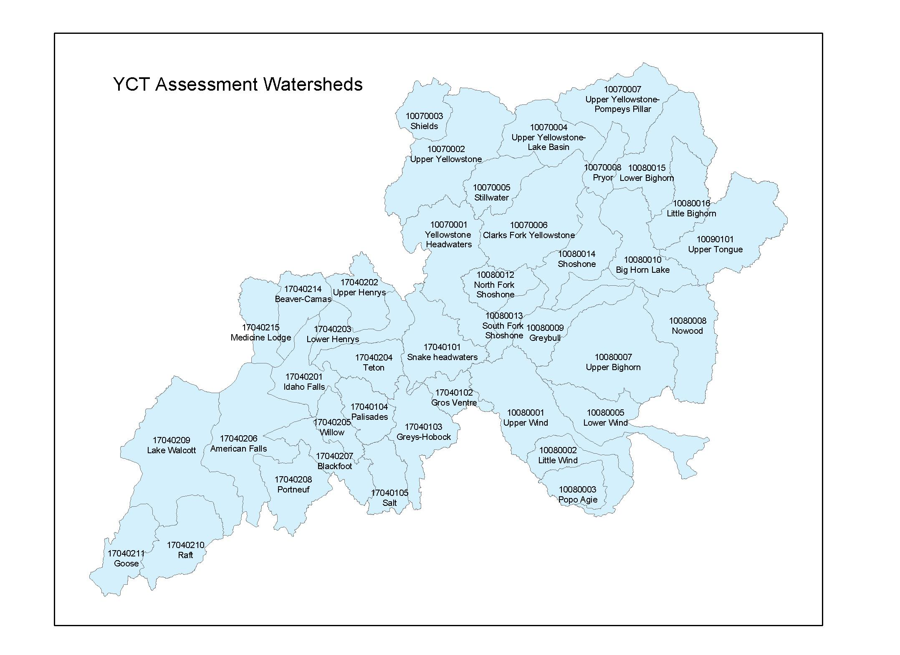

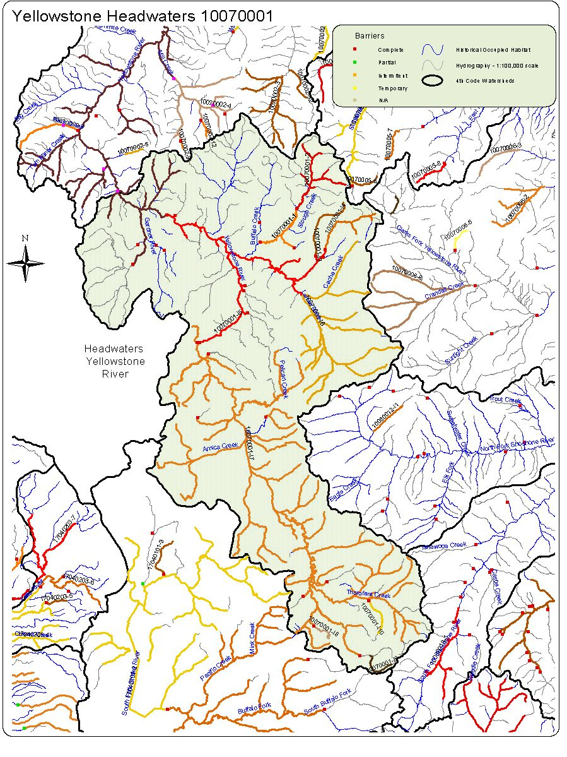

10070001 Yellowstone Headwaters Conservation Populations with competitive Species.
Conservation Population Identification Number | Competitive Species Present | Total Miles of YCT | Total Miles with Competitive Species | Number of Stream Segments w/ competitive species
10070001-1 | No | 16.2
10070001-2 | No | 28.1
10070001-l10 | No | 7.2
10070001-13 | No | 13.2
10070001-14 | Yes | 15.6 | 1.2 | 1
10070001-15 | Yes | 80.4 | 1.8 | 2
10070001-16 | No | 115.8
10070001-17 | No | 477.2
10070001-18 | No | 4.3
10070001-19 | No | 6.7

10070001 Yellowstone Headwaters. Abundance by Conservation Population
Conservation Population Identification Number | Abundance |  |  |  | Total  Miles
Conservation Population Identification Number | Abundant  (Segments) | Common  (Segments) | Rare  (Segments) | Unknown  (Segments) | Total  Miles
10070001-1 | 1 | 1 |  |  | 16.2
10070001-2 | 2 | 3 |  | 1 | 28.1
10070001-l10 |  | 1 |  |  | 7.2
10070001-13 |  | 1 |  |  | 13.2
10070001-14 |  | 1 |  | 1 | 15.6
10070001-15 | 6 | 4 | 4 | 5 | 80.4
10070001-16 | 4 | 4 | 1 | 4 | 115.8
10070001-17 | 14 | 28 | 5 | 8 | 477.2
10070001-18 |  |  |  | 1 | 4.3
10070001-19 |  | 1 |  |  | 6.7

Watershed Name Yellowstone Headwaters Watershed Number 10070001
Conservation  Population Identification Number | Population Type | Source | Genetic Makeup |  |  |  |  |  | Total Miles
Conservation  Population Identification Number | Population Type | Source | Tested Genetically  Unaltered  (Segments) | Tested  75%-99%  YCT  (Segments) | Tested  >75%  YCT  (Segments) | Untested  Potentially  Unaltered  (Segments) | Untested  Suspected  Altered  (Segments) | Mixed Stock –pure & altered  (Segments) | Total Miles
10070001-1 | Isolet | Yes | 1 |  |  | 1 |  |  | 16.2
10070001-2 | Meta-population | Yes | 1 |  |  | 5 |  |  | 28.1
10070001-l10 | Isolet | Yes | 1 |  |  |  |  |  | 7.2
10070001-13 | Isolet | Yes | 1 |  |  |  |  |  | 13.2
10070001-14 | Isolet | Yes |  | 1 |  |  | 1 |  | 15.8
10070001-15 | Meta population | Yes | 1 |  |  | 1 | 17 |  | 80.4
10070001-16 | Meta-population | Yes | 4 |  |  |  | 19 |  | 115.8
10070001-17 | Meta-population | Yes | 8 |  |  | 47 |  |  | 477.2
10070001-18 | Isolet | Yes | 1 |  |  |  |  |  | 4.3
10070001-19 | Isolet | Yes | 1 |  |  |  |  |  | 6.7

Conservation Population Identification Number | Genetic Risk Score | Population Risk Scores |  |  |  | Composite Score
Conservation Population Identification Number | Genetic Risk Score | Temporal  Factors  Score | Population  Size Factor  Score | Demographic  Factors  Score | Isolation  Factor  Score | Composite Score
10070001-1 | 1 | 2 | 2 | 1 | 4 | 7.4
10070001-2 | 1 | 1 | 2 | 1 | 2 | 5.7
10070001-I10 | 1 | 3 | 3 | 2 | 4 | 10.9
10070001-I3 | 1 | 3 | 3 | 1 | 4 | 9.3
10070001-I4 | 2 | 3 | 3 | 2 | 4 | 10.9
10070001-I5 | 4 | 1 | 1 | 1 | 1 | 4
10070001-I6 | 3 | 1 | 1 | 1 | 1 | 4
10070001-I7 | 1 | 1 | 1 | 2 | 1 | 5.6
10070001-I8 | 1 | 4 | 3 | 2 | 4 | 11.6
10070001-I9 | 1 | 3 | 3 | 2 | 4 | 10.9
Watershed Yellowstone Headwaters Number 10070001

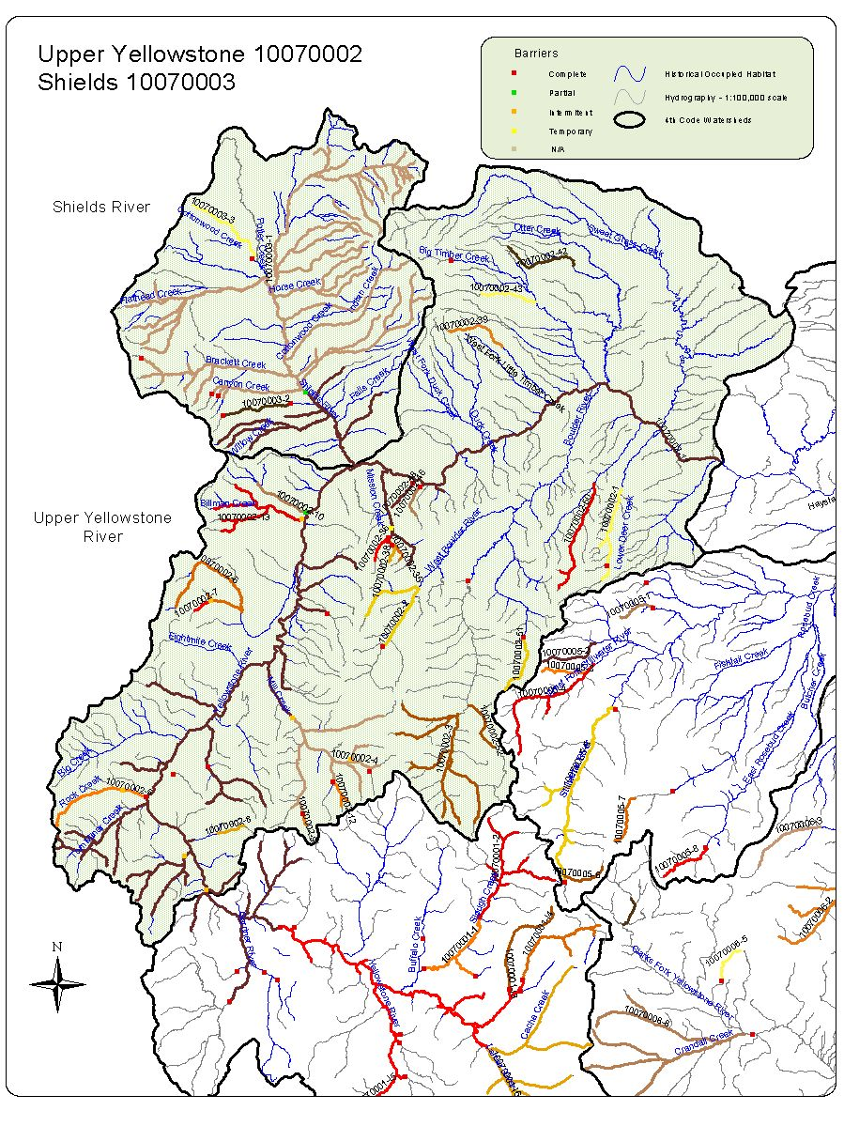

10070002 Upper Yellowstone Conservation Populations with competitive Species.

Conservation Population Identification Number | Competitive Species Present | Total Miles of YCT | Total Miles with Competitive Species | Number of Stream Segments Occupied
10070002-1 | Yes | 12.8 | 12.8 | 2
10070002-10 | Yes | 7.0
10070002-11 | Yes | 356.9
10070002-12 | No | 4.0
10070002-13 | Yes | 24.0
10070002-2 | Yes | 15.7
10070002-3 | Yes | 45.2
10070002-35 | No | 2.8
10070002-36 | No | 3.3
10070002-38 | No | 2.2
10070002-39 | Yes | 7.3
10070002-4 | Yes | 42.3
10070002-42 | No | 10.0
10070002-43 | Yes | 6.4
10070002-46 | No | 3.8
10070002-48 | No | 3.6
10070002-5 | No | 12.3
10070002-50 | Yes | 14.6
10070002-51 | No | 7.2
10070002-52 | No | 6.5
10070002-6 | Yes | 19.2
10070002-7 | No | 2.2
10070002-8 | Yes | 3.1
10070002-9 | No | 1.6

10070002. Upper Yellowstone Abundance by Conservation Population

Conservation Population Identification Number | Abundance |  |  |  | Total  Miles
Conservation Population Identification Number | Abundant  (Segments) | Common  (Segments) | Rare  (Segments) | Unknown  (Segments) | Total  Miles
10070002-1 |  |  | 2 |  | 12.8
10070002-10 |  | 1 |  |  | 7.0
10070002-11 | 9 | 19 | 23 | 11 | 356.9
10070002-12 |  | 1 | 1 |  | 4.0
10070002-13 |  | 3 | 1 |  | 24.0
10070002-2 | 1 | 1 |  |  | 15.7
10070002-3 | 2 | 3 | 2 |  | 45.2
10070002-35 |  |  |  | 1 | 2.8
10070002-36 |  | 1 |  |  | 3.3
10070002-38 |  |  | 1 |  | 2.2
10070002-39 |  | 1 |  |  | 7.3
10070002-4 | 2 | 5 | 2 |  | 42.3
10070002-42 |  | 1 |  |  | 10.0
10070002-43 | 1 |  |  |  | 6.4
10070002-46 |  | 1 |  |  | 3.8
10070002-48 |  |  | 1 |  | 3.6
10070002-5 | 1 |  |  |  | 12.3
10070002-50 |  |  | 2 |  | 14.6
10070002-51 | 1 |  |  |  | 7.2
10070002-52 |  |  | 1 |  | 6.5
10070002-6 |  | 2 | 1 |  | 19.2
10070002-7 |  |  | 1 |  | 2.2
10070002-8 |  | 1 |  |  | 3.1
10070002-9 | 1 |  |  |  | 1.6

10070002 Upper Yellowstone.
Conservation  Population Identification Number | Population Type | Source | Genetic Makeup |  |  |  |  |  | Total Miles
Conservation  Population Identification Number | Population Type | Source | Genetically  Altered  (Segments) | Tested  75%-99%  YCT  (Segments) | Tested  >75%  YCT  (Segments) | Untested  Potentially  Unaltered  (Segments) | Untested  Suspected  Altered  (Segments) | Mixed Stock –pure & altered  (Segments) | Total Miles
10070002-1 | Isolet | Yes | 2 |  |  |  |  |  | 12.8
10070002-10 | Isolet | Yes |  |  |  |  | 1 |  | 7.0
10070002-11 | Meta-population | Yes | 26 | 16 | 1 | 8 | 10 | 1 | 356.9
10070002-12 | Isolet | Yes |  |  |  | 1 | 1 |  | 4.0
10070002-13 | Meta-population | Yes | 2 | 1 |  | 1 |  |  | 24.0
10070002-2 | Isolet | Yes |  | 2 |  |  |  |  | 15.7
10070002-3 | Meta-population | Yes | 2 | 3 |  |  | 2 |  | 45.2
10070002-35 | Isolet | Yes |  | 1 |  |  |  |  | 2.8
10070002-36 | Isolet | Yes |  |  |  | 1 |  |  | 3.3
10070002-38 | Isolet | Yes |  |  |  | 1 |  |  | 2.2
10070002-39 | Isolet | Yes | 1 |  |  |  |  |  | 7.3
10070002-4 | Meta-population | Yes | 5 | 1 |  | 3 |  |  | 42.3
10070002-42 | Isolet | Yes |  |  |  |  | 1 |  | 10.0
10070002-43 | Isolet | Yes | 1 |  |  |  |  |  | 6.4
10070002-46 | Isolet | Yes |  | 1 |  |  |  |  | 3.8
10070002-48 | Isolet | No |  | 1 |  |  |  |  | 3.6
10070002-5 | Meta-population | Yes | 1 |  |  |  |  |  | 12.3
10070002-50 | Isolet | Yes | 2 |  |  |  |  |  | 14.6
10070002-51 | Isolet | Yes | 1 |  |  |  |  |  | 7.2
10070002-52 | Isolet | Yes | 1 |  |  |  |  |  | 6.5
10070002-6 | Meta-population | Yes | 1 | 1 |  | 1 |  |  | 19.2
10070002-7 | Isolet | Yes | 1 |  |  |  |  |  | 2.2
10070002-8 | Isolet | Yes |  | 1 |  |  |  |  | 3.1
10070002-9 | Isolet | Yes |  |  |  | 1 |  |  | 1.6

Conservation Population Identification Number | Genetic Risk Score | Population Risk Scores
Conservation Population Identification Number | Genetic Risk Score | Temporal  Factors  Score | PopulationSize  Score | Demographic  Factors  Score | Isolation  Factor  Score | Composite  Score
10070002-1 | 1 | 3 | 3 | 3 | 4 | 12.5
10070002-10 | 4 | 3 | 3 | 3 | 4 | 12.5
10070002-11 | 4 | 1 | 1 | 1 | 2 | 4.5
10070002-12 | 1 | 4 | 3 | 3 | 4 | 13.2
10070002-13 | 3 | 2 | 3 | 3 | 3 | 11.3
10070002-2 | 3 | 3 | 2 | 1 | 3 | 7.6
10070002-3 | 4 | 2 | 2 | 1 | 3 | 6.9
10070002-35 | 1 | 4 | 4 | 4 | 4 | 16
10070002-36 | 1 | 4 | 3 | 2 | 4 | 11.6
10070002-38 | 1 | 4 | 4 | 3 | 4 | 14.4
10070002-39 | 2 | 4 | 3 | 1 | 4 | 10
10070002-4 | 4 | 1 | 2 | 2 | 2 | 7.3
10070002-42 | 2 | 3 | 3 | 1 | 4 | 9.3
10070002-43 | 2 | 4 | 2 | 1 | 4 | 8.8
10070002-46 | 1 | 4 | 3 | 2 | 4 | 11.6
10070002-48 | 1 | 4 | 3 | 2 | 4 | 11.6
10070002-5 | 1 | 2 | 3 | 2 | 4 | 10.2
10070002-50 | 2 | 2 | 3 | 2 | 4 | 10.2
10070002-51 | 1 | 4 | 3 | 1 | 4 | 10
10070002-52 | 1 | 4 | 3 | 1 | 4 | 10
10070002-6 | 4 | 3 | 3 | 3 | 3 | 12
10070002-7 | 1 | 4 | 4 | 2 | 4 | 12.8
10070002-8 | 2 | 4 | 3 | 2 | 4 | 11.6
10070002-9 | 1 | 4 | 4 | 2 | 4 | 12.8
Watershed Upper Yellowstone Number 10070002

10070003 Shields Conservation Populations with competitive Species.

Conservation Population Identification Number | Competitive Species Present | Total Miles of YCT | Total Miles with Competitive Species | Number of Stream Segments Occupied
10070003-1 | Yes | 303.4 | 264.0 | 44
10070003-2 | No | 8.0
10070003-3 | Yes | 10.9 | 8.0 | 1

10070003. Abundance by Conservation Population

Conservation Population Identification Number | Abundance |  |  |  | Total  Miles
Conservation Population Identification Number | Abundant  (Segments) | Common  (Segments) | Rare  (Segments) | Unknown  (Segments) | Total  Miles
10070003-1 | 6 | 31 | 19 | 5 | 303.4
10070003-2 |  | 1 |  |  | 8.0
10070003-3 | 1 |  |  |  | 10.9

Conservation  Population Identification Number | Population Type | Source | Genetic Makeup |  |  |  |  |  | Total Miles
Conservation  Population Identification Number | Population Type | Source | Genetically  Altered  (Segments) | Tested  75%-99%  YCT  (Segments) | Tested  >75%  YCT  (Segments) | Untested  Potentially  Unaltered  (Segments) | Untested  Suspected  Altered  (Segments) | Mixed Stock –pure & altered  (Segments) | Total Miles
10070003-1 | Meta-population | Yes | 26 | 1 |  | 26 | 3 | 5 | 303.4
10070003-2 | Isolet | Yes | 1 |  |  |  |  |  | 8.0
10070003-3 | Isolet | Yes | 1 |  |  |  |  |  | 10.9
Watershed Name Shields Watershed Number 10070003

Conservation Population Identification Number | Genetic Risk Score | Population Risk Scores
Conservation Population Identification Number | Genetic Risk Score | Temporal  Factors  Score | PopulationSize  Score | Demographic  Factors  Score | Isolation  Factor  Score | Composite  Score
10070003-1 | 4 | 1 | 1 | 2 | 2 | 4
10070003-2 | 3 | 3 | 2 | 2 | 4 | 3
10070003-3 | 3 | 3 | 2 | 2 | 4 | 3
Watershed Shields Number 10070003

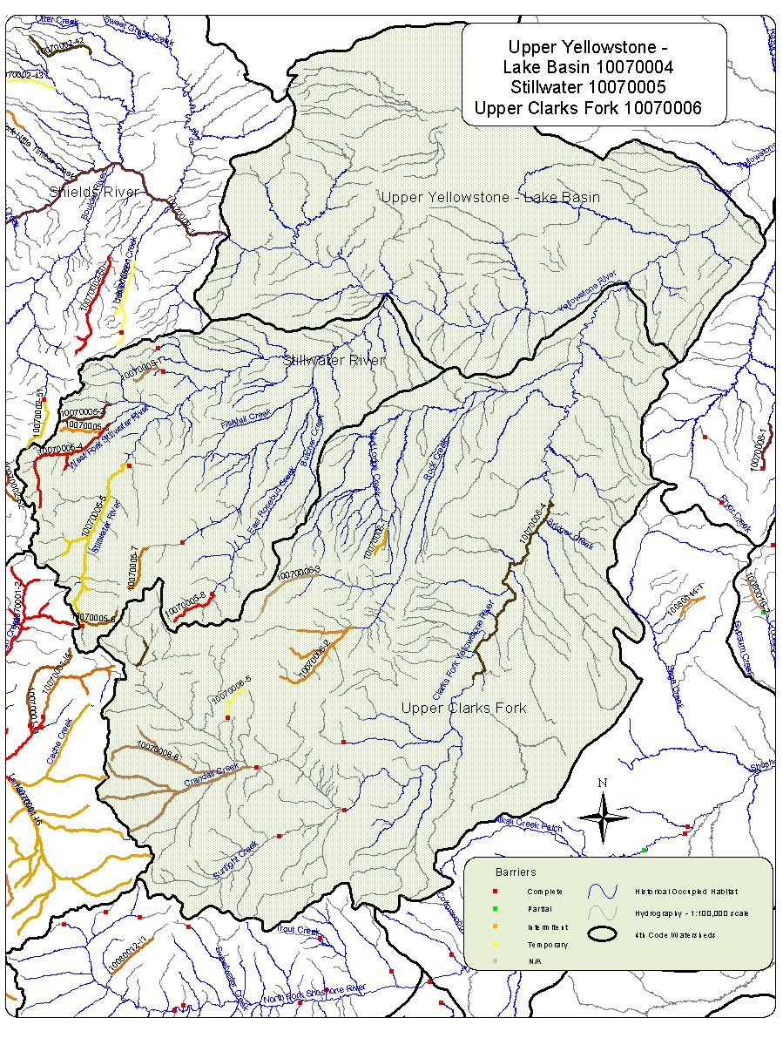
10070004 Upper Yellowstone-Lake Basin

There were no identified conservation populations within this HUC.

10070005 Stillwater Conservation Populations with competitive Species.

Conservation Population Identification Number | Competitive Species Present | Total Miles of YCT | Total Miles with Competitive Species | Number of Stream Segments Occupied
10070005-1 | Yes | 4.4 | 4.4 | 1
10070005-2 | No | 7.0
10070005-3 | No | 5.5
10070005-4 | Yes | 18.8 | 16.7 | 1
10070005-5 | Yes | 32.9 | 32.2 | 7
10070005-6 | Yes | 5.1 | 5.1 | 1
10070005-7 | Yes | 6.2 | 6.2 | 1
10070005-8 | Yes | 6.9 | 6.9 | 1

10070005 Upper. Abundance by Conservation Population

Conservation Population Identification Number | Abundance |  |  |  | Total  Miles
Conservation Population Identification Number | Abundant  (Segments) | Common  (Segments) | Rare  (Segments) | Unknown  (Segments) | Total  Miles
10070005-1 |  |  | 1 |  | 4.4
10070005-2 |  | 4 |  |  | 7.0
10070005-3 |  | 1 |  |  | 5.5
10070005-4 | 1 |  | 1 |  | 18.8
10070005-5 |  | 7 | 1 |  | 32.9
10070005-6 |  | 1 |  |  | 5.1
10070005-7 |  | 1 |  |  | 6.2
10070005-8 |  | 1 |  |  | 6.9

Conservation  Population Identification Number | Population Type | Source | Genetic Makeup |  |  |  |  |  | Total Miles
Conservation  Population Identification Number | Population Type | Source | Genetically  Altered  (Segments) | Tested  75%-99%  YCT  (Segments) | Tested  >75%  YCT  (Segments) | Untested  Potentially  Unaltered  (Segments) | Untested  Suspected  Altered  (Segments) | Mixed Stock –pure & altered  (Segments) | Total Miles
10070005-1 | Isolet | No | 1 |  |  |  |  |  | 4.4
10070005-2 | Isolet | No | 1 |  |  |  |  |  | 7.0
10070005-3 | Isolet | Yes |  | 1 |  |  |  |  | 5.5
10070005-4 | Meta-population | No |  |  |  |  | 2 |  | 18.8
10070005-5 | Meta-population | No |  |  |  |  | 8 |  | 32.9
10070005-6 | Isolet | Yes |  | 1 |  |  |  |  | 5.1
10070005-7 | Isolet | No |  |  |  | 1 |  |  | 6.2
10070005-8 | Isolet | No |  |  |  | 1 |  |  | 6.9
Watershed Name Stillwater Watershed Number 10070005

Conservation Population Identification Number | Genetic Risk Score | Population Risk Scores
Conservation Population Identification Number | Genetic Risk Score | Temporal  Factors  Score | PopulationSize  Score | Demographic  Factors  Score | Isolation  Factor  Score | Composite  Score
10070005-1 | 1 | 4 | 4 | 4 | 4 | 16
10070005-2 | 1 | 3 | 3 | 1 | 4 | 9.3
10070005-3 | 1 | 3 | 3 | 1 | 4 | 9.3
10070005-4 | 3 | 3 | 2 | 1 | 3 | 7.6
10070005-5 | 3 | 2 | 2 | 1 | 3 | 6.9
10070005-6 | 2 | 4 | 3 | 1 | 4 | 10
10070005-7 | 3 | 4 | 3 | 1 | 4 | 10
10070005-8 | 1 | 4 | 3 | 1 | 4 | 10
Watershed Stillwater Number 10070005

10070006 Clarks Fork Yellowstone Conservation Populations with competitive Species.

Conservation Population Identification Number | Competitive Species Present | Total Miles of YCT | Total Miles with Competitive Species | Number of Stream Segments Occupied
10070006-1 | Yes | 3.6 | 3.1 | 1
10070006-2 | Yes | 24.2 | 18.8 | 3
10070006-3 | Yes | 8.9 | 8.9 | 1
10070006-4 | Yes | 32.8 | 32.8 | 2
10070006-5 | No | 5.0
10070006-6 | No | 55.9

10070006. Abundance by Conservation Population

Conservation Population Identification Number | Abundance |  |  |  | Total  Miles
Conservation Population Identification Number | Abundant  (Segments) | Common  (Segments) | Rare  (Segments) | Unknown  (Segments) | Total  Miles
10070006-1 |  |  | 1 |  | 3.6
10070006-2 |  | 4 |  |  | 24.2
10070006-3 |  | 1 |  |  | 8.9
10070006-4 |  | 2 |  |  | 32.8
10070006-5 | 1 |  |  |  | 5.0
10070006-6 |  |  | 1 | 1 | 55.9

Conservation  Population Identification Number | Population Type | Source | Genetic Makeup |  |  |  |  |  | Total Miles
Conservation  Population Identification Number | Population Type | Source | Genetically  Altered  (Segments) | Tested  75%-99%  YCT  (Segments) | Tested  >75%  YCT  (Segments) | Untested  Potentially  Unaltered  (Segments) | Untested  Suspected  Altered  (Segments) | Mixed Stock –pure & altered  (Segments) | Total Miles
10070006-1 | Isolet | No | 1 |  |  |  |  |  | 3.6
10070006-2 | Meta-population | No | 1 |  |  |  | 3 |  | 24.2
10070006-3 | Isolet | No |  |  |  |  | 1 |  | 8.9
10070006-4 | Meta-population | No |  |  |  |  | 2 |  | 32.8
10070006-5 | Isolet | No | 1 |  |  |  |  |  | 5.0
10070006-6 | Meta-population | No |  |  |  |  | 3 | 3 | 55.9
Watershed Name Clarks Fork Yellowstone Watershed Number 10070006

Conservation Population Identification Number | Genetic Risk Score | Population Risk Scores
Conservation Population Identification Number | Genetic Risk Score | Temporal  Factors  Score | PopulationSize  Score | Demographic  Factors  Score | Isolation  Factor  Score | Composite  Score
10070006-1 | 2 | 4 | 3 | 4 | 4 | 14.8
10070006-2 | 3 | 2 | 2 | 1 | 3 | 6.9
10070006-3 | 3 | 3 | 3 | 1 | 4 | 9.3
10070006-4 | 1 | 3 | 2 | 1 | 3 | 7.6
10070006-5 | 1 | 4 | 2 | 1 | 4 | 8.8
10070006-6 | 3 | 2 | 1 | 2 | 1 | 6.3
10070006-1 | 2 | 4 | 3 | 4 | 4 | 14.8

Watershed Clarks Fork Yellowstone Number 10070006

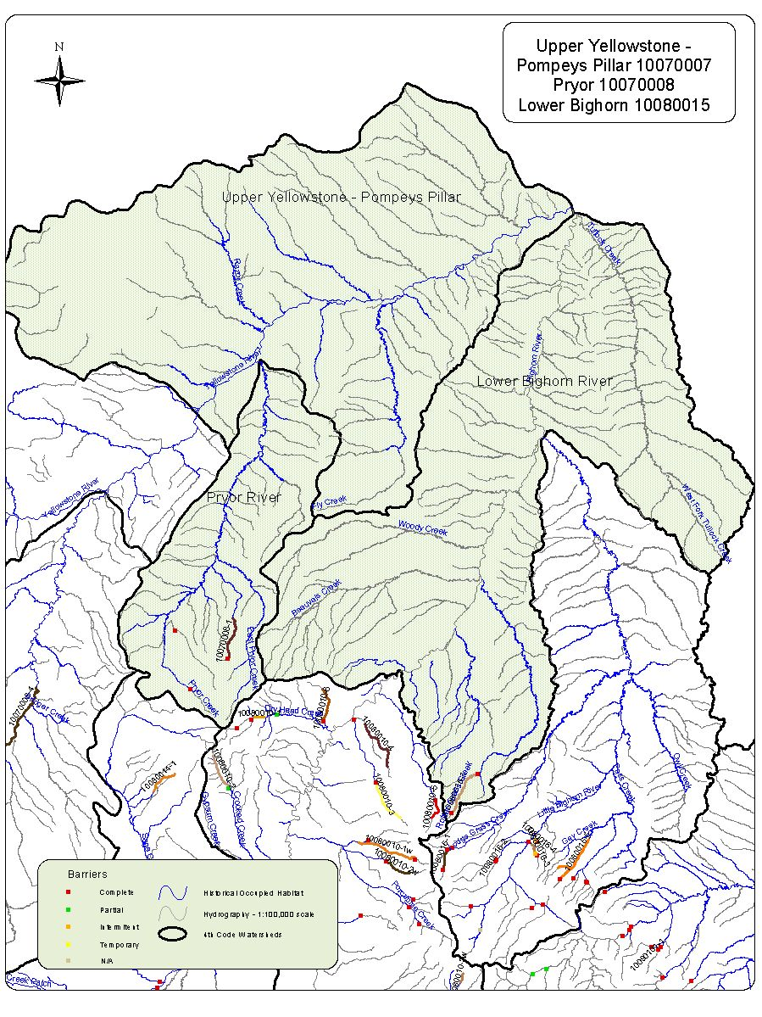

10070007 Upper Yellowstone Pompey’s Pillar

There no conservation populations identified in this HUC.

10070008 Pryor Conservation Populations with competitive Species.

Conservation Population Identification Number | Competitive Species Present | Total Miles of YCT | Total Miles with Competitive Species | Number of Stream Segments Occupied
10070008-1 | Yes | 6.2 | 6.2 | 1

10070008. Abundance by Conservation Population

Conservation Population Identification Number | Abundance |  |  |  | Total  Miles
Conservation Population Identification Number | Abundant  (Segments) | Common  (Segments) | Rare  (Segments) | Unknown  (Segments) | Total  Miles
10070008-1 |  |  |  | 1 | 6.2

Conservation  Population Identification Number | Population Type | Source | Genetic Makeup |  |  |  |  |  | Total Miles
Conservation  Population Identification Number | Population Type | Source | Genetically  Altered  (Segments) | Tested  75%-99%  YCT  (Segments) | Tested  >75%  YCT  (Segments) | Untested  Potentially  Unaltered  (Segments) | Untested  Suspected  Altered  (Segments) | Mixed Stock –pure & altered  (Segments) | Total Miles
10070008-1 | Isolet | No | 1 |  |  |  |  |  | 6.2
Watershed Name Pryor Watershed Number 10070008

Conservation Population Identification Number | Genetic Risk Score | Population Risk Scores
Conservation Population Identification Number | Genetic Risk Score | Temporal  Factors  Score | PopulationSize  Score | Demographic  Factors  Score | Isolation  Factor  Score | Composite  Score
 | 3 | 4 | 3 | 2 | 4 | 11.6
  10070008-1
Watershed Pryor Number 10070008

10080015. Little Bighorn Abundance by Conservation Population

Conservation Population Identification Number | Abundance |  |  |  | Total  Miles
Conservation Population Identification Number | Abundant  (Segments) | Common  (Segments) | Rare  (Segments) | Unknown  (Segments) | Total  Miles
10080015-1 |  | 1 |  |  | 6.8

10080015. Conservation Populations with competitive Species.

Conservation Population Identification Number | Competitive Species Present | Total Miles of YCT | Total Miles with Competitive Species | Number of Stream Segments Occupied
10080015-1 | No | 6.8

Conservation  Population Identification Number | Population Type | Source | Genetic Makeup |  |  |  |  |  | Total Miles
Conservation  Population Identification Number | Population Type | Source | Genetically  Altered  (Segments) | Tested  75%-99%  YCT  (Segments) | Tested  >75%  YCT  (Segments) | Untested  Potentially  Unaltered  (Segments) | Untested  Suspected  Altered  (Segments) | Mixed Stock –pure & altered  (Segments) | Total Miles
10080015-1 | Isolet | NO |  | 1 |  |  |  |  | 6.8
Watershed Name Lower Bighorn Watershed Number 10080015

Conservation Population Identification Number | Genetic Risk Score | Population Risk Scores
Conservation Population Identification Number | Genetic Risk Score | Temporal  Factors  Score | PopulationSize  Score | Demographic  Factors  Score | Isolation  Factor  Score | Composite  Score
 | 1 | 3 | 2 | 2 | 4 | 9.7
  10080015-1
Watershed Lower Bighorn Number 10080015

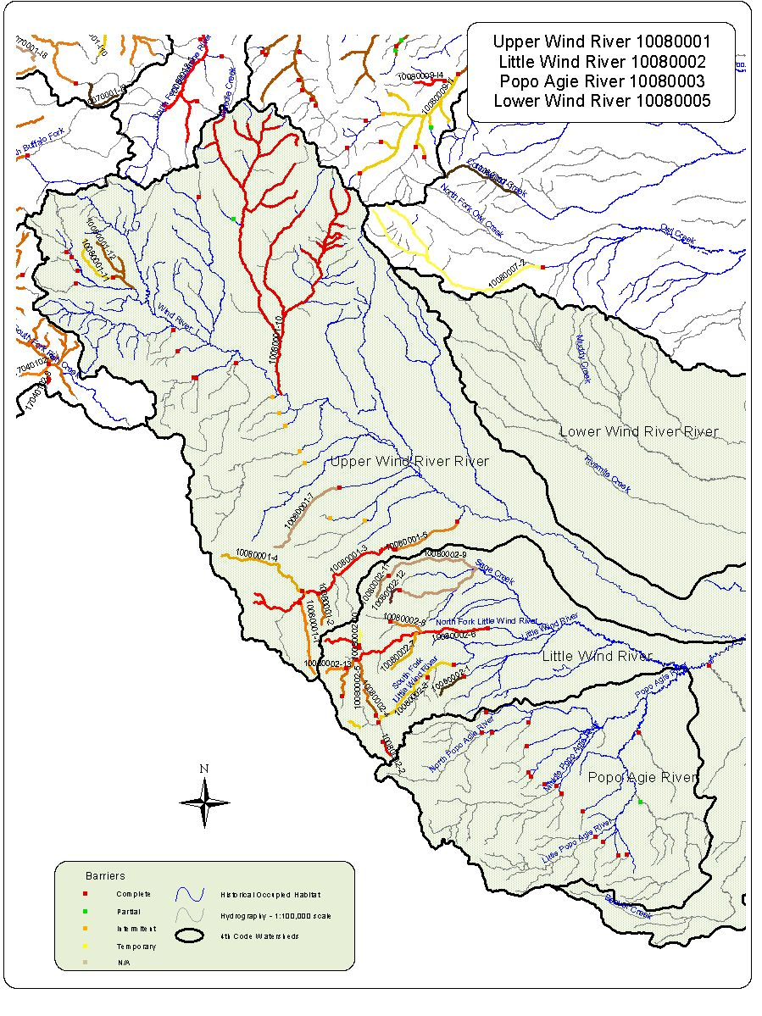
10080001 Upper Wind River Conservation Populations with competitive Species.

Conservation Population Identification Number | Competitive Species Present | Total Miles of YCT | Total Miles with Competitive Species | Number of Stream Segments Occupied
10080001-1 | Yes | 10.1 | 10.1 | 1
10080001-10 | Yes | 143.5 | 143.5 | 20
10080001-11 | Yes | 7.8 | 7.8 | 1
10080001-12 | Yes | 11.9 | 4.3 | 2
10080001-2 | Yes | 4.4 | 4.4 | 1
10080001-3 | Yes | 28.2 | 28.2 | 5
10080001-4 | Yes | 14.0 | 14.0 | 2
10080001-5 | Yes | 8.8 | 8.8 | 1
10080001-7 | Yes | 12.4 | 12.4 | 1

10080001. Abundance by Conservation Population

Conservation Population Identification Number | Abundance |  |  |  | Total  Miles
Conservation Population Identification Number | Abundant  (Segments) | Common  (Segments) | Rare  (Segments) | Unknown  (Segments) | Total  Miles
10080001-1 | 1 |  |  |  | 10.1
10080001-10 | 3 | 6 | 11 |  | 143.5
10080001-11 | 1 |  |  |  | 7.8
10080001-12 |  | 3 | 1 |  | 11.9
10080001-2 |  | 1 |  |  | 4.4
10080001-3 | 2 | 3 |  |  | 28.2
10080001-4 |  | 2 |  |  | 14.0
10080001-5 | 1 |  |  |  | 8.8
10080001-7 |  | 1 |  |  | 12.4

Conservation  Population Identification Number | Population Type | Source | Genetic Makeup |  |  |  |  |  | Total Miles
Conservation  Population Identification Number | Population Type | Source | Genetically  Altered  (Segments) | Tested  75%-99%  YCT  (Segments) | Tested  >75%  YCT  (Segments) | Untested  Potentially  Unaltered  (Segments) | Untested  Suspected  Altered  (Segments) | Mixed Stock –pure & altered  (Segments) | Total Miles
10080001-1 | Isolet | Yes |  |  |  |  | 1 |  | 10.1
10080001-10 | Meta-population | No | 6 |  |  |  | 14 |  | 143.5
10080001-11 | Isolet | No |  |  |  | 1 |  |  | 7.8
10080001-12 | Isolet | No |  |  |  |  | 4 |  | 11.9
10080001-2 | Isolet | Yes |  |  |  |  | 1 |  | 4.4
10080001-3 | Isolet | Yes |  | 1 |  | 1 | 3 |  | 28.2
10080001-4 | Isolet | Yes |  |  |  |  | 2 |  | 14.0
10080001-5 | Isolet | No |  |  |  |  | 1 |  | 8.8
10080001-7 | Isolet | No |  |  |  | 1 |  |  | 12.4
Watershed Name Upper Wind Watershed Number 10080001

Conservation Population Identification Number | Genetic Risk Score | Population Risk Scores
Conservation Population Identification Number | Genetic Risk Score | Temporal  Factors  Score | PopulationSize  Score | Demographic  Factors  Score | Isolation  Factor  Score | Composite  Score
10080001-1 | 1 | 3 | 2 | 1 | 4 | 8.1
10080001-10 | 4 | 1 | 1 | 2 | 1 | 5.6
10080001-11 | 2 | 4 | 3 | 2 | 4 | 11.6
10080001-12 | 3 | 3 | 2 | 2 | 4 | 9.7
10080001-2 | 1 | 3 | 3 | 1 | 4 | 9.3
10080001-3 | 1 | 2 | 1 | 1 | 4 | 6.2
10080001-4 | 1 | 2 | 2 | 1 | 4 | 7.4
10080001-5 | 1 | 3 | 1 | 2 | 4 | 8.5
10080001-7 | 1 | 3 | 2 | 1 | 4 | 8.1
Watershed Upper Wind Number 10080001

10080002 Little Wind Conservation Populations with competitive Species.

Conservation Population Identification Number | Competitive Species Present | Total Miles of YCT | Total Miles with Competitive Species | Number of Stream Segments Occupied
10080002-1 | Yes | 4.1 | 4.1 | 1
10080002-10 | Yes | 2.1 | 2.1 | 1
10080002-11 | Yes | 3.3 | 3.3 | 1
10080002-12 | Yes | 2.5 | 2.5 | 1
10080002-13 | No | 3.0
10080002-2 | Yes | 2.0 | 2.0 | 1
10080002-3 | Yes | 16.8 | 2.0 | 1
10080002-4 | No | 2.4
10080002-5 | Yes | 11.3 | 11.4 | 2
10080002-6 | Yes | 25.3 | 25.3 | 2
10080002-7 | Yes | 6.0 | 6.0 | 1
10080002-8 | Yes | 4.5 | 4.5 | 1
10080002-9 | Yes | 25.7 | 25.7 | 2

10080002. Abundance by Conservation Population

Conservation Population Identification Number | Abundance |  |  |  | Total  Miles
Conservation Population Identification Number | Abundant  (Segments) | Common  (Segments) | Rare  (Segments) | Unknown  (Segments) | Total  Miles
10080002-1 |  |  |  | 1 | 4.1
10080002-10 |  | 1 |  |  | 2.1
10080002-11 |  | 1 |  |  | 3.3
10080002-12 |  | 1 |  |  | 2.5
10080002-13 |  | 1 |  |  | 3.0
10080002-2 |  | 1 |  |  | 2.0
10080002-3 |  | 2 |  |  | 16.8
10080002-4 |  | 1 |  |  | 2.4
10080002-5 |  | 2 |  |  | 11.3
10080002-6 |  | 2 |  |  | 25.3
10080002-7 |  | 1 |  |  | 6.0
10080002-8 |  | 1 |  |  | 4.5
10080002-9 |  | 2 |  |  | 25.7

Conservation  Population Identification Number | Population Type | Source | Genetic Makeup |  |  |  |  |  | Total Miles
Conservation  Population Identification Number | Population Type | Source | Genetically  Altered  (Segments) | Tested  75%-99%  YCT  (Segments) | Tested  >75%  YCT  (Segments) | Untested  Potentially  Unaltered  (Segments) | Untested  Suspected  Altered  (Segments) | Mixed Stock –pure & altered  (Segments) | Total Miles
10080002-1 | Isolet | No |  |  |  | 1 |  |  | 4.1
10080002-10 | Isolet | No |  |  |  | 1 |  |  | 2.1
10080002-11 | Isolet | Yes |  |  |  | 1 |  |  | 3.3
10080002-12 | Isolet | Yes |  |  |  | 1 |  |  | 2.5
10080002-13 | Isolet | Yes |  |  |  | 1 |  |  | 3.0
10080002-2 | Isolet | No |  |  |  | 1 |  |  | 2.0
10080002-3 | Meta-population | No |  |  |  |  | 2 |  | 16.8
10080002-4 | Isolet | Yes |  |  |  |  | 1 |  | 2.4
10080002-5 | Meta-population | Yes | 2 |  |  |  |  |  | 11.3
10080002-6 | Isolet | Yes |  |  |  |  | 2 |  | 25.3
10080002-7 | Isolet | Yes |  |  |  | 1 |  |  | 6.0
10080002-8 | Isolet | Yes |  |  |  | 1 |  |  | 4.5
10080002-9 | Meta-population | No |  |  |  | 2 |  |  | 25.7
Watershed Name Little wind Watershed Number 10080002

Conservation Population Identification Number | Genetic Risk Score | Population Risk Scores
Conservation Population Identification Number | Genetic Risk Score | Temporal  Factors  Score | PopulationSize  Score | Demographic  Factors  Score | Isolation  Factor  Score | Composite  Score
10080002-1 | 1 | 3 | 3 | 3 | 4 | 12.5
10080002-10 | 1 | 3 | 3 | 2 | 4 | 10.9
10080002-11 | 1 | 4 | 3 | 3 | 4 | 13.2
10080002-12 | 1 | 4 | 3 | 3 | 4 | 13.2
10080002-13 | 1 | 4 | 3 | 2 | 4 | 11.6
10080002-2 | 1 | 4 | 3 | 1 | 4 | 10
10080002-3 | 1 | 2 | 1 | 1 | 3 | 5.7
10080002-4 | 1 | 4 | 3 | 2 | 4 | 11.6
10080002-5 | 2 | 2 | 2 | 1 | 1 | 5.9
10080002-6 | 4 | 3 | 2 | 3 | 2 | 10.3
10080002-7 | 1 | 3 | 2 | 1 | 4 | 8.1
10080002-8 | 1 | 3 | 2 | 2 | 4 | 9.7
10080002-9 | 1 | 2 | 2 | 4 | 2 | 11.2
Watershed Little Wind Number 10080002

10080003 – Popo Agie and 10080005 – Lower Wind. These HUC’s had no conservation populations identified.
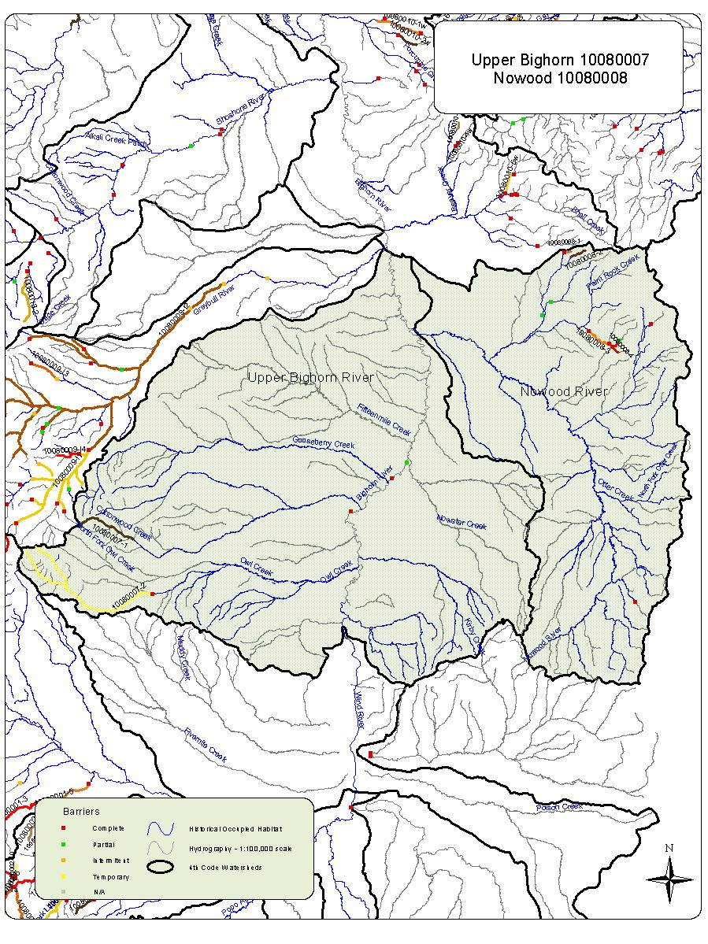
10080007. Upper Bighorn. Abundance by Conservation Population

Conservation Population Identification Number | Abundance |  |  |  | Total  Miles
Conservation Population Identification Number | Abundant  (Segments) | Common  (Segments) | Rare  (Segments) | Unknown  (Segments) | Total  Miles
10080007-1 |  |  | 1 |  | 11.1
10080007-2 |  | 2 |  |  | 36.9

Conservation Populations with competitive Species.

Conservation Population Identification Number | Competitive Species Present | Total Miles of YCT | Total Miles with Competitive Species | Number of Stream Segments Occupied
10080007-1 | None | 11.1
10080007-2 | None | 36.9

Conservation  Population Identification Number | Population Type | Source | Genetic Makeup |  |  |  |  |  | Total Miles
Conservation  Population Identification Number | Population Type | Source | Genetically  Altered  (Segments) | Tested  75%-99%  YCT  (Segments) | Tested  >75%  YCT  (Segments) | Untested  Potentially  Unaltered  (Segments) | Untested  Suspected  Altered  (Segments) | Mixed Stock –pure & altered  (Segments) | Total Miles
10080007-1 | Isolet | No |  |  |  |  | 1 |  | 11.1
10080007-2 | Meta-population | No |  |  |  |  | 2 |  | 36.9
Watershed Name Upper Bighorn Watershed Number 10080007

Conservation Population Identification Number | Genetic Risk Score | Population Risk Scores
Conservation Population Identification Number | Genetic Risk Score | Temporal  Factors  Score | PopulationSize  Score | Demographic  Factors  Score | Isolation  Factor  Score | Composite  Score
10080007-1 | 3 | 4 | 3 | 2 | 4 | 11.6
10080007-2 | 3 | 3 | 3 | 3 | 1 | 11
Watershed Upper Bighorn Number 10080007

10080008 Nowood Conservation Populations with competitive Species.

Conservation Population Identification Number | Competitive Species Present | Total Miles of YCT | Total Miles with Competitive Species | Number of Stream Segments Occupied
10080008-1 | No | 1.0
10080008-2 | No | 2.8
10080008-3 | Yes | 5.2 | 5.2 | 1
1008000-4 | No | 1.4

10080008. Abundance by Conservation Population

Conservation Population Identification Number | Abundance |  |  |  | Total  Miles
Conservation Population Identification Number | Abundant  (Segments) | Common  (Segments) | Rare  (Segments) | Unknown  (Segments) | Total  Miles
10080008-1 |  | 1 | 1 |  | 1.0
10080008-2 |  | 1 |  |  | 2.8
10080008-3 | 1 |  |  |  | 5.2
10080008-4 |  |  | 1 |  | 1.4

Conservation  Population Identification Number | Population Type | Source | Genetic Makeup |  |  |  |  |  | Total Miles
Conservation  Population Identification Number | Population Type | Source | Genetically  Altered  (Segments) | Tested  75%-99%  YCT  (Segments) | Tested  >75%  YCT  (Segments) | Untested  Potentially  Unaltered  (Segments) | Untested  Suspected  Altered  (Segments) | Mixed Stock –pure & altered  (Segments) | Total Miles
10080008-1 | Isolet | No |  |  |  | 1 |  |  | 1.0
10080008-2 | Isolet | No |  |  |  | 1 |  |  | 2.8
10080008-3 | Isolet | No | 1 |  |  |  |  |  | 5.2
10080008-4 | Isolet | Yes | 1 |  |  |  |  |  | 1.4
Watershed Name Nowood Watershed Number 10080008

Conservation Population Identification Number | Genetic Risk Score | Population Risk Scores
Conservation Population Identification Number | Genetic Risk Score | Temporal  Factors  Score | PopulationSize  Score | Demographic  Factors  Score | Isolation  Factor  Score | Composite  Score
10080008-1 | 1 | 4 | 3 | 1 | 4 | 10
10080008-2 | 1 | 4 | 3 | 1 | 4 | 10
10080008-3 | 1 | 4 | 1 | 1 | 4 | 7.6
10080008-4 | 1 | 4 | 3 | 1 | 4 | 10
Watershed Nowood Number 10080008

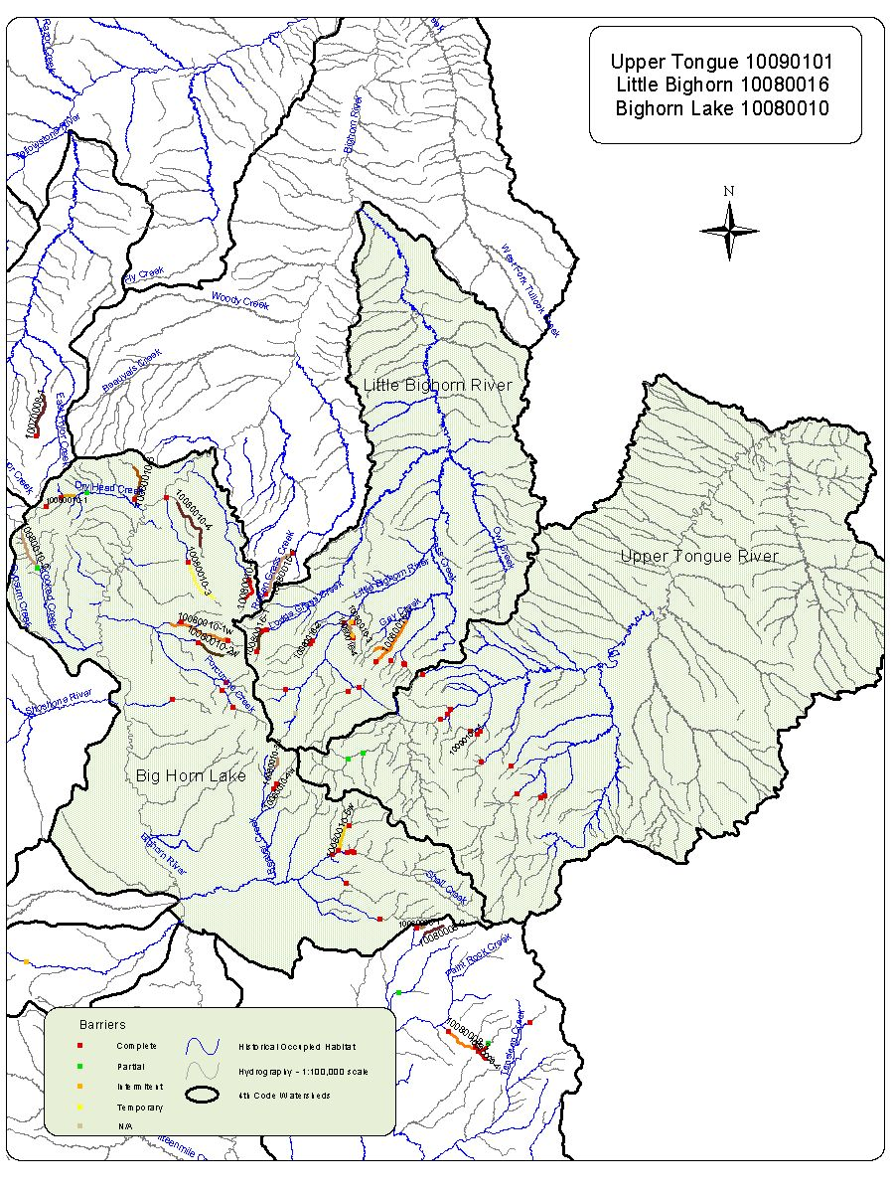
10080010 Bighorn Lake Conservation Populations with competitive Species.

Conservation Population Identification Number | Competitive Species Present | Total Miles of YCT | Total Miles with Competitive Species | Number of Stream Segments Occupied
10080010-1 | No | 1.5
10080010-1w | Yes | 8.4 | 8.4 | 1
10080010-2 | No | 5.0
10080010-2w | No | 3.5
10080010-3 | No | 6.1
10080010-3w | No | 1.2
10080010-4 | No | 7.3
10080010-4w | No | 0.7
10080010-5 | No | 2.8
10080010-5w | No | 4.0
10080010-6 | No | 4.8

10080010. Abundance by Conservation Population

Conservation Population Identification Number | Abundance |  |  |  | Total  Miles
Conservation Population Identification Number | Abundant  (Segments) | Common  (Segments) | Rare  (Segments) | Unknown  (Segments) | Total  Miles
10080010-1 |  |  | 1 |  | 1.5
10080010-1w |  | 1 |  |  | 8.4
10080010-2 |  | 1 |  |  | 5.0
10080010-2w |  | 1 |  |  | 3.5
10080010-3 | 1 |  |  |  | 6.1
10080010-3w |  | 1 |  |  | 1.2
10080010-4 |  |  |  | 1 | 7.3
10080010-4w |  | 1 |  |  | 0.7
10080010-5 |  |  |  | 1 | 2.8
10080010-5w |  | 1 |  |  | 4.0
10080010-6 |  | 1 |  |  | 4.8

Conservation  Population Identification Number | Population Type | Source | Genetic Makeup |  |  |  |  |  | Total Miles
Conservation  Population Identification Number | Population Type | Source | Genetically  Altered  (Segments) | Tested  75%-99%  YCT  (Segments) | Tested  >75%  YCT  (Segments) | Untested  Potentially  Unaltered  (Segments) | Untested  Suspected  Altered  (Segments) | Mixed Stock –pure & altered  (Segments) | Total Miles
10080010-1 | Isolet | No | 1 |  |  |  |  |  | 1.5
10080010-1w | Isolet | No | 1 |  |  |  |  |  | 8.4
10080010-2 | Isolet | No |  |  |  | 1 |  |  | 5.0
10080010-2w | Isolet | No | 1 |  |  |  |  |  | 3.5
10080010-3 | Isolet | No | 1 |  |  |  |  |  | 6.1
10080010-3w | Isolet | No | 1 |  |  |  |  |  | 1.2
10080010-4 | Isolet | No | 1 |  |  |  |  |  | 7.3
10080010-4w | Isolet | No | 1 |  |  |  |  |  | 0.7
10080010-5 | Isolet | No |  |  |  |  | 1 |  | 2.8
10080010-5w | Isolet | No | 1 |  |  |  |  |  | 4.0
10080010-6 | Meta-population | No |  |  |  | 1 |  |  | 4.8
Watershed Name Bighorn Lake Watershed Number 10080010

Conservation Population Identification Number | Genetic Risk Score | Population Risk Scores
Conservation Population Identification Number | Genetic Risk Score | Temporal  Factors  Score | PopulationSize  Score | Demographic  Factors  Score | Isolation  Factor  Score | Composite  Score
10080010-1 | 2 | 4 | 4 | 4 | 4 | 16
10080010-1w | 2 | 4 | 3 | 2 | 4 | 11.6
10080010-2 | 2 | 3 | 3 | 2 | 4 | 10.9
10080010-2w | 1 | 4 | 3 | 1 | 4 | 10
10080010-3 | 2 | 4 | 2 | 1 | 4 | 8.8
10080010-3w | 1 | 4 | 3 | 1 | 4 | 10
10080010-4 | 2 | 4 | 4 | 2 | 4 | 12.8
10080010-4w | 1 | 4 | 3 | 1 | 4 | 10
10080010-5 | 2 | 4 | 4 | 2 | 4 | 12.8
10080010-5w | 1 | 4 | 3 | 1 | 4 | 10
10080010-6 | 2 | 4 | 4 | 2 | 4 | 12.8
Watershed Bighorn Lake Number 10080010

10080016 Little Bighorn Conservation Populations with competitive Species.

Conservation Population Identification Number | Competitive Species Present | Total Miles of YCT | Total Miles with Competitive Species | Number of Stream Segments Occupied
10080016-1 | No | 3.4
10080016-2 | No | 0.3
10080016-3 | Yes | 1.8 | 1.5 | 1
10080016-4 | Yes | 0.4 | 0.4 | 12
10080016-5 | Yes | 8.8 | 8.8 | 2

10080016. Abundance by Conservation Population

Conservation Population Identification Number | Abundance |  |  |  | Total  Miles
Conservation Population Identification Number | Abundant  (Segments) | Common  (Segments) | Rare  (Segments) | Unknown  (Segments) | Total  Miles
10080016-1 |  | 1 |  |  | 3.4
10080016-2 |  | 1 |  |  | 0.3
10080016-3 |  | 2 |  |  | 1.8
10080016-4 |  |  | 1 |  | 0.4
10080016-5 |  | 2 |  |  | 8.8

Conservation  Population Identification Number | Population Type | Source | Genetic Makeup |  |  |  |  |  | Total Miles
Conservation  Population Identification Number | Population Type | Source | Genetically  Altered  (Segments) | Tested  75%-99%  YCT  (Segments) | Tested  >75%  YCT  (Segments) | Untested  Potentially  Unaltered  (Segments) | Untested  Suspected  Altered  (Segments) | Mixed Stock –pure & altered  (Segments) | Total Miles
10080016-1 | Isolet | No | 1 |  |  |  |  |  | 3.4
10080016-2 | Isolet | No | 1 |  |  |  |  |  | 0.3
10080016-3 | Isolet | No | 2 |  |  |  |  |  | 1.8
10080016-4 | Isolet | No1 |  |  |  |  |  |  | 0.4
10080016-5 | Isolet | No | 2 |  |  |  |  |  | 8.8
Watershed Name Little Bighorn Watershed Number 10080016

Conservation Population Identification Number | Genetic Risk Score | Population Risk Scores
Conservation Population Identification Number | Genetic Risk Score | Temporal  Factors  Score | PopulationSize  Score | Demographic  Factors  Score | Isolation  Factor  Score | Composite  Score
10080016-1 | 1 | 4 | 3 | 1 | 4 | 10
10080016-2 | 1 | 4 | 3 | 1 | 4 | 10
10080016-3 | 1 | 4 | 3 | 2 | 4 | 11.6
10080016-4 | 3 | 4 | 3 | 2 | 4 | 11.6
10080016-5 | 3 | 4 | 2 | 2 | 4 | 10.4
Watershed Little Bighorn Number 10080016

Watershed Upper Tongue Number 10090101

Conservation Population Identification Number | Competitive Species Present | Total Miles of YCT | Total Miles with Competitive Species | Number of Stream Segments Occupied
10090101-1 | Yes | 0.5 | 0.5 | 1

10090101. Abundance by Conservation Population

Conservation Population Identification Number | Abundance |  |  |  | Total  Miles
Conservation Population Identification Number | Abundant  (Segments) | Common  (Segments) | Rare  (Segments) | Unknown  (Segments) | Total  Miles
10090101-1 |  | 1 |  |  | 0.5

Conservation  Population Identification Number | Population Type | Source | Genetic Makeup |  |  |  |  |  | Total Miles
Conservation  Population Identification Number | Population Type | Source | Genetically  Altered  (Segments) | Tested  75%-99%  YCT  (Segments) | Tested  >75%  YCT  (Segments) | Untested  Potentially  Unaltered  (Segments) | Untested  Suspected  Altered  (Segments) | Mixed Stock –pure & altered  (Segments) | Total Miles
10090101-1 | Isolet | No | 1 |  |  |  |  |  | 0.5
Watershed Name Upper Tongue Watershed Number 10090101

Conservation Population Identification Number | Genetic Risk Score | Population Risk Scores
Conservation Population Identification Number | Genetic Risk Score | Temporal  Factors  Score | PopulationSize  Score | Demographic  Factors  Score | Isolation  Factor  Score | Composite  Score
 | 1 | 4 | 3 | 2 | 4 | 11.6
  10090101-1
Watershed Upper Tongue Number 10090101

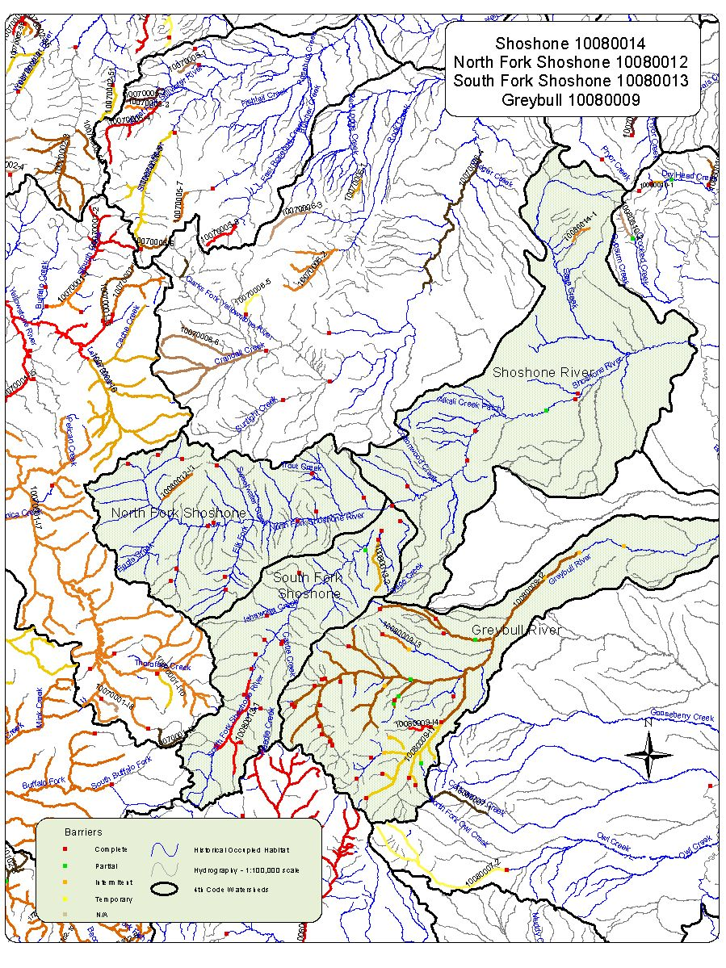
10080009 Greybull Conservation Populations with competitive Species.

Conservation Population Identification Number | Competitive Species Present | Total Miles of YCT | Total Miles with Competitive Species | Number of Stream Segments Occupied
10080009-11 | Yes | 42.0 | 17.3 | 3
10080009-12 | Yes | 165.2 | 51.9 | 3
10080009-13 | No | 5.4
10080009-14 | Yes | 4.8 | 4.8 | 2

10080009. Abundance by Conservation Population

Conservation Population Identification Number | Abundance |  |  |  | Total  Miles
Conservation Population Identification Number | Abundant  (Segments) | Common  (Segments) | Rare  (Segments) | Unknown  (Segments) | Total  Miles
10080009-11 | 3 | 5 | 1 |  | 42.0
10080009-12 | 7 | 9 | 5 |  | 165.2
10080009-13 |  | 1 |  |  | 5.4
10080009-14 |  | 2 |  |  | 4.8

Conservation  Population Identification Number | Population Type | Source | Genetic Makeup |  |  |  |  |  | Total Miles
Conservation  Population Identification Number | Population Type | Source | Genetically  Altered  (Segments) | Tested  75%-99%  YCT  (Segments) | Tested  >75%  YCT  (Segments) | Untested  Potentially  Unaltered  (Segments) | Untested  Suspected  Altered  (Segments) | Mixed Stock –pure & altered  (Segments) | Total Miles
10080009-11 | Meta-population | Yes | 5 |  |  | 4 |  |  | 42.0
10080009-12 | Meta-population | No | 5 |  |  | 16 |  |  | 165.2
10080009-13 | Isolet | Yes |  |  |  | 1 |  |  | 5.4
10080009-14 | Isolet | Yes |  |  |  | 2 |  |  | 4.8
Watershed Name Greybull Watershed Number 10080009

Conservation Population Identification Number | Genetic Risk Score | Population Risk Scores
Conservation Population Identification Number | Genetic Risk Score | Temporal  Factors  Score | PopulationSize  Score | Demographic  Factors  Score | Isolation  Factor  Score | Composite  Score
10080009-I1 | 1 | 1 | 1 | 1 | 1 | 4
10080009-I2 | 1 | 1 | 1 | 1 | 1 | 4
10080009-I3 | 1 | 3 | 3 | 2 | 4 | 10.9
10080009-I4 | 1 | 4 | 2 | 3 | 4 | 12
Watershed Greybull Number 10080009

10080012 North Fork Shoshone Conservation Populations with competitive Species.

Conservation Population Identification Number | Competitive Species Present | Total Miles of YCT | Total Miles with Competitive Species | Number of Stream Segments Occupied
10080012-11 | Yes | 7.0 | 7.0 | 1

10080012. Abundance by Conservation Population

Conservation Population Identification Number | Abundance |  |  |  | Total  Miles
Conservation Population Identification Number | Abundant  (Segments) | Common  (Segments) | Rare  (Segments) | Unknown  (Segments) | Total  Miles
10080012-11 |  | 1 |  |  | 7.0

Conservation Population Identification Number | Population Type | Source | Genetic Makeup |  |  |  |  |  | Total Miles
Conservation Population Identification Number | Population Type | Source | Genetically  Altered  (Segments) | Tested  75%-99%  YCT  (Segments) | Tested  >75%  YCT  (Segments) | Untested  Potentially  Unaltered  (Segments) | Untested  Suspected  Altered  (Segments) | Mixed Stock –pure & altered  (Segments) | Total Miles
10080012-11 | Isolet | No |  | 1 |  |  |  |  | 7.0
Watershed Name NF Shoshone Watershed Number 10080012

Conservation Population Identification Number | Genetic Risk Score | Population Risk Scores
Conservation Population Identification Number | Genetic Risk Score | Temporal  Factors  Score | PopulationSize  Score | Demographic  Factors  Score | Isolation  Factor  Score | Composite  Score
 | 4 | 4 | 3 | 2 | 4 | 11.6
  10080012-I1
Watershed NF Shoshone Number 10080012

10080013 South Fork Shoshone Conservation Populations with competitive Species.

Conservation Population Identification Number | Competitive Species Present | Total Miles of YCT | Total Miles with Competitive Species | Number of Stream Segments Occupied
10080013-1 | Yes | 23.3 | 23.3 | 4
10080013-2 | No | 9.5

10080013. Abundance by Conservation Population

Conservation Population Identification Number | Abundance |  |  |  | Total  Miles
Conservation Population Identification Number | Abundant  (Segments) | Common  (Segments) | Rare  (Segments) | Unknown  (Segments) | Total  Miles
10080013-1 | 1 | 3 |  |  | 23.3
10080013-2 | 1 |  |  |  | 9.5

Conservation  Population Identification Number | Population Type | Source | Genetic Makeup |  |  |  |  |  | Total Miles
Conservation  Population Identification Number | Population Type | Source | Genetically  Altered  (Segments) | Tested  75%-99%  YCT  (Segments) | Tested  >75%  YCT  (Segments) | Untested  Potentially  Unaltered  (Segments) | Untested  Suspected  Altered  (Segments) | Mixed Stock –pure & altered  (Segments) | Total Miles
10080013-1 | Meta-population | No | 4 |  |  |  |  |  | 23.3
10080013-2 | Isolet | No | 1 |  |  |  |  |  | 9.5
Watershed Name SF Shoshone Watershed Number 10080013

Conservation Population Identification Number | Genetic Risk Score | Population Risk Scores
Conservation Population Identification Number | Genetic Risk Score | Temporal  Factors  Score | PopulationSize  Score | Demographic  Factors  Score | Isolation  Factor  Score | Composite  Score
10080013-1 | 2 | 2 | 1 | 1 | 3 | 5.7
10080013-2 | 2 | 3 | 2 | 3 | 4 | 11.3
Watershed SF Shoshone Number 10080013

10080014. Shoshone Abundance by Conservation Population

Conservation Population Identification Number | Abundance |  |  |  | Total  Miles
Conservation Population Identification Number | Abundant  (Segments) | Common  (Segments) | Rare  (Segments) | Unknown  (Segments) | Total  Miles
10080014-1 |  |  | 1 |  | 4.0

Conservation Populations with competitive Species.

Conservation Population Identification Number | Competitive Species Present | Total Miles of YCT | Total Miles with Competitive Species | Number of Stream Segments Occupied
10080014-1 | None | 4.0

Conservation  Population Identification Number | Population Type | Source | Genetic Makeup |  |  |  |  |  | Total Miles
Conservation  Population Identification Number | Population Type | Source | Genetically  Altered  (Segments) | Tested  75%-99%  YCT  (Segments) | Tested  >75%  YCT  (Segments) | Untested  Potentially  Unaltered  (Segments) | Untested  Suspected  Altered  (Segments) | Mixed Stock –pure & altered  (Segments) | Total Miles
10080014-1 | Isolet | No | 1
Watershed Name Shoshone Watershed Number 10080014

Conservation Population Identification Number | Genetic Risk Score | Population Risk Scores
Conservation Population Identification Number | Genetic Risk Score | Temporal  Factors  Score | PopulationSize  Score | Demographic  Factors  Score | Isolation  Factor  Score | Composite  Score
 | 1 | 4 | 3 | 2 | 4 | 11.6
  10080014-1
Watershed Shoshone Number 10080014

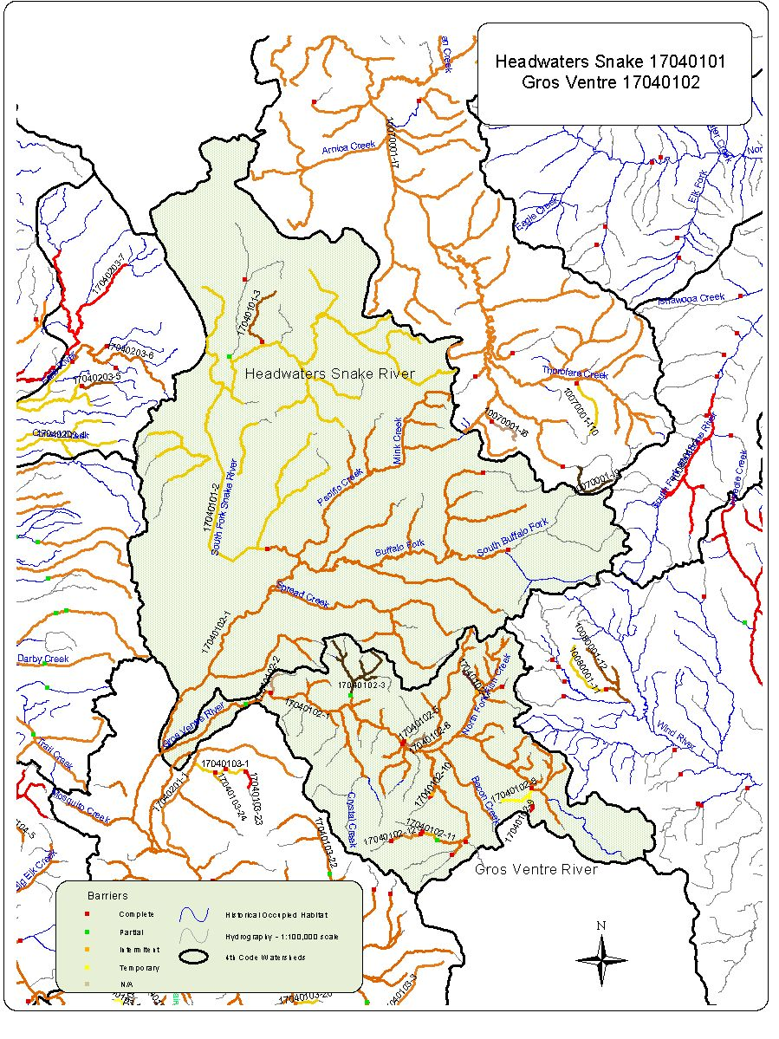
17040101 Headwaters Snake River Conservation Populations with competitive Species.

Conservation Population Identification Number | Competitive Species Present | Total Miles of YCT | Total Miles with Competitive Species | Number of Stream Segments Occupied
17040101-2 | Yes | 180.7 | 83.8 | 6
17040101-3 | No | 7.9

17040101. Abundance by Conservation Population

Conservation Population Identification Number | Abundance |  |  |  | Total  Miles
Conservation Population Identification Number | Abundant  (Segments) | Common  (Segments) | Rare  (Segments) | Unknown  (Segments) | Total  Miles
17040101-2 |  | 9 | 1 | 8 | 180.7
17040101-3 |  |  |  | 1 | 7.9

Conservation  Population Identification Number | Population Type | Source | Genetic Makeup |  |  |  |  |  | Total Miles
Conservation  Population Identification Number | Population Type | Source | Genetically  Altered  (Segments) | Tested  75%-99%  YCT  (Segments) | Tested  >75%  YCT  (Segments) | Untested  Potentially  Unaltered  (Segments) | Untested  Suspected  Altered  (Segments) | Mixed Stock –pure & altered  (Segments) | Total Miles
17040101-2 | Meta-population | Yes |  |  |  | 18 |  |  | 180.7
17040101-3 | Isolet | Yes |  |  |  | 1 |  |  | 7.9
Watershed Name Snake Headwaters Watershed Number 17040101

Conservation Population Identification Number | Genetic Risk Score | Population Risk Scores
Conservation Population Identification Number | Genetic Risk Score | Temporal  Factors  Score | PopulationSize  Score | Demographic  Factors  Score | Isolation  Factor  Score | Composite  Score
17040101-2 | 1 | 1 | 1 | 2 | 1 | 5.6
17040101-3 | 1 | 4 | 3 | 1 | 4 | 10
Watershed Snake Headwaters Number 17040101

17040102 Gros Ventre Conservation Populations with competitive Species.

Conservation Population Identification Number | Competitive Species Present | Total Miles of YCT | Total Miles with Competitive Species | Number of Stream Segments Occupied
17040102--1 | Yes | 1521.2 | 890.4 | 95
17040102-10 | No | 0.7
17040102-11 | Yes | 2.8 | 2.8 | 1
17040102-12 | Yes | 4.2 | 4.2 | 1
17040102-2 | No | 2.7
17040102-3 | Yes | 18.1 | 16.5 | 5
17040102-5 | No | 0.5
17040102-6 | Yes | 3.0 | 3.0 | 1
17040102-7 | No | 3.1
17040102-8 | No | 5.6
17040102-9 | No | 0.6

17040102. Abundance by Conservation Population

Conservation Population Identification Number | Abundance |  |  |  | Total  Miles
Conservation Population Identification Number | Abundant  (Segments) | Common  (Segments) | Rare  (Segments) | Unknown  (Segments) | Total  Miles
17040102--1 | 41 | 135 | 46 | 34 | 1521.2
17040102-10 |  | ` |  |  | 0.7
17040102-11 |  | 1 |  |  | 2.8
17040102-12 |  |  | 1 |  | 4.2
17040102-2 |  | 1 |  |  | 2.7
17040102-3 |  | 6 | 1 |  | 18.1
17040102-5 |  | 1 |  |  | 0.5
17040102-6 |  | 1 |  |  | 3.0
17040102-7 |  | 1 |  |  | 3.1
17040102-8 |  | 2 |  |  | 5.6
17040102-9 |  | 1 |  |  | 0.6

Conservation  Population Identification Number | Population Type | Source | Genetic Makeup |  |  |  |  |  | Total Miles
Conservation  Population Identification Number | Population Type | Source | Genetically  Altered  (Segments) | Tested  75%-99%  YCT  (Segments) | Tested  >75%  YCT  (Segments) | Untested  Potentially  Unaltered  (Segments) | Untested  Suspected  Altered  (Segments) | Mixed Stock –pure & altered  (Segments) | Total Miles
17040102--1 | Meta-population | No | 5 |  |  | 237 | 13 | 1 | 1521.2
17040102-10 | Isolet | Yes |  |  |  | 1 |  |  | 0.7
17040102-11 | Isolet | Yes |  |  |  | 1 |  |  | 2.8
17040102-12 | Isolet | Yes |  |  |  | 1 |  |  | 4.2
17040102-2 | Isolet | Yes |  |  |  | 1 |  |  | 2.7
17040102-3 | Meta-population | Yes |  |  |  | 7 |  |  | 18.1
17040102-5 | Isolet | Yes |  |  |  | 1 |  |  | 0.5
17040102-6 | Isolet | Yes |  |  |  | 1 |  |  | 3.0
17040102-7 | Isolet | Yes |  |  |  | 1 |  |  | 3.1
17040102-8 | Isolet | Yes |  |  |  | 2 |  |  | 5.6
17040102-9 | Isolet | Yes |  |  |  | 1 |  |  | 0.6
Watershed Name Gros Ventre Watershed Number 17040102

Conservation Population Identification Number | Genetic Risk Score | Population Risk Scores
Conservation Population Identification Number | Genetic Risk Score | Temporal  Factors  Score | PopulationSize  Score | Demographic  Factors  Score | Isolation  Factor  Score | Composite  Score
17040102-1 | 1 | 4 | 3 | 2 | 4 | 11.6
17040102-10 | 1 | 4 | 3 | 1 | 4 | 10
17040102-11 | 1 | 4 | 4 | 1 | 4 | 11.2
17040102-12 | 1 | 4 | 3 | 1 | 4 | 10
17040102-2 | 1 | 2 | 2 | 1 | 2 | 6.4
17040102-3 | 1 | 4 | 4 | 1 | 4 | 11.2
17040102-5 | 1 | 4 | 3 | 1 | 4 | 10
17040102-6 | 1 | 4 | 3 | 2 | 4 | 11.6
17040102-7 | 1 | 4 | 3 | 2 | 4 | 11.6
17040102-8 | 1 | 4 | 4 | 2 | 4 | 12.8
17040102-9 | 1 | 4 | 3 | 2 | 4 | 11.6
Watershed Gros Ventre Number 17040102

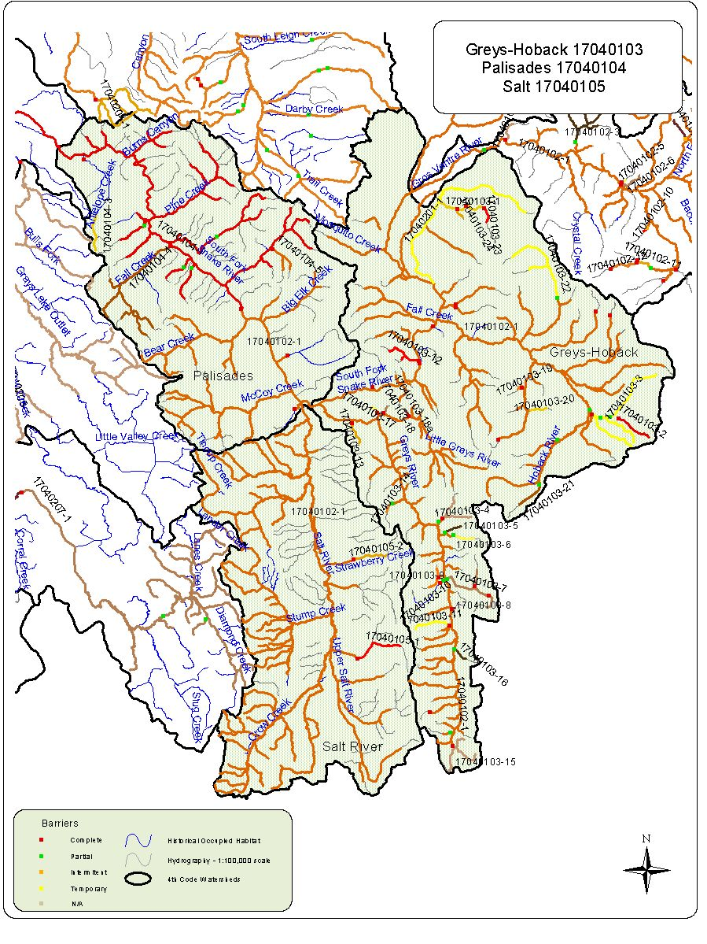
17040103 Greys-Hoback Conservation Populations with competitive Species.

Conservation Population Identification Number | Competitive Species Present | Total Miles of YCT | Total Miles with Competitive Species | Number of Stream Segments Occupied
17040103-1 | Yes | 7.2 | 7.2 | 1
17040103-10 | No | 0.5
17040103-11 | No | 4.8
17040103-12 | No | 5.3
17040103-13 | No | 3.0
17040103-14 | No | 1.4
17040103-15 | Yes | 9.6 | 3.5 | 1
17040103-16 | No | 1.8
17040103-17 | No | 1.4
17040103-18 | No | 0.9
17040103-18a | No | 0.9
17040103-19 | No | 0.9
17040103-2 | No | 4.6
17040103-20 | No | 2.1
17040103-21 | No | 3.7
17040103-22 | Yes | 13.3 | 10.7 | 1
17040103-23 | Yes | 2.0 | 2.0 | 1
17040103-24 | Yes | 1.4 | 1.4 | 1
17040103-3 | Yes | 23.9 | 7.4 | 1
17040103-4 | No | 6.8
17040103-5 | No | 2.2
17040103-6 | No | 2.5
17040103-7 | Yes | 10.9 | 8.5 | 1
17040103-8 | No | 0.4
17040103-9 | No | 3.7

17040103 Greys-Hoback Conservation Populations with competitive Species.

Conservation Population Identification Number | Competitive Species Present | Total Miles of YCT | Total Miles with Competitive Species | Number of Stream Segments Occupied
17040103-1 | Yes | 7.2 | 7.2 | 1
17040103-10 | No | 0.5
17040103-11 | No | 4.8
17040103-12 | No | 5.3
17040103-13 | No | 3.0
17040103-14 | No | 1.4
17040103-15 | Yes | 9.6 | 3.5 | 1
17040103-16 | No | 1.8
17040103-17 | No | 1.4
17040103-18 | No | 0.9
17040103-18a | No | 0.9
17040103-19 | No | 0.9
17040103-2 | No | 4.6
17040103-20 | No | 2.1
17040103-21 | No | 3.7
17040103-22 | Yes | 13.3 | 10.7 | 1
17040103-23 | Yes | 2.0 | 2.0 | 1
17040103-24 | Yes | 1.4 | 1.4 | 1
17040103-3 | Yes | 23.9 | 7.4 | 1
17040103-4 | No | 6.8
17040103-5 | No | 2.2
17040103-6 | No | 2.5
17040103-7 | Yes | 10.9 | 8.5 | 1
17040103-8 | No | 0.4
17040103-9 | No | 3.7

Watershed Name Greys-Hoback Watershed Number 17040103
Conservation  Population Identification Number | Population Type | Source | Genetic Makeup |  |  |  |  |  | Total Miles
Conservation  Population Identification Number | Population Type | Source | Genetically  Altered  (Segments) | Tested  75%-99%  YCT  (Segments) | Tested  >75%  YCT  (Segments) | Untested  Potentially  Unaltered  (Segments) | Untested  Suspected  Altered  (Segments) | Mixed Stock –pure & altered  (Segments) | Total Miles
17040103-1 | Isolet | No |  |  |  | 1 |  |  | 7.2
17040103-10 | Isolet | Yes |  |  |  | 1 |  |  | 0.5
17040103-11 | Isolet | Yes |  |  |  | 1 |  |  | 4.8
17040103-12 | Isolet | Yes |  |  |  | 2 |  |  | 5.3
17040103-13 | Isolet | Yes |  |  |  | 1 |  |  | 3.0
17040103-14 | Isolet | Yes |  |  |  | 1 |  |  | 1.4
17040103-15 | Meta-population | No |  |  |  | 3 |  |  | 9.6
17040103-16 | Isolet | Yes |  |  |  | 1 |  |  | 1.8
17040103-17 | Isolet | Yes |  |  |  | 1 |  |  | 1.4
17040103-18 | Isolet | Yes |  |  |  | 1 |  |  | 0.9
17040103-18a | Isolet | Yes |  |  |  | 1 |  |  | 0.9
17040103-19 | Isolet | Yes |  |  |  | 1 |  |  | 0.9
17040103-2 | Isolet | Yes |  |  |  | 1 |  |  | 4.6
17040103-20 | Isolet | Ywa |  |  |  | 1 |  |  | 2.1
17040103-21 | Isolet | Yes |  |  |  | 1 |  |  | 3.7
17040103-22 | Meta-population | No |  |  |  | 2 |  |  | 13.3
17040103-23 | Isolet | No |  |  |  | 1 |  |  | 2.0
17040103-24 | Isolet | No |  |  |  | 1 |  |  | 1.4
17040103-3 | Meta-population | No |  |  |  | 3 |  |  | 23.9
17040103-4 | Isolet | Yes |  |  |  | 2 |  |  | 6.8
17040103-5 | Isolet | Yes |  |  |  | 1 |  |  | 2.2
17040103-6 | Isolet | Yes |  |  |  | 1 |  |  | 2.5
17040103-7 | Isolet | Yes |  |  |  | 2 |  |  | 10.9
17040103-8 | Isolet | Yes |  |  |  | 1 |  |  | 0.4
17040103-9 | Isolet | Yes |  |  |  | 3 |  |  | 3.7

Conservation Population Identification Number | Genetic Risk Score | Population Risk Scores
Conservation Population Identification Number | Genetic Risk Score | Temporal  Factors  Score | PopulationSize  Score | Demographic  Factors  Score | Isolation  Factor  Score | Composite  Score
17040103-1 | 1 | 4 | 4 | 2 | 4 | 12.8
17040103-10 | 1 | 4 | 4 | 2 | 4 | 12.8
17040103-11 | 1 | 4 | 4 | 2 | 4 | 12.8
17040103-12 | 1 | 4 | 4 | 2 | 4 | 12.8
17040103-13 | 1 | 4 | 4 | 2 | 4 | 12.8
17040103-14 | 1 | 4 | 4 | 2 | 4 | 12.8
17040103-15 | 1 | 3 | 3 | 2 | 4 | 10.9
17040103-16 | 1 | 4 | 4 | 2 | 4 | 12.8
17040103-17 | 1 | 4 | 4 | 2 | 4 | 12.8
17040103-18 | 1 | 4 | 4 | 2 | 4 | 12.8
17040103-18a | 1 | 4 | 4 | 2 | 4 | 12.8
17040103-19 | 1 | 4 | 4 | 2 | 4 | 12.8
17040103-2 | 1 | 4 | 4 | 2 | 4 | 12.8
17040103-20 | 1 | 4 | 4 | 2 | 4 | 12.8
17040103-21 | 1 | 4 | 4 | 2 | 4 | 12.8
17040103-22 | 1 | 3 | 3 | 2 | 4 | 10.9
17040103-23 | 1 | 4 | 4 | 2 | 4 | 12.8
17040103-24 | 1 | 4 | 4 | 2 | 4 | 12.8
17040103-3 | 1 | 2 | 3 | 2 | 4 | 10.2
17040103-4 | 1 | 4 | 4 | 2 | 4 | 12.8
17040103-5 | 1 | 4 | 4 | 2 | 4 | 12.8
17040103-6 | 1 | 4 | 4 | 2 | 4 | 12.8
17040103-7 | 1 | 3 | 3 | 2 | 4 | 10.9
17040103-8 | 1 | 4 | 4 | 2 | 4 | 12.8
17040103-9 | 1 | 4 | 3 | 2 | 4 | 11.6
Watershed Greys Hoback Number 17040103

17040104 Palisades Conservation Populations with competitive Species.

Conservation Population Identification Number | Competitive Species Present | Total Miles of YCT | Total Miles with Competitive Species | Number of Stream Segments Occupied
17040104-1 | Yes | 170.0 | 139.7 | 17
17040104-3 | No | 4.7
17040104-4 | Yes | 28.9 | 28.9 | 5
17040104-5 | Yes | 5.5 | 5.5 | 2

17040104. Abundance by Conservation Population

Conservation Population Identification Number | Abundance |  |  |  | Total  Miles
Conservation Population Identification Number | Abundant  (Segments) | Common  (Segments) | Rare  (Segments) | Unknown  (Segments) | Total  Miles
17040104-1 | 16 | 5 | 7 |  | 170.0
17040104-3 |  | 1 |  |  | 4.7
17040104-4 |  | 5 |  |  | 28.9
17040104-5 |  |  | 2 |  | 5.5

Conservation  Population Identification Number | Population Type | Source | Genetic Makeup |  |  |  |  |  | Total Miles
Conservation  Population Identification Number | Population Type | Source | Genetically  Altered  (Segments) | Tested  75%-99%  YCT  (Segments) | Tested  >75%  YCT  (Segments) | Untested  Potentially  Unaltered  (Segments) | Untested  Suspected  Altered  (Segments) | Mixed Stock –pure & altered  (Segments) | Total Miles
17040104-1 | Meta-population | No | 3 | 5 |  | 14 | 6 |  | 170.0
17040104-3 | Isolet | Yes |  |  |  | 1 |  |  | 4.7
17040104-4 | Meta-population | No |  |  |  | 5 |  |  | 28.9
17040104-5 | Isolet | Yes |  |  |  | 2 |  |  | 5.5
Watershed Name Palisades Watershed Number 17040104

Conservation Population Identification Number | Genetic Risk Score | Population Risk Scores
Conservation Population Identification Number | Genetic Risk Score | Temporal  Factors  Score | PopulationSize  Score | Demographic  Factors  Score | Isolation  Factor  Score | Composite  Score
17040104-1 | 4 | 1 | 1 | 2 | 1 | 5.6
17040104-3 | 1 | 4 | 3 | 2 | 4 | 11.6
17040104-4 | 1 | 2 | 2 | 2 | 4 | 9
17040104-5 | 1 | 4 | 3 | 1 | 4 | 10
Watershed Palisades Number 17040104

17040105 Salt Conservation Populations with competitive Species.

Conservation Population Identification Number | Competitive Species Present | Total Miles of YCT | Total Miles with Competitive Species | Number of Stream Segments Occupied
17040105-1 | Yes | 6.5 | 6.5 | 1
17040105-2 | Yes | 4.6 | 4.6 | 1

17040105. Abundance by Conservation Population

Conservation Population Identification Number | Abundance |  |  |  | Total  Miles
Conservation Population Identification Number | Abundant  (Segments) | Common  (Segments) | Rare  (Segments) | Unknown  (Segments) | Total  Miles
17040105-1 |  | 1 |  |  | 6.5
17040105-2 |  | 1 |  |  | 4.6

Conservation  Population Identification Number | Population Type | Source | Genetic Makeup |  |  |  |  |  | Total Miles
Conservation  Population Identification Number | Population Type | Source | Genetically  Altered  (Segments) | Tested  75%-99%  YCT  (Segments) | Tested  >75%  YCT  (Segments) | Untested  Potentially  Unaltered  (Segments) | Untested  Suspected  Altered  (Segments) | Mixed Stock –pure & altered  (Segments) | Total Miles
17040105-1 | Isolet | Yes |  |  |  | 1 |  |  | 6.5
17040105-2 | Isolet | Yes |  |  |  | 1 |  |  | 4.6
Watershed Name Salt Watershed Number 17040105

Conservation Population Identification Number | Genetic Risk Score | Population Risk Scores
Conservation Population Identification Number | Genetic Risk Score | Temporal  Factors  Score | PopulationSize  Score | Demographic  Factors  Score | Isolation  Factor  Score | Composite  Score
17040105-1 | 1 | 4 | 4 | 1 | 4 | 11.2
17040105-2 | 1 | 4 | 3 | 1 | 4 | 10
Watershed Salt Number 17040105

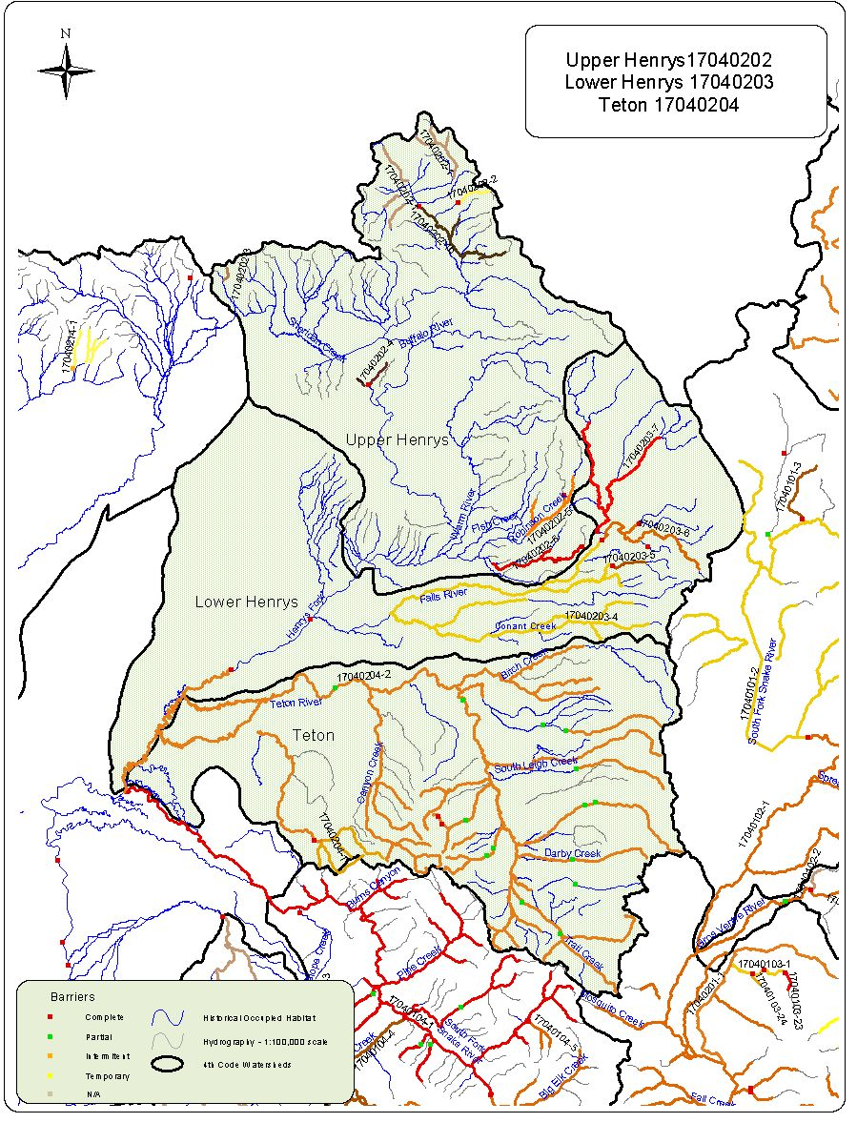
17040202 Upper Henrys Conservation Populations with competitive Species.

Conservation Population Identification Number | Competitive Species Present | Total Miles of YCT | Total Miles with Competitive Species | Number of Stream Segments Occupied
17040202-1 | Yes | 20.6 | 20.6 | 6
17040202-1b | Yes | 16.7 | 16.7 | 5
17040202-2 | No | 3.5
17040202-3 | Yes | 1.6 | 1.6 | 1
17040202-4 | No | 4.2
17040202-5 | Yes | 13.5 | 13.5 | 3
17040202-6 | Yes | 12.8 | 12/8 | 2

17040202 Upper Henrys Conservation Populations with competitive Species.

Conservation Population Identification Number | Competitive Species Present | Total Miles of YCT | Total Miles with Competitive Species | Number of Stream Segments Occupied
17040202-1 | Yes | 20.6 | 20.6 | 6
17040202-1b | Yes | 16.7 | 16.7 | 5
17040202-2 | No | 3.5
17040202-3 | Yes | 1.6 | 1.6 | 1
17040202-4 | No | 4.2
17040202-5 | Yes | 13.5 | 13.5 | 3
17040202-6 | Yes | 12.8 | 12/8 | 2

Conservation  Population Identification Number | Population Type | Source | Genetic Makeup |  |  |  |  |  | Total Miles
Conservation  Population Identification Number | Population Type | Source | Genetically  Altered  (Segments) | Tested  75%-99%  YCT  (Segments) | Tested  >75%  YCT  (Segments) | Untested  Potentially  Unaltered  (Segments) | Untested  Suspected  Altered  (Segments) | Mixed Stock –pure & altered  (Segments) | Total Miles
17040202-1 | Meta-population | No |  |  |  | 1 | 6 |  | 20.6
17040202-1b | Meta-population | No |  |  |  |  | 5 |  | 16.7
17040202-2 | Isolet | Yes |  | 1 |  |  |  |  | 3.5
17040202-3 | Isolet | No |  |  |  |  | 1 |  | 1.6
17040202-4 | Meta-population | No |  |  |  | 1 | 2 |  | 4.2
17040202-5 | Isolet | No |  |  |  |  | 3 |  | 13.5
17040202-6 | Isolet | No |  |  |  |  | 2 |  | 12.8
Watershed Name Upper Henrys Watershed Number 17040202

Conservation Population Identification Number | Genetic Risk Score | Population Risk Scores
Conservation Population Identification Number | Genetic Risk Score | Temporal  Factors  Score | PopulationSize  Score | Demographic  Factors  Score | Isolation  Factor  Score | Composite  Score
17040202-1 | 4 | 2 | 1 | 3 | 1 | 7.9
17040202-1b | 3 | 3 | 3 | 3 | 4 | 12.5
17040202-2 | 1 | 4 | 2 | 1 | 4 | 8.8
17040202-3 | 3 | 4 | 4 | 3 | 4 | 14.4
17040202-4 | 4 | 4 | 4 | 1 | 1 | 9.7
17040202-5 | 4 | 3 | 3 | 3 | 4 | 12.5
17040202-6 | 3 | 4 | 3 | 3 | 4 | 13.2
Watershed Upper Henrys Number 17040202

17040203 :Lower Henrys Conservation Populations with competitive Species.

Conservation Population Identification Number | Competitive Species Present | Total Miles of YCT | Total Miles with Competitive Species | Number of Stream Segments Occupied
17040203-4 | Yes | 96.1 | 91.2 | 9
17040203-5 | Yes | 4.1 | 4.1 | 1
17040203-6 | Yes | 20.4 | 20.4 | 3
17040203-7 | Yes | 30.1 | 30.1 | 2

17040203. Abundance by Conservation Population

Conservation Population Identification Number | Abundance |  |  |  | Total  Miles
Conservation Population Identification Number | Abundant  (Segments) | Common  (Segments) | Rare  (Segments) | Unknown  (Segments) | Total  Miles
17040203-4 |  | 3 | 7 |  | 96.1
17040203-5 |  | 1 |  |  | 4.1
17040203-6 |  |  | 3 |  | 20.4
17040203-7 |  |  | 2 |  | 30.1

Conservation  Population Identification Number | Population Type | Source | Genetic Makeup |  |  |  |  |  | Total Miles
Conservation  Population Identification Number | Population Type | Source | Genetically  Altered  (Segments) | Tested  75%-99%  YCT  (Segments) | Tested  >75%  YCT  (Segments) | Untested  Potentially  Unaltered  (Segments) | Untested  Suspected  Altered  (Segments) | Mixed Stock –pure & altered  (Segments) | Total Miles
17040203-4 | Meta-population | No |  |  |  |  | 9 |  | 96.1
17040203-5 | Isolet | Yes |  |  |  |  | 1 |  | 4.1
17040203-6 | Isolet | Yes |  |  |  |  | 3 |  | 20.4
17040203-7 | Meta-population | No |  |  |  |  | 2 |  | 30.1
Watershed Name Lower Henrys Watershed Number 17040203

Conservation Population Identification Number | Genetic Risk Score | Population Risk Scores
Conservation Population Identification Number | Genetic Risk Score | Temporal  Factors  Score | PopulationSize  Score | Demographic  Factors  Score | Isolation  Factor  Score | Composite  Score
17040203-4 | 4 | 2 | 2 | 3 | 3 | 10.1
17040203-5 | 4 | 4 | 3 | 3 | 4 | 13.2
17040203-6 | 4 | 3 | 4 | 4 | 4 | 15.3
17040203-7 | 4 | 1 | 2 | 2 | 3 | 7.8
Watershed Lower Henrys Number 17040203

17040204 Teton Conservation Populations with competitive Species.

Conservation Population Identification Number | Competitive Species Present | Total Miles of YCT | Total Miles with Competitive Species | Number of Stream Segments Occupied
17040204-1 | Yes | 21.3 | 21.3 | 4
17040204-2 | Yes | 409.1 | 379.3 | 40

17040204. Abundance by Conservation Population

Conservation Population Identification Number | Abundance |  |  |  | Total  Miles
Conservation Population Identification Number | Abundant  (Segments) | Common  (Segments) | Rare  (Segments) | Unknown  (Segments) | Total  Miles
17040204-1 |  | 2 | 2 |  | 21.3
17040204-2 | 16 | 16 | 11 |  | 409.1

Conservation  Population Identification Number | Population Type | Source | Genetic Makeup |  |  |  |  |  | Total Miles
Conservation  Population Identification Number | Population Type | Source | Genetically  Altered  (Segments) | Tested  75%-99%  YCT  (Segments) | Tested  >75%  YCT  (Segments) | Untested  Potentially  Unaltered  (Segments) | Untested  Suspected  Altered  (Segments) | Mixed Stock –pure & altered  (Segments) | Total Miles
17040204-1 | Meta-population | No |  |  |  | 4 |  |  | 21.3
17040204-2 | Meta-population | No |  | 3 |  | 6 | 34 |  | 409.1
Watershed Name Teton Watershed Number 17040204

Conservation Population Identification Number | Genetic Risk Score | Population Risk Scores
Conservation Population Identification Number | Genetic Risk Score | Temporal  Factors  Score | PopulationSize  Score | Demographic  Factors  Score | Isolation  Factor  Score | Composite  Score
17040204-1 | 1 | 3 | 2 | 2 | 3 | 9.2
17040204-2 | 4 | 1 | 1 | 3 | 1 | 7.2
Watershed Teton Number 17040204

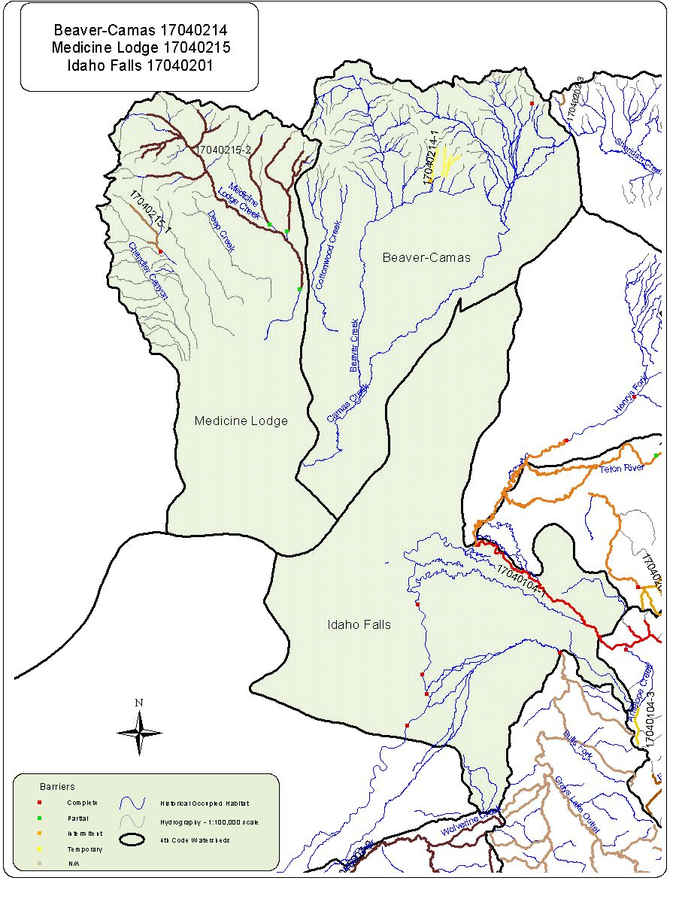
17040201 Idaho Falls Conservation Populations with competitive Species.

Conservation Population Identification Number | Competitive Species Present | Total Miles of YCT | Total Miles with Competitive Species | Number of Stream Segments Occupied
17040201-1 | Yes | 29.5 | 29.5 | 1

17040201. Abundance by Conservation Population

Conservation Population Identification Number | Abundance |  |  |  | Total  Miles
Conservation Population Identification Number | Abundant  (Segments) | Common  (Segments) | Rare  (Segments) | Unknown  (Segments) | Total  Miles
17040201-1 | 1 |  |  |  | 29.5

Conservation  Population Identification Number | Population Type | Source | Genetic Makeup |  |  |  |  |  | Total Miles
Conservation  Population Identification Number | Population Type | Source | Genetically  Altered  (Segments) | Tested  75%-99%  YCT  (Segments) | Tested  >75%  YCT  (Segments) | Untested  Potentially  Unaltered  (Segments) | Untested  Suspected  Altered  (Segments) | Mixed Stock –pure & altered  (Segments) | Total Miles
17040201-1 | Meta-population | Yes |  |  |  | 1 |  |  | 29.5
Watershed Name Idaho Falls Watershed Number 17040201

Conservation Population Identification Number | Genetic Risk Score | Population Risk Scores
Conservation Population Identification Number | Genetic Risk Score | Temporal  Factors  Score | PopulationSize  Score | Demographic  Factors  Score | Isolation  Factor  Score | Composite  Score
 | 4 | 2 | 1 | 2 | 1 | 6.3
  17040201-1
Watershed Idaho Falls Number 17040201

17040214 Beaver-Camas Conservation Populations with competitive Species.

Conservation Population Identification Number | Competitive Species Present | Total Miles of YCT | Total Miles with Competitive Species | Number of Stream Segments Occupied
17040214-1 | Yes | 12.3 | 3.1 | 1

17040214. Abundance by Conservation Population

Conservation Population Identification Number | Abundance |  |  |  | Total  Miles
Conservation Population Identification Number | Abundant  (Segments) | Common  (Segments) | Rare  (Segments) | Unknown  (Segments) | Total  Miles
17040214-1 |  | 3 | 1 |  | 12.3

Conservation  Population Identification Number | Population Type | Source | Genetic Makeup |  |  |  |  |  | Total Miles
Conservation  Population Identification Number | Population Type | Source | Genetically  Altered  (Segments) | Tested  75%-99%  YCT  (Segments) | Tested  >75%  YCT  (Segments) | Untested  Potentially  Unaltered  (Segments) | Untested  Suspected  Altered  (Segments) | Mixed Stock –pure & altered  (Segments) | Total Miles
17040214-1 | Meta-population | No |  |  |  | 3 | 1 |  | 12.3
Watershed Name Beaver-Camas Watershed Number 17040214

Conservation Population Identification Number | Genetic Risk Score | Population Risk Scores
Conservation Population Identification Number | Genetic Risk Score | Temporal  Factors  Score | PopulationSize  Score | Demographic  Factors  Score | Isolation  Factor  Score | Composite  Score
 | 4 | 2 | 3 | 3 | 3 | 11.3
  17040214-1
Watershed Beaver Camas Number 17040214

17040215 Medicine Lodge Conservation Populations with competitive Species.

Conservation Population Identification Number | Competitive Species Present | Total Miles of YCT | Total Miles with Competitive Species | Number of Stream Segments Occupied
17040215-1 | Yes | 8.1 | 8.1 | 2
17040215-2 | Yes | 93.6 | 93.6 | 15

17040215. Abundance by Conservation Population

Conservation Population Identification Number | Abundance |  |  |  | Total  Miles
Conservation Population Identification Number | Abundant  (Segments) | Common  (Segments) | Rare  (Segments) | Unknown  (Segments) | Total  Miles
17040215-1 |  |  | 2 |  | 8.1
17040215-2 |  |  | 15 |  | 93.6

Conservation  Population Identification Number | Population Type | Source | Genetic Makeup |  |  |  |  |  | Total Miles
Conservation  Population Identification Number | Population Type | Source | Genetically  Altered  (Segments) | Tested  75%-99%  YCT  (Segments) | Tested  >75%  YCT  (Segments) | Untested  Potentially  Unaltered  (Segments) | Untested  Suspected  Altered  (Segments) | Mixed Stock –pure & altered  (Segments) | Total Miles
17040215-1 | Isolet | No |  |  |  | 2 |  |  | 8.1
17040215-2 | Meta-population | No |  |  |  |  | 15 |  | 93.6
Watershed Name Medicine Lodge Watershed Number 17040215

Conservation Population Identification Number | Genetic Risk Score | Population Risk Scores
Conservation Population Identification Number | Genetic Risk Score | Temporal  Factors  Score | PopulationSize  Score | Demographic  Factors  Score | Isolation  Factor  Score | Composite  Score
17040215-1 | 1 | 4 | 4 | 3 | 4 | 14.4
17040215-2 | 4 | 1 | 3 | 4 | 3 | 12.2
Watershed Medicine Lodge Number 17040215

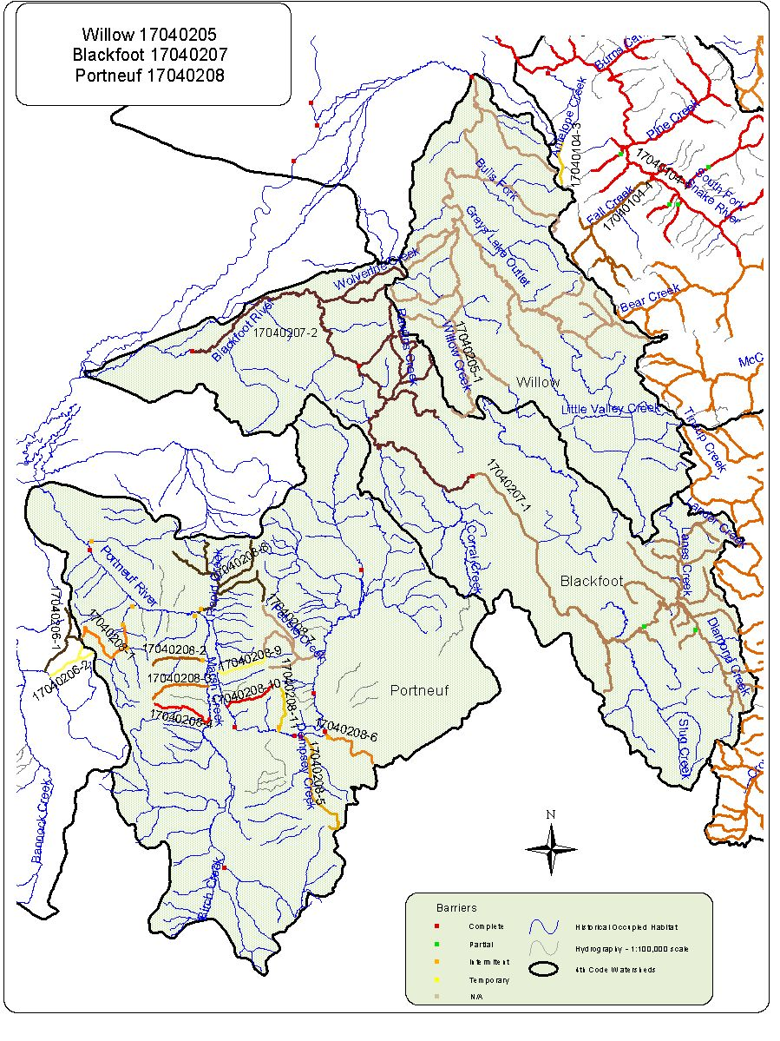
17040205 Willow Conservation Populations with competitive Species.

Conservation Population Identification Number | Competitive Species Present | Total Miles of YCT | Total Miles with Competitive Species | Number of Stream Segments Occupied
17040205-1 | Yes | 187.1 | 145.8 | 11

17040205. Abundance by Conservation Population

Conservation Population Identification Number | Abundance |  |  |  | Total  Miles
Conservation Population Identification Number | Abundant  (Segments) | Common  (Segments) | Rare  (Segments) | Unknown  (Segments) | Total  Miles
17040205-1 | 4 | 7 | 7 |  | 187.1

Conservation  Population Identification Number | Population Type | Source | Genetic Makeup |  |  |  |  |  | Total Miles
Conservation  Population Identification Number | Population Type | Source | Genetically  Altered  (Segments) | Tested  75%-99%  YCT  (Segments) | Tested  >75%  YCT  (Segments) | Untested  Potentially  Unaltered  (Segments) | Untested  Suspected  Altered  (Segments) | Mixed Stock –pure & altered  (Segments) | Total Miles
17040205-1 | Meta-population | No | 7 | 1 |  | 10 |  |  | 187.1
Watershed Name Willow Watershed Number 17040205

Conservation Population Identification Number | Genetic Risk Score | Population Risk Scores
Conservation Population Identification Number | Genetic Risk Score | Temporal  Factors  Score | PopulationSize  Score | Demographic  Factors  Score | Isolation  Factor  Score | Composite  Score
 | 3 | 1 | 1 | 4 | 1 | 8.8
  17040205-1
Watershed Willow Number 17040205

17040207 Blackfoot Conservation Populations with competitive Species.

Conservation Population Identification Number | Competitive Species Present | Total Miles of YCT | Total Miles with Competitive Species | Number of Stream Segments Occupied
17040206-1 | Yes | 161.7 | 139.4 | 16
17040206-2 | Yes | 118.0 | 92.8 | 5

17040207. Abundance by Conservation Population

Conservation Population Identification Number | Abundance |  |  |  | Total  Miles
Conservation Population Identification Number | Abundant  (Segments) | Common  (Segments) | Rare  (Segments) | Unknown  (Segments) | Total  Miles
17040207-1 | 10 | 3 | 2 | 5 | 161.7
17040207-2 | 6 | 1 | 1 |  | 118.0

Conservation  Population Identification Number | Population Type | Source | Genetic Makeup |  |  |  |  |  | Total Miles
Conservation  Population Identification Number | Population Type | Source | Genetically  Altered  (Segments) | Tested  75%-99%  YCT  (Segments) | Tested  >75%  YCT  (Segments) | Untested  Potentially  Unaltered  (Segments) | Untested  Suspected  Altered  (Segments) | Mixed Stock –pure & altered  (Segments) | Total Miles
17040207-1 | Meta-population | Yes |  |  | 1 | 3 | 15 | 1 | 161.7
17040207-2 | Meta-population | Yes |  |  |  | 5 | 3 |  | 118.0
Watershed Name Blackfoot Watershed Number 17040207

Conservation Population Identification Number | Genetic Risk Score | Population Risk Scores
Conservation Population Identification Number | Genetic Risk Score | Temporal  Factors  Score | PopulationSize  Score | Demographic  Factors  Score | Isolation  Factor  Score | Composite  Score
17040207-1 | 4 | 1 | 1 | 2 | 1 | 5.6
17040207-2 | 4 | 1 | 1 | 2 | 1 | 5.6
Watershed Blackfoot Number 17040207

17040208 Portneuf Conservation Populations with competitive Species.

Conservation Population Identification Number | Competitive Species Present | Total Miles of YCT | Total Miles with Competitive Species | Number of Stream Segments Occupied
17040208-1 | Yes | 9.7 | 4.1 | 1
17040208-10 | No | 5.7
17040208-11 | No | 5.0
17040208-2 | No | 5.5
17040208-3 | No | 6.4
17040208-4 | No | 6.8
17040208-5 | No | 12.6
17040208-6 | No | 7.4
17040208-7 | Yes | 18.4 | 5.0 | 2
17040208-8 | Yes | 30.1 | 10.2 | 2
17040208-9 | No | 5.6

17040208. Abundance by Conservation Population

Conservation Population Identification Number | Abundance |  |  |  | Total  Miles
Conservation Population Identification Number | Abundant  (Segments) | Common  (Segments) | Rare  (Segments) | Unknown  (Segments) | Total  Miles
17040208-1 |  | 1 | 1 |  | 9.7
17040208-10 | 1 |  |  |  | 5.7
17040208-11 |  | 1 |  |  | 5.0
17040208-2 |  |  | 1 |  | 5.5
17040208-3 |  | 1 |  |  | 6.4
17040208-4 |  | 1 |  |  | 6.8
17040208-5 | 1 |  |  |  | 12.6
17040208-6 | 1 |  |  |  | 7.4
17040208-7 | 3 | 2 |  |  | 18.4
17040208-8 |  | 4 | 3 |  | 30.1
17040208-9 |  | 1 |  |  | 5.6

Conservation  Population Identification Number | Population Type | Source | Genetic Makeup |  |  |  |  |  | Total Miles
Conservation  Population Identification Number | Population Type | Source | Genetically  Altered  (Segments) | Tested  75%-99%  YCT  (Segments) | Tested  >75%  YCT  (Segments) | Untested  Potentially  Unaltered  (Segments) | Untested  Suspected  Altered  (Segments) | Mixed Stock –pure & altered  (Segments) | Total Miles
17040208-1 | Isolet | No |  |  |  | 1 | 1 |  | 9.7
17040208-10 | Isolet | No |  |  |  | 1 |  |  | 5.7
17040208-11 | Isolet | No |  |  |  | 1 |  |  | 5.0
17040208-2 | Isolet | No |  |  |  | 1 |  |  | 5.5
17040208-3 | Isolet | No |  |  |  | 1 |  |  | 6.4
17040208-4 | Isolet | No |  |  |  | 1 |  |  | 6.8
17040208-5 | Isolet | No |  |  |  | 1 |  |  | 12.6
17040208-6 | Isolet | No |  |  |  | 1 |  |  | 7.4
17040208-7 | Meta-population | No | 1 | 1 |  |  | 3 |  | 18.4
17040208-8 | Meta-population | No |  |  |  | 7 |  |  | 30.1
17040208-9 | Isolet | No | 1 |  |  |  |  |  | 5.6
Watershed Name Portneuf Watershed Number 17040208

Conservation Population Identification Number | Genetic Risk Score | Population Risk Scores
Conservation Population Identification Number | Genetic Risk Score | Temporal  Factors  Score | PopulationSize  Score | Demographic  Factors  Score | Isolation  Factor  Score | Composite  Score
17040208-1 | 3 | 4 | 3 | 1 | 4 | 10
17040208-10 | 3 | 4 | 3 | 2 | 4 | 11.6
17040208-11 | 3 | 4 | 3 | 2 | 4 | 11.6
17040208-2 | 3 | 4 | 3 | 2 | 4 | 11.6
17040208-3 | 3 | 4 | 3 | 2 | 4 | 11.6
17040208-4 | 3 | 4 | 3 | 2 | 4 | 11.6
17040208-5 | 3 | 4 | 3 | 2 | 4 | 11.6
17040208-6 | 3 | 4 | 3 | 2 | 4 | 11.6
17040208-7 | 2 | 3 | 2 | 2 | 1 | 8.2
17040208-8 | 3 | 2 | 2 | 2 | 1 | 7.5
17040208-9 | 3 | 4 | 3 | 2 | 4 | 11.6
17040208-1 | 3 | 4 | 3 | 1 | 4 | 10
Watershed Portneuf Number 17040208

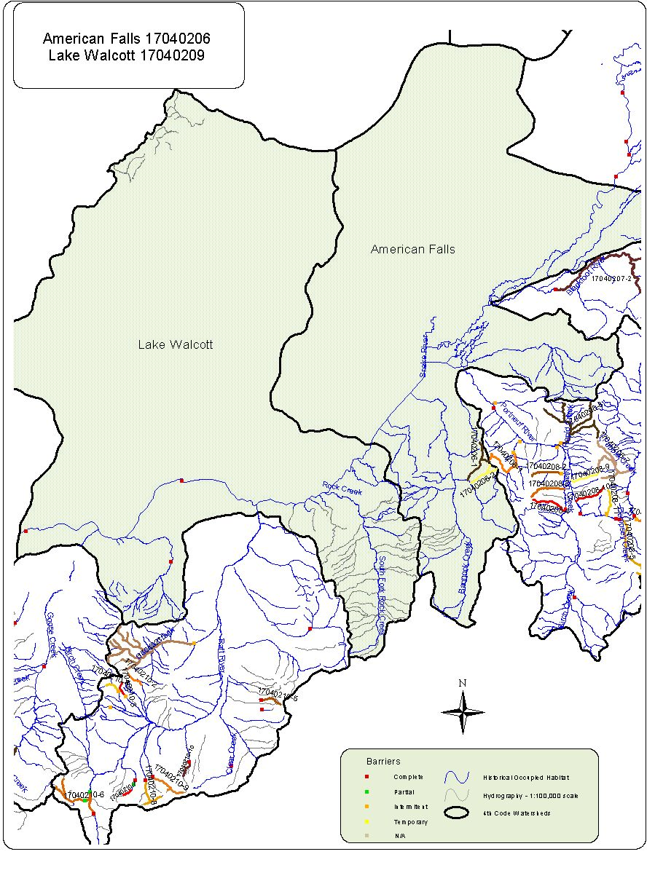
17040206. American Falls Abundance by Conservation Population

Conservation Population Identification Number | Abundance |  |  |  | Total  Miles
Conservation Population Identification Number | Abundant  (Segments) | Common  (Segments) | Rare  (Segments) | Unknown  (Segments) | Total  Miles
17040206-1 |  | 1 |  | 1 | 9.4
17040206-2 |  | 1 |  | 1 | 6.8

Conservation Populations with competitive Species.

Conservation Population Identification Number | Competitive Species Present | Total Miles of YCT | Total Miles with Competitive Species | Number of Stream Segments Occupied
17040207-1 | None | 9.4
17040207-2 | None | 6.8

Conservation  Population Identification Number | Population Type | Source | Genetic Makeup |  |  |  |  |  | Total Miles
Conservation  Population Identification Number | Population Type | Source | Genetically  Altered  (Segments) | Tested  75%-99%  YCT  (Segments) | Tested  >75%  YCT  (Segments) | Untested  Potentially  Unaltered  (Segments) | Untested  Suspected  Altered  (Segments) | Mixed Stock –pure & altered  (Segments) | Total Miles
17040206-1 | Isolet | No |  |  |  | 2 |  |  | 9.4
17040206-2 | Isolet | No |  |  |  | 2 |  |  | 6.8
Watershed Name American Falls Watershed Number 17040206

Conservation Population Identification Number | Genetic Risk Score | Population Risk Scores
Conservation Population Identification Number | Genetic Risk Score | Temporal  Factors  Score | PopulationSize  Score | Demographic  Factors  Score | Isolation  Factor  Score | Composite  Score
17040206-1 | 1 | 3 | 3 | 2 | 4 | 10.9
17040206-2 | 1 | 4 | 3 | 2 | 4 | 11.6
Watershed American Falls Number 17040206

17040209 Lake Walcott. There were no conservation populations identified in this HUC.
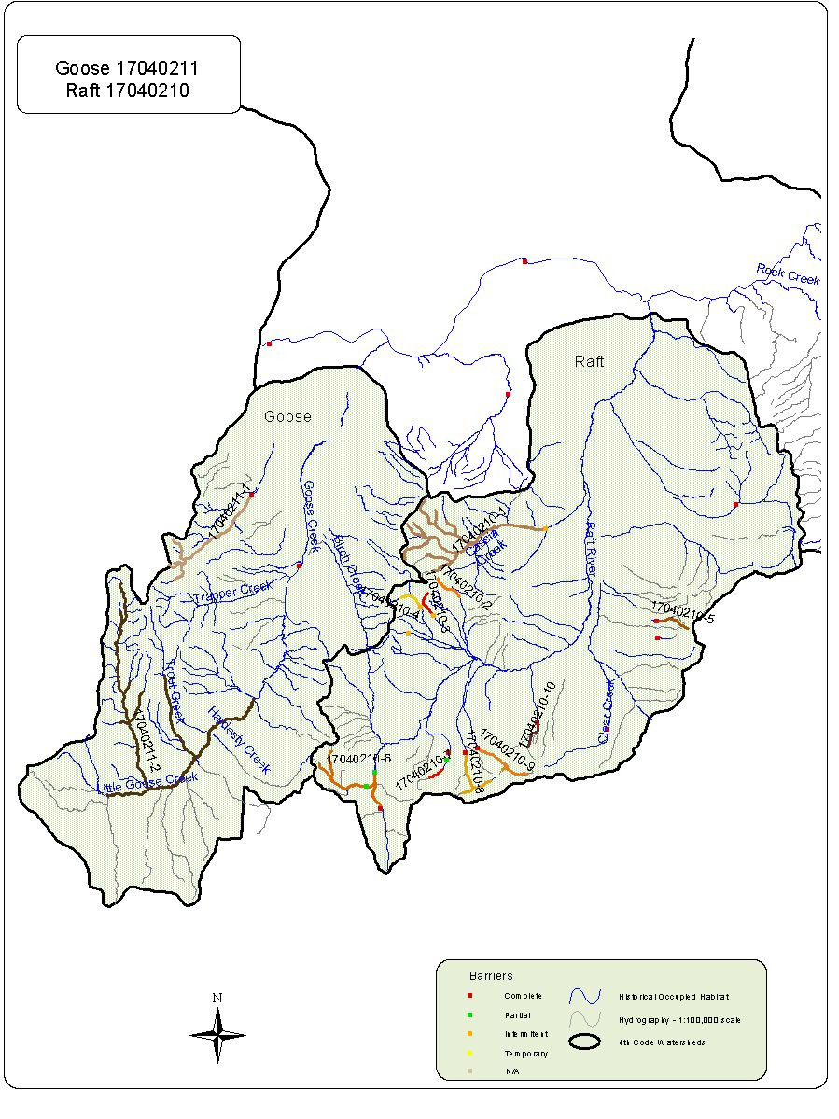
17040210 Raft River Conservation Populations with competitive Species.

Conservation Population Identification Number | Competitive Species Present | Total Miles of YCT | Total Miles with Competitive Species | Number of Stream Segments Occupied
17040210-1 | Yes | 43.2 | 43.2 | 10
17040210-10 | No | 3.0
17040210-2 | No | 3.1
17040210-3 | No | 2.9
17040210-4 | No | 2.7
17040210-5 | No | 3.5
17040210-6 | No | 15.2
17040210-7 | No | 1.7
17040210-8 | Yes | 7.5 | 7.5 | 3
17040210-9 | Yes | 7.0 | 7.0 | 2

17040210. Abundance by Conservation Population

Conservation Population Identification Number | Abundance |  |  |  | Total  Miles
Conservation Population Identification Number | Abundant  (Segments) | Common  (Segments) | Rare  (Segments) | Unknown  (Segments) | Total  Miles
17040210-1 | 8 | 1 |  | 1 | 43.2
17040210-10 |  | 2 |  |  | 3.0
17040210-2 | 1 |  |  |  | 3.1
17040210-3 | 1 |  |  |  | 2.9
17040210-4 | 1 |  |  |  | 2.7
17040210-5 |  | 2 |  |  | 3.5
17040210-6 | 2 |  | 1 |  | 15.2
17040210-7 |  |  | 1 |  | 1.7
17040210-8 |  | 1 | 1 | 1 | 7.5
17040210-9 | 1 | 1 |  |  | 7.0

Conservation  Population Identification Number | Population Type | Source | Genetic Makeup |  |  |  |  |  | Total Miles
Conservation  Population Identification Number | Population Type | Source | Genetically  Altered  (Segments) | Tested  75%-99%  YCT  (Segments) | Tested  >75%  YCT  (Segments) | Untested  Potentially  Unaltered  (Segments) | Untested  Suspected  Altered  (Segments) | Mixed Stock –pure & altered  (Segments) | Total Miles
17040210-1 | Meta-population | No |  |  |  |  | 10 |  | 43.2
17040210-10 | Isolet | No |  |  |  | 2 |  |  | 3.0
17040210-2 | Isolet | No |  |  |  | 1 |  |  | 3.1
17040210-3 | Isolet | No |  |  |  | 1 |  |  | 2.9
17040210-4 | Isolet | No |  |  |  | 1 |  |  | 2.7
17040210-5 | Isolet | No | 2 |  |  |  |  |  | 3.5
17040210-6 | Meta-population | No |  |  |  | 3 |  |  | 15.2
17040210-7 | Isolet | No |  |  |  | 1 |  |  | 1.7
17040210-8 | Meta-population | No |  |  |  | 3 |  |  | 7.5
17040210-9 | Isolet | No |  |  |  |  | 2 |  | 7.0
Watershed Name Raft Watershed Number 17040210

Conservation Population Identification Number | Genetic Risk Score | Population Risk Scores
Conservation Population Identification Number | Genetic Risk Score | Temporal  Factors  Score | PopulationSize  Score | Demographic  Factors  Score | Isolation  Factor  Score | Composite  Score
17040210-1 | 4 | 2 | 2 | 2 | 4 | 9
17040210-10 | 1 | 4 | 3 | 1 | 4 | 10
17040210-2 | 1 | 4 | 3 | 1 | 4 | 10
17040210-3 | 1 | 4 | 3 | 1 | 4 | 10
17040210-4 | 1 | 4 | 3 | 1 | 4 | 10
17040210-5 | 1 | 4 | 3 | 2 | 4 | 11.6
17040210-6 | 1 | 3 | 1 | 1 | 1 | 5.4
17040210-7 | 1 | 4 | 3 | 1 | 4 | 10
17040210-8 | 1 | 3 | 1 | 2 | 1 | 7
17040210-9 | 3 | 3 | 1 | 2 | 4 | 8.5
Watershed Raft Number 17040210

17040211 Goose Conservation Populations with competitive Species.

Conservation Population Identification Number | Competitive Species Present | Total Miles of YCT | Total Miles with Competitive Species | Number of Stream Segments Occupied
17040211-1 | No | 19.0
17040211-2 | Yes | 69.2 | 53.2 | 4

17040211. Abundance by Conservation Population

Conservation Population Identification Number | Abundance |  |  |  | Total  Miles
Conservation Population Identification Number | Abundant  (Segments) | Common  (Segments) | Rare  (Segments) | Unknown  (Segments) | Total  Miles
17040211-1 | 3 | 1 |  |  | 19.0
17040211-2 |  | 5 | 2 |  | 69.2

Conservation  Population Identification Number | Population Type | Source | Genetic Makeup |  |  |  |  |  | Total Miles
Conservation  Population Identification Number | Population Type | Source | Genetically  Altered  (Segments) | Tested  75%-99%  YCT  (Segments) | Tested  >75%  YCT  (Segments) | Untested  Potentially  Unaltered  (Segments) | Untested  Suspected  Altered  (Segments) | Mixed Stock –pure & altered  (Segments) | Total Miles
17040211-1 | Isolet | No |  |  |  |  | 4 |  | 19.0
17040211-2 | Meta-population | No | 2 |  |  | 5 |  |  | 69.2
Watershed Name Goose Watershed Number 17040211

Conservation Population Identification Number | Genetic Risk Score | Population Risk Scores
Conservation Population Identification Number | Genetic Risk Score | Temporal  Factors  Score | PopulationSize  Score | Demographic  Factors  Score | Isolation  Factor  Score | Composite  Score
17040211-1 | 1 | 2 | 2 | 2 | 4 | 9
17040211-2 | 2 | 2 | 2 | 3 | 2 | 9.6
Watershed Goose Number 17040211

Executive summary of YCT status assessment completed for Montana in 1999. Author: Bruce E. May.

