StreamNet

Report on the Status of Salmon and Steelhead in the Columbia River Basin - 1995

April, 1996

Bonneville Power Administration
Columbia River Inter-Tribal Fish Commission
Idaho Department of Fish and Game
National Marine Fisheries Service
Northwest Power Planning Council
Oregon Department of Fish and Wildlife
Pacific States Marine Fisheries Commission
Shoshone-Bannock Tribes
U.S. Fish and Wildlife Service
Washington Department of Fish and Wildlife

This report was funded by the Bonneville Power Administration (BPA), U.S. Department of Energy, as part of BPA's program to protect, mitigate, and enhance fish and wildlife affected by the development and operation of hydroelectric facilities on the Columbia River and its tributaries. The views in this report are the author’s and do not necessarily represent the views of BPA.

For additional copies of this report, write to:

Bonneville Power Administration
Public Information Center - CKPS-1
P.O. Box 3621
Portland, OR 97208

Please include title, author, and DOE/BP number from upper left corner of back cover in the request.
StreamNet
The Northwest Aquatic Resource Information Network

Report on the Status of Salmon and Steelhead in the Columbia River Basin - 1995

Prepared by:

Duane A. Anderson
Pacific States Marine Fisheries Commission

Ray Beamesderfer
Oregon Department of Fish and Wildlife

Bob Woodard
Washington Department of Fish and Wildlife

Mike Rowe
Shoshone-Bannock Tribes

Gary Christofferson
Pacific States Marine Fisheries Commission

Jerome Hansen
Idaho Department of Fish and Game

Prepared for:

Northwest Power Planning Council
851 S.W. Sixth Avenue, Suite 1100
Portland, OR 97204-1348

BPA Project Number 88-108-04
Contract Number 95BI65130

APRIL 1996
table of Contents

List of Figures
List of Tables
Abbreviations and Acronyms Used in this Report
Introduction
1. Abundance / Survival Information
A. Adults/Jacks
1. Total Columbia River Run
2. Total Regional Escapement
3. Upstream Survival Rates
4. Natural Spawning
5. Hatchery Rack
B. Juveniles
1. Abundance
2. Migration Timing
3. Travel Time
4. Fish Passage Efficiency
5. Juvenile Transportation Program
6. Survival
7. Mainstem Predator Control
C. Population Trend Summary
1. Natural
2. Hatchery
2. Ocean Distribution
3. Freshwater Distribution and Population Summary
4. Habitat
A. Columbia River Basin Dam Development
B. Mainstem
1. Hydropower Project Summary
2. Long Term Change In Hydrograph
3. Recent Flow And Spill Conditions
C. Tributary
1. Habitat Lost Due To Hydro Development
2. Habitat Condition
3. Habitat Limiting Factors
4. Habitat Changes
5. Diversions and Screens
D. Ocean Conditions
1. Upwelling Index
2. Southern Oscillation Index
3. Sea Surface Temperatures
5. Hatchery Production
A. Hatchery Distribution
B. Total Hatchery Releases
C. Hatchery Authorization and Funding
E. Freshwater Coded Wire Tag Recoveries
6. Harvest
A. Mainstem Columbia
B. Tributary
C. Ocean
D. Value
7. Mitigation Efforts
A. Bonneville Power Administration
B. U.S. Army Corps of Engineers
C. Mitchell Act
8. Bibliography Of Pertinent Research And Project Publications
9. Example Populations
Cowlitz Hatchery Coho
Cowlitz Fall Chinook
Lewis Fall Chinook
Lyons Ferry Fall Chinook
John Day Spring Chinook
Marsh Creek Spring Chinook
Wenatchee Sockeye
Literature Cited
Glossary
Appendix A. Data Dictionary

List of Figures

Figure 1. Minimum Numbers of Salmon and Steelhead Entering the Columbia River, 1938-1994, and Commercial Landings of Salmon and Steelhead from the Columbia River. (ODFW, WDFW 1995)
Figure 2. Estimate of total escapement (adults and jacks) to Columbia River Regions (PSMFC 1995 and ODFW, WDFW 1995).
Figure 3. Estimate of total escapement (adults and jacks) by species/run (PSMFC 1995 and ODFW, WDFW 1995).
Figure 4. Average number of spring chinook redds from index areas per stream in Snake River subbasins, 1957-1994 (PSMFC 1995)
Figure 5. Total hatchery rack returns above and below Bonneville Dam. Data from the 1960’s and 1970’s is incomplete for some hatcheries. Hatchery rack returns do not necessarily reflect total hatchery production or performance (PSMFC 1995).
Figure 6. Total hatchery rack returns by species and run. Some years may be incomplete (PSMFC 1995).
Figure 7. Passage indices of juveniles at selected dams, 1984-94.
Figure 8. Migration timing of juvenile salmon and steelhead (all species, hatchery, and natural pooled) at selected dams during 1994 (FPC 1995). Dots connected with lines indicate 10% and 90% passage dates by species for 1994. Open circles indicate average 10% and 90% dates by species averaged for 1991-93.
Figure 9. Water particle travel time and flow in the lower Snake River during the spring period (April 15-June 15) from 1929 to 1990 (Columbia Basin Indian Tribes and the State and Federal Fish and Wildlife Agencies 1993). Arrows indicate years of dam completion.
Figure 10. Fish passage efficiency based on 1994 conditions (FPC 1995). Values for spring chinook are averages for April 1 - June 20 in the Snake River and April 1 - June 30 in the lower Columbia River. Values for fall chinook are averages for June 21 - August 31 in the Snake and July 1 - August 31 in the lower Columbia.
Figure 11. Transport to control ratios for marked test groups and total number of juvenile fish transported from dams to lower Columbia River release sites, 1968-93, with species breakdown for 1993 (Hurson et al. 1995, Mundy et al. 1994). Transport to control ratios are averages for species and release dam by year for values summarized in Mundy et al. 1994. The dotted line indicates equal survival of transported and control groups.
Figure 12. Locations of squawfish sport reward fishery registration stations in 1995. 1 = Cathlamet Marina, 2 = Kalama Marina, 3 = Gleason Ramp, 4 = Washougal Ramp, 5 = The Fishery, 6 = Hamilton Island, 7 = Bingen Marina, 8 = The Dalles Ramp, 9 = Giles French Ramp, 10 = Umatilla Marina, 11 = Columbia Point Park, 12 = Vernita Bridge, 13 = Hood Park, 14 = Greenbelt Ramp.
Figure 13. Percentage of natural spawning index ratios (average of ending five years divided by average of beginning five years) falling in three categories by region (trend analysis from data in PSMFC 1995). Black bars indicate a decrease in the number of spawners.
Figure 14. Percentage of hatchery rack return index ratios (average of ending five years divided by average of beginning five years) falling in three categories by region (trend analysis from data in PSMFC 1995). Black bars indicate a decrease in the number of adults returning to the hatcheries.
Figure 15. Generalized ocean migration patterns for steelhead.
Figure 16. Generalized ocean migration patterns for chinook.
Figure 17. Generalized ocean migration patterns for coho.
Figure 18. Spring/Summer Chinook Distribution by USGS Cataloging Units for the Columbia Basin (PSMFC 1995, based on 1989 Subbasin Planning Presence / Absence Data).
Figure 19. Fall Chinook Distribution by USGS Cataloging Units for the Columbia Basin (PSMFC 1995, based on 1989 Subbasin Planning Presence / Absence Data).
Figure 20. Summer Steelhead Distribution by USGS Cataloging Units for the Columbia Basin (PSMFC 1995, based on 1989 Subbasin Planning Presence / Absence Data).
Figure 21. Coho Distribution by USGS Cataloging Units for the Columbia Basin (PSMFC 1995, based on 1989 Subbasin Planning Presence / Absence Data).
Figure 22. Winter Steelhead Distribution by USGS Cataloging Units for the Columbia Basin (PSMFC 1995, based on 1989 Subbasin Planning Presence / Absence Data).
Figure 23. Average daily flows in the Columbia River at The Dalles for three time periods; Annual (top), Spring (middle), and Summer (bottom) (PSMFC 1996).
Figure 24. Cumulative storage capacity in the Columbia River Basin in millions of acre feet (PSMFC 1996).
Figure 25. Daily average total flow (top) and spill (bottom) for the mainstem projects between the Columbia River mouth and Snake River spawning grounds (PSMFC 1996).
Figure 26. Average summer and spring spills expressed as percentage of total flow for the mainstem dams between the Columbia River mouth and Idaho spawning grounds.
Figure 27. Allocation of 18,700 miles of historically accessible anadromous habitat blocked by hydro development in the U.S. portion of the Columbia River Basin (PSMFC 1996).
Figure 28. Allocation of 16,800 miles currently in use by salmon and steelhead in the U.S. portion of the Columbia River Basin (PSMFC 1996).
Figure 29. Allocation of the 30,600 miles of currently accessible anadromous habitat in the U.S. portion of the Columbia River Basin (PSMFC 1996).
Figure 30. Percent of excellent, good, fair, and poor salmon habitat identified by Subbasin Planners by Columbia River Region (PSMFC 1995 from Subbasin Planning, 1989).
Figure 31. Percent of excellent, good, fair, and poor steelhead habitat identified by Subbasin Planners by Columbia River Region (PSMFC 1995 from Subbasin Planning, 1989).
Figure 32. Upwelling anomalies-difference between current year and 1948-1967 average for four coastal locations. Positive values represent stronger upwelling than normal, negative values represent weaker (PSMFC 1996).
Figure 33. 5 month running means of the Southern Oscillation Index. Negative values less than -1 represent the onset on El Niño events (Sevilleta LTER 1995).
Figure 34. Average May-August sea surface temperatures at three near shore ocean sites.
Figure 35. Total hatchery releases (all species, in millions) by Columbia River Region since 1980 (PSMFC 1995, based on data provided by the Regional Mark Processing Center (RMPC)).
Figure 36. Total hatchery releases (millions) by species and run in the Columbia River Basin since 1980 (PSMFC 1995).
Figure 37. Hatchery spring/summer chinook releases by USGS Cataloging Units for the Columbia Basin (PSMFC 1995, based on data from the RMPC).
Figure 38. Hatchery fall chinook releases by USGS Cataloging Units for the Columbia Basin (PSMFC 1995, based on data from the RMPC).
Figure 39. Hatchery summer steelhead releases by USGS Cataloging Units for the Columbia Basin (PSMFC 1995, based on data from the RMPC).
Figure 40. Hatchery winter steelhead releases by USGS Cataloging Units for the Columbia Basin (PSMFC 1995, based on data from the RMPC).
Figure 41. Hatchery coho releases by USGS Cataloging Units for the Columbia Basin (PSMFC 1995, based on data from the RMPC).
Figure 42. Hatchery sockeye releases by USGS Cataloging Units for the Columbia Basin (PSMFC 1995, based on data from the RMPC).
Figure 43. Allocation of total hatchery releases in the Columbia River Basin since 1980 by primary hatchery authorization and funding source (PSMFC 1996).
Figure 44. Total mainstem harvest by type (ODFW, WDFW, 1995).
Figure 45. Total Columbia River harvest (including estuary) by species (ODFW, WDFW, 1995).
Figure 46. Average proportion of harvest (all species) for four time periods and three fisheries (ODFW, WDFW, 1995). Total harvest values shown are in numbers of fish.
Figure 47. Tributary sport harvest of salmon and steelhead by Columbia River Region since 1975 (PSMFC, 1996).
Figure 48. Total estimated sport harvest in Columba River tributaries (PSMFC 1996).
Figure 49. PFMC Management Areas.
Figure 50. Annual landings of salmon and fishing effort in U. S. coastal waters north of Cape Falcon, Oregon (PMFC 1995).
Figure 51. Total BPA obligations by region from 1981-1993 (PSMFC 1996, data provided by BPA)
Figure 52. Total project dollars spent since 1990 by Bonneville Power Administration (PSMFC 1996, data provided by BPA).
Figure 53. U.S. Army Corps of Engineers Lower Columbia / Snake Rivers Existing Fish Mitigation and Capital Costs Through Fiscal Year 1987.
Figure 54. North Pacific Division, Corps of Engineers Fish Passage Development and Evaluation Program (FPDEP) Fisheries Research Expenditures.
Figure 55. Lower Snake River Compensation Program (LSRCP) funding levels by major activity (Crateau 1996).
Figure 56. Funds expended by the Columbia River Fisheries Development Program from 1949 through 1988 (Delarm 1990).
Figure 57. Locations of sample populations included in this report.

List of Tables

Table 1. Estimates of upstream adult survival (conversion) rates for Spring Chinook for the Lower Columbia and Snake River Reaches.
Table 2. Number of juvenile salmon and steelhead captured in river traps or sampled in dam collection facilities by the 1994 smolt monitoring program (FPC 1995). Percent of passage index sampled is in parentheses.
Table 3. Wild percentage of juvenile salmon and steelhead captured in river traps or sampled in dam collection facilities by the 1994 smolt monitoring program (FPC 1995).
Table 4. Approximate average travel times in 1994 for juvenile salmon and steelhead based on PIT tag observations (pooled estimates for hatchery and wild fish derived from FPC 1995).
Table 5. Number of salmonids captured by purse seine in Lower Granite Reservoir or handled at Lower Granite, Little Goose, or Lower Monumental dams for NMFS/UW survival studies. Percent wild is in parentheses where known.
Table 6. Average survival probabilities estimated for individual PIT-tagged fish in the Snake River. Number of release groups is in parentheses. Refer to Iwamoto et al. (1994) and Muir et al. (1995) for release dates, number marked, etc.
Table 7. Number and exploitation rate (percentage of population of northern squawfish 250 mm and larger) removed by the squawfish management program. Index values describe relative magnitude of predation in each area relative to John Day Reservoir (Ward et al. 1994).
Table 8. Stock distribution data by Columbia River region in miles (PSMFC 1995, from Subbasin Planning, 1989, based on mileages from 1:250,000 scale). Mileages do not include mainstem (Columbia or Snake river) use except for fall chinook in the Snake River.
Table 9. Number of natural and hatchery/mixed stocks identified in the Stock Summary Reports.
Table 10. Number of runs and life history information by species, run, and Columbia River Region. Format for dates is mm/dd/Yr_{x}, where Yr_{x} represents the year of the life history relative to adult immigration (year 1).
Table 11. Number of hydropower and multipurpose dams in the Columbia Basin by region (NID, 1994 and BC Hydro, 1996).
Table 12. Project summary data for passable mainstem dams on the Columbia and Snake rivers. (USDOE et. al 1994).
Table 13. Spring period average total flows (kcfs) and percent of that flow which was spilled by project (PSMFC 1996).
Table 14. Summer period average total flows (kcfs) and percent of that flow which was spilled by project (PSMFC 1996).
Table 15. Major habitat constraints by stock and region (Subbasin Planning, 1989). Values are expressed as percentages (total miles identified with constraints divided by total miles of spawning and/or rearing habitat).
Table 16. Historical habitat changes in pool frequency and current abundance of large woody debris for select eastern Oregon and Washington subbasins from 1934-92.
Table 17. Gravity diversion screens constructed or replaced in Columbia River Basin tributaries, 1985-1994 (Hawkes, Columbia Basin Fish and Wildlife Authority, personal communication). Totals include sites eliminated by consolidation or conversion to ground water. Totals do not include intake pump screens or fishways constructed or replaced by this project.
Table 18. Hatcheries which have released fish into the Columbia River Basin since 1980, by management agency (PSMFC, 1996).
Table 19. Estimated number of fish with given tag code represented by CWT recoveries within the Columbia Basin for chinook, since 1973. Numbers in bold boxes represent recoveries of tagged fish in the subbasin of their release. Other numbers represent tagged fish recovered in a subbasin other than the one in which they were released (RMIS 1995).
Table 20. Estimated number of fish with given tag code represented by CWT recoveries within the Columbia Basin for steelhead since 1973. Numbers in bold boxes represent recoveries of tagged fish in the subbasin of their release. Other numbers represent tagged fish recovered in a subbasin other than the one in which they were released (RMIS 1995).
Table 21. Estimated number of fish with given tag code represented by CWT recoveries within the Columbia Basin for coho since 1973. Numbers in bold boxes represent recoveries of tagged fish in the subbasin of their release. Other numbers represent tagged fish recovered in a subbasin other than the one in which they were released (RMIS 1995).
Table 22. Distribution of catch in ocean fisheries (% of total) of Columbia Basin salmon and steelhead. Chinook salmon are denoted by age of juvenile migration (age 0 for fall chinook and age 1 for spring and summer chinook).
Table 23. Pacific Salmon Commission chinook salmon indicator stocks from the Columbia Basin and brood year exploitation rates (%) in combined U.S. and Canada ocean fisheries (PSC 1994b). Rates less than 5% are inferred from low tag recovery rates (Bohn, Oregon Department of Fish and Wildlife, personal communication).
Table 24. Exvessel values (nominal dollars in thousands) of salmon (coho and chinook) landed by non-Indian ocean troll (PFMC 1995) and salmon (chinook, coho, sockeye, chum) and steelhead landed by inriver fisheries (ODFW and WDFW 1995).
Table 25. Estimates of coastal community and state personal income impacts (thousands in 1994 dollars) of the troll and recreational ocean salmon fisheries (PFMC 1995).

Abbreviations and Acronyms Used in this Report

# - number
Abund - abundance
Admin - administration
Apr - April
Aug - August
Avg - average
BC - British Columbia
Bel - below
BON - Bonneville Dam
BPA - Bonneville Power Administration
C - Centigrade
C&S - ceremonial and subsistence
CDFO - Canadian Department of Fisheries and Oceans
cfs - cubic feet per second
Ch - chinook salmon
Chf - chief
CHJ - Chief Joseph Dam
CIS - Coordinated Information System
Co - coho salmon
Col - Columbia
Collect - collected
Comm - commercial
Comp - compensation
Coord - coordination
Cr - creek
CRFDP - Columbia River Fisheries Development Program
CWT - coded wire tag
dd - day
Dist - distributed
DS - Distributed System
ENSO - El Niño/Southern Oscillation
Est - estimate
ETSD - Environmental Technical Services Division
FPC - Fish Passage Center
FPDEP - Fish Passage Development and Evaluation Program
Frm - from
FSOC - Fish Screening Oversight Committee
ft - foot
FW - freshwater
Gr - Grande
IDFG - Idaho Department of Fish and Game
IHN - infectious hematopoietic necrosis
IHR - Ice Harbor Dam
Is - island
JDA - John Day Dam
Jun - June
Juve - juvenile
kcfs - 1,000 cubic feet per second
km - kilometer
Koot - Kootenai
LGS - Little Goose Dam
LGR - Lower Granite Dam
Li - little
LMN - Lower Monumental Dam
Lo - lower
LSRCP - Lower Snake River Compensation Program
m - meter
Mar - March
MCN - McNary Dam
MFSR - Middle Fork Salmon River
mi - mile
Misc - miscellaneous
mm - month
n - number
N - north
NA - not available
NC - north central
NID - National Inventory of Dams
NMFS - National Marine Fisheries Service
NWHS - Northwest Hydropower System
NWPPC - Northwest Power Planning Council
O&M - operation and maintenance
ODFW - Oregon Department of Fish and Wildlife
OEA - OEA Research
Ore - Oreille
OWRD - Oregon Water Resources Department
PC - personal computer
Pend Ore - Pend Oreille
PFMC - Pacific Fishery Management Council
PIT - Passive Integrated Transponder
Pop - population
PRD - Priest Rapids Dam
Prelim - preliminary
Proj - project
PSC - Pacific Salmon Commission
PSMFC - Pacific States Marine Fisheries Commission
R - river
Rap - rapids
Res - reservoir or resident
RIS - Rock Island Dam
RM - river mile
RMIS - Regional Mark Information System
RMPC - Regional Mark Processing Center
RRH - Rocky Reach Dam
SE - southeast
sec - second
Sep - September
SMP - Smolt Monitoring Program
So - sockeye salmon
SOI - Southern Oscillation Index
Spawng - spawning
Spok - Spokane
Spr - spring
St - steelhead
Steelhd - steelhead
StlHead - steelhead
TAC - U.S. v. Oregon Technical Advisory Committee
TDA - The Dalles Dam
Temp - temperature
Trans - transported
URB - upriver bright
USDOE - U.S. Department of Energy
USGS - U.S. Geological Survey
UW - University of Washington
Vanc - Vancouver
W - west
Wash - Washington

WDFW - Washington Department of Fish and Wildlife
WEL - Wells Dam
Yr - year

Introduction
Information on fish populations, fisheries, and fish habitat is crucial to the success of ongoing programs to protect, recover, enhance, and manage fish resources in the Columbia River Basin. However, pertinent data is often difficult to locate because it is scattered among many agencies and is often unpublished. The goal of this annual report is to bring many diverse data types and sources into a single comprehensive report on the status of anadromous fish runs in the Columbia River Basin and the environmental conditions that may affect that status. Brief summaries are provided to identify the type and scope of available information. This synopsis is intended to complement other more detailed reports to which readers are referred for comprehensive treatment of specific subjects.

This first report focuses mainly on anadromous salmon and steelhead (primarily through 1994) but we intend to expand the scope of future issues to include resident species. This is the first of what we intend to be an annual report. We welcome constructive suggestions for improvement.

In this report, we identify available information but make no attempt to evaluate its implications. Inclusion does not represent endorsement of methods or results. When applying the information, it is incumbent on the reader to understand the limitations of the data imposed by the method of collection and related assumptions. We do attempt to flag controversial issues. Most of the summary data in this report was generated using the StreamNet (formerly Coordinated Information System and Northwest Environmental Data Base) database system. The StreamNet Distributed System (DS) is a PC based database application containing fully referenced data and a user friendly interface to query, report, or export the data. Contents of the DS are shown in Appendix A (to receive a copy, contact Duane Anderson at 503-650-5400). As with any summary information derived from a database, this report represents conditions to the best of our knowledge. No warranty for the correctness, accuracy, or usefulness of this data is expressed or implied. If errors or inaccuracies are discovered please contact any of the author’s of the report. Data in the report that came from sources other than the StreamNet database are cited in the bibliography.

This report is a product of the StreamNet project which is funded by the Bonneville Power Administration (BPA), U.S. Department of Energy, as part of BPA's program to protect, mitigate, and enhance fish and wildlife affected by the development and operation of hydroelectric facilities on the Columbia River and its tributaries. The project is called for in the Fish and Wildlife Program of the Northwest Power Planning Council. The project’s objective is to promote exchange and dissemination of information in a standardized electronic format throughout the basin. This project is administered by the Pacific States Marine Fisheries Commission with active participation by tribal, state, and federal fish and wildlife agencies.

To facilitate the presentation of large amounts of data in this report, the Columbia River Basin has been divided into four regions. Included in each region are both the mainstem Columbia and/or Snake rivers and their adjoining tributary systems. The regions are defined as follows: Below Bonneville - the Columbia River and its tributaries below Bonneville Dam; Bonneville to Priest Rapids - the Columbia River and its tributaries between Bonneville Dam and Priest Rapids Dam; Snake - the Snake River and its tributaries up to Hells Canyon Dam; and Priest Rapids to Chief Joseph - the Columbia River and its tributaries between Priest Rapids Dam and Chief Joseph Dam.

1. Abundance / Survival Information

A. Adults/Jacks

1. Total Columbia River Run
Since 1938, the minimum number of salmon and steelhead, including jacks, entering the Columbia has ranged from a high of 3.2 million fish in 1986 to a new low of 856,500 fish in 1994 (Figure 1). 1994 Columbia River commercial landings were the second lowest in history (Figure 1).
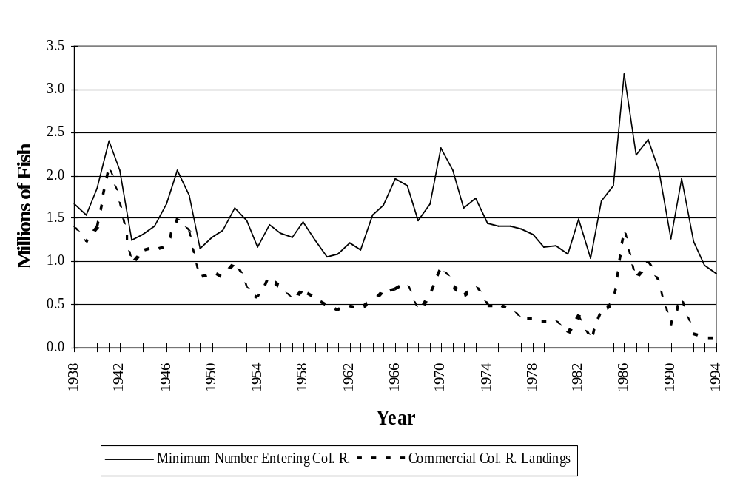
Figure 1. Minimum Numbers of Salmon and Steelhead Entering the Columbia River, 1938-1994, and Commercial Landings of Salmon and Steelhead from the Columbia River (ODFW, WDFW 1995).

2. Total Regional Escapement
Following a significant increase in the early 1980’s, total escapement to the various Columbia River regions has been in decline since 1986 (Figure 2). Total escapement to Columbia River Basin was just over 700,000 adults and jacks in 1994. Adult and jack escapement to regions above Bonneville Dam comprised only about 441,000 fish of that total. Total escapement of spring chinook was the lowest in recorded history (Figure 3).
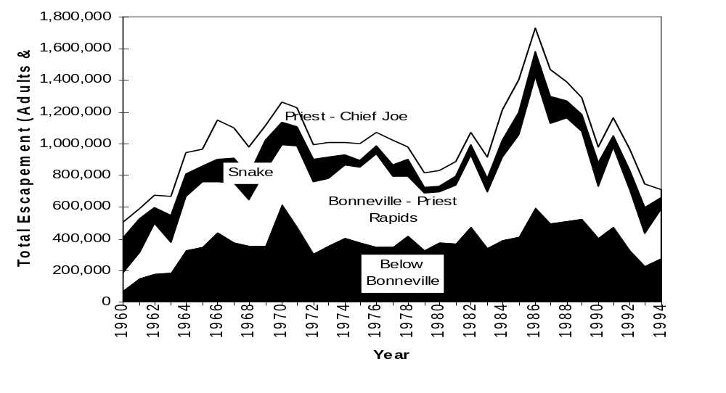
Figure 3. Estimate of total escapement (adults and jacks) to Columbia River Regions (PSMFC 1995 and ODFW, WDFW 1995).
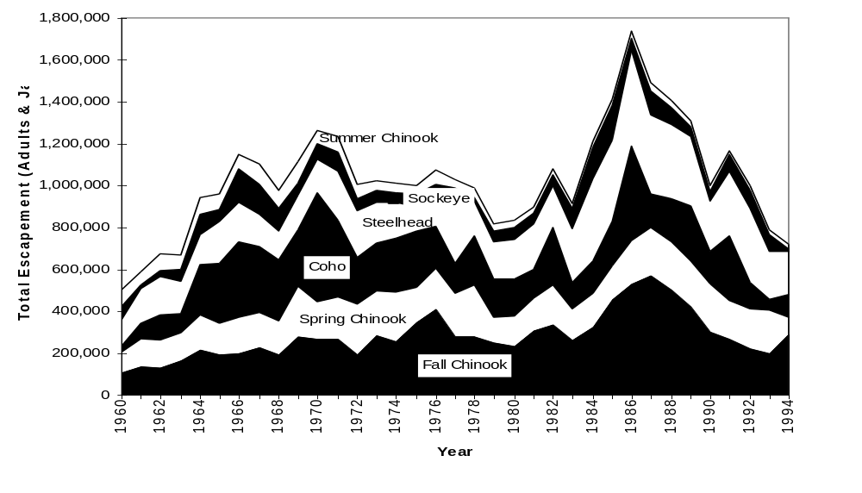
Figure 2. Estimate of total escapement (adults and jacks) by species/run (PSMFC 1995 and ODFW, WDFW 1995).

3. Upstream Survival Rates

Adult upstream survival rates have been estimated for various stretches of the system by members of the U.S. vs. Oregon Technical Advisory Committee (Table 1, personal communication, Ray Beamesderfer, report in progress). Using dam counts, harvest estimates, and estimates of numbers of fish returning to tributaries between dams, it is possible to estimate adult survival between dams. These survival rates are also known as conversion rates and they vary substantially from year to year and have a significant impact on adult escapement. For Snake River spring chinook stocks, the adult conversion rate for the river section from Bonneville Dam to Lower Granite Dam has averaged only about 60% since 1979.

Table 1. Estimates of upstream adult survival (conversion) rates for Spring Chinook for the Lower Columbia and Snake River Reaches.

Year | BON-MCN | MCN Pool | IHR-  LGR | Total BON-LGR
79 | 0.51 | 0.86 | 0.83 | 0.37
80 | 0.42 | 1.01 | 0.69 | 0.29
81 | 0.61 | 1.13 | 0.88 | 0.61
82 | 0.49 | 1.00 | 0.88 | 0.43
83 | 0.75 | 0.84 | 0.81 | 0.50
84 | 0.66 | 1.01 | 0.83 | 0.55
85 | 0.85 | 1.09 | 0.82 | 0.76
86 | 0.81 | 0.97 | 0.84 | 0.66
87 | 0.85 | 0.93 | 0.94 | 0.74
88 | 0.79 | 1.04 | 0.89 | 0.73
89 | 0.63 | 1.00 | 0.82 | 0.51
90 | 0.79 | 0.89 | 0.88 | 0.62
91 | 0.66 | 1.05 | 0.69 | 0.48
92 | 0.85 | 1.03 | 0.87 | 0.76
93 | 0.81 | 1.13 | 0.87 | 0.80
94 | 0.77 | 1.04 | 0.91 | 0.73
Averages
1979-94 | 0.70 | 1.00 | 0.84 | 0.60
1990-94 | 0.77 | 1.06 | 0.83 | 0.69

4. Natural Spawning

Comprehensive estimates of the total number of natural spawners are not available in the Columbia River Basin at this time. The reasons for this are both institutional (different management agencies have differing monitoring and estimation techniques), and geographic (spawning in the Columbia River Basin occurring in thousands of stream miles for long time periods making it unfeasible to count all of the spawners in all of the streams). Data for many individual populations are available, however, and are shown in the example population section of this report.

While estimates of total spawners are not consistent between management agencies or stocks of fish, these estimates hold the best promise for monitoring overall natural spawning trends. Idaho Department of Fish and Game and Oregon Department of Fish and Wildlife, for example, have been counting spring chinook redds in Snake River drainage subbasins since the late 1950’s (Figure 4). In 1994, index areas in 44 streams were surveyed averaging only 3 redds per stream, the lowest level since surveys began.
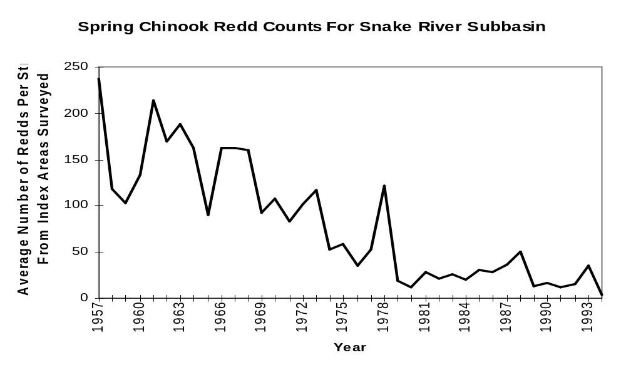
Figure 4. Average number of spring chinook redds from index areas per stream in Snake River subbasins, 1957-1994 (PSMFC 1995)

As the StreamNet data compilation process becomes more sophisticated, it may prove advisable to establish key indicator streams throughout the Basin that would be surveyed in a pre-defined, consistent manner in order to provide more accurate estimates of spawning populations, life stage survival, and production basin-wide.

5. Hatchery Rack
The majority of hatchery rack returns occur in the region below Bonneville Dam (Figure 5). This is predictable given that the majority of the Basin’s hatcheries are in this region, as are the majority of hatchery releases.
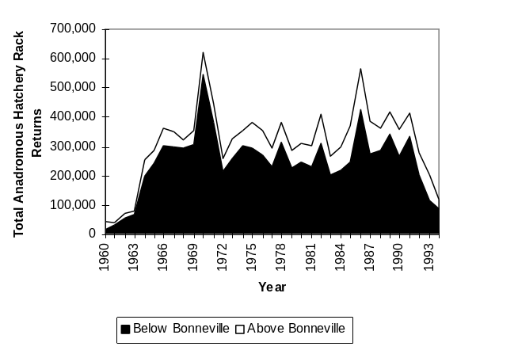
Figure 5. Total hatchery rack returns above and below Bonneville Dam. Data from the 1960’s and 1970’s is incomplete for some hatcheries. Hatchery rack returns do not necessarily reflect total hatchery production or performance (PSMFC 1995).

Hatchery returns by species and run are shown in Figure 6. Coho comprise the majority of returns in most years but have declined substantially in the last five years. Fall chinook make up the next most abundant returns followed by spring chinook and summer steelhead.
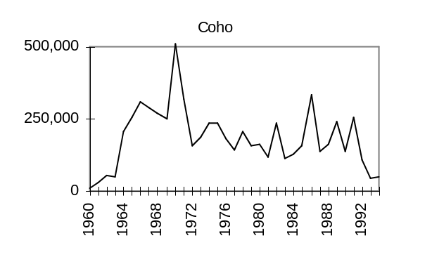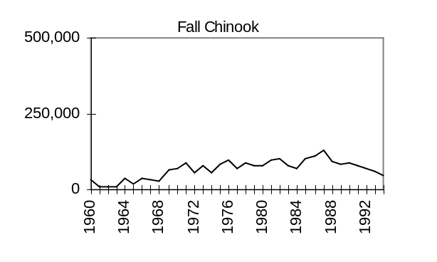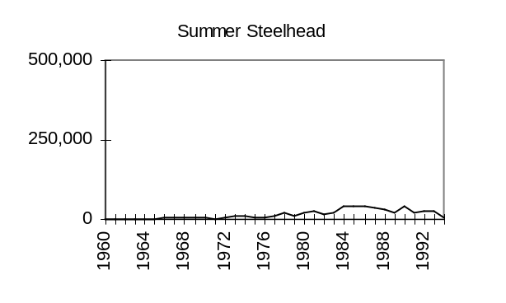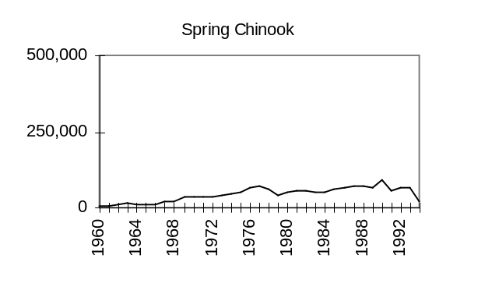
Figure 6. Total hatchery rack returns by species and run. Some years may be incomplete (PSMFC 1995).

B. Juveniles

1. Abundance
Detailed information on migrant abundance, condition, and behavior is provided by the Smolt Monitoring Program (SMP) whose primary objective is to provide up-to-date information for management of a water budget and spill agreement. The SMP is administered by the Fish Passage Center and conducted by federal agencies, state agencies, and Indian tribes (FPC 1995). Chinook salmon and hatchery-reared juveniles comprised the majority of the almost 1.5 million migrants sampled at various sites in 1994 (Tables 2 and 3).
Table 2. Number of juvenile salmon and steelhead captured in river traps or sampled in dam collection facilities by the 1994 smolt monitoring program (FPC 1995). Percent of passage index sampled is in parentheses.
Location | Chinook 1 | Chinook 0 | Sockeye | Coho | Steelhead | Total
Salmon R. trap | 43,672 | 0 | 17 | 0 | 7,947 | 51,636
Clearwater R. trap | 34,136 | 31 | 0 | 0 | 6,414 | 40,581
Snake R. trap | 23,819 | 58 | 0 | 0 | 35,101 | 58,978
Imnaha R. trap | 53,582 | 0 | 0 | 0 | 36,826 | 90,408
Gr. Ronde R. trap | 3,270 | 208 | 0 | 0 | 6,995 | 10,473
LGR Dam | 37,286 (2) | 2,468 (36) | 1,446 (5) | 0 | 98,936 (2) | 140,136 (2)
LGS Dam | 49,350 (5) | 1,782 (37) | 991 (5) | 0 | 50,564 (4) | 102,687 (5)
LMN Dam | 109,774 (10) | 2,250 (33) | 637 (14) | 0 | 68,118 (11) | 180,779 (10)
RIS Dam | 8,471 (69) | 10,777 (75) | 8,676 (66) | 0 | 9,846 (64) | 37,770 (68)
MCN Dam | 64,746 (2) | 267,524 (5) | 14,232 (2) | 5,719 (2) | 18,109 (3) | 370,330 (4)
JDA Dam | 34,071 (8) | 75,164 (6) | 7,260 (8) | 11,385 (8) | 22,058 (8) | 149,938 (7)
BON Dam | 34,362 (4) | 125,954 (4) | 2,954 (3) | 22,378 (4) | 7,711 (4) | 193,359 (4)
1994 total | 496,539 | 486,216 | 36,213 | 39,482 | 368,625 | 1,427,056

A passage index of juvenile salmonid abundance is estimated based on number collected in juvenile diversion systems at dams with a correction for the proportion of flow which is spilled rather than passed through the powerhouse. (This index thus represents an underestimate of total juvenile abundance because it does not account for fish that pass through the turbines.) Annual passage indices varied substantially among years, species, and dams (Figure 7) depending on hatchery releases, natural production, number transported, and survival rates of migrants.
Table 3. Percentage of wild juvenile salmon and steelhead captured in river traps or sampled in dam collection facilities by the 1994 smolt monitoring program (FPC 1995).
Location | Age 1  chinook | Age 0  chinook | Sock-eye | Steel-head | Total
Salmon R. trap | 11 |  |  | 7 | 10
Clearwater R. trap | 4 | 100 | 0 | 28 | 8
Snake R. trap | 10 | 100 | 0 | 10 | 8
Imnaha R. trap | 12 |  | 0 | 13 | 13
Gr. Ronde R. trap | 28 | 100 | 0 | 19 | 21
LGR Dam | 29 | 100 | 100 | 10 | 18
LGS Dam | 21 | 100 | 100 | 18 | 21
LMN Dam | 12 | 100 | 100 | 13 | 14
RIS Dam | --ª | --ª | 96 | 33 | --ª
MCN Dam | --ª | --ª | 94 | 17 | --ª
JDA Dam | --ª | --ª | 97 | 34 | --ª
BON Dam | --ª | 95 | 96 | 48 | --ª
ªAll hatchery fish could not be distinguished because of unmarked releases in the mid-Columbia.
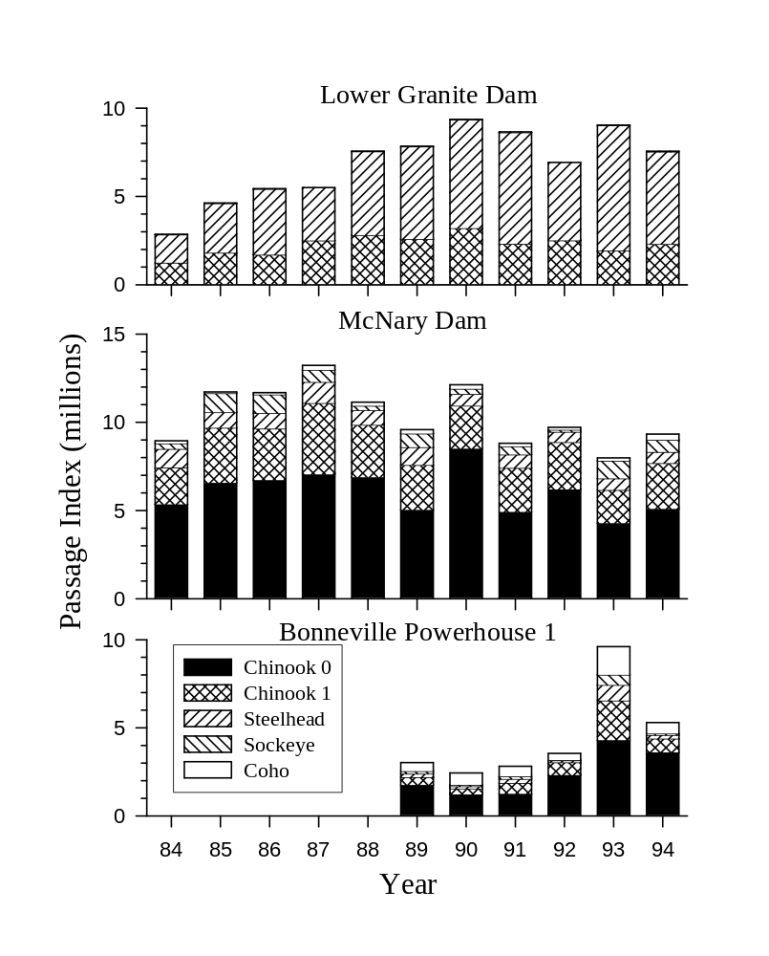
Figure 7. Passage indices of juveniles at selected dams, 1984-94.

2. Migration Timing
Peak migration periods are May through June for steelhead, sockeye, coho, and age 1 chinook juveniles and June through July for age 0 chinook juveniles. Migration timing at most sites was roughly comparable between 1994 with the average for the previous three years (Figure 8).
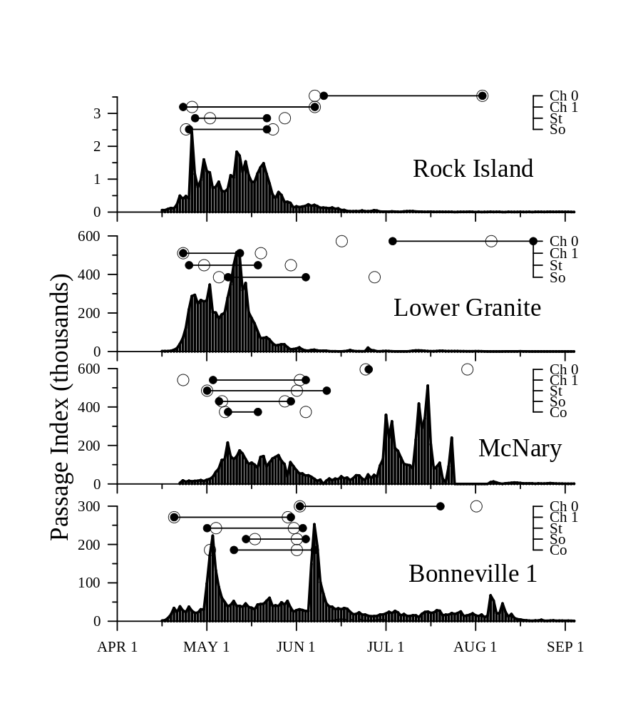
Figure 8. Migration timing of juvenile salmon and steelhead (all species, hatchery, and natural pooled) at selected dams during 1994 (FPC 1995). Dots connected with lines indicate 10% and 90% passage dates by species for 1994. Open circles indicate average 10% and 90% dates by species averaged for 1991-93.
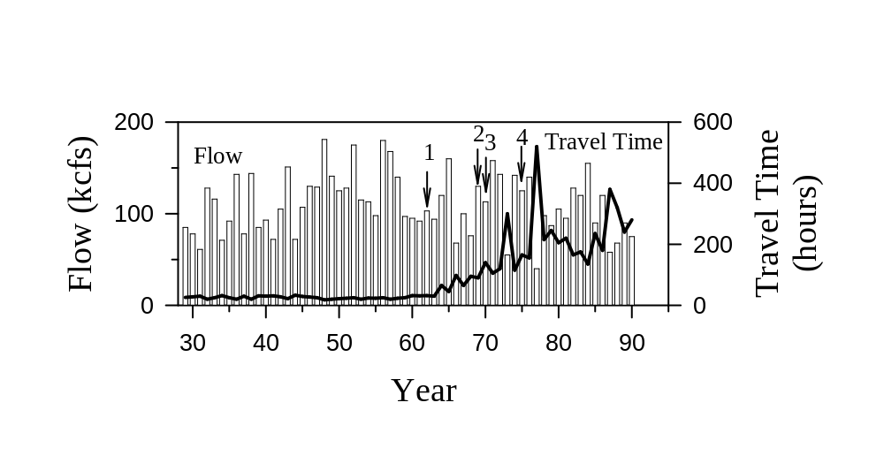
Figure 9. Water particle travel time and flow in the lower Snake River during the spring period (April 15-June 15) from 1929 to 1990 (Columbia Basin Indian Tribes and the State and Federal Fish and Wildlife Agencies 1993). Arrows indicate years of dam completion.

3. Travel Time
Migration speed is often considered an index of survival rate with shorter travel times corresponding to higher survival rates although the strength of this relationship is a question of considerable debate. Smolt travel time is closely correlated with water particle travel time. Water particle travel time in the Columbia and Snake river mainstems increased with dam construction which has increased the cross-sectional area of the river and decreased flow. Average water particle travel time through the Snake River has increased ten-fold since 1962 while average discharge has been reduced by less than half (Figure 9). Travel times for summer migrants such as subyearling chinook are typically longer than those of spring migrants including yearling chinook and steelhead (Table 4). Travel times also vary between hatchery and wild fish and seasonally in relation to changes in flow and degree of smoltification (FPC 1995).

Table 4. Approximate average travel times (days) in 1994 for juvenile salmon and steelhead based on PIT tag observations (pooled estimates for hatchery and wild fish derived from FPC 1995).
From | To | Miles | Dams | Chinook 0 | Chinook 1 | Sockeye | Steelhead
Whitebird | Lo. Granite | 134 | 1 |  | 12.3 |  | 6.9
Lewiston | Lo. Granite | 32 | 1 |  | 6.9 |  | 3.7
L. Granite | McNary | 140 | 4 |  | 13.5 |  | 11.6
Rock Island | McNary | 161 | 4 | 24.5 | 13.9 | 10.9 | 10.4

4. Fish Passage Efficiency
Fish passage efficiency or FPE refers to the proportion of juvenile migrants which pass a dam by means other than turbines. Passage mortality is generally thought to be reduced by increasing passage efficiency to avoid turbines which impose an approximate 10-15% mortality rate per dam. Passage efficiency is improved by increasing the proportion of river flow which is passed over spillways and by increasing the proportion of fish which are diverted from turbines by bypass systems such as submersible traveling screens. Fish guidance efficiency (FGE) refers to the proportion of migrants which pass via the powerhouse but are diverted from turbines by the bypass systems. Passage efficiency and guidance efficiency are affected by stage of smoltification which varies seasonally. Benefits of improving FPE with high spill rates are controversial because of the resulting gas supersaturation which can also be lethal to fish. Passage efficiencies in 1994 generally fell below the 70 or 80% levels typically recommended by state, tribal, and federal fishery management agencies (Figure 10).
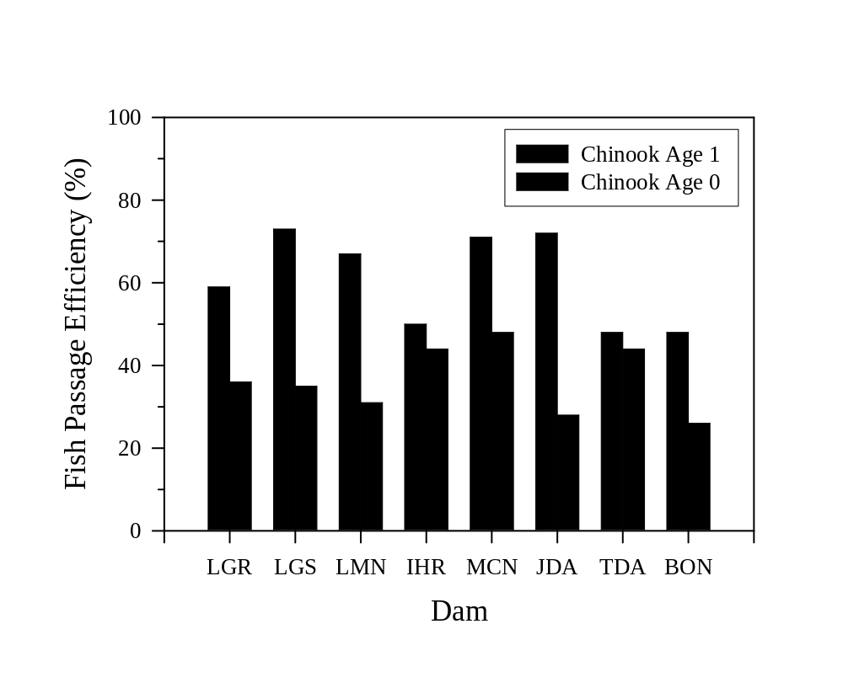
Figure 10. Fish passage efficiency based on 1994 conditions (FPC 1995). Values for spring chinook are averages for April 1 - June 20 in the Snake River and April 1 - June 30 in the lower Columbia River. Values for fall chinook are averages for June 21 - August 31 in the Snake and July 1 - August 31 in the lower Columbia.

5. Juvenile Transportation Program
In an attempt to avoid passage mortality through the mainstem Columbia and Snake rivers, over 15 million juvenile salmon and steelhead were collected in 1993 (Figure 11) at Lower Granite, Little Goose, Lower Monumental, and McNary dams and transported by barge or truck to release sites downstream from Bonneville Dam (Hurson et al. 1995). Fish are collected out of turbine intake bypass systems where they are diverted with screens. Transportation began on an experimental basis in 1968 and has been conducted by the U. S. Army Corps of Engineers since 1981 (BPA et al. 1994, Harmon et al. 1995). Comparisons of the relative number of transported and non-transported marked fish observed in fisheries, hatcheries, and other sample sites have been used as an index of transportation benefits (Harmon et al. 1995) but interpretation of this information is extremely controversial (Mundy et al. 1994).

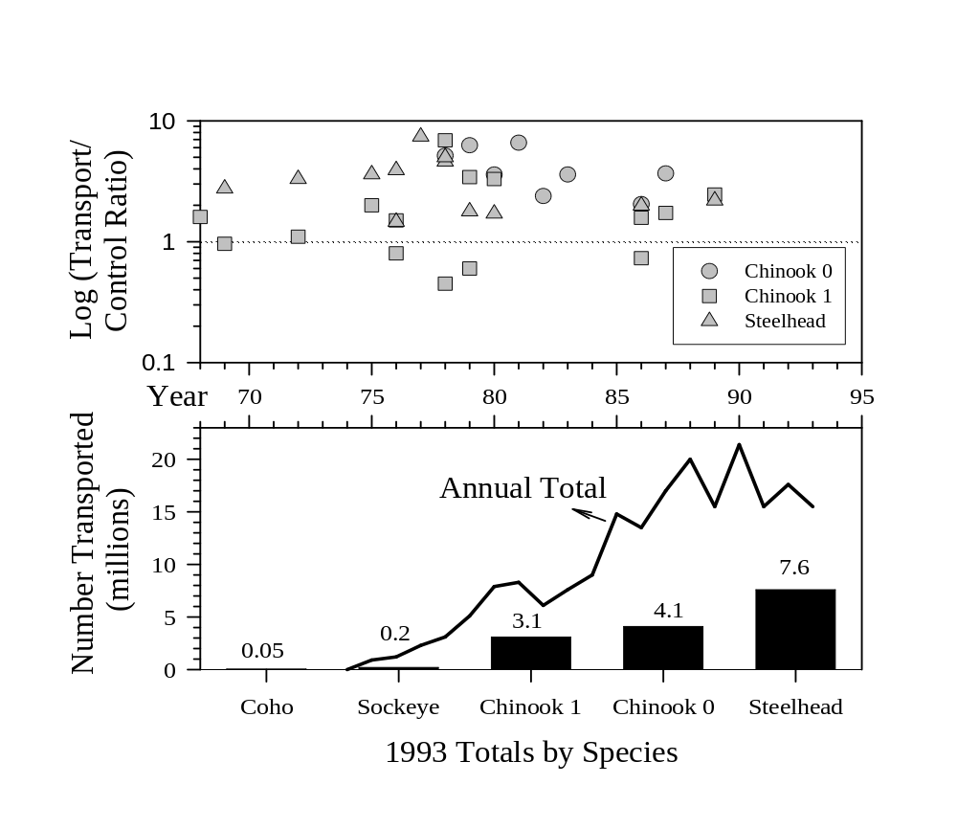
Figure 11. Transport to control ratios for marked test groups and total number of juvenile fish transported from dams to lower Columbia River release sites, 1968-93, with species breakdown for 1993 (Hurson et al. 1995, Mundy et al. 1994). Transport to control ratios are averages for species and release dam by year for values summarized in Mundy et al. 1994. The dotted line indicates equal survival of transported and control groups.

6. Survival

During 1993 and 1994, the National Marine Fisheries Service (NMFS) and the University of Washington (UW) tested methods for estimating survival probabilities of individual yearling chinook salmon and steelhead in the Snake River using passive integrated transponder (PIT) tags (Table 5, Iwamoto et al. 1994; Muir et al. 1995). These probabilities (Table 6) are related but not equivalent to survival rates (K. Steinhorst, University of Idaho, unpublished). Survival estimates remain controversial with unresolved questions related to the validity of statistical assumptions; inferences to other river reaches, river conditions, and portions of the outmigration including saltwater entry; and impacts of associated fish capture and handling.

Table 5. Number of salmonids captured by purse seine in Lower Granite Reservoir or handled at Lower Granite, Little Goose, or Lower Monumental dams for NMFS/UW survival studies. Percent wild is in parentheses where known.

 | 1993 | 1994
Juveniles | 96,486 (15) | 272,375 (13)
Sockeye | 2 | 70
Chinook | 49,042 (19) | 142,620 (12)
Steelhead | 47,442 (11) | 129,685 (15)
Adults
Steelhead | 116 | 50

Table 6. Average survival probabilities estimated for individual PIT-tagged fish in the Snake River. Number of release groups is in parentheses. Refer to Iwamoto et al. (1994) and Muir et al. (1995) for release dates, number marked, etc.
From | To | Year | Hatchery  chinook | Wild  chinook | Hatchery  steelhead
Nisqually John | Lo. Granite tailrace | 1993 | 0.902 (7)
Silcott Island | Lo. Granite tailrace | 1994 | 0.922 (10) | 0.923 (1) | 0.904 (9)
Lo. Granite tailrace | Lit. Goose tailrace | 1993 | 0.862 (7)
 |  | 1994 | 0.794 (10) | 0.827 (1) | 0.784 (9)
Lit. Goose tailrace | Lo. Mon. tailrace | 1994 | 0.891 (10) | 0.944 (1) | 0.831 (9)
Silcott Island | Lo. Mon. tailrace | 1994 | 0.659 (10) | 0.728 (1) | 0.598 (9)

Minimum survival estimates were also produced by radiotelemetry studies on hatchery chinook salmon juveniles used in evaluation of the transportation program (Schreck et al. 1994). Up to 70% of radio-tagged smolts transported from Lower Granite Dam and released downstream from Bonneville Dam were detected 160 km downstream from the release site. These estimates are conservative because not all fish retain tags and not all tags are detected.

7. Mainstem Predator Control
Predation by northern squawfish is a significant problem for migrating salmon and steelhead juveniles. Efforts to control northern squawfish by fishing have been underway in the Columbia and Snake mainstems since 1990 (Willis and Young 1995). Squawfish are harvested by agency employees who electrofish, angle, and gillnet at dams and hatchery release sites, and by recreational anglers who are paid rewards for each squawfish turned in to check stations. In 1994, 14 check stations were operated 7 days a week from May 1 through September 25 (Figure 12). Registered anglers logged 40,800 days of effort and averaged 3.2 fish per day (Smith et al. 1995). Over 700,000 fish were removed from 1990 through 1994. In 1994, exploitation rate (% of the population harvested) increased to 13% from a program low of 9% in 1993 (Table 7). The 1994 exploitation rate was within the 10-20% annual goal for the program.
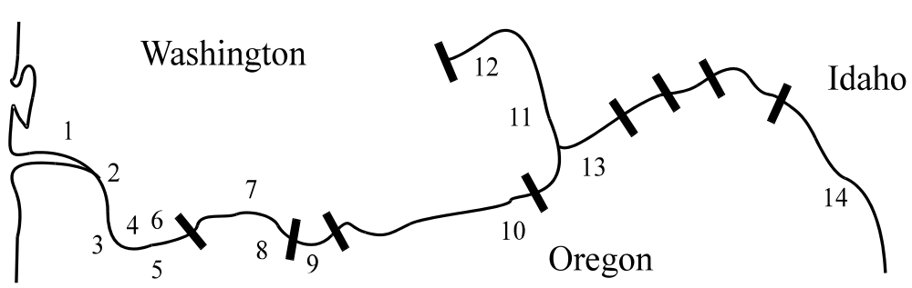

Figure 12. Locations of squawfish sport reward fishery registration stations in 1995. 1 = Cathlamet Marina, 2 = Kalama Marina, 3 = Gleason Ramp, 4 = Washougal Ramp, 5 = The Fishery, 6 = Hamilton Island, 7 = Bingen Marina, 8 = The Dalles Ramp, 9 = Giles French Ramp, 10 = Umatilla Marina, 11 = Columbia Point Park, 12 = Vernita Bridge, 13 = Hood Park, 14 = Greenbelt Ramp.

Table 7. Number and exploitation rate (percentage of population of northern squawfish 250 mm and larger) removed by the squawfish management program. Index values describe relative magnitude of predation in each area relative to John Day Reservoir (Ward et al. 1994).
Area | km | Index | 1990 | 1991 | 1992 | 1993 | 1994 | Total
Lower Columbia | 224 | 7.3 | 1,963 | 60,260 | 86,453 | 53,785 | 76,167 | 278,628
Bonneville Res. | 74 | 0.9 | 4,460 | 26,981 | 24,609 | 15,709 | 24,304 | 96,063
The Dalles Res. | 38 | 1.7 | 2,205 | 41,180 | 33,797 | 14,258 | 18,370 | 109,810
John Day Res. | 123 | 1.0 | 10,425 | 13,684 | 11,148 | 6,456 | 4,709 | 46,422
McNary Res. | 98 | 0.5 | 1,345 | 8,624 | 21,069 | 19,176 | 21,404 | 71,618
Lower Snake | 242 | 0.3 | 0 | 44,968 | 40,471 | 14,120 | 10,713 | 110,272
Total | 799 | 11.7 | 20,398 | 195,697 | 217,547 | 123,504 | 155,667 | 712,813
Exploitation (%) |  |  |  | 11 | 12 | 9 | 13

C. Population Trend Summary

1. Natural
Using adult abundance information we looked at general trends in escapement (adult returns) throughout the region. Only those trends with at least 15 years of data having at least one data point in the 1990’s were used. We divided the average of the last five years of each trend by the average of the first five years of the trend to get the trend value. Values near one indicated little change, less than one indicated declines in abundance, and greater than one indicated increases in abundance. We performed two analyses, one for indicators of natural spawning escapement and one for hatchery rack escapement. The results of the natural trends are shown in Figure 13. The results of this exercise are fairly consistent for all chinook stocks, with those in the lower and mid Columbia regions doing better than those in the Snake. Summer steelhead, however, are doing slightly better in the Snake than in the Lower Columbia. Coho populations below Bonneville (not shown) were nearly all in decline (95% in the <0.75 category).

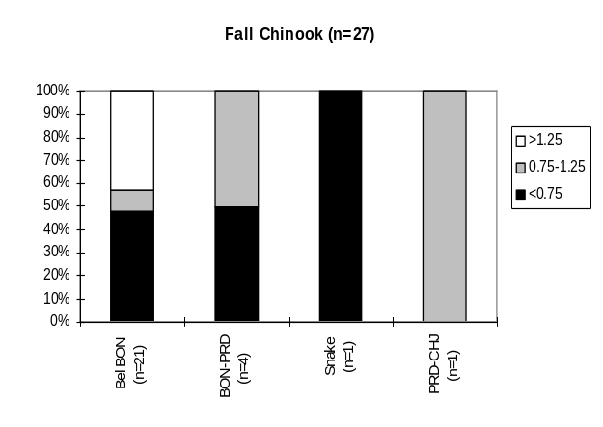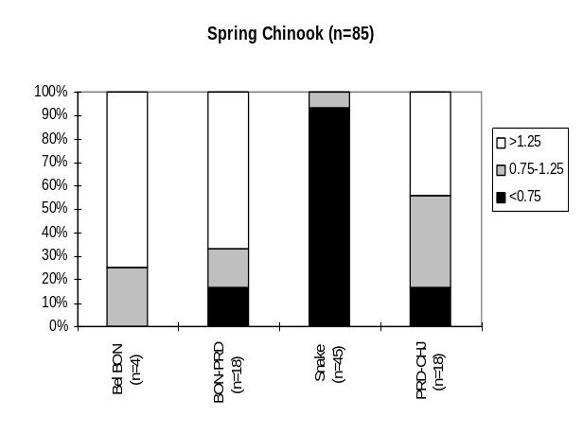
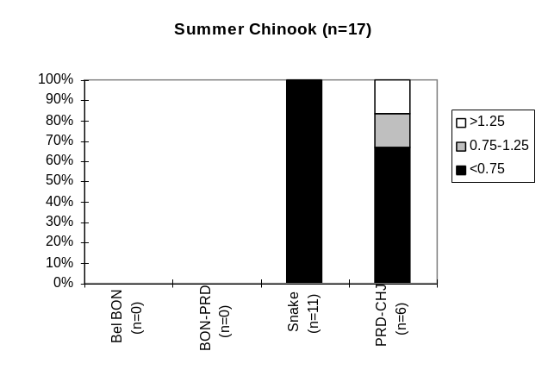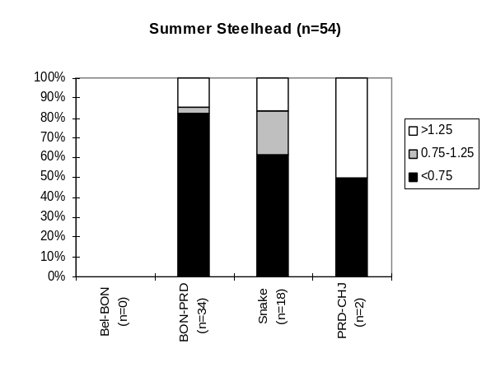
Figure 13. Percentage of natural spawning index ratios (average of ending five years divided by average of beginning five years) falling in three categories by region (trend analysis from data in PSMFC 1995). Black bars indicate a decrease in the number of spawners.

2. Hatchery
Hatchery stocks exhibit similar behavior to natural stocks (Figure 14). Chinook stocks are generally performing better in the Columbia River as compared to the Snake River, while steelhead stocks exhibit the converse pattern.
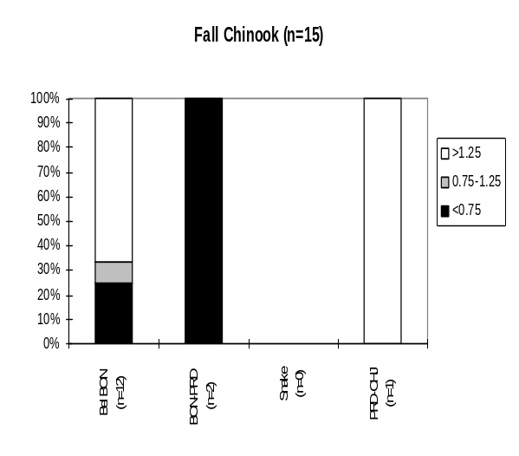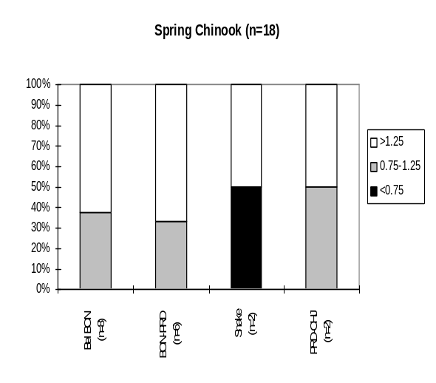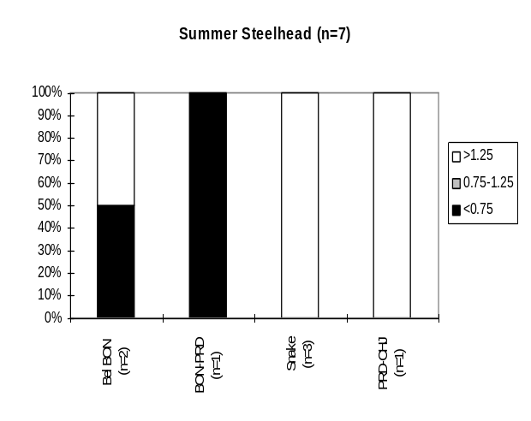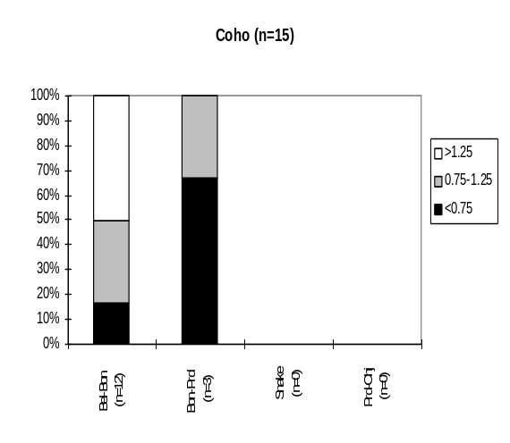
Figure 14. Percentage of hatchery rack return index ratios (average of ending five years divided by average of beginning five years) falling in three categories by region (trend analysis from data in PSMFC 1995). Black bars indicate a decrease in the number of adults returning to the hatcheries.

2. Ocean Distribution
Salmon and steelhead travel great distances during the ocean phases of their life history. Generalized ocean migration patterns are shown in figures 15-17 (CDFO).
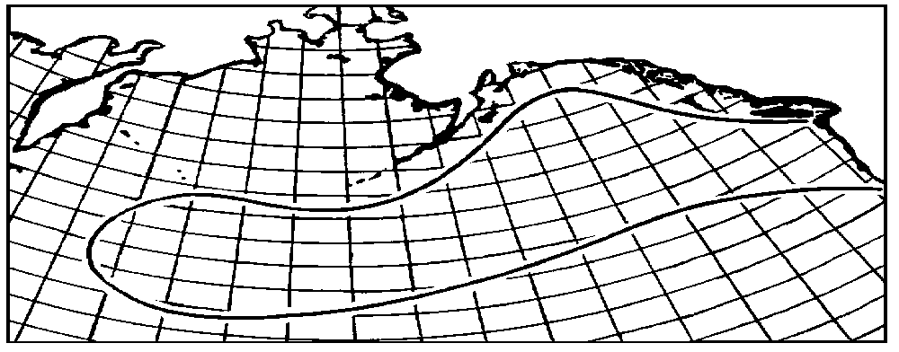
Figure 15. Generalized ocean migration patterns for steelhead.

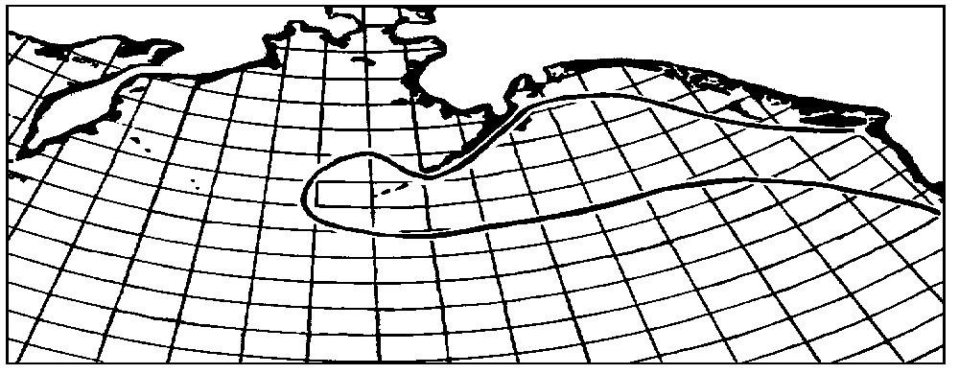
Figure 16. Generalized ocean migration patterns for chinook.
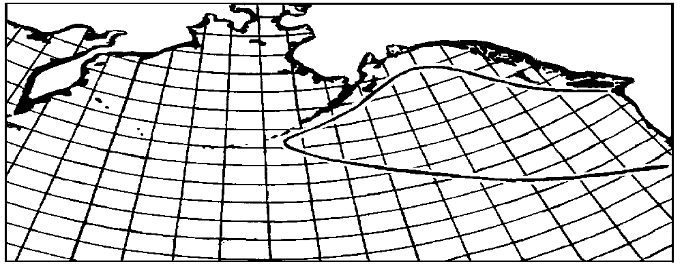

Figure 17. Generalized ocean migration patterns for coho. 3. Freshwater Distribution and Population Summary

Salmon and steelhead stocks utilize thousands of miles of streams throughout the Columbia River Basin (Table 8). Chinook and summer steelhead stocks generally inhabit all major portions of the Basin that are currently accessible (Figures 18-20). Winter steelhead and coho are confined primarily to areas below Bonneville Dam (Figures 21-22), although some remnant coho populations do exist in the Columbia Basin above Priest Rapids dam.

Table 8. Stock distribution data by Columbia River region in miles (PSMFC 1995, from Subbasin Planning 1989, based on mileages from 1:250,000 scale). Mileages do not include mainstem (Columbia or Snake river) use except for fall chinook in the Snake River.

Species/Run | Columbia River Region | Utilized By Stock | Spawning & Rearing | Rearing Only | Migration Only
Coho | Below Bonneville | 2538 | 1498 | 814 | 226
 | Bonneville-Priest Rap | 1268 | 210 | 1057 | 0
 | Snake River | 0 | 0 | 0 | 0
 | Priest - Chief Joe | 297 | 172 | 125 | 0
Fall Chinook | Below Bonneville | 1189 | 749 | 416 | 24
 | Bonneville-Priest Rap | 829 | 372 | 457 | 0
 | Snake River | 412 | 264 | 148 | 0
 | Priest - Chief Joe | 168 | 18 | 150 | 0
Spring Chinook | Below Bonneville | 1422 | 715 | 583 | 124
 | Bonneville-Priest Rap | 1750 | 614 | 840 | 296
 | Snake River | 3766 | 2367 | 797 | 603
 | Priest - Chief Joe | 428 | 186 | 134 | 108
Summer Chinook | Below Bonneville | 148 | 0 | 148 | 0
 | Bonneville-Priest Rap | 312 | 63 | 249 | 0
 | Snake River | 1080 | 445 | 533 | 102
 | Priest - Chief Joe | 312 | 141 | 148 | 23
Summer Steelhead | Below Bonneville | 1672 | 902 | 613 | 158
 | Bonneville-Priest Rap | 4734 | 3278 | 940 | 517
 | Snake River | 7532 | 5934 | 763 | 835
 | Priest - Chief Joe | 581 | 391 | 167 | 23
Winter Steelhead | Below Bonneville | 3155 | 1997 | 915 | 243
 | Bonneville-Priest Rap | 358 | 258 | 99 | 1
 | Snake River | 0 | 0 | 0 | 0
 | Priest - Chief Joe | 0 | 0 | 0 | 0

Figure 18. Spring/Summer Chinook Distribution by USGS Cataloging Units for the Columbia Basin (PSMFC 1995, based on 1989 Subbasin Planning Presence / Absence Data).
The Stock Summary Reports (Hymer et al. 1992, Kiefer et al. 1992, Olsen et al. 1992) identify 287 populations of anadromous fish within the Columbia River Basin (Table 9). These populations are discreet species/run groups of fish that inhabit a particular drainage basin and do not necessarily represent genetically unique stocks. Natural (including wild) runs make up 45% of these stocks while the remaining 55% are hatchery or mixed runs. Detailed run timing information is shown in Table 10.

Table 9. Number of natural and hatchery/mixed stocks identified in the Stock Summary Reports.

Columbia River Region | Natural | Hatchery / Mixed | Total
Below Bonneville | 65 | 79 | 144
Bonneville to Priest Rapids | 274 | 35 | 62
Snake River | 34 | 32 | 66
Priest Rapids to Chief Joseph | 4 | 11 | 15
Total | 130 | 157 | 287

Figure 19. Fall Chinook Distribution by USGS Cataloging Units for the Columbia Basin (PSMFC 1995, based on 1989 Subbasin Planning Presence / Absence Data).
Figure 20. Summer Steelhead Distribution by USGS Cataloging Units for the Columbia Basin (PSMFC 1995, based on 1989 Subbasin Planning Presence / Absence Data).

Figure 21. Coho Distribution by USGS Cataloging Units for the Columbia Basin (PSMFC 1995, based on 1989 Subbasin Planning Presence / Absence Data).
Table 10. Number of runs and life history information by species, run, and Columbia River Region. Format for dates is mm/dd/Yr_{x}, where Yr_{x} represents the year of the life history relative to adult immigration (year 1).
Figure 22. Winter Steelhead Distribution by USGS Cataloging Units for the Columbia Basin (PSMFC 1995, based on 1989 Subbasin Planning Presence / Absence Data).
Species/Run | Columbia River Region | Production Type | # Runs | Adult Immigration | Spawning | Egg\Alevin Incubation | Emergence | Rearing | Juvenile Emigration
Chum | Below Bonneville | Hatchery/Mixed | 3 | 10/15/Yr1-12/31/Yr1 | 11/15/Yr1-12/15/Yr1 | - | 3/15/Yr2-4/15/Yr2 | - | -
Chum | Below Bonneville | Natural | 1 | 10/15/Yr1-11/30/Yr1 | - | - | - | - | -
Coho | Below Bonneville | Hatchery/Mixed | 10 | 8/1/Yr1-1/31/Yr2 | 10/15/Yr1-11/15/Yr1 | - | - | - | -
Coho | Below Bonneville | Natural | 8 | 8/1/Yr1-2/15/Yr2 | 8/15/Yr1-12/31/Yr1 | 8/15/Yr1-3/15/Yr2 | 1/15/Yr2-3/31/Yr2 | 1/15/Yr2-7/31/Yr3 | 3/1/Yr3-7/31/Yr3
Coho | Bonneville-Priest Rap | Hatchery/Mixed | 5 | 9/1/Yr1-1/15/Yr2 | 10/15/Yr1-12/15/Yr1 | 10/15/Yr1-3/15/Yr2 | 1/15/Yr2-5/15/Yr2 | 3/15/Yr2-5/31/Yr3 | 2/1/Yr3-6/30/Yr3
Coho | Bonneville-Priest Rap | Natural | 3 | 9/1/Yr1-10/31/Yr1 | 10/1/Yr1-11/30/Yr1 | - | - | - | -
Coho | Snake | Hatchery/Mixed | 1 | - | - | - | - | - | -
Coho | Snake | Natural | 1 | 9/15/Yr1-11/15/Yr1 | 11/15/Yr1-12/15/Yr1 | 11/15/Yr1-4/15/Yr2 | 2/15/Yr2-4/15/Yr2 | 2/15/Yr2-5/15/Yr3 | 9/15/Yr2-6/15/Yr3
Coho (N Type - Late) | Below Bonneville | Hatchery/Mixed | 6 | 9/1/Yr1-10/31/Yr1 | 11/15/Yr1-3/31/Yr2 | - | 1/1/Yr2-4/30/Yr2 | - | -
Coho (N Type - Late) | Below Bonneville | Natural | 2 | 9/15/Yr1-3/31/Yr2 | 11/1/Yr1-3/31/Yr2 | 11/1/Yr1-5/15/Yr2 | 1/1/Yr2-5/31/Yr2 | 1/1/Yr2-6/15/Yr3 | 10/1/Yr2-7/31/Yr3
Coho (N Type - Late) | Bonneville-Priest Rap | Hatchery/Mixed | 2 | 9/15/Yr1-10/31/Yr1 | 9/15/Yr1-3/31/Yr2 | - | 1/15/Yr2-2/28/Yr2 | - | -
Coho (S Type - Early) | Below Bonneville | Hatchery/Mixed | 6 | 8/1/Yr1-9/30/Yr1 | 10/15/Yr1-10/15/Yr1 | - | 1/1/Yr2-4/30/Yr2 | - | -
Coho (S Type - Early) | Below Bonneville | Natural | 4 | 8/1/Yr1-12/31/Yr1 | 9/1/Yr1-12/31/Yr1 | 9/15/Yr1-4/30/Yr2 | 11/15/Yr1-4/30/Yr2 | 11/15/Yr1-7/31/Yr3 | 3/1/Yr3-7/31/Yr3
Coho (S Type - Early) | Bonneville-Priest Rap | Hatchery/Mixed | 2 | 8/15/Yr1-11/15/Yr1 | 9/15/Yr1-11/15/Yr1 | - | 1/15/Yr2-2/28/Yr2 | - | -
Fall Chinook | Below Bonneville | Hatchery/Mixed | 15 | 8/1/Yr1-11/30/Yr1 | 9/15/Yr1-1/31/Yr2 | 9/15/Yr1-4/15/Yr2 | 12/1/Yr1-8/15/Yr2 | 3/1/Yr2-8/31/Yr2 | 4/15/Yr2-12/31/Yr2
Fall Chinook | Below Bonneville | Natural | 9 | 8/1/Yr1-2/15/Yr2 | 8/15/Yr1-2/15/Yr2 | 8/15/Yr1-5/15/Yr2 | 11/1/Yr1-6/30/Yr2 | 11/15/Yr1-9/15/Yr2 | 3/15/Yr2-9/15/Yr2
Fall Chinook | Bonneville-Priest Rap | Hatchery/Mixed | 3 | 8/1/Yr1-11/30/Yr1 | 9/15/Yr1-10/31/Yr1 | - | 1/1/Yr2-3/31/Yr2 | - | -
Fall Chinook | Bonneville-Priest Rap | Natural | 4 | 6/15/Yr1-10/31/Yr1 | 10/1/Yr1-12/31/Yr1 | 11/1/Yr1-3/31/Yr2 | 1/1/Yr2-4/15/Yr2 | 2/1/Yr2-6/30/Yr2 | 5/1/Yr2-7/31/Yr2
Fall Chinook | Snake | Hatchery/Mixed | 1 | - | - | - | - | - | -
Fall Chinook | Snake | Natural | 2 | 10/15/Yr1-11/30/Yr1 | 11/1/Yr1-12/31/Yr1 | - | - | - | -
Fall Chinook | Priest Rap-Chief Joe | Hatchery/Mixed | 2 | 8/15/Yr1-10/31/Yr1 | 10/15/Yr1-12/31/Yr1 | - | 12/15/Yr1-1/15/Yr2 | - | 3/15/Yr2-7/31/Yr2
Fall Chinook (Tule) | Below Bonneville | Hatchery/Mixed | 1 | 8/15/Yr1-9/30/Yr1 | - | - | - | - | -
Fall Chinook (Tule) | Below Bonneville | Natural | 2 | - | 9/15/Yr1-10/15/Yr1 | - | - | - | -
Fall Chinook (Tule) | Bonneville-Priest Rap | Hatchery/Mixed | 3 | 8/1/Yr1-9/30/Yr1 | 9/1/Yr1-10/15/Yr1 | 9/1/Yr1-12/15/Yr1 | 12/1/Yr1-3/31/Yr2 | 12/15/Yr1-5/15/Yr2 | 5/15/Yr2-9/30/Yr2
Fall Chinook (URB) | Below Bonneville | Natural | 1 | 8/1/Yr1-2/15/Yr2 | 11/15/Yr1-2/15/Yr2 | 11/15/Yr1-5/15/Yr2 | 5/1/Yr2-6/30/Yr2 | 5/15/Yr2-9/30/Yr2 | 5/15/Yr2-9/30/Yr2
Fall Chinook (URB) | Bonneville-Priest Rap | Hatchery/Mixed | 3 | 8/1/Yr1-1/15/Yr2 | 10/15/Yr1-1/15/Yr2 | 10/15/Yr1-4/15/Yr2 | 1/15/Yr2-4/15/Yr2 | - | 2/15/Yr2-11/15/Yr2
Sockeye | Below Bonneville | Hatchery/Mixed | 1 | - | - | - | - | - | -
Sockeye | Below Bonneville | Natural | 1 | - | - | - | - | - | -
Sockeye | Bonneville-Priest Rap | Hatchery/Mixed | 1 | - | - | - | - | - | -
Sockeye | Bonneville-Priest Rap | Natural | 1 | 7/1/Yr1-9/30/Yr1 | 9/15/Yr1-11/15/Yr1 | 11/1/Yr1-4/15/Yr2 | 3/15/Yr2-5/15/Yr2 | 6/1/Yr2-6/30/Yr2 | 3/1/Yr3-5/31/Yr3
Sockeye | Snake | Natural | 2 | 6/1/Yr1-10/31/Yr1 | 10/1/Yr1-11/15/Yr1 | 10/1/Yr1-3/31/Yr2 | 4/1/Yr2-5/31/Yr2 | 4/1/Yr2-8/31/Yr3 | 4/1/Yr3-5/31/Yr3
Sockeye | Priest Rap-Chief Joe | Hatchery/Mixed | 2 | 5/15/Yr1-8/31/Yr1 | 10/15/Yr1-10/15/Yr1 | - | 3/15/Yr2-4/30/Yr2 | - | -
Spring Chinook | Below Bonneville | Hatchery/Mixed | 13 | 1/1/Yr1-11/30/Yr1 | 8/15/Yr1-11/15/Yr1 | 8/15/Yr1-2/15/Yr2 | 11/1/Yr1-3/31/Yr2 | 11/15/Yr1-5/15/Yr3 | 11/1/Yr2-7/31/Yr3
Spring Chinook | Below Bonneville | Natural | 9 | 1/1/Yr1-11/30/Yr1 | 8/1/Yr1-11/30/Yr1 | 9/15/Yr1-4/30/Yr2 | 11/15/Yr1-7/15/Yr2 | 2/1/Yr2-3/31/Yr3 | 3/1/Yr2-6/15/Yr4
Spring Chinook | Bonneville-Priest Rap | Hatchery/Mixed | 8 | 3/1/Yr1-8/15/Yr1 | 8/1/Yr1-9/30/Yr1 | 8/15/Yr1-2/15/Yr2 | 12/15/Yr1-3/15/Yr2 | 1/15/Yr2-7/15/Yr3 | 9/15/Yr2-8/15/Yr3
Spring Chinook | Bonneville-Priest Rap | Natural | 4 | 4/1/Yr1-6/30/Yr1 | 8/15/Yr1-9/30/Yr1 | 9/1/Yr1-3/31/Yr2 | 1/1/Yr2-5/31/Yr2 | 4/1/Yr2-5/31/Yr3 | 3/1/Yr3-6/30/Yr3
Spring Chinook | Snake | Hatchery/Mixed | 13 | 2/15/Yr1-9/30/Yr1 | 6/15/Yr1-10/15/Yr1 | 7/1/Yr1-2/15/Yr2 | 9/15/Yr1-4/30/Yr2 | 9/15/Yr1-5/15/Yr3 | 8/15/Yr2-6/15/Yr3
Spring Chinook | Snake | Natural | 10 | 3/15/Yr1-8/31/Yr1 | 7/15/Yr1-9/30/Yr1 | 7/15/Yr1-2/28/Yr2 | 11/15/Yr1-4/15/Yr2 | 12/1/Yr1-4/30/Yr3 | 2/1/Yr3-6/30/Yr3
Spring Chinook | Priest Rap-Chief Joe | Hatchery/Mixed | 3 | 4/15/Yr1-7/31/Yr1 | 8/15/Yr1-9/30/Yr1 | - | - | - | -
Summer Chinook | Below Bonneville | Hatchery/Mixed | 1 | - | - | - | - | - | -
Summer Chinook | Bonneville-Priest Rap | Hatchery/Mixed | 1 | - | - | - | - | - | -
Summer Chinook | Bonneville-Priest Rap | Natural | 1 | - | - | - | - | - | -
Summer Chinook | Snake | Hatchery/Mixed | 3 | 5/1/Yr1-10/31/Yr1 | 8/1/Yr1-10/31/Yr1 | 7/15/Yr1-6/15/Yr2 | 10/15/Yr1-6/15/Yr2 | 10/15/Yr1-5/31/Yr3 | 2/15/Yr3-4/30/Yr3
Summer Chinook | Snake | Natural | 4 | 5/15/Yr1-8/15/Yr1 | 8/15/Yr1-12/31/Yr1 | 8/15/Yr1-6/30/Yr2 | 3/1/Yr2-6/30/Yr2 | 3/1/Yr2-4/15/Yr3 | 3/1/Yr3-4/30/Yr3
Summer Chinook | Priest Rap-Chief Joe | Hatchery/Mixed | 3 | 5/15/Yr1-9/30/Yr1 | 9/15/Yr1-11/30/Yr1 | - | 1/1/Yr2-4/30/Yr2 | - | 6/1/Yr2-7/31/Yr2
Summer StlHead | Below Bonneville | Hatchery/Mixed | 11 | 3/1/Yr1-2/15/Yr2 | 11/15/Yr1-6/15/Yr2 | 11/15/Yr1-6/15/Yr2 | 1/15/Yr2-8/15/Yr2 | 6/1/Yr2-4/15/Yr3 | 3/15/Yr2-6/30/Yr4
Summer StlHead | Below Bonneville | Natural | 10 | 3/1/Yr1-2/28/Yr2 | 2/1/Yr1-6/15/Yr2 | 11/15/Yr1-6/30/Yr2 | 12/1/Yr1-8/31/Yr2 | - | 5/1/Yr1-6/15/Yr3
Summer StlHead | Bonneville-Priest Rap | Hatchery/Mixed | 4 | 4/15/Yr1-6/15/Yr2 | 3/15/Yr2-6/15/Yr2 | 3/15/Yr2-7/15/Yr2 | 5/15/Yr2-7/15/Yr2 | 5/15/Yr2-5/15/Yr3 | 3/15/Yr3-7/15/Yr3
Summer StlHead | Bonneville-Priest Rap | Natural | 9 | 3/1/Yr1-6/30/Yr2 | 2/1/Yr1-6/15/Yr2 | 3/1/Yr2-8/15/Yr2 | 5/1/Yr2-8/31/Yr2 | 5/1/Yr2-7/31/Yr2 | 4/1/Yr1-5/31/Yr4
Summer StlHead | Snake | Hatchery/Mixed | 13 | 1/15/Yr1-6/30/Yr2 | 3/1/Yr1-6/30/Yr2 | 2/15/Yr1-7/31/Yr2 | 4/1/Yr1-11/15/Yr2 | 4/1/Yr1-6/15/Yr3 | 2/15/Yr2-6/15/Yr3
Summer StlHead | Snake | Natural | 13 | 6/15/Yr1-6/30/Yr2 | 4/1/Yr1-6/30/Yr2 | 2/15/Yr2-7/31/Yr2 | 4/15/Yr2-11/15/Yr2 | 7/15/Yr1-6/15/Yr3 | 4/15/Yr2-5/31/Yr4
Summer StlHead | Priest Rap-Chief Joe | Hatchery/Mixed | 1 | 5/1/Yr1-10/31/Yr1 | 1/1/Yr2-3/31/Yr2 | - | - | - | -
Summer StlHead | Priest Rap-Chief Joe | Natural | 4 | 7/15/Yr1-11/30/Yr1 | 4/1/Yr1-6/30/Yr2 | - | - | - | -
Summer StlHead (A Run) | Snake | Natural | 1 | 9/1/Yr1-12/15/Yr1 | 2/1/Yr2-5/15/Yr2 | 3/1/Yr2-4/30/Yr2 | 4/15/Yr2-5/31/Yr2 | - | 3/1/Yr2-5/15/Yr2
Summer StlHead (B Run) | Snake | Hatchery/Mixed | 1 | 1/1/Yr1-5/31/Yr1 | 2/1/Yr1-5/15/Yr1 | 3/1/Yr1-6/15/Yr1 | 3/15/Yr1-7/15/Yr1 | 7/15/Yr1-4/30/Yr2 | 4/1/Yr2-5/31/Yr2
Summer StlHead (B Run) | Snake | Natural | 1 | 8/1/Yr1-5/31/Yr2 | 3/15/Yr2-6/15/Yr2 | 4/1/Yr2-6/15/Yr2 | 6/1/Yr2-7/31/Yr2 | - | 3/15/Yr3-6/15/Yr3
Winter StlHead | Below Bonneville | Hatchery/Mixed | 12 | 2/1/Yr1-5/15/Yr2 | 4/15/Yr1-5/15/Yr2 | 1/1/Yr2-5/31/Yr2 | 2/15/Yr2-6/30/Yr2 | 2/15/Yr2-7/31/Yr3 | 2/15/Yr3-6/30/Yr4
Winter StlHead | Below Bonneville | Natural | 16 | 1/1/Yr1-6/15/Yr2 | 2/1/Yr1-6/30/Yr2 | 1/15/Yr1-7/31/Yr2 | 3/1/Yr1-5/31/Yr3 | 3/1/Yr1-5/15/Yr4 | 4/15/Yr1-11/30/Yr3
Winter StlHead | Bonneville-Priest Rap | Hatchery/Mixed | 3 | - | - | - | - | - | -
Winter StlHead | Bonneville-Priest Rap | Natural | 5 | 1/1/Yr1-12/31/Yr1 | 3/1/Yr1-6/30/Yr2 | - | - | - | 4/1/Yr1-5/31/Yr1

4. Habitat

A. Columbia River Basin Dam Development
Hydroelectric and other purpose dam development in the Columbia River Basin has been widespread and ongoing for over 100 years. There are at least 145 hydropower dams in the basin and over 900 other purpose dams greater than 10 ft. in height, (Table 11).
Table 11. Number of hydropower and multipurpose dams in the Columbia Basin by region (NID 1994 and BC Hydro 1996).
Columbia River Region | Hydro Power | Non Hydro Power | Total
Below Bonneville | 40 | 167 | 207
Bonneville to  Priest Rapids | 16 | 152 | 168
Snake River | 42 | 310 | 352
Priest Rapids to Chief Joseph | 10 | 54 | 64
Chief Joseph to Headwaters | 37 | 168 | 205
Unknown Stream in Basin | 0 | 68 | 68
Total | 145 | 919 | 1,064

Dam development in the Columbia River Basin has affected anadromous fish production in a variety of ways including: 1) complete loss of upstream habitat due to blockage, 2) direct mortality caused by the dams to both downstream and upstream migrants, and 3) indirect mortality caused by alteration of the environment (change in flow patterns and travel time, etc.).

B. Mainstem

1. Hydropower Project Summary
Grand Coulee Dam on the Columbia (completed in 1941) and Hells Canyon Dam on the Snake (completed in 1967) completely blocked fish passage. There are currently 13 passage mainstem dams operated in Basin at this time (Table 12). The only truly free flowing section of the Columbia River that remains above Bonneville Dam is the Hanford Reach.
Table 12. Project summary data for passable mainstem dams on the Columbia and Snake rivers. (USDOE et. al 1994).
Dam (Powerhouse) |  | Year  Complete |  | Full Pool (ft) |  | Minimum Operating Pool (ft) |  | # Turbine Units |  | # Units with Screens |  | MW Cap. |  | Pool  Length  (mi)
Bonneville (1) |  | 1938 |  | 77 |  | 70 |  | 10 |  | 10 |  | 518 |  | 46
Bonneville (2) |  | 1982 |  |  |  |  |  | 8 |  | 8 |  | 532
The Dalles |  | 1960 |  | 160 |  | 155 |  | 14 (1960)  8 (1973) |  | 0 |  | 1,780 |  | 24
John Day |  | 1971 |  | 268 |  | 257 |  | 16 |  | 16 |  | 2,160 |  | 76
McNary |  | 1957 |  | 340 |  | 335 |  | 14 |  | 14 |  | 980 |  | 61
Ice Harbor |  | 1962 |  | 440 |  | 437 |  | 3 (1962)  3 (1975) |  | 6 |  | 603 |  | 32
Lower Monumental |  | 1970 |  |  |  |  |  |  |  |  |  |  |  | 29
Little Goose |  | 1970 |  | 638 |  | 633 |  | 3 (1970)  3 (1978) |  | 6 |  | 810 |  | 37
Lower Granite |  | 1975 |  | 738 |  | 733 |  | 3 (1975)  3 (1978) |  | 6 |  | 810 |  | 5
Priest Rapids |  | 1959 |  | 83 |  | 18 |  |  |  |  |  |  |  | 18
Wanapum | 1963 |  | 84 |  | 38 |  |  |  |  |  |  |  | 38
Rock Island |  | 1933 |  | 54 |  | 21 |  |  |  |  |  |  |  | 21
Rocky Reach |  | 1961 |  | 93 |  | 42 |  |  |  |  |  |  |  | 42
Wells |  | 1967 |  | 72 |  | 29 |  |  |  |  |  |  |  | 29

2. Long Term Change In Hydrograph
Hydro-development, and the increased storage capacity that resulted from it, as well as irrigation has had a significant impact on seasonal flows in the Columbia River Basin. While the annual average flow of the Columbia has not changed significantly, spring and summer flows have been reduced (Figure 23) and winter flows increased. This reduction in spring and summer flows has been aggravated by lower than normal run-off in 8 of the last 10 years.
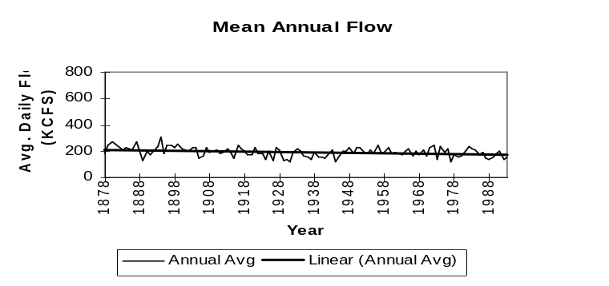
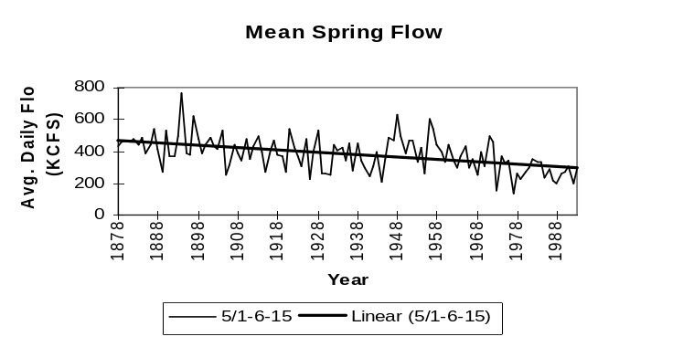
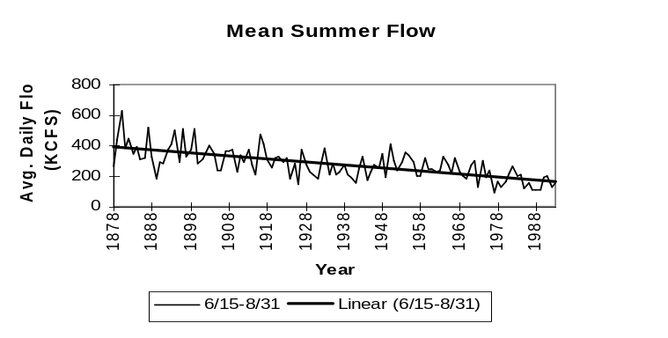
Figure 23. Average daily flows in the Columbia River at The Dalles for three time periods; Annual (top), Spring (middle), and Summer (bottom) (PSMFC 1996).

Reservoir storage capacity in the Columbia River Basin has reached over 100 million acre feet (Figure 24). Total storage available increased over 50% in one year alone (1973) with the completion of Libby Dam in Montana, Dworshak dam in Idaho, and the Mica Dam in British Columbia. Mica dam has an incredible storage capacity of over 23 million acre feet.
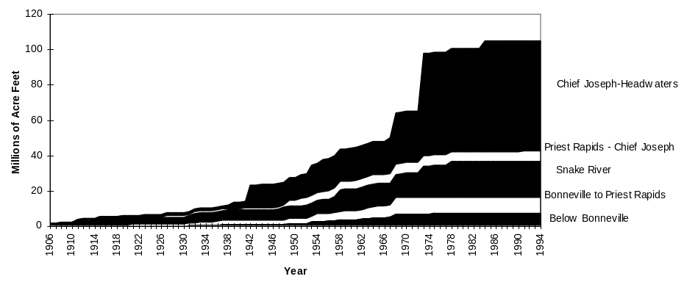
Figure 24. Cumulative storage capacity in the Columbia River Basin in millions of acre feet (PSMFC 1996).

3. Recent Flow And Spill Conditions

Table 13 shows daily average total project flows and percent spill for the spring period (April 16 to May 31 for all projects except the four lower Columbia dams (Bonneville, The Dalles, John Day, and McNary) and May 1 - June 15 for those projects). Summer flows and percent spill are shown in Table 14. The summer period was defined as June 1 through July 31st for upriver projects and June 16th through August 31st for the four lower Columbia dams.

Table 13. Spring period average total flows (kcfs) and percent of that flow spilled by each project (PSMFC 1996).
 | 1975 | 1976 | 1977 | 1978 | 1979 | 1980 | 1981 | 1982 | 1983 | 1984 | 1985 | 1986 | 1987 | 1988 | 1989 | 1990 | 1991 | 1992 | 1993 | 1994 | 1995
BON | 308-53% | 319-58% | 128-3% | 251-42% | 211-31% | 251-41% | 248-38% | 351-41% | 290-25% | 335-41% | 226-30% | 250-40% | 189-20% | 175-13% | 231-30% | 243-33% | 263-38% | 194-50% | 239-44% | 193-45% | 254-35%
TDA | 284-21% | 311-33% | 122-0% | 241-1% | 203-0% | 239-5% | 242-12% | 340-34% | 275-20% | 323-20% | 214-8% | 242-18% | 183-0% | 168-0% | 223-6% | 233-8% | 257-13% | 188-7% | 232-26% | 186-19% | 236-54%
JDA | 286-21% | 323-24% | 124-0% | 250-2% | 210-1% | 247-7% | 250-18% | 356-33% | 287-36% | 339-28% | 219-7% | 249-17% | 185-0% | 170-1% | 224-2% | 236-7% | 260-11% | 187-2% | 235-16% | 189-4% | 248-3%
MCN | 277-22% | 314-49% | 123-1% | 242-9% | 195-5% | 234-22% | 237-19% | 335-42% | 273-37% | 317-43% | 211-4% | 242-13% | 182-10% | 163-0% | 214-5% | 234-9% | 254-23% | 183-3% | 224-19% | 183-8% | 241-39%
IHR | 121-63% | 131-44% | 36-0% | 94-12% | 81-14% | 97-23% | 86-34% | 141-47% | 107-39% | 155-41% | 80-10% | 98-30% | 50-1% | 56-0% | 82-14% | 67-13% | 68-16% | 48-33% | 104-31% | 63-32% | 97-35%
LMN | 121-53% | 129-58% | 37-0% | 93-30% | 83-4% | 100-11% | 88-35% | 141-61% | 106-43% | 154-40% | 82-18% | 98-35% | 52-14% | 58-9% | 82-33% | 68-31% | 69-36% | 48-22% | 103-23% | 62-8% | 97-16%
LGS | 125-48% | 135-60% | 38-0% | 94-12% | 82-0% | 98-0% | 86-0% | 143-28% | 107-19% | 155-29% | 82-0% | 98-5% | 52-0% | 58-0% | 82-0% | 67-0% | 67-1% | 48-0% | 103-23% | 62-24% | 96-20%
LGR | 120-73% | 135-59% | 37-0% | 94-6% | 81-3% | 98-2% | 87-9% | 144-30% | 107-14% | 156-32% | 80-1% | 98-4% | 51-0% | 57-0% | 81-0% | 66-0% | 67-0% | 48-0% | 103-13% | 62-13% | 97-12%
PRD | 150-10% | 172-13% | 86-2% | 138-3% | 111-6% | 130-12% | 155-18% | 190-56% | 158-31% | 152-28% | 128-10% | 136-15% | 126-10% | 106-9% | 128-15% | 165-21% | 182-31% | 138-17% | 118-21% | 123-12% | 136-22%
RIS | 144-46% | 181-59% | 85-17% | 137-44% | 109-8% | 125-8% | 146-11% | 176-36% | 150-23% | 145-25% | 124-8% | 133-11% | 123-12% | 101-12% | 124-15% | 156-18% | 172-18% | 130-9% | 111-18% | 116-12% | 127-10%
RRH | 138-3% | 166-9% | 81-1% | 132-3% | 103-5% | 120-10% | 146-13% | 177-32% | 148-19% | 145-12% | 122-6% | 129-7% | 118-7% | 94-6% | 119-6% | 153-10% | 168-8% | 126-5% | 108-8% | 113-11% | 121-10%
WEL | 138-4% | 167-17% | 81-1% | 129-3% | 105-5% | 119-6% | 143-10% | 174-32% |  | 142-21% | 119-6% | 127-7% | 115-5% | 95-5% | 122-5% | 158-15% | 170-7% | 125-6% | 107-9% | 112-5% | 117-6%

Table 14. Summer period average total flows (kcfs) and percent of that flow spilled by each project (PSMFC 1996).
 | 1975 | 1976 | 1977 | 1978 | 1979 | 1980 | 1981 | 1982 | 1983 | 1984 | 1985 | 1986 | 1987 | 1988 | 1989 | 1990 | 1991 | 1992 | 1993 | 1994 | 1995
BON | 200-32% | 245-42% | 101-1% | 176-24% | 128-4% | 168-21% | 221-27% | 259-26% | 202-21% | 213-20% | 120-7% | 149-8% | 114-0% | 114-1% | 112-5% | 181-18% | 193-26% | 134-37% | 155-44% | 135-37% | 194-45%
TDA | 193-13% | 235-20% | 95-0% | 168-0% | 123-0% | 163-4% | 217-9% | 253-30% | 191-11% | 206-12% | 112-4% | 146-4% | 110-0% | 110-0% | 110-5% | 180-6% | 188-7% | 127-4% | 151-5% | 130-9% | 184-61%
JDA | 194-14% | 243-14% | 97-0% | 172-0% | 125-0% | 165-6% | 222-17% | 262-26% | 197-21% | 211-28% | 111-0% | 151-10% | 109-1% | 110-3% | 108-6% | 180-7% | 190-9% | 126-7% | 150-7% | 131-5% | 190-3%
MCN | 193-16% | 243-27% | 97-0% | 168-0% | 123-0% | 165-15% | 219-13% | 253-34% | 193-3% | 206-25% | 111-0% | 147-1% | 109-0% | 109-0% | 108-0% | 180-7% | 190-10% | 125-0% | 149-0% | 129-2% | 186-15%
IHR | 116-61% | 82-28% | 28-0% | 80-8% | 50-2% | 74-28% | 77-61% | 117-40% | 97-36% | 124-40% | 49-6% | 72-28% | 23-0% | 32-0% | 51-7% | 51-20% | 56-14% | 27-15% | 76-24% | 39-33% | 89-40%
LMN | 116-47% | 81-42% | 29-0% | 81-28% | 52-0% | 75-19% | 77-66% | 118-50% | 96-29% | 125-37% | 51-9% | 72-31% | 25-5% | 34-2% | 52-18% | 53-35% | 57-36% | 27-24% | 74-6% | 38-6% | 89-9%
LGS | 120-49% | 86-46% | 31-0% | 82-5% | 51-0% | 74-0% | 76-11% | 119-20% | 97-16% | 124-24% | 51-0% | 72-12% | 25-0% | 34-0% | 52-0% | 52-4% | 56-0% | 27-0% | 74-6% | 38-6% | 88-11%
LGR | 115-56% | 85-46% | 30-0% | 81-4% | 51-0% | 74-4% | 77-21% | 119-22% | 97-10% | 125-26% | 50-1% | 72-12% | 25-0% | 33-0% | 51-0% | 51-0% | 56-1% | 27-0% | 74-1% | 39-10% | 87-7%
PRD | 142-9% | 174-9% | 76-0% | 127-2% | 98-0% | 142-12% | 221-26% | 200-47% | 143-22% | 138-24% | 93-1% | 127-13% | 102-3% | 98-1% | 94-3% | 187-21% | 179-29% | 123-11% | 116-4% | 132-13% | 143-10%
RIS | 139-43% | 180-59% | 75-10% | 124-35% | 95-5% | 137-8% | 204-13% | 187-21% | 138-13% | 133-10% | 91-0% | 124-14% | 100-0% | 94-0% | 91-0% | 177-17% | 168-8% | 116-3% | 109-4% | 125-3% | 135-4%
RRH | 129-7% | 168-3% | 72-0% | 119-0% | 92-0% | 135-10% | 211-21% | 188-27% | 137-13% | 129-7% | 89-0% | 120-11% | 98-2% | 89-1% | 86-0% | 174-14% | 164-10% | 115-0% | 108-1% | 124-7% | 133-4%
WEL | 127-7% | 163-15% | 72-0% | 113-0% | 93-0% | 133-4% | 202-13% | 182-20% | 131-9% | 124-14% | 86-0% | 119-8% | 96-2% | 89-4% | 88-4% | 176-26% | 161-8% | 114-5% | 106-5% | 123-4% | 123-5%

Average project flow and spill rates vary dramatically from year to year based on run-off conditions, operational mandates, and storage capacity in the Columbia River Basin. We averaged the flow and spill at the dams existing in a given year between the Columbia River mouth and Snake River spawning grounds for spring and summer time periods (Figure 25). Both spring and summer flow and spill levels have decreased significantly since the early 1960’s. Flow reduction has been significantly influenced by the increased storage capacity developed in the Columbia River Basin during that period (Figure 24), more than doubling from about 50 million acre feet in 1961 to over 105 million acre feet in 1995. Spill reductions have been influenced by reduced flows and by increased powerhouse capacity from additional turbine installations made at the mainstem dams.
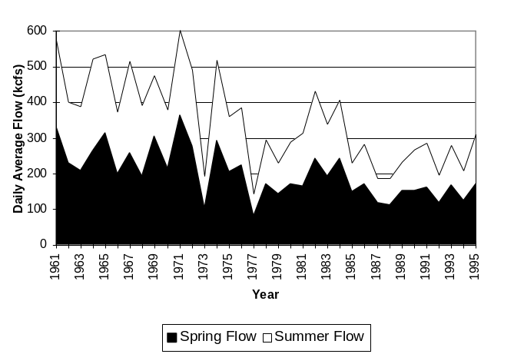
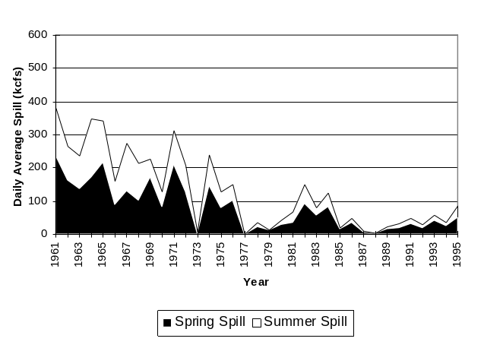

Figure 25. Daily average total flow (top) and spill (bottom) for the mainstem projects between the Columbia River mouth and Snake River spawning grounds (PSMFC 1996).

The average spring and summer spill levels of the mainstem dams between the Columbia River mouth and Snake River spawning grounds (expressed as a percentage of average total flow) declined through the 1960’s and 1970’s. Spill levels have steadily increased since 1988 (Figure 26), though they are still far below those of the early 1960’s.
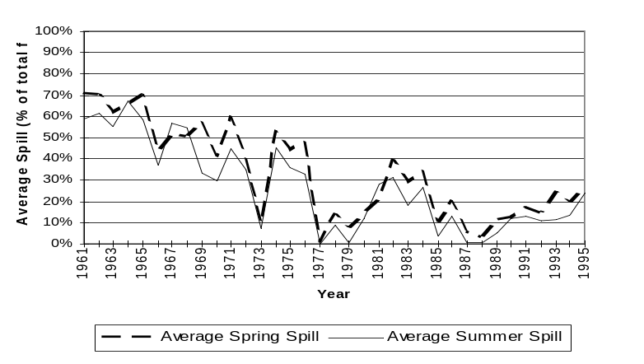
Figure 26. Average summer and spring spills expressed as percentage of total flow for the mainstem dams between the Columbia River mouth and Idaho spawning grounds.

C. Tributary

1. Habitat Lost Due To Hydro Development
Freshwater habitat for anadromous fish in the Columbia River Basin has been severely depleted by hydroelectric development. For the U. S. portion of the Columbia River Basin, we calculate that over 18,700 miles of historically accessible streams have been blocked by hydroelectric dams (based on 1:250,000 digital line file). This represents nearly 38% of the estimated
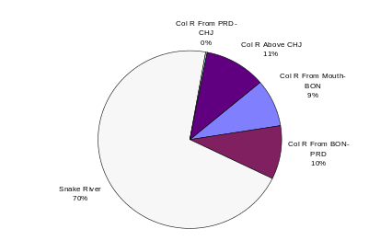
Figure 27. Allocation of 18,700 miles of historically accessible anadromous habitat blocked by hydro development in the U.S. portion of the Columbia River Basin (PSMFC 1996).
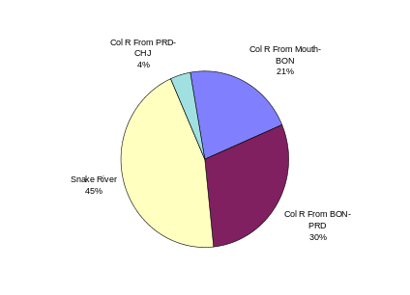
Figure 28. Allocation of 16,800 miles currently in use by salmon and steelhead in the U.S. portion of the Columbia River Basin (PSMFC 1996).
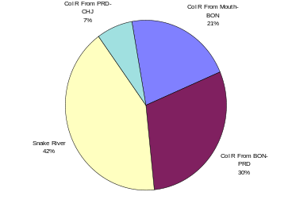
Figure 29. Allocation of the 30,600 miles of currently accessible anadromous habitat in the U.S. portion of the Columbia River Basin (PSMFC 1996).

historical range of 49,300 miles. The allocation of this habitat loss varies widely throughout the Basin with the Snake River area sustaining the largest loss (Figure 27). Currently accessible habitat is approximately 30,600 miles (Figure 29) although a little over half of that habitat is actually in use by anadromous fish at this time (Figure 28).

As the figures indicate, while the Snake River Region has sustained the largest historical loss of habitat due to hydro development, it still represents the majority of available habitat in the U.S. portion of the Columbia River Basin. Note that Grand Coulee Dam blocked significant historic production areas in Canada. These losses are not reflected in the figures below.

2. Habitat Condition

In the late 1980’s, agencies and tribes participating in the Northwest Power Planning Council’s subbasin planning process subjectively rated habitat quality for all currently utilized salmon and steelhead production areas in the Columbia River Basin. Habitat conditions were rated based on relative comparisons of the present fish producing potential of habitat within a given subbasin (not based on comparisons of habitat to that in other subbasins.) Excellent habitat was defined as that which would support the highest productivity for a species within a subbasin. Poor was the classification for habitat which would support the lowest level of productivity. Good and fair were used to describe habitats that were intermediate relative to the other two categories (NWPPC 1989). We summarized these habitat ratings for salmon and steelhead by Columbia River Region. Figure 30 shows the results for salmon. The area below Bonneville was the only region where more than half of the salmon habitat was rated as good or excellent.
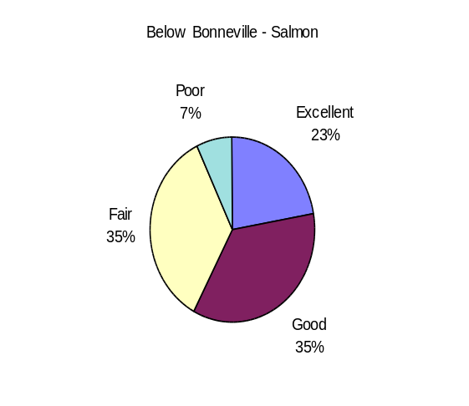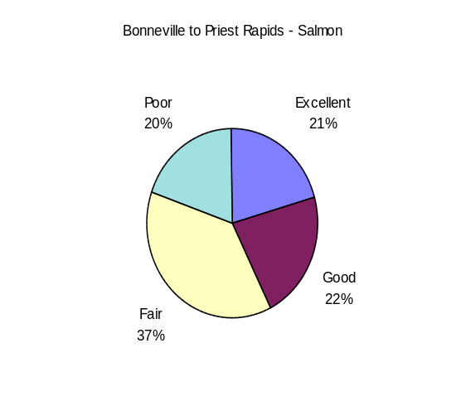
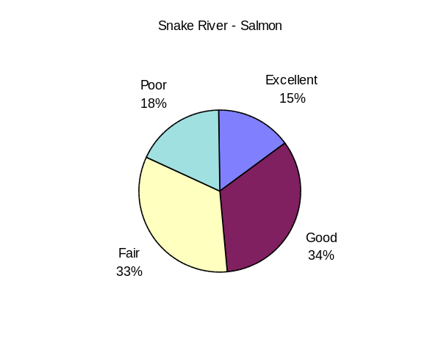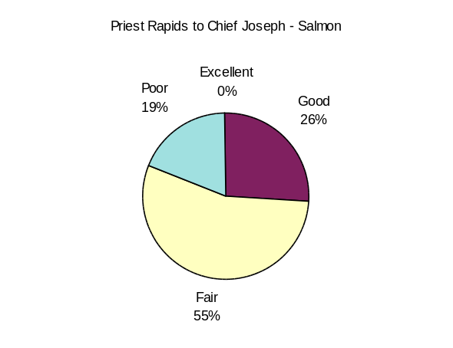
Figure 30. Percent of excellent, good, fair, and poor salmon habitat identified by Subbasin Planners by Columbia River Region (PSMFC 1995 from Subbasin Planning, 1989).

Results for steelhead are shown in Figure 31. While the contrast between the Columbia River and Snake River regions for salmon was not that great, the picture is different for steelhead. While below Bonneville and the Snake regions were found to possess 60% or greater excellent or good habitat, only 25% of the Bonneville to Priest Rapids regions received excellent or good ratings.
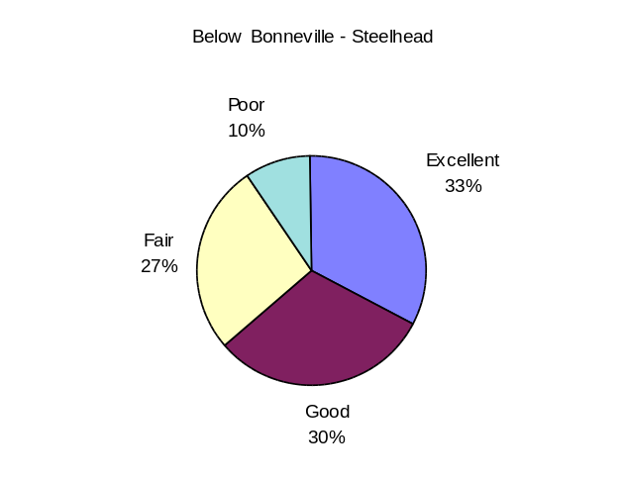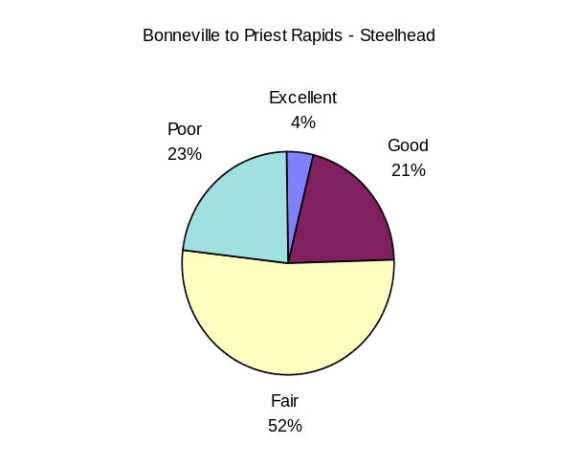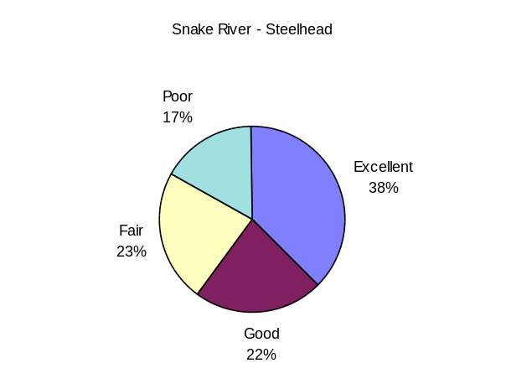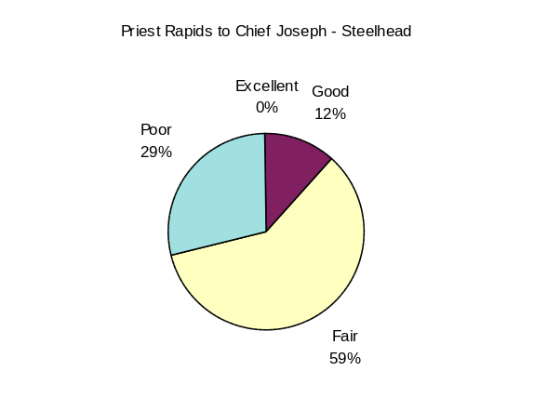
Figure 31. Percent of excellent, good, fair, and poor steelhead habitat identified by Subbasin Planners by Columbia River Region (PSMFC 1995 from Subbasin Planning, 1989).

3. Habitat Limiting Factors
While hydro development and harvest have played major roles in the decline of Columbia River salmon and steelhead, habitat degradation has also been significant. Sedimentation problems linked to poor land use practices, are prevalent throughout the Basin (Table 15). High instream temperatures, loss of large woody debris, degraded instream and streambank conditions, loss of habitat due to channelization, and low flow levels have also reduced the productivity of many of the Basin’s streams.

Table 15. Major habitat constraints by stock and region (Subbasin Planning, 1989). Values are expressed as percentages (total miles identified with constraints divided by total miles of spawning and/or rearing habitat).

Species/Run | Columbia River Region | Flow Levels Low | Gravel Quantity Low | High Temperature |  |  | In- stream Cover |  | Inter- specific Comp-etition |  | Pool- Riffle Ratio Low |  | Sedi- ments |  | Stream Bank De- graded
Coho | Below Bonneville | 16.1% | 7.6% | 29.7% |  |  | 2.6% |  | 12.4% |  | 9.2% |  | 20.1% |  | 2.7%
 | Bonneville-Priest Rap | 2.3% | 0.4% | 0.2% |  |  | 4.6% |  | 0.2% |  | 5.1% |  | 0.4% |  | 0.2%
 | Snake River *
 | Priest - Chief Joe | 0.2% | 0.8% |  |  |  | 37.1% |  |  |  | 3.5% |  | 8.1%
Fall Chinook | Below Bonneville | 9.3% | 6.8% | 25.0% |  |  | 1.4% |  | 16.8% |  | 0.5% |  | 20.4% |  | 15.7%
 | Bonneville-Priest Rap | 9.1% | 7.7% |  |  |  | 2.2% |  |  |  | 5.7% |  | 16.2% |  | 5.6%
 | Snake River | 1.1% |  | 4.4% |  |  | 2.5% |  | 2.5% |  | 2.5% |  | 22.4%
 | Priest - Chief Joe |  |  |  |  |  | 10.7% |  |  |  | 6.3%
Spr Chinook | Below Bonneville | 20.9% | 8.9% | 27.6% |  |  | 3.3% |  | 11.9% |  | 2.8% |  | 16.9% |  | 4.1%
 | Bonneville-Priest Rap | 11.3% | 9.8% | 16.3% |  |  | 10.6% |  | 7.6% |  | 10.2% |  | 10.2% |  | 14.4%
 | Snake River | 7.7% | 2.0% | 13.4% |  |  | 5.4% |  |  |  | 6.3% |  | 20.4% |  | 8.4%
 | Priest - Chief Joe | 41.3% | 8.6% | 0.8% |  |  | 56.4% |  |  |  | 12.7% |  | 7.5%
Sum Chinook | Below Bonneville *
 | Bonneville-Priest Rap *
 | Snake River | 4.5% |  |  |  |  |  |  |  |  |  |  | 25.5% |  | 2.3%
 | Priest - Chief Joe | 8.6% | 8.4% | 21.1% |  |  | 36.7% |  |  |  |  |  | 24.8%
Sum Stlhead | Below Bonneville | 15.7% | 13.8% | 22.5% |  |  | 9.7% |  | 9.2% |  | 5.8% |  | 12.2% |  | 2.8%
 | Bonneville-Priest Rap | 31.7% | 12.4% | 36.0% |  |  | 17.9% |  | 10.9% |  | 16.0% |  | 25.3% |  | 40.1%
 | Snake River | 15.2% | 2.0% | 13.6% |  |  | 6.2% |  | 0.1% |  | 9.1% |  | 25.8% |  | 13.5%
 | Priest - Chief Joe | 18.6% | 6.8% | 19.8% |  |  | 28.0% |  |  |  | 13.2% |  | 7.5% |  | 0.1%
Win Stlhead | Below Bonneville | 14.2% | 13.0% | 20.6% |  |  | 6.4% |  | 12.1% |  | 5.3% |  | 15.3% |  | 1.9%
 | Bonneville-Priest Rap | 37.4% | 6.4% | 18.7% |  |  | 30.1% |  |  |  | 40.3% |  | 18.8% |  | 13.0%
 | Snake River *
 | Priest - Chief Joe *
* Species/run is not found in this region

4. Habitat Changes

McIntosh et al. (1994) identified changes in fish habitat over a 50-year period in selected Columbia Basin tributaries by comparing the frequency of large pools and coarse woody debris from two time periods based on surveys in 1934-42 and 1990-92 (Table 16). The frequency of large pools increased in managed and unmanaged watersheds of the mid-Columbia River, with the increase twice as great in unmanaged watersheds. Large pool frequency declined in managed watersheds of the Snake River, except for the Tucannon River where there was a significant increase. Coarse woody debris was generally more common in unmanaged than in managed areas. Large pools were identified as key rearing habitat for juveniles and resting habitat for adults. Coarse woody debris creates and maintains high-quality fish habitat by providing cover, enhancing pool development, and reducing erosion.
These data suggest a reduction in damaging land use practices in the mid-Columbia watersheds during the last 50 years and continuing effects of more recent activities in the Snake watersheds.

5. Diversions and Screens
Table 16. Historical habitat changes in pool frequency and current abundance of coarse woody debris for select eastern Oregon and Washington subbasins from 1934-92.

Basin,  useª | Subbasin | Pools^{b} | Wood^{c}
Columbia
Managed | Methow | 100% | 69.2
 | Wenatchee | 57% | 26.7
 | Yakima | 111% | 32.8
 | Combined | 89% | ??
Unmanaged | Methow | 240% | 40.2
 | Wenatchee | 200% | 72.5
 | Yakima | 144% | 72.7
 | Combined | 195% | 66.1
Snake
Managed | Asotin | -33%
 | Grande Ronde | -66% | 36.0
 | Tucannon | 171%
 | Combined | -19%

ª Managed streams were used for timber, livestock, agriculture, or mining while unmanaged were wilderness or roadless areas
^{b} Change in frequency
^{c} Pieces per km at least 0.1 m in diameter and 2.0 m in length
A large-scale program to install new fish screens on unscreened irrigation diversions and to upgrade or replace existing fish screens has been under way since 1991 in an attempt to improve survival of juvenile salmon and steelhead in Columbia and Snake river tributaries upstream from Bonneville Dam (FSOC 1996). With funding from the Federal Mitchell Act and from the Bonneville Power Administration, 163 screens have been constructed in 1991-94 to National Marine Fisheries Service's current design criteria. By 2002, fish screens will be installed at over 300 unscreened diversions and 602 old fish screens will be replaced or upgraded. To reduce fish passage delay and fish screen operation and maintenance costs, irrigation ditches are also being consolidated or replaced with pumps or groundwater wells. Finally, this program also is screening irrigation pump intakes and is upgrading fish ladders of tributary obstructions.
Table 17. Gravity diversion screens constructed or replaced in Columbia River Basin tributaries, 1985-1994 (Hawkes, Columbia Basin Fish and Wildlife Authority, personal communication). Totals include sites eliminated by consolidation or conversion to ground water. Totals do not include intake pump screens or fishways constructed or replaced by this project.
Year | Idaho | Oregon | Washington | Total
1985 | 0 | 0 | 4 | 4
1986 | 0 | 0 | 2 | 2
1987 | 0 | 16 | 2 | 18
1988 | 0 | 0 | 4 | 4
1989 | 0 | 4 | 5 | 9
1990 | 0 | 1 | 3 | 4
1991 | 1 | 0 | 0 | 1
1992 | 7 | 12 | 6 | 25
1993 | 15 | 25 | 12 | 52
1994 | 18 | 50 | 17 | 85
1995-2002ª | 435 | 412 | 99 | 946
ªTo be completed.

D. Ocean Conditions

1. Upwelling Index
Ocean conditions are highly variable and can have a significant impact on production and survival of anadromous fish. Coastal upwelling conditions are generally thought to influence early ocean smolt survival with higher levels of upwelling associated with more favorable fish conditions. Figure 32 shows the mean March - September upwelling anomaly for sites off the Oregon and Washington coasts. Values greater than 0 represent greater than average levels of upwelling while negative values represent less than average. In 7 of the last 10 years upwelling has been below normal.
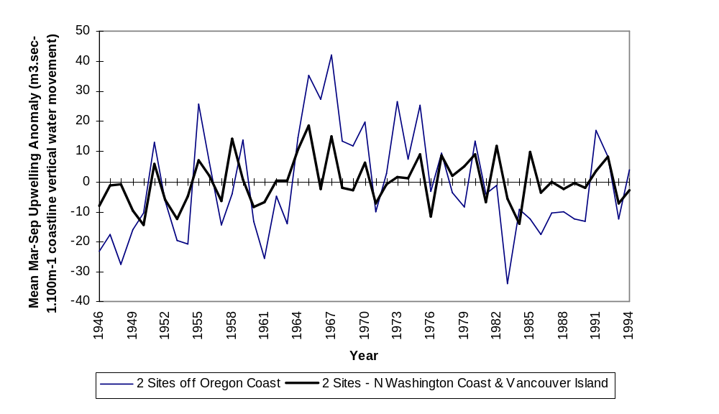
Figure 32. Upwelling anomalies-difference between current year and 1948-1967 average for four coastal locations. Positive values represent stronger upwelling than normal, negative values represent weaker (PSMFC 1996).

2. Southern Oscillation Index
Another commonly accepted measure of ocean conditions is the Southern Oscillation Index-SOI which is related to El Niño events. The El Niño/Southern Oscillation (ENSO) phenomenon is an atmosphere-ocean coupling across the central tropical Pacific Ocean which influences climate in many regions of the Earth. Values of the SOI that are less than minus one are generally thought to be related to El Niño events; the lower the SOI, the stronger the event. Much of the North American continent is influenced to some extent by the ENSO phenomenon and fish production in the Pacific is also affected. Again, the SOI indicates that ocean conditions have been less than optimal in the majority of years since 1977 (Figure 33).

3. Sea Surface Temperatures
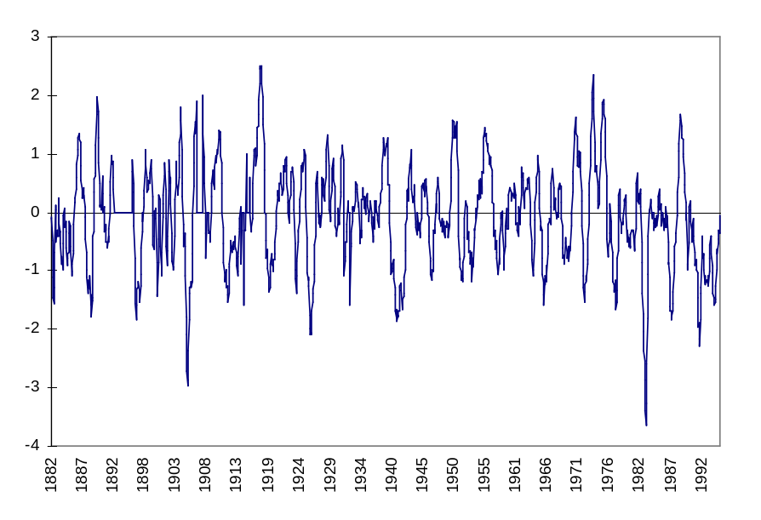
Figure 33. 5 month running means of the Southern Oscillation Index. Negative values less than -1 represent the onset on El Niño events (Sevilleta LTER 1995).
Another general indicator of ocean conditions is sea surface temperature (Figure 34). Again, the data is highly variable but shows a general tendency for increasing temperatures in southerly coastal areas, a condition generally recognized as being unfavorable to the production and growth of anadromous species which inhabit these areas.
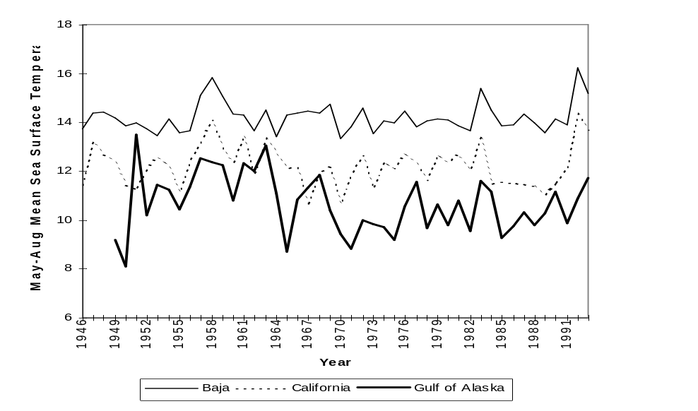
Figure 34. Average May-August sea surface temperatures at three near shore ocean sites.

5. Hatchery Production

A. Hatchery Distribution
Hatchery releases have been widespread and numerous in the Columbia River Basin. Only a few watersheds in the Columbia which have not received hatchery plants since 1975 (Figures 37-42). Notable areas that have not received plants during that time include the John Day Basin and portions of the Salmon River Basin. Hatcheries releasing fish in the Columbia Basin since 1980 are listed in Table 18 by management agency.

Table 18. Hatcheries which have released fish into the Columbia River Basin since 1980, by management agency (PSMFC, 1996).

Agency | Hatchery | Agency | Hatchery | Agency | Hatchery
IDFG | CLEARWATER | ODFW | ROARING RIVER | WDFW | COTTONWOOD POND
IDFG | CROOKED RIVER TRAP | ODFW | ROUND BUTTE | WDFW | COWLITZ SALMON
IDFG | HAYDEN CREEK | ODFW | SANDY | WDFW | CURL LAKE
IDFG | MACKAY | ODFW | SF KLASKANINE POND | WDFW | DAYTON POND
IDFG | MAGIC VALLEY | ODFW | SOUTH SANTIAM | WDFW | EASTBANK
IDFG | MCCALL | ODFW | STAYTON PD | WDFW | ELOKOMIN
IDFG | NIAGARA SPRINGS | ODFW | TROJAN PD | WDFW | GRAYS RIVER
IDFG | OXBOW | ODFW | UMATILLA | WDFW | KALAMA FALLS
IDFG | PAHSIMEROI | ODFW | VANDERVELDT PONDS | WDFW | KLICKITAT
IDFG | POWELL SATELLITE | ODFW | WAHKEENA PD | WDFW | LEWIS RIVER
IDFG | RAPID RIVER | ODFW | WALLOWA | WDFW | LOWER KALAMA
IDFG | RED RIVER POND | ODFW | WILLAMETTE | WDFW | LYONS FERRY SALMON
IDFG | SAWTOOTH | USFWS | ABERNATHY SCTC | WDFW | METHOW
ODFW | BIG CANYON | USFWS | BIG WHITE SALMON POND | WDFW | PRIEST RAPIDS
ODFW | BIG CREEK | USFWS | CARSON NFH | WDFW | RINGOLD SALMON POND
ODFW | BONNEVILLE | USFWS | DWORSHAK NFH | WDFW | ROCKY REACH
ODFW | CASCADE | USFWS | EAGLE CREEK NFH | WDFW | SIMILKAMEEN POND
ODFW | CLACKAMAS | USFWS | ENTIAT NFH | WDFW | SKAMANIA
ODFW | DEXTER PD | USFWS | HAGERMAN NFH | WDFW | SPEELYAI
ODFW | GNAT CREEK | USFWS | KOOSKIA NFH | WDFW | TOUTLE
ODFW | IRRIGON | USFWS | LEAVENWORTH NFH | WDFW | WASHOUGAL
ODFW | KLASKANINE | USFWS | LITTLE WHITE SALMON NFH | WDFW | WELLS SALMON
ODFW | LEABURG | USFWS | SPRING CREEK NFH | WDFW | WELLS TROUT
ODFW | LOOKINGGLASS | USFWS | WARM SPRINGS NFH | WDFW | WENATCHEE NET PENS
ODFW | MARION FORKS | USFWS | WILLARD NFH | WDFW | WEYCO POND (GRAYS R)
ODFW | MCKENZIE | USFWS | WINTHROP NFH | WDFW COOP | SEA RESOURCES
ODFW | OAK SPRINGS | WDFW | BEAVER CREEK | YIN | NILE SPRINGS PONDS
 |  | WDFW | CARLTON POND

B. Total Hatchery Releases
Average annual hatchery releases into the Columbia River Basin have exceeded 185 million fish since 1980. During this time, the region below Bonneville Dam has received, on average, about 60% of all hatchery plants. The Bonneville to Priest Rapids Region of the basin has received about 26%, the Snake River Region about 9%, and the area above Priest Rapids has received about 4% of all hatchery releases (Figure 35). Releases in 1994 were about 25% lower than releases in the years 1990 through 1992.
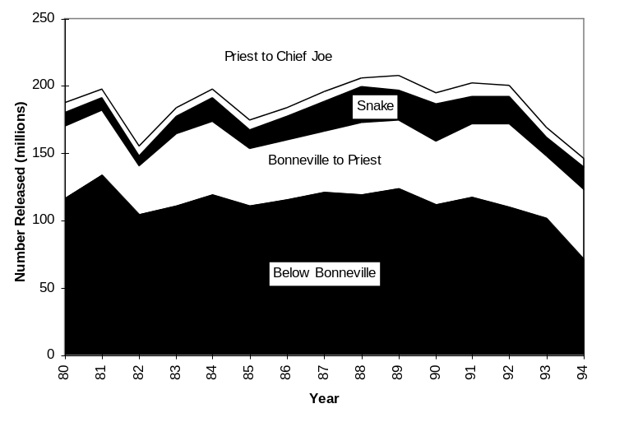
Figure 35. Total hatchery releases (all species, in millions) by Columbia River region since 1980 (PSMFC 1995, based on data provided by the Regional Mark Processing Center (RMPC)).

Since 1980, fall chinook account for the majority of hatchery releases (Figure 36), with 53% of the total releases, followed by coho with 22% of the releases, spring chinook with 18%, and summer steelhead with 5%. Releases of coho in 1994 were down more than 40% from 1990 levels while spring chinook and summer steelhead releases in 1994 were both down more than 33% from totals in 1990.
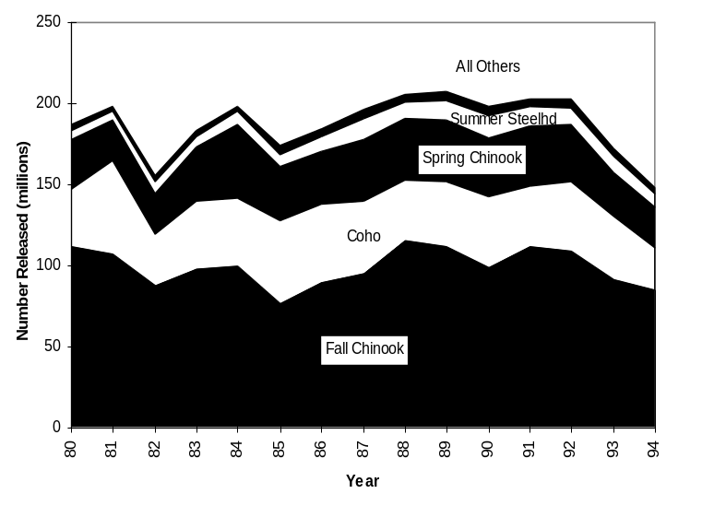
Figure 36. Total hatchery releases (millions) by species and run in the Columbia River Basin since 1980 (PSMFC 1995).

Figure 37. Hatchery spring/summer chinook releases by USGS Cataloging Units for the Columbia Basin (PSMFC 1995, based on data from the RMPC).
Figure 38. Hatchery fall chinook releases by USGS Cataloging Units for the Columbia Basin (PSMFC 1995, based on data from the RMPC).

Figure 39. Hatchery summer steelhead releases by USGS Cataloging Units for the Columbia Basin (PSMFC 1995, based on data from the RMPC).
Figure 40. Hatchery winter steelhead releases by USGS Cataloging Units for the Columbia Basin (PSMFC 1995, based on data from the RMPC).

Figure 41. Hatchery coho releases by USGS Cataloging Units for the Columbia Basin (PSMFC 1995, based on data from the RMPC).
Figure 42. Hatchery sockeye releases by USGS Cataloging Units for the Columbia Basin (PSMFC 1995, based on data from the RMPC).

C. Hatchery Authorization and Funding
The majority of hatchery releases in the Columbia River Basin have been authorized and funded either through federally mandated programs like the Mitchell Act and the Lower Snake River Compensation Program, or as part of specific dam mitigation programs. These two broad categories of authorization have been responsible for about 93% of the total hatchery releases since 1980 (Figure 43).
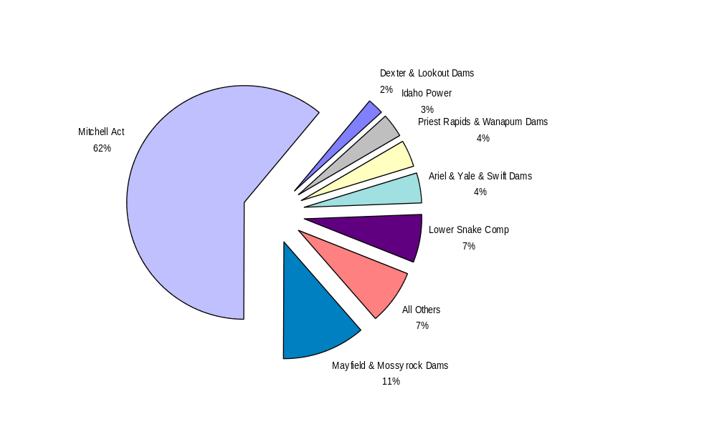
Figure 43. Allocation of total hatchery releases in the Columbia River Basin since 1980 by primary hatchery authorization and funding source (PSMFC 1996).

E. Freshwater Coded Wire Tag Recoveries
Records of coded wire tag (CWT) recoveries are a useful index of the incidence of straying. Straying of hatchery fish varies by stock (Tables 19-21). Individual fish from some stocks such as Hood River chinook in the lower Columbia have been recovered as far away as the Snake River in Washington.

Table 19. Estimated number of fish with given tag code represented by CWT recoveries within the Columbia Basin for chinook, since 1973. Numbers in bold boxes represent recoveries of tagged fish in the subbasin of their release. Other numbers represent tagged fish recovered in a subbasin other than the one in which they were released (RMIS 1995).
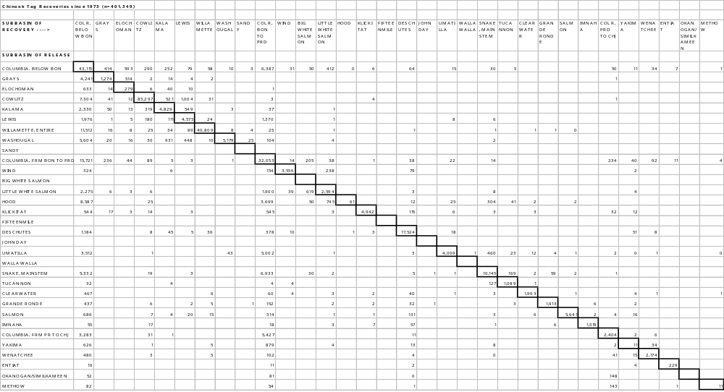
Table 20. Estimated number of fish with given tag code represented by CWT recoveries within the Columbia Basin for steelhead since 1973. Numbers in bold boxes represent recoveries of tagged fish in the subbasin of their release. Other numbers represent tagged fish recovered in a subbasin other than the one in which they were released (RMIS 1995).

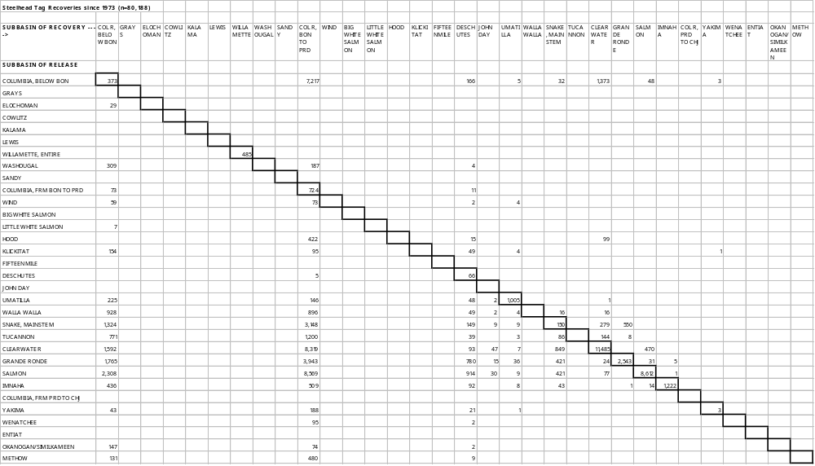

Table 21. Estimated number of fish with given tag code represented by CWT recoveries within the Columbia Basin for coho since 1973. Numbers in bold boxes represent recoveries of tagged fish in the subbasin of their release. Other numbers represent tagged fish recovered in a subbasin other than the one in which they were released (RMIS 1995).

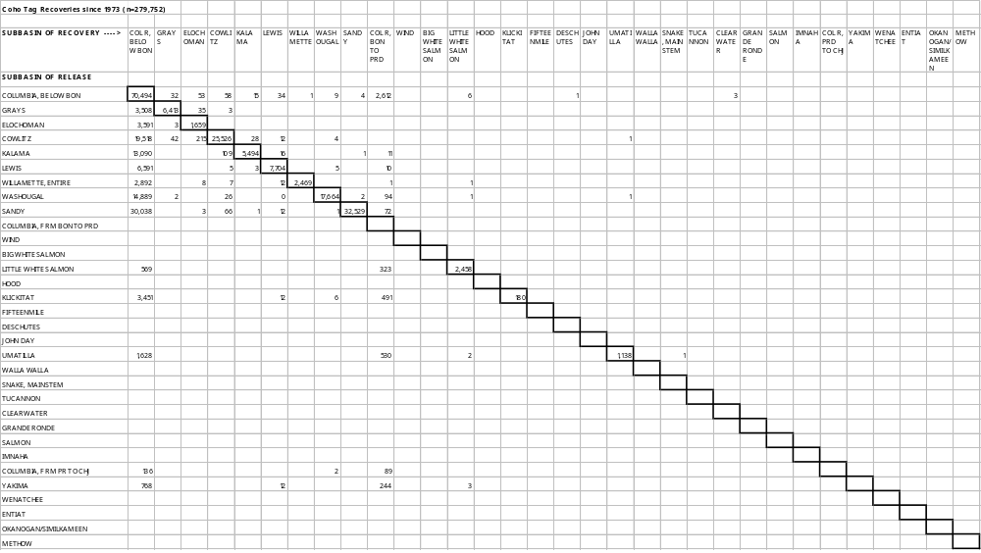

6. Harvest

A. Mainstem Columbia

Columbia River harvest is divided into 3 broad categories; sport, commercial, and tribal. Sport harvest is typically constrained to the lower river and estuary. Non-sport harvest is regulated by 6 defined areas or zones on the river; Zones 1 through 5 define the area from the mouth to Bonneville Dam and are typically reserved for non-Indian commercial fisheries. Zone 6 is defined as the area from Bonneville Dam to McNary Dam and is typically reserved for Indian harvest.

Since 1960, harvest peaked in 1986 when 1.6 million fish were taken (Figure 44). Since 1986, harvest has dropped dramatically.
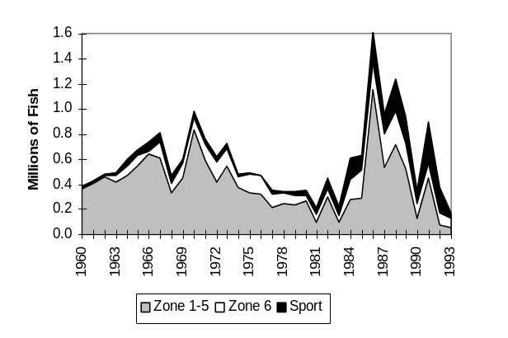

Figure 44. Total mainstem harvest by type (ODFW, WDFW, 1995).

In most years, coho and fall chinook comprise the majority of harvest (Figure 45). Since 1960, coho harvest has averaged 36% of the total while fall chinook has averaged 35%. Steelhead harvest represents about 16% of the total, but the number of steelhead harvested has been increasing for the past 10 years. Spring/summer chinook harvest has averaged 9% of the total since 1960, but only 2% of the total harvest since 1974.
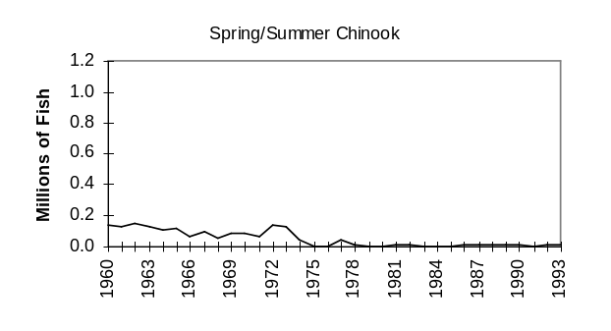
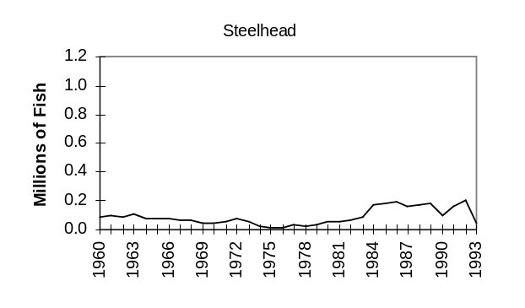
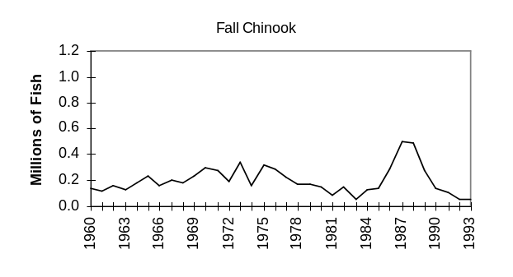
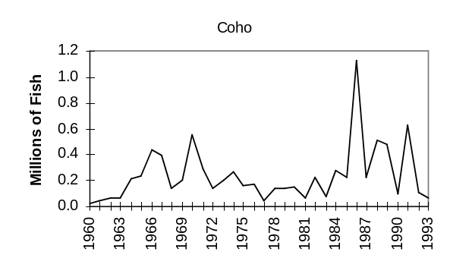
Figure 45. Total Columbia River harvest (including estuary) by species (ODFW, WDFW, 1995).
Average total harvest in the mainstem Columbia was around 550,000 in the 1960’s and 1970’s, rose to around 720,000 in the 1980’s, and has declined to about 440,000 so far in the 1990’s (Figure 46).

The allocation of that harvest has changed dramatically (Figure 46). The proportion of Columbia River harvest attributed to commercial fishing (zones 1-5) has declined from over 80% in the 1960’s to 40% in the 1990’s. Sport harvest has increased five-fold from 7% in the 1960’s to 37% in the 1990’s. Tribal harvest increased markedly from the 1960’s to the 1970’s (10%-21%) but has remained about constant since that time.
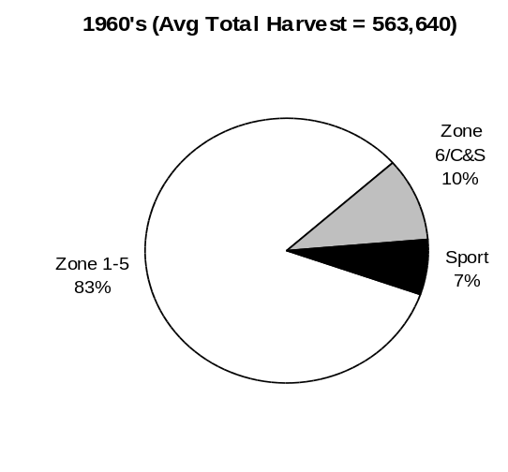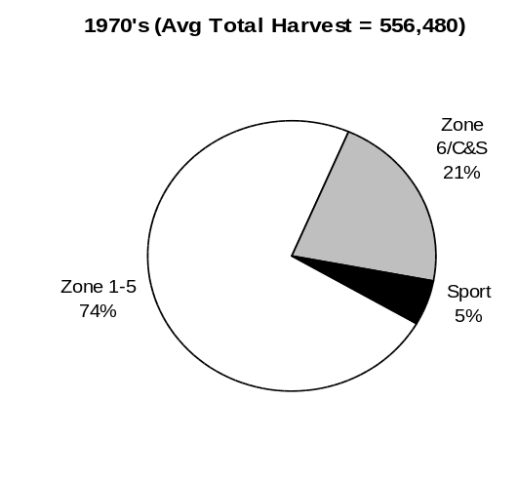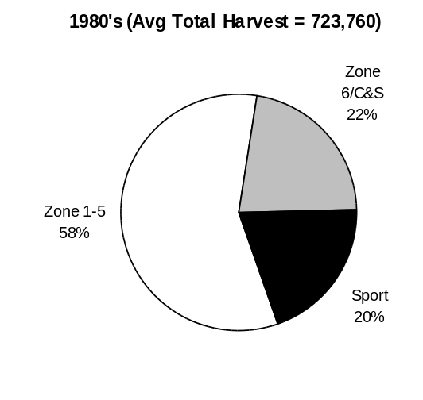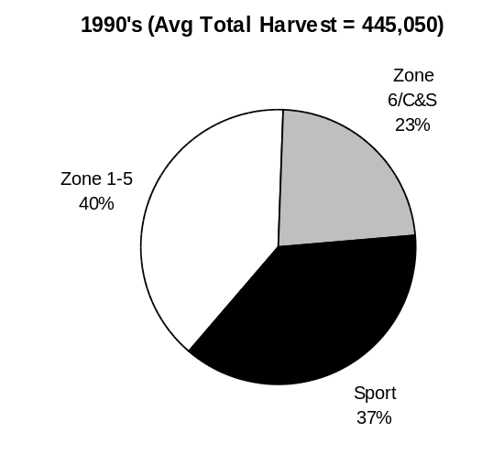

Figure 46. Average proportion of harvest (all species) for four time periods and three fisheries (ODFW and WDFW 1995). Total harvest values shown are in numbers of fish.

B. Tributary
Most harvest in tributaries is attributed to sport fishing. Sport harvest in the tributary systems is concentrated in subbasins below Bonneville Dam (Figure 47). Since 1975, sport harvest below Bonneville Dam has comprised, on average, nearly 71% of the total.
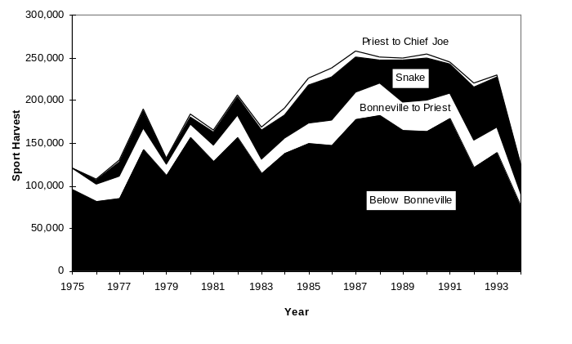
Figure 47. Tributary sport harvest of salmon and steelhead by Columbia River Region since 1975 (PSMFC 1996).

Species composition of the sport harvest is shown in Figure 48. Summer and winter steelhead comprise, on average, nearly 65% of the sport harvest in the Columbia River Basin. Spring chinook average about 24% of the catch while coho and fall chinook comprise about 7 and 3% respectively.
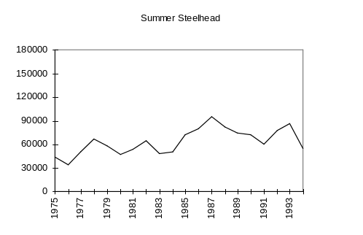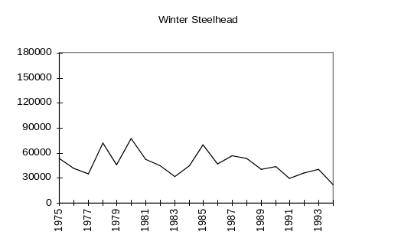
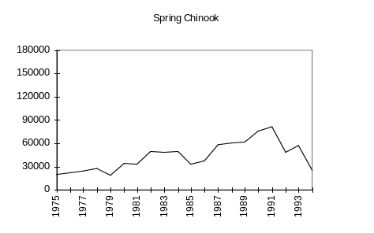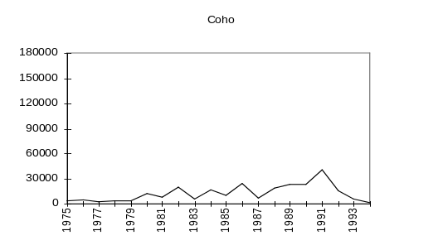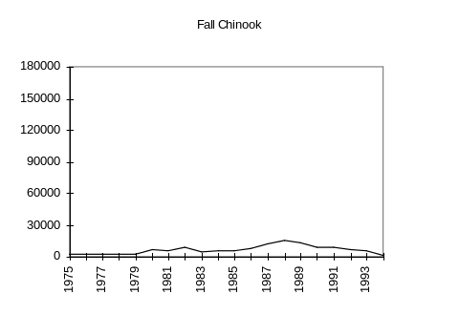
Figure 48. Total estimated sport harvest in Columbia River tributaries (PSMFC 1996).

C. Ocean
Ocean salmon harvest is regulated by the respective states within 3 miles of shore and by the Pacific Fishery Management Council (PFMC) from 3 to 200 miles from shore (PFMC 1995). PFMC divides the Washington, Oregon, and California coast into four management areas of which only the northern-most, Cape Falcon to the Canada border, affects Columbia River stocks (Figure 49). Landings and fishing effort between Cape Falcon and Canada were much reduced in 1994 over previous years (Figure 50). Some Columbia River stocks are also intercepted in Canadian and Alaskan fisheries (Table 22). Ocean exploitation rates in recent U. S. and Canadian ocean fisheries average 46-58% for tule chinook stocks, 24-39% for upriver bright chinook stocks, 24% for Willamette spring chinook, and less than 5% for upriver spring and summer chinook (Table 23).

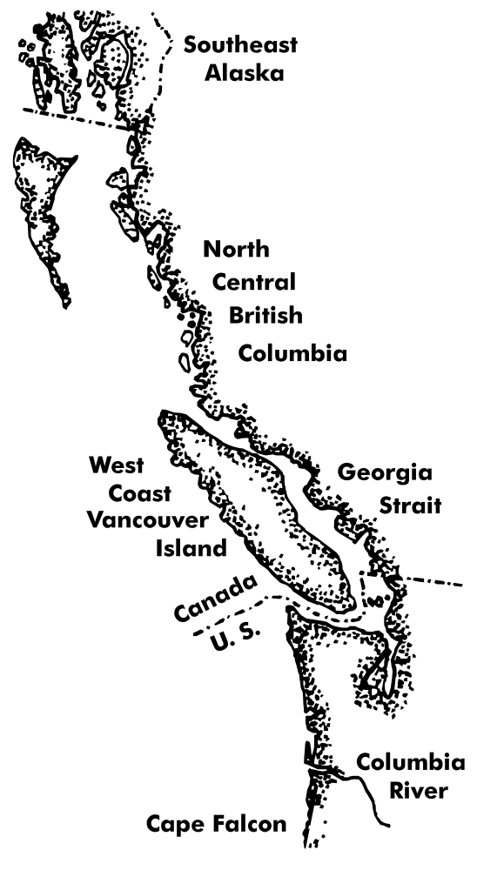
Figure 49. PFMC Ocean Salmon Harvest Management Areas.
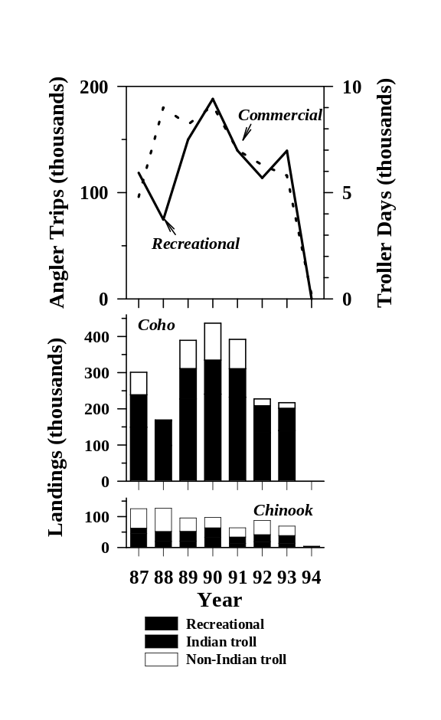

Figure 50. Annual landings of salmon and fishing effort in U. S. coastal waters north of Cape Falcon, Oregon (PFMC 1995).

Table 22. Distribution of catch in ocean fisheries (% of total) of Columbia Basin salmon and steelhead. Chinook salmon are denoted by age of juvenile migration (age 0 for fall chinook and age 1 for spring and summer chinook).
Fishery | Chinook 0  (tule)¹ | Chinook 0  (bright)² | Chinook 1  (spring)³ | Chinook 1  (summer)³ | Coho | Sockeye⁵ | Steelhead
PFMC
Recreational | 16 | 12 | <1 | <1 | --⁴ | 0 | 0
Troll | 21 | 6 | <1 | <1 | --⁴ | 0 | 0
PSC
W. Coast Vanc. Is. troll | 31 | 18 | <1 | <1 | --⁴ | 0 | 0
Georgia Strait troll | 1 | <1 | <1 | <1 | --⁴ | 0 | 0
Canadian recreational | 1 | 1 | <1 | <1 | --⁴ | 0 | 0
N. C. British Columbia | 4 | 13 | <1 | <1 | 0 | 0 | 0
S. E. Alaska | 2 | 17 | <1 | <1 | 0 | 0 | 0
¹Recent average for Cowlitz, Spring Creek, Bonneville, Stayton Pond indicator stocks (PSC 1994a).
²Recent average for Columbia River, Hanford wild, Lewis wild, and Lyons Ferry indicator stocks (PSC 1994a).
³ Inference from PSC indicator stocks for Columbia basin excluding the Willamette (Bohn, Oregon Department of Fish and Wildlife, personal comunication).
⁴Fishery takes coho salmon in an unknown proportion. (PSC 1994b)
⁵McIsaac, Oregon Department of Fish and Wildlife, personal communication.

Table 23. Pacific Salmon Commission chinook salmon indicator stocks from the Columbia Basin and brood year exploitation rates (%) in combined U.S. and Canada ocean fisheries (PSC 1994b). Rates less than 5% are inferred from low tag recovery rates (Bohn, Oregon Department of Fish and Wildlife, personal communication).
Stock | 1982 | 1983 | 1984 | 1985 | 1986 | 1987 | 1988 | 1989 | Average
Cowlitz Fall Tule | 46 | 37 | 40 | 48 | 43 | 39 | 47 | 66 | 46
Stayton Pond Tule | 64 | 63 | 59 | 66 | 59 | 52 | 43 | 55 | 58
Spring Creek Fall Tule | 42 | 38 | 50 | 56 | 48 | 52 | 43 | 57 | 48
Lewis Fall Bright (wild) | 27 | 33 | 23 | 25 | 25 | 24 | 26 | 12 | 24
Upriver Fall Bright | 36 | 42 | 40 | 39 | 42 | 32 | 41 | 37 | 39
Hanford Fall Bright (wild) |  |  |  |  | 32 | 49 | 31 | 45 | 39
Lyons Ferry Fall Bright |  |  | 38 | 37 | 46 | 25 | 27 | 30 | 34
Willamette Spring | 24 | 36 | 25 | 16 | 21 | 19 | 21 |  | 24
Leavenworth Spring | <5 | <5 | <5 | <5 | <5 | <5 | <5 | <5 | <5
Rapid River Spring | <5 | <5 | <5 | <5 | <5 | <5 | <5 | <5 | <5
Sawtooth Spring | <5 | <5 | <5 | <5 | <5 | <5 | <5 | <5 | <5
McCall Summer | <5 | <5 | <5 | <5 | <5 | <5 | <5 | <5 | <5

D. Value

Economic values of salmon fisheries can be described by prices paid to commercial fishers for their landings (exvessel value) and total personal income associated with fisheries. Exvessel values in 1994 were only 24% of the 1981-93 average for combined commercial fisheries for salmon and steelhead in the U.S. controlled portion of the ocean and in the Columbia River (Table 24). Personal income values in 1994 were only 30% of the 1986-93 average for combined U.S. ocean salmon fisheries (Table 25).

Table 24. Exvessel values (nominal dollars in thousands) of salmon (coho and chinook) landed by non-Indian ocean troll (PFMC 1995) and salmon (chinook, coho, sockeye, chum) and steelhead landed by inriver fisheries (ODFW and WDFW 1995).
Year | Ocean  California | Ocean  Oregon | Ocean  Washington | Inriver  Non-Indian | Treaty  all gears | Total
1981 | 14,322 | 9,573 | 5,921 | 1,831 | 1,107 | 32,754
1982 | 19,489 | 9,895 | 6,730 | 3,301 | 836 | 40,251
1983 | 4,608 | 2,296 | 1,465 | 891 | 482 | 9,742
1984 | 7,562 | 1,595 | 410 | 3,648 | 2,076 | 15,291
1985 | 11,515 | 5,774 | 1,601 | 3,190 | 1,773 | 23,853
1986 | 15,112 | 7,954 | 1,175 | 9,263 | 2,082 | 35,586
1987 | 25,623 | 16,763 | 1,960 | 11,266 | 5,569 | 61,181
1988 | 41,927 | 21,536 | 2,337 | 19,724 | 7,892 | 93,416
1989 | 13,485 | 10,025 | 1,230 | 5,202 | 2,160 | 32,102
1990 | 12,056 | 6,641 | 1,648 | 2,781 | 2,356 | 25,482
1991 | 9,047 | 3,120 | 1,126 | 3,625 | 787 | 17,705
1992 | 4,505 | 2,712 | 1,299 | 889 | 778 | 10,183
1993 | 5,707 | 1,671 | 795 | 562 | 504 | 9,239
1994 | 5,934 | 689 |  | 534 | 437 | 7,594

Table 25. Estimates of coastal community and state personal income impacts (thousands in 1994 dollars) of the troll and recreational ocean salmon fisheries (PFMC 1995).
 |  | Troll |  |  | Sport
Year | Calif. | Oregon | Wash. | Calif. | Oregon | Wash. | Total
1986 | 46,636 | 22,852 | 3,182 | 17,284 | 11,797 | 8,989 | 110,740
1987 | 71,791 | 43,188 | 4,817 | 22,774 | 16,175 | 8,346 | 167,091
1988 | 112,460 | 51,830 | 5,447 | 21,047 | 16,066 | 5,419 | 212,269
1989 | 35,784 | 24,626 | 3,143 | 21,625 | 16,679 | 9,731 | 111,588
1990 | 29,880 | 14,904 | 3,745 | 20,008 | 15,388 | 11,832 | 95,757
1991 | 22,019 | 7,447 | 2,515 | 16,160 | 11,723 | 8,250 | 68,114
1992 | 10,423 | 5,857 | 2,731 | 10,698 | 9,880 | 7,017 | 46,606
1993 | 13,441 | 3,503 | 1,671 | 14,677 | 4,772 | 7,824 | 45,888
1994 | 13,866 | 1,401 | 30 | 14,990 | 1,410 | 0 | 31,697

7. Mitigation Efforts

A. Bonneville Power Administration

BPA is the primary parties involved with mitigation activities in the Columbia River Basin. BPA’s fish protection, restoration, and enhancement projects in the Basin have totaled nearly $370 million from 1981-1993 with funding distributed throughout the Basin (Figure 51).
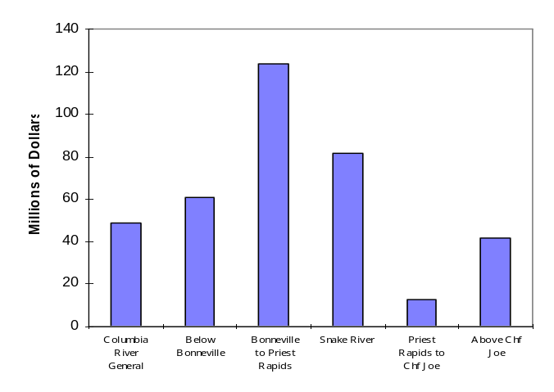
Figure 51. Total BPA obligations by region from 1981-1993 (PSMFC 1996, data provided by BPA)

The types of projects funded and the amount spent have changed dramatically since 1990 (Figure 52). Total spending for 1995 is over $80 million dollars on over 200 projects.
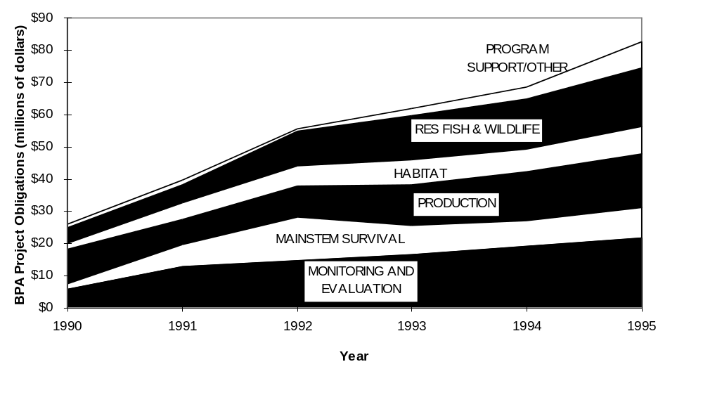
Figure 52. Total project dollars spent since 1990 by Bonneville Power Administration (PSMFC 1996, data provided by BPA).

B. U.S. Army Corps of Engineers

The U.S. Army Corps of Engineers is another major player in anadromous fish mitigation activities in the Columbia Basin. Primary activities funded by the Corps include project modifications aimed at improving juvenile and adult fish passage, hatcheries (Lower Snake River Compensation Program), research, spillway modifications, and juvenile fish transportation. Through fiscal year 1987, the Corps has spent nearly $545 million in the Columbia Basin on fish mitigation measures (Figure 53, Mighetto 1994).
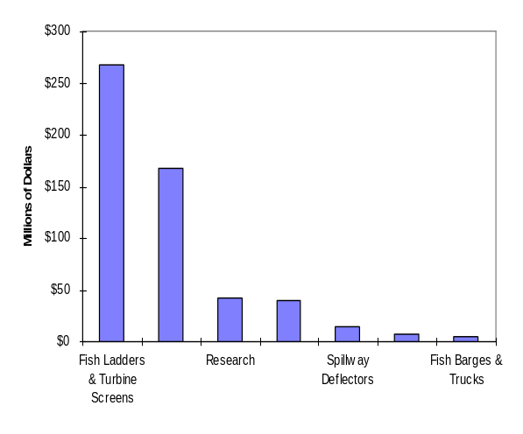
Figure 53. U.S. Army Corps of Engineers Lower Columbia / Snake Rivers Existing Fish Mitigation and Capital Costs Through Fiscal Year 1987.
Research activities have been funded by the Corps since 1953 with total research expenditures exceeding $63 million through 1993 (Figure 54, Mighetto 1994).
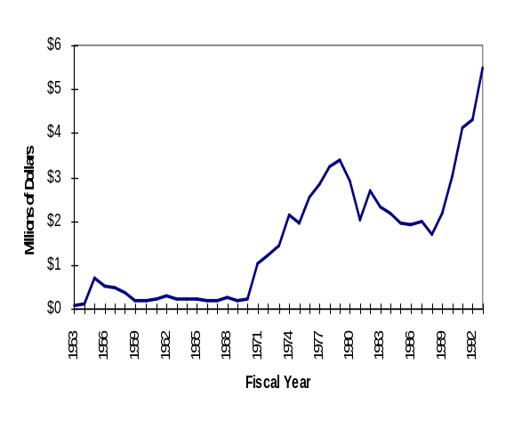
Figure 54. North Pacific Division, Corps of Engineers Fish Passage Development and Evaluation Program (FPDEP) Fisheries Research Expenditures.

Corps expenditures for the operation, maintenance, and research operations for Lower Snake River Compensation Program (LSRCP) hatcheries currently exceed $12 million per year (Figure 55).

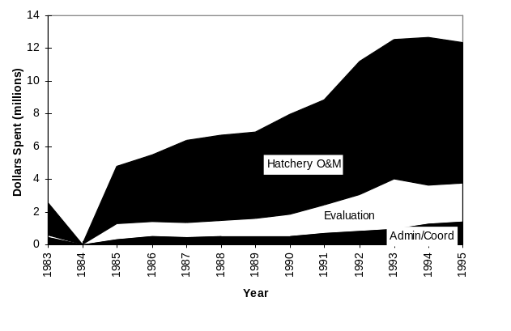
Figure 55. Lower Snake River Compensation Program (LSRCP) funding levels by major activity (Crateau 1996).

C. Mitchell Act

The Mitchell Act, passed by Congress in 1938, funds state and federal hatcheries on the lower Columbia River. Its objective was to offset the impacts to fish resulting from the construction of Bonneville and Grand Coulee Dams, as well as the effects of logging and pollution (Mighetto 1994). Funds are also used to pay for large irrigation diversion screening programs. The Columbia River Fisheries Development Program (CRFDP) was authorized under the Mitchell Act in 1949 and is currently administered by the Environmental and Technical Services Division (ETSD) of the National Marine Fisheries Service (NMFS) in Portland. The CRFDP is a cooperative effort between NMFS and the Oregon Department of Fish and Wildlife (ODFW), the Washington Department of Fish and Wildlife (WDFW), Idaho Department of Fish and Game (IDFG), and the U.S. Fish and Wildlife Service (Delarm 1990). Between 1949 and 1989, the program has expended over $183 million dollars, primarily on the construction and operation of hatcheries (Figure 56). The program is currently authorized to expend approximately $10 million dollars per year.
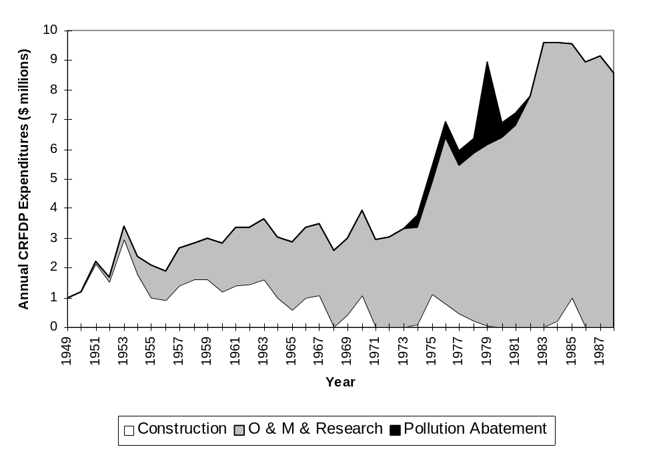
Figure 56. Funds expended by the Columbia River Fisheries Development Program from 1949 through 1988 (Delarm 1990).

8. Bibliography Of 1995 Research And Project Publications

Ainsworth, B.D., May, D., Aplanalp, D., and Hills, K. 1995. Magic Valley Fish Hatchery 1993 Brood Year .
Alexandersdottir, M., Cox, P., and Beeghley-White, W. 1995. Washington state sport catch report for foodfish 1993. Washington Department of Fish and Wildlife, Olympia, WA.
Allen, D., Flatter, B.J., and Fite, K. 1995. Redband Trout (Oncorhynchus mykiss gairdneri) Population And Habitat Surveys In Jump, Reynolds, And Sheep Creeks, And Sections Of The Owyhee County, Idaho.
American Fisheries Society, University of Idaho, and American Fisheries Society 1995. Salmon Management In The 21st Century: Recovering Stocks In Decline.
Basham, L.R. 1995. Adult Fishway Inspections on the Columbia and Snake Rivers.
Beamesderfer, R.C.P., North, J.A. 1995. Growth, natural mortality, and predicted response to fishing for largemouth and smallmouth bass populations in North America. North American Journal of Fisheries Management. 15:688-704.
Beamesderfer, R.C.P., Rien, T.A., and Nigro, A.A. 1995. Differences in the dynamics and potential production of impounded and unimpounded white sturgeon populations in the lower Columbia River. Transactions of the American Fisheries Society. 124:857-872.
Beeghley-White, W., Barbour, S., and Milward, D. 1995. 1991 Ocean Sampling Program Annual Report .
Bennett, D.E., Foster, C.A. 1995. 1994 Willamette River spring chinook salmon run, fisheries, and passage at Willamette Falls, draft. Unpublished.
Berger 1995. Hellsgate Winter Range Mitigation Project: Long-term Management Plan.
Bonneville Power Administration 1995. Snake River Sockeye Salmon Sawtooth Valley Project Conservation And Rebuilding Program.
Bonneville Power Administration 1995. Draft Supplemental Environmental Assessment Snake River Sockeye Salmon Sawtooth Valley Project Conservation And Rebuilding Program.
Bradbury, B. 1995. Handbook for Prioritizing Native Salmon and Watershed Protection and Restoration. (In review).
Byrne, J. 1995. Stock Characteristics And Hatchery Investigations Of Anadromous Fish At Beaver Creek And Skamania Hatcheries.
Chapman, J., Elmore, R. 1995. Niagara Springs Fish Hatchery 1993 Steelhead Brood Year Report .
Contor, C.R., Hoverson, E., and Kissner, P. 1995. Umatilla basin natural production monitoring and evaluation, Annual progress report 1993-1994. Bonneville Power Administation, Portland OR.
Cooney, C.X., Jacobs, S.E. 1995. Oregon coastal salmon spawning surveys, 1993. Oregon Department of Fish and Wildlife, Portland, OR.
Cross, D., Everson, L. 1995. Fish habitat attributes of reference and managed watersheds with special reference to the location of bull charr (Salvelinus confluentus) spawning sites in the upper Spokane River ecosystem, northern Idaho.
Elms-Cockrum, T.J., Kiefer, S., and Petrosky, C.E. 1995. Salmon spawning ground surveys, 1995 (draft only). Idaho Dept. of Fish and Game, Boise, ID.
Elms-Cockrum, T.J., Leitzinger, E., and Petrosky, C.E. 1995. Salmon spawning ground surveys, 1994. Idaho Dept. of Fish and Game, Boise, ID.
Ewing, R.D., Buchanan, D.V., and Wade, M. 1995. Effect of Hatchery Lighting on Smolting, Migration, and Survival of Steelhead. Oregon Department of Fish and Wildlife.
Gessel, M., Sandford, B., and Dey, D.B. 1995. Studies to evaluate the effectiveness of extended-length screens at Little Goose Dam, 1994.
Gillis, A.M. 1995. What's at stake in the Pacific Northwest salmon debate?.
Hislop, J.R. 1995. Oxbow Fish Hatchery 1993 Steelhead Brood Year Report 1992 Spring Chinook Brood Year Report.
Iwamoto, Muir, W.D., Sandford, McIntyre, Frost, Williams, Smith, and Skalski, J.R. 1995. Survival Estimates For The Passage Of Juvenile Chinook Salmon Through Snake River Dams And Reservoirs, 1994.
McArthur, T. 1995. Total number of resident and on resident steelhead anglers, days fished, fish caught, and catch rate in spring 1995 by section and drainage. Idaho Dept. of Fish and Game, Boise, ID.
McKibben, B. 1995. A refuge without borders.
McPherson, D.E., Munson, D. 1995. Mccall Fish Hatchery 1992 Summer Chinook Salmon Brood Year Report .
Melcher, C.E., Watts, J.W. 1995. The 1994 Lower Columbia River and Buoy 10 recreational fisheries. Oregon Department of Fish and Wildlife, Columbia River Management, Clackamas, OR.
Miller, S.,Wells Dam Pud, Leslie Sikora 1995. Annual Counts And Period Of Counting Of Salmon And Steelhead Trout At Wells Dam With Updates For 1992-1994.
Mobrand, L.E., Lichatowich, J.A. 1995. Analysis of Chinook salmon in the Columbia River from an ecosystem perspective.
Moore, B., Engemann, D. 1995. Pahsimeroi Hatchery 1992 Brood Year Report, Summer Chinook.
Muir, Smith, Iwamoto, Kamikawa, McIntyre, Hockersmith, Sanford, Ocker, Ruehle, Willams, and Skalski 1995. Survival Estimates for the Passage of Juvenile Salmonids through Snake River Dams and Reservoirs, 1994.
Muir, W.D., Smith, S.G., Iwamoto, R.N., Kamikawa, D.J., McIntyre, K.W., Hockersmith, E.E., Sandford, B.P., Ocker, P.A., Ruehle, T.E., Williams, J.G., and Skalski, J.R. 1995. Survival estimates for the passage of juvenile salmonids through Snake River dams and reservoirs, 1994 Annual Report. DOE/BP-10891-2, March 1995.
Mundy, P.R., Fryer, J.K. 1995. Abundance based criteria for recognition of damaged salmon populations, pp. 202-212.
National Marine Fisheries Service 1995. Life-Cycle and Passage Model Analyses Considered in Evaluating Effects of Actions during Reinitiation of Consultation on the Biological Opinion on 1994-1998 Operation of the Federal Columbia River Powe.
National Marine Fisheries Service 1995. Proposed Recovery Plan for Snake River Salmon. Summary. March 1995.
National Marine Fisheries Service 1995. Economics of Snake River Salmon Recovery. A Report to the National Marine Fisheries Service. February 1995..
Noss, R.F., LaRoe, E.T., and Scott, J.M. 1995. Endangered ecosystems of the United States: A preliminary assessment of loss and degradation.
Olsen, E.A., French, R.A., and Ritchey, A.D. 1995. Hood River and Pelton Ladder evaluation studies, Annual report 1994, Draft. Oregon Department of Fish and Wildlife, Portland, OR.
Oregon Department of Fish and Wildlife, Washington Department of Fish and Wildlife 1995. Status Report, Columbia River fish runs and fisheries, 1938-1994. Washington Department of Fish and Wildlife, Olympia, WA.
Oregon Department of Fish and Wildlife 1995. Oregon Coho Salmon Biological Status Assessment And Staff Conclusion For Listing Under The Oregon Endangered Species Act.
Pacific Fisheries Management Council 1995. Review of 1994 ocean salmon fisheries. Pacific Fishery Management Council.
Pacific Fisheries Management Council 1995. Preseason Report I. Stock abundance analysis for 1995 ocean salmon fisheries. (includes Data Synopsis of ocean salmon Fisheries off Washington, Oregon and California..
Pacific Fisheries Management Council 1995. Preseason Report II: Analysis of Proposed Regulatory Options for 1995 Ocean Salmon Fisheries.
Parker, R.M., Zimmerman, M.P., and Ward, D.L. 1995. Variability in biological characteristics of northern squawfish in the lower Columbia and Snake Rivers. Transactions of the American Fisheries Society. 124:335-346.
Pascual, M.A., Quinn, T.P. 1995. Geographical patterns of straying of fall chinook salmon, Oncorhynchus tshawytscha (Walbaum), from Columbia River (USA) hatcheries.
Peterson, D., Cayan, D., DiLeo, J., Noble, M., and Dettinger, M. 1995. Role of climate in estuarine variability.
Pettit, R. 1995. Escapement database for spring chinook in Washington tributaries above Bonneville Dam, 1970-1994. Washington Department of Fish and Wildlife, Battleground, WA..
Phelps, S.R., LeClair, L.L., Young, S., and Blankenship, H.L. 1995. Genetic diversity patterns of chum salmon in the Pacific Northwest.
Platts, W.S., Hill, M.T., and Hopkins, I.A. 1995. Historical trends in bull trout abundance in Idaho, Montana, Oregon and Washington.
Public Power Council 1995. Public Power Fundamentals. Portland, Oregon.
Riley, S.C., Elms-Cockrum, T.J. 1995. Salmon spawning ground surveys, 1993. Idaho Dept. of Fish and Game, Boise, ID.
Roler, R. 1995. Summary of upriver returns above McNary Dam and in the Deschutes River, 1993. Washington Department of Fisheries, Battle Ground, WA.
Roler, R. 1995. Summary of upriver returns above McNary Dam and in the Deschutes River, 1992. Washington Department of Fish and Wildlife, Battleground, WA.
Schmitten, R., Stelle, J.W., and Jones, J.R.P. 1995. Proposed recovery plan for Snake River salmon.
Starke, G., Dalen, J. 1995. Pacific Lamprey (Lampetra Tridentata) Passage Patterns Past Bonneville Dam and Incidental Observations of Lamprey at the Portland District Columbia River Dams in 1993.
Stephens, G. 1995. Staus And Analysis Of Salmonid Fisheries, Project F-73-R-16, Subproject Ii, Study Iv, Job 5. Sensitive Species.
Thiesfeld, S.L., Stuart, A.M., Nolte, D.A., Buckman, M.A., and Ratliff, D.E. 1995. Angler Surveys on Lake Billy Chinook, Oregon, 1990-1993. Oregon Department of Fish and Wildlife.
U.S. Army Corps of Engineers 1995. Columbia River Treaty Fishing Access Sites. Draft Phase Two Evaluation Report. Technical Appendices. January 1995.
U.S. Army Corps of Engineers 1995. The Dalles and John Day Dams North Ladder Entrance Spill Attraction Flow Evaluation. January 1995.
U.S. Army Corps of Engineers 1995. Columbia River Treaty Fishing Access Sites. Draft Phase Two Evaluation Report and Environmental Assessment. January 1995.
U.S. Bureau of Reclamation 1995. Agricultural Crop Water Use Summary 1988-1994..
Underwood, Martin, Schuck, and Scholz 1995. Investigations of Bull Trout (Salvelinus) Confluentus), Steelhead Trout (Oncorhynchus Mykiss), and Spring Chinook Salmon (O.Tshawytscha) Interactions in SE Washington Streams.
Waples, R.S., Do, C. 1995. Genetic risk associated with supplementation of Pacific salmonids: captive broodstock programs.
Ward, D.L., Petersen, J.H., and Loch, J. 1995. Index of predation on juvenile salmonids by northern squawfish in the lower and middle Columbia River and in the lower Snake River. Transactions of the American Fisheries Society. 124:321-335.
Warren, C.D., Partridge, F.E. 1995. Salmon Falls Creek Fish Inventory.
Williams, R.N., Evans, R.P., and Shiozawa, D.K. 1995. Mitochondrial DNA diversity in bull trout from the Columbia River Basin.
Willis C.F, and Ward,D.L. 1995. [ed.] Development of a systemwide program: Stepwise implementation of a predation index, predator control fisheries, and evaluation plan in the Columbia River Basin. Bonneville Power Administration.
Young, M.K. 1995. Conservation assessment for inland cutthroat trout.
Zimmerman, M.P., Parker, R.M. 1995. Relative density and distribution of smallmouth bass, channel catfish, and walleye in the lower Columbia and Snake rivers. Northwest Science. 69:19-28.

9. Example Populations
Example populations for which detailed information is presented were selected from areas where information was readily available (Figure 57). Future editions of this annual report will expand this section to include key populations from throughout the Basin including all index populations for listed endangered species.

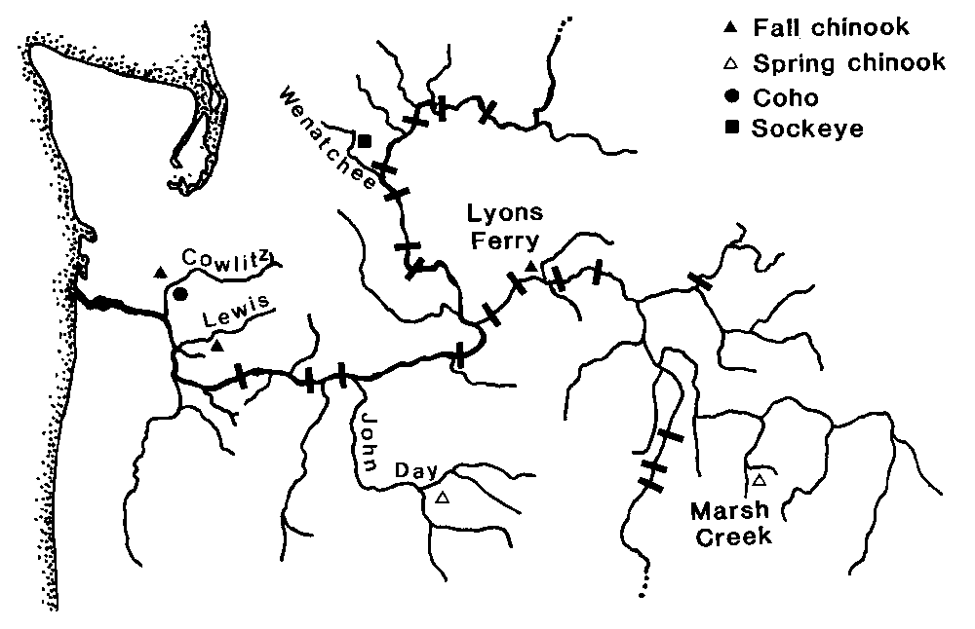
Figure 57. Locations of sample populations included in this report.

Cowlitz Hatchery Coho
Distribution: Presently, most Cowlitz River coho are of hatchery origin. Mayfield Dam has blocked tributaries above river mile (RM) 52 since 1968 but natural production still occurs in several small tributaries of the lower Cowlitz including Olequa, Lacamas, Ostrander, Blue, Otter, Brights, Mill, Arkansas, Foster, and Hill creeks. Adults are also released each year to spawn in the Tilton and upper Cowlitz rivers.
Abundance: The Washington Department of Fisheries estimated coho escapement at about 32,500 fish in 1951. Coho counts past Mayfield from 1961-66 averaged 24,579. Hatchery-produced returns averaged 24,997 adults and 9,723 jacks in 1980-94 with a peak of 54,685 adults in 1986 and 19,178 jacks in 1987. The Northwest Power Planning Council's model estimated smolt production capacity of 123,123 for the lower Cowlitz River, 131,318 for Tilton River and Winston Creek, and 155,018 for above Cowlitz Falls.
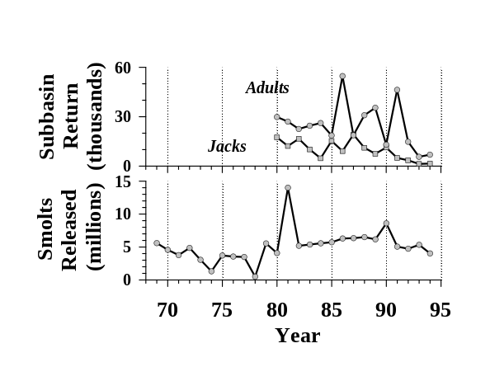
Hatchery Production: Hatchery coho have been planted in the subbasin since at least 1915, from the Tilton River Hatchery which operated downstream of Morton until 1921. A salmon hatchery also operated in the upper Cowlitz near the mouth of the Clear Fork until it was abandoned in 1949 because of low water temperatures. Cowlitz Hatchery, completed in 1967, produces about 4.8
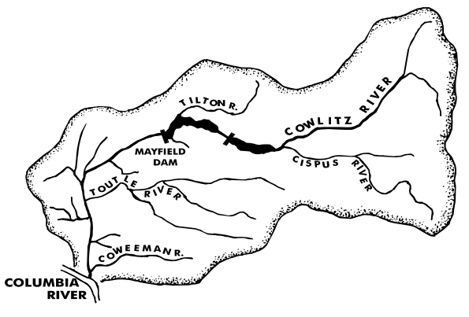
million yearling smolts annually. More than 15,700 coho were also released upstream from the Cowlitz Hatchery annually to spawn naturally from 1967 through 1971.
Harvest: Coded-wire tag recoveries of the 1982 brood late coho revealed that most of the ocean catch occurred in Washington (26%) and Oregon (11%) followed by British Columbia (7%) and California (0.1%). Columbia River fisheries accounted for an additional 37% of the total harvest. Escapement was 20% overall. Harvest rates have averaged 79% and 85% for Type-S and N stocks, respectively, between 1983 and 1987. Harvest of Type-S coho is occasionally constrained by fall chinook. Harvest of Type-N coho is rarely constrained by weak stocks.
Habitat: The Mt. St. Helens eruption in 1980 severely affected spawning areas downstream from the mouth of the Toutle River at RM 20. Habitat quality has also been significantly degraded by land use and development. Spring flows have been generally less than average since 1975.
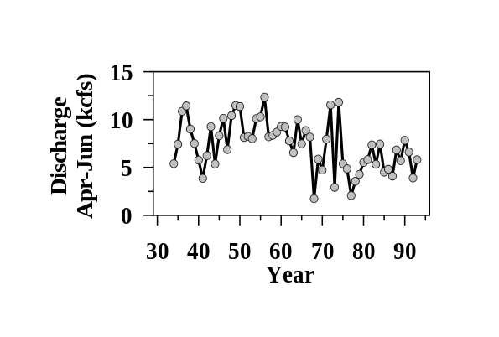

Cowlitz Fall Chinook
Distribution: Fall chinook historically occurred from near the mouth to upper tributaries including the Ohanapecosh and Tilton rivers. Completion of Mayfield Dam at RM 52 in 1968 blocked fish migration into upper Cowlitz River tributaries and eliminated 37% of spawning areas based on redd count distribution. Fall chinook continue to spawn naturally in the Cowlitz mainstem with most spawning occurring between the Cowlitz salmon (RM 52) and Cowlitz trout hatcheries (RM 41.3)
Abundance: In 1951, an estimated 10,900 fall chinook returned to the Cowlitz mainstem, plus 500 to the Tilton River. Run size declined to an average of 5,992 adults and 2,543 jacks at Mayfield Dam in 1961-66. Hatchery produced returns averaged 6,470 adults and 935 jacks in 1980-94 building to peaks of 13,798 adults in 1988 and 3,348 jacks in 1985. Numbers of naturally-spawned fish in the basin averaged 3,876 adults and 254 jacks in 1981-94.
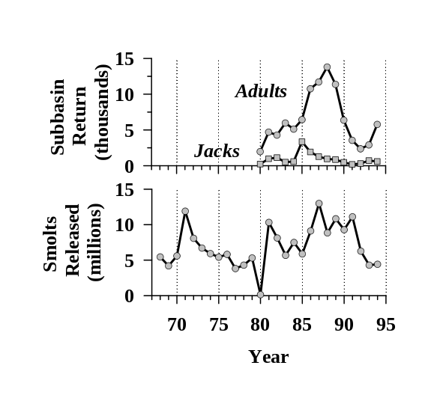
Hatchery Production: The Cowlitz Salmon hatchery was completed in 1967 to mitigate for upstream habitat losses. Fall chinook broodstock are collected from the Cowlitz Salmon Hatchery barrier dam except for some of the fish planted in 1968 (Toutle),
1971 (Kalama), and 1981 (Big Creek, Kalama, Bonneville). Hatchery and natural fall chinook are not separated during broodstock collection and both also spawn naturally. Cowlitz Salmon Hatchery mitigation goals include 8,300 fall chinook. Original hatchery designs called for 10 million fall chinook juveniles (66,400 lb.).
Harvest: Coded-wire tag recoveries of 1985-86 brood in the ocean catch were mostly in Washington (18%) and British Columbia (14%), followed by Oregon (11%) and Alaska (3%). Columbia River fisheries accounted for an additional 24% of the total harvest. Escapement was 31%.
Habitat: The Mt. St. Helens eruption in 1980 severely affected spawning areas downstream from the Toutle River mouth at RM 20. Habitat quality has also been significantly degraded by land use and development. Spring flows have been generally less than average since 1975.

Lewis Fall Chinook
Distribution: Fall chinook historically occurred from near the mouth to the upper tributaries. With the construction of Merwin Dam in 1931, the majority of the spawning reaches became inaccessible. Fall chinook continue to spawn naturally in the North Fork Lewis River with most spawning occurring between the Lewis River Hatchery (RM 12) to Merwin Dam (RM 16).
Abundance: Current fall chinook production is entirely natural in the North and East Fork Lewis rivers. Natural spawning escapement in the North Fork Lewis River from 1967-94 return years averaged 10,974 adults and 2,045 jacks, with a peak of 21,199 adults in 1989 and 17,596 jacks in 1970. The number of wild juvenile fall chinook that migrated from the North Fork Lewis River between 1977-87 (excluding 1980 and 1981) has averaged 2,786,667 and ranged from a low of 1,540,000 for the 1986 brood and a peak of 4,650,000 for the 1983 brood (estimates are based on simple Peterson recapture method using coded wire tags recovered from adult returns).
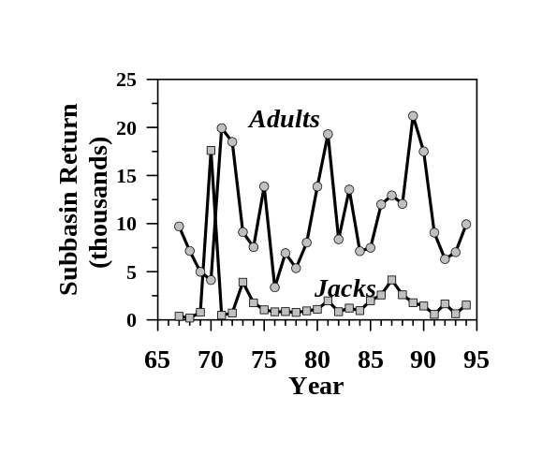
Hatchery Production: North Fork Lewis River hatchery production of fall chinook have been inconsistent in terms of numbers and types of releases. Some release
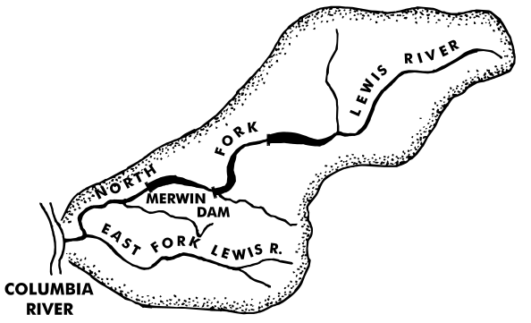
groups were for experimental rather than production purposes. Since 1971, progeny releases from adults collected at Merwin Dam did not exceed 550,000 fingerlings and typically ranged from 50,000 to 150,000 fish. Most of those releases were offspring of an early spawning segment of the run. No fall chinook have been planted since 1985.
Harvest: A harvest profile of Lewis River wild fall chinook based on coded-wire tag recoveries of the 1985-1986 brood fall chinook revealed that most of the ocean catch occurred in British Columbia (14% percent) and Washington (5%), followed by Alaska (4%) and Oregon (3%). Columbia River fisheries accounted for an additional 13% of the total harvest. Escapement was 62% overall.
Habitat: Habitat quality has been significantly degraded by land use, development, and dams since the mid-1900's. Spring flows have generally decreased during the last 60 years.
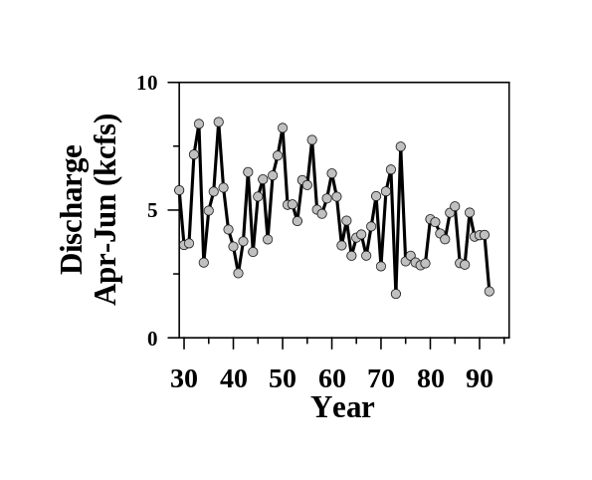

Lyons Ferry Fall Chinook
Distribution: The Lyons Ferry Hatchery is located at the confluence of the Palouse River with the lower Snake River at RM 56.2. Fall chinook salmon are hatched and reared at the Lyons Ferry facility and either released on station or barged downstream and released.
Abundance: Hatchery produced returns averaged 1,312 adults and 913 jacks in 1984-94 building to a peak of 3,267 adults in 1987 and 4,160 jacks in 1985.
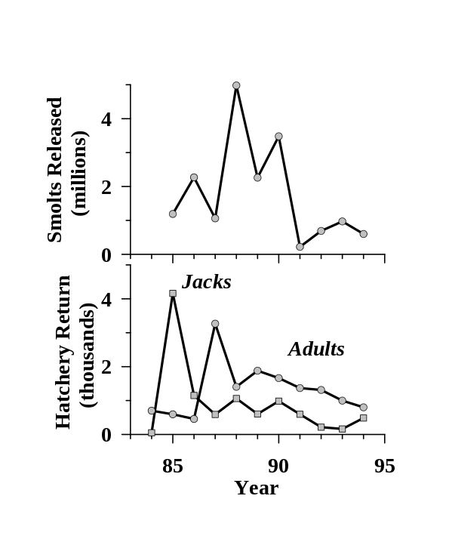
Hatchery Production: The objectives of the Lyons Ferry Fish Hatchery under the Lower Snake River Compensation Plan are to compensate for the losses of 18,300 fall chinook, Snake River stock. The facility has a single pass well water system through the incubators, two adult holding ponds, and 28 raceways. Design capacity is 101,800 pounds of fall chinook. Adult fall chinook salmon return to the fish ladder at the Lyons Ferry facility for brood stocks. Numbers of fall chinook salmon returning to the Lyons Ferry Fish Hatchery ladder are increasing. On-station releases since 1985 are returning as
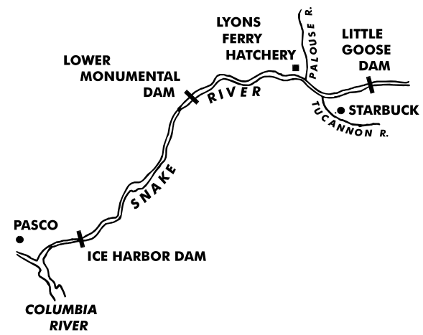
adults. As of 1987, voluntary returns to the hatchery have been the primary source of brood stock. Prior to completion of the Lyons Ferry Fish Hatchery, a portion of the Snake River stock fall chinook salmon adults were collected and reared at the Kalama Falls Fish Hatchery on the lower Columbia River as part of the Snake River Fall Chinook Egg Bank Program. When the Lyons Ferry facility was completed, eyed eggs were transported from the Kalama Falls Fish Hatchery to Lyons Ferry for rearing and subsequent release. Hatchery staff transported 219,800 1984 brood eggs, 1,182,000 1985 brood eggs, and 749,355 1986 brood eggs from Kalama Falls Fish Hatchery.
Harvest: Ocean commercial and recreational fisheries from Alaska to Washington, in addition to Columbia River treaty, non-treaty and sport fisheries all harvest a portion of the Snake River fall chinook.

John Day Spring Chinook
Distribution: Current natural spawning areas include portions of the upper mainstem, middle fork mainstem, north fork mainstem, and Granite Creek which is a tributary of the North Fork (Lindsay et al. 1986).
Abundance: Average redd counts in index areas ranged between 2.6 per km in 1959 and 22.2 per km in 1962 (Lindsey et al. 1986). Escapement to the subbasin averaged 2,100 adults and jacks during 1979-94 (TAC 1994). Recruit per spawner ratios (to spawning grounds) remained below replacement levels for an extended period during the 1970’s (Petrosky et al. 1996).
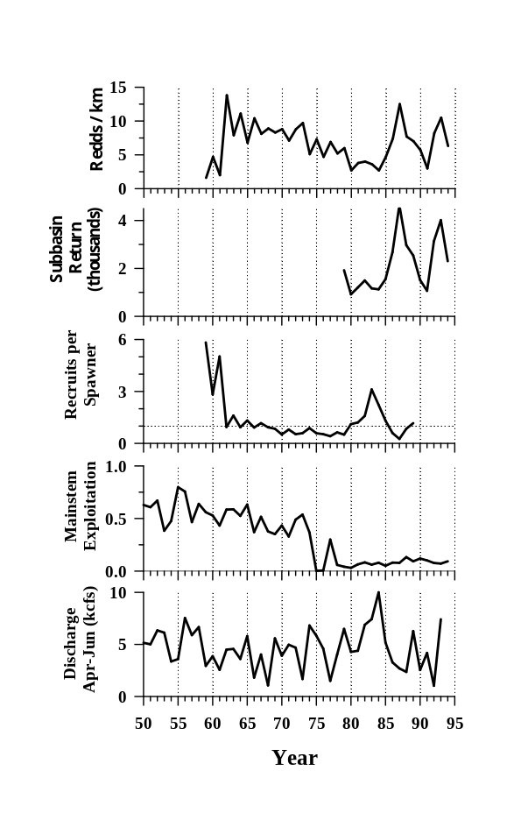
Hatchery production: Hatchery-reared spring chinook salmon have never been released into the John Day River subbasin (ODFW et al. 1990).
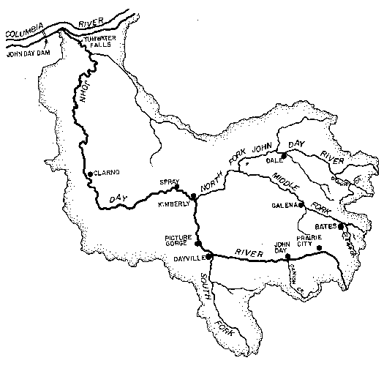
Harvest: John Day spring chinook are taken in ocean and Columbia River mainstem sport, commercial, and tribal fisheries. Ocean exploitation rates rarely exceed 5%. Mainstem exploitation rates for spring chinook including the John Day population have declined from an average of 52% during 1950-74 to an average of 8% from 1975-94 as fisheries were curtailed to protect weak stocks (ODFW and WDFW 1995). Small numbers (0-41 per year) have also been harvested in the basin by the Umatilla Tribe since 1986. Sport fisheries for spring chinook in the subbasin have been closed since 1978.
Habitat: Average spring discharge has ranged from 1 to 10 kcfs over the last 40 years. Spawning and rearing habitat for spring chinook has been degraded and fragmented by extensive water withdrawal, grazing, mining, and logging (Lindsay et al. 1986, OWRD 1986, Wissmar et al. 1994). Habitat quality remains high in wilderness areas of the north fork mainstem and Granite Creek. High summer water temperatures (>25°C) limit fish production in the upper mainstem and middle fork, which flow mainly through agricultural lands. Screens are currently maintained on several hundred water diversions. Significant habitat improvement efforts began on federal lands in 1973 and on private lands in 1984.

Marsh Creek Spring Chinook
Distribution: Spring chinook occur in 28 tributaries throughout the Middle Fork Salmon River (MFSR) drainage (Mallet 1974). In the Marsh Creek drainage, they spawn in Marsh, Beaver, Cape Horn and Knapp creeks (Elms-Cockrum, et al. in press).
Abundance: Spawning escapements for the Marsh Creek drainage during 1957-1969 ranged from 180 to 1,290 adults (Petrosky et al. 1996). Estimated recruits to the Columbia River mouth from these brood years ranged from 1,236 to 6,620. As with other Snake River stocks, the population productivity declined and became more variable following construction of the lower Snake River dams (Petrosky and Schaller 1992). Recent spawning escapements (brood years 1975-1994) were much reduced, ranging from 16 to 491; no redds were found in the Marsh Creek drainage during the 1995 spawning ground survey (IDFG unpublished data).
Hatchery Production: The entire MFSR is managed for wild, native spring and summer chinook and steelhead (Kiefer et al. 1992). Only one experimental release of hatchery chinook has been made into the MFSR drainage (Matthews and Waples 1991; 22,000 nonindiginous spring chinook fry into Cape Horn Creek in 1975 by University of Idaho).
Harvest: MFSR spring chinook are currently taken in ocean and Columbia river mainstem sport, commercial and tribal fisheries. Ocean exploitation rates are less than 5%. Mainstem exploitation rates for spring chinook including MFSR populations have declined from an average of 52% during 1950-74 to an average of 8% from 1975-94 as fisheries were curtailed to protect weak stocks (ODFW and WDFW 1995).
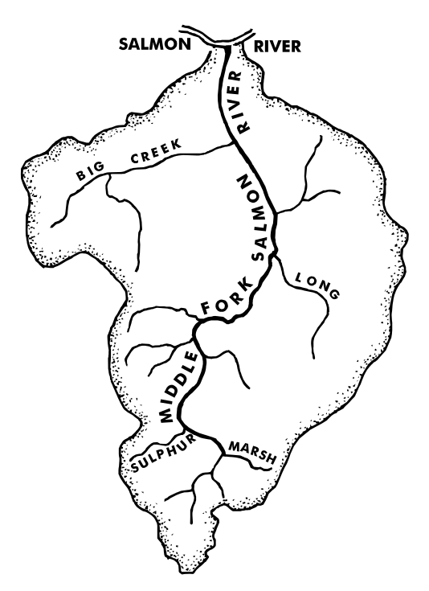
On average, 24% of Idaho’s salmon sport harvest, 1959-1978, came from the MFSR drainage (Horner and Bjornn 1981). Maximum annual sport harvest in the MFSR was 3,851 spring chinook in 1955-1958 (Gebhards 1959 cited in Thurow 1985). Sport harvest ranged from 349 to 1,906 and averaged 1,003 fish in 1969-1978 (Howell et al. 1985). The MFSR has been closed to sport harvest of chinook since 1978.
Habitat: The MFSR drains 2,830 square miles of central Idaho (Kiefer et al. 1992). Most of the drainage, including the mainstem, is within the Frank Church River of No Return Wilderness Area. The rugged topography and wilderness designation has preserved high quality habitat, except in some headwater streams. Summer water temperatures are suitable for salmonid rearing throughout the drainage. Major irrigation diversions are absent. Cattle grazing has historically degraded a portion of mainstem Marsh Creek (OEA 1987); cattle were excluded from the drainage in 1993.

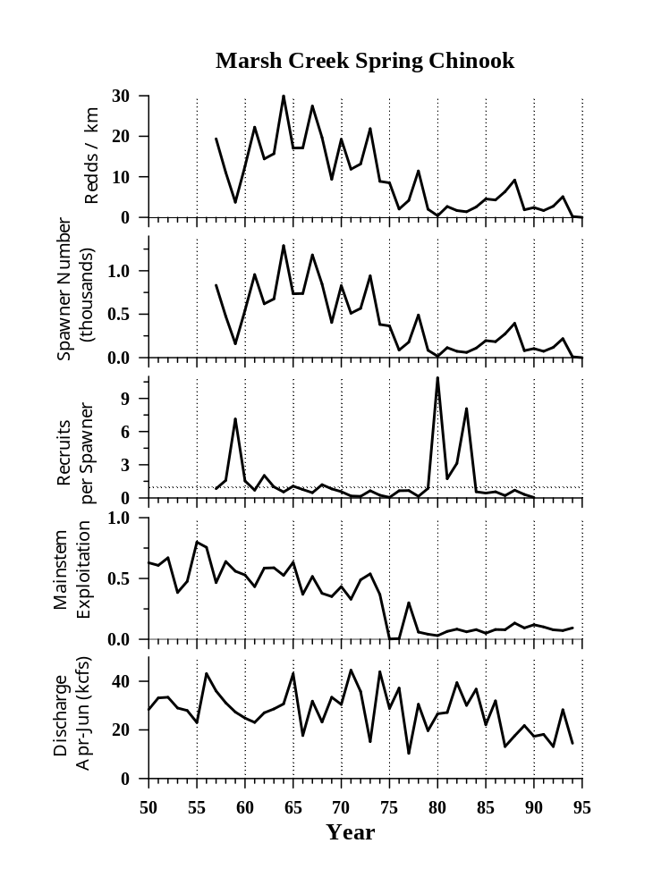

Wenatchee Sockeye
Distribution: Sockeye spawn in the lower 3.5 miles of the Little Wenatchee, the lower 5 miles of the White River at the upper end of Lake Wenatchee (RM 59), and in the Napeequa River (a tributary to the White River). In the 1960's, production also occurred in Nason Creek.
Abundance: The Wenatchee River sockeye natural spawn escapement from 1960-93 return years averaged 24,824 with a low return of 6,600 in 1978 and a peak of 64,600 for the 1977 return.
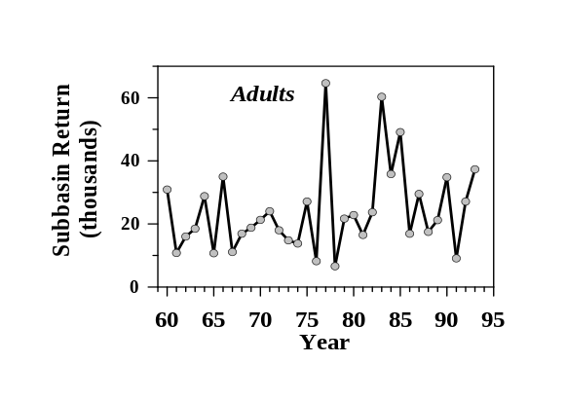
Hatchery Production: Beginning in 1939, and continuing until 1943, sockeye were trapped at Rock Island Dam for relocation to three national fish hatcheries (Leavenworth, Entiat, and Winthrop). Releases of sockeye smolts occurred from 1941 through 1969, with all three Grand Coulee Fish Maintenance Project hatcheries contributing to the Wenatchee River Basin. The Leavenworth facility continued to rear sockeye up until 1969 when it was decided to abandon sockeye propagation due to a number of factors, including losses from IHN. Mullan (1986) contends that the effects of artificial propagation of sockeye salmon in the Columbia River were not inconsequential, indicating that hatchery production composed as much as 98% of the return in some years. Wenatchee sockeye are presently managed on a natural stock basis.
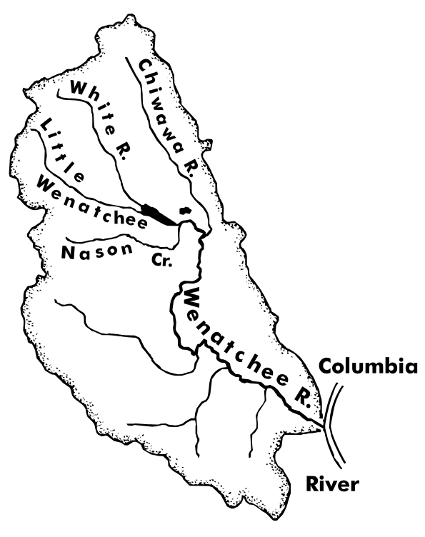
Harvest: Sockeye are not harvested in significant numbers in ocean fisheries. Limited non-treaty and treaty commercial gillnet fisheries, as well as subsistence net fisheries and the Lake Wenatchee sport fishery, all harvest a portion of the Lake Wenatchee origin sockeye. No commercial season has occurred since 1988.
Habitat: Habitat quality has been significantly degraded by land use and development in the basin.
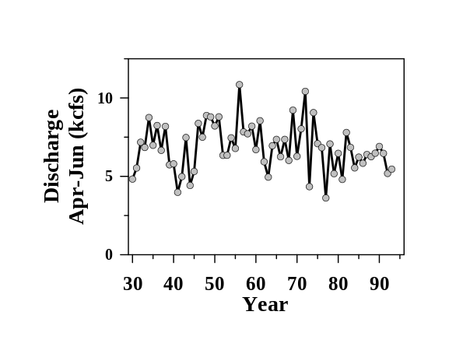

Literature Cited

Allen, S.T., D. O’Connor, P.B. Roger, R. Beamesderfer, and M. Rowe. 1994. Columbia River Coordinated Information System, FY 1994 Annual Report. Report of Pacific States Marine Fisheries Commission (Contract No. DE-FC79-89BP94402) to Bonneville Power Administration, Portland.

BC Hydro (British Columbia Hydro). 1996. British Columbia Dam Data, electronic submission from Ron Ungless. BC.

BPA (Bonneville Power Administration), U. S. Army Corps of Engineers, and U. S. Bureau of Reclamation. 1994. Columbia River system operation review, draft environmental impact statement, appendix C-2 juvenile fish transportation program. Portland.

CDFO (Canadian Department of Fisheries and Oceans). The incredible salmonids. A brochure written by C. Groot, Pacific Biological Station.

Columbia Basin Indian Tribes and the State and Federal Fish and Wildlife Agencies. 1993. Detailed fishery operating plan with 1994 operating criteria. (Available from Columbia Basin Fish and Wildlife Authority, Portland.)

Crateau, E. 1996. Personal Communication. Summary budget sheets from LSRCP annual reports. LSRCP Office, Boise, ID.

Delarm, M.R., and R.Z. Smith. 1990. Columbia River Fisheries Development Program annual report for F.Y. 1989. NOAA Technical Memorandum NMFS F/NWR-30. National Oceanic and Atmospheric Administration, Portland, OR.

Elms-Cockrum, T.J., E.J. Leitzinger and C.E. Petrosky. (in press). Salmon spawning ground surveys, 1994. Report of Idaho Department of Fish and Game (Contract NA47FP0346) for Pacific Salmon Treaty Program.

FPC (Fish Passage Center). 1995. 1994 annual report. Columbia Basin Fish and Wildlife Authority, Portland.

FSOC (Fish Screen Oversight Committee). 1996. Fish Passage Work in the Columbia River Basin - 1995. Report of Columbia Basin Fish and Wildlife Authority report Northwest Power Planning Council. Portland.

Gebhards, S. V. 1959. Preliminary planning report - Salmon River. Columbia River Fisheries Development Program. Idaho Department of Fish and Game, Boise.

Harmon, J. R., D. J. Kamikawa, B. P. Sandford, K. W. McIntyre, K. L. Thomas, N. N. Paasch, and G. M. Mathews. 1995. Research related to transportation of juvenile salmonids on the Columbia and Snake rivers, 1993. Annual report by the National Marine Fisheries Service, Coastal Zone and Estuarine Studies Division, Seattle.

Horner, N. and T.C. Bjornn. 1981. Status of upper Columbia and Snake River Summer Chinook Salmon in relation to the Endangered Species Act. Report of Idaho Cooperative Fishery Research Unit to U. S. Fish and Wildlife Service.

Howell, P., K. Jones, D. Scarnecchia, L. LaVoy, W. Kendra, and D. Ortman. 1985. Stock assessment of Columbia River anadromous salmonids: volume 1, chinook, coho, chum and sockeye salmon stock summaries. Report (contract DE-AI79-84BP12737) to Bonneville Power Administration, Portland.

Hurson, D. F., and 15 co-authors. 1995. Juvenile fish transportation program 1993 annual report. U. S. Army Corps of Engineers, Walla Walla.

Hymer, J., R. Petit, M. Wastel, P. Hahn, and K. Hatch. 1992. Stock summary reports for Columbia River salmonids. Vol. III: Washington below Walla Walla and Vol. IV: Washington Walla Walla and above. Coordinated Information System, Phase II, project 88-108 final report. Bonneville Power Administration, Portland, OR.

Kiefer, S. W., M. Rowe, and K. Hatch. 1992. Stock summary reports for Columbia Basin anadromous salmonids, volume V. Report (contract DE-FC79-89BP94402) to Bonneville Power Administration, Portland.

Lindsay, R.B., W.J. Knox, M.W. Flesher, B.J. Smith, E.A. Olsen and W.S. Lutz. 1986. Study of wild spring chinook in the John Day River System. Final Report of Oregon Department of Fish and Wildlife (Contract DE-AI79-83BP39796) to Bonneville Power Administration, Portland.

Mallet, J. 1974. Inventory of salmon and steelhead resources, habitat use and demands. Idaho Department of Fish and Game Federal Aid in Fish Restoration Job Performance Report (Project F-58-R-1). Boise.

Matthews, G.M. and R.S. Waples. 1991. Status review for Snake River spring/summer chinook. National Oceanic and Atmospheric Administration, National Marine Fisheries Service Technical Memorandum NMFS F/NWC-200.

McIntosh, B. A., J. R. Sedell, J. E. Smith, R. C. Wissmar, S. E. Clarke, G. H. Reeves, and J. R. Sedell. 1994. Historical changes in fish habitat for select river basins of eastern Oregon and Washington. Northwest Science 68:36-53.

Mighetto, L., and W.J. Ebel. 1994. Saving the salmon: a history of the U.S. Army Corps of Engineers' efforts to protect anadromous fish on the Columbia and Snake rivers. Prepared for U.S. Army Corps of Engineers, North Pacific Division, Portland and Walla Walla Districts. Historical Research Associates, Inc. Seattle, WA.

Muir, W. D., S. G. Smith, R. N. Iwamoto, D. J. Kamikawa, K. W. McIntyre, E. E. Hockersmith, B. P. Sandford, P. A. Ocker, T. E. Ruehle, and J. G. Williams. 1995. Survival estimates for the passage of juvenile salmonids through Snake River dams and reservoirs, 1994. National Marine Fisheries Service annual report (contract DE-AI79-93BP10891) to Bonneville Power Administration, Portland.

Mullan, J. 1986. Determinants of sockeye salmon abundance in the Columbia River, 1880's-1982: a review and synthesis. U. S. Fish and Wildlife Service Biological Report 86:12

Mundy, P. R., D. Neeley, C. R. Steward, T. P. Quinn, B. A. Barton, R. N. Williams, D. Goodman, R. R. Whitney, M. W. Erho, Jr., and L. W. Botsford. 1994. Transportation of juvenile salmonids from hydroelectric projects in the Columbia River basin; an independent peer review. Final report to the U. S. Fish and Wildlife Service, Portland.

NID (National Inventory of Dams). 1994. National Inventory of Dams 1993-94 CD-ROM. Venture Computing Group, NY.

NWPPC (Northwest Power Planning Council). 1989. Salmon and steelhead system planning documentation. Prepared by the Monitoring and Evaluation Group. Northwest Power Planning Council, Portland, OR.

ODFW and WDFW (Oregon Department of Fish and Wildlife, Washington Department of Fish and Wildlife). 1995. Status report: Columbia River fish runs and fisheries 1938-1994. The Joint Columbia River Management Staff. Clackamas, OR / Battleground, WA.

ODFW et al. (Oregon Department of Fish and Wildlife, Confederated Tribes of the Umatilla Indian Reservation, Confederated Tribes of the Warm Springs Reservation of Oregon). 1990a. John Day River Subbasin salmon and steelhead production plan, Columbia Basin System Planning. Northwest Power planning Council and Columbia Basin Fish and Wildlife Authority.

OEA (OEA Research). 1987. Middle Fork of the Salmon River, aquatic and riparian area inventories. Report (Project 84-24) to Bonneville Power Administration, Portland.

Olsen, E., P. Pierce, M. McLean, and K. Hatch. 1992. Stock summary reports for Columbia River salmonids. Vol. I: Oregon below Bonneville Dam and Vol. II: Oregon above Bonneville Dam. Coordinated Information System, Phase II, project 88-108 final report. Bonneville Power Administration, Portland, OR.

OWRD (Oregon Water Resources Department). 1986. John Day River basin report. Salem, OR.
Petrosky, C.E., and H.A. Schaller. 1992. A comparison of productivities for Snake River and lower Columbia River spring and summer chinook stocks. Proceedings of Salmon Management in the 21st Century: Recovering Stocks in Decline. 1992 Northeast Pacific Chinook and Coho Workshop. Idaho Chapter of the American Fisheries Society. Boise, ID.

Petrosky, C.E., H.A. Schaller, R.C.P. Beamesderfer, O. Langness, and L. LaVoy. 1996. Spawner-recruit relationships for spring and summer chinook salmon populations in several Columbia and Snake River subbasins. Report (unpublished) to Bonneville Power Administration, Portland.

PFMC (Pacific Fishery Management Council). 1995. Review of 1994 ocean salmon fisheries. Portland.

PSC (Pacific Salmon Commission). 1994a. Joint chinook technical committee 1993 annual report. Report TCCHINOOK (94)-1. Vancouver, British Columbia.

PSC (Pacific Salmon Commission). 1994b. Interim estimates of coho stock composition for 1984-91 southern area fisheries and for 1987-91 northern panel area fisheries. Report TCCOHO (94)-1. Vancouver, British Columbia.

PSMFC (Pacific States Marine Fisheries Commission). 1995. Coordinated Information System (CIS) Distributed System. An IBM PC compatible information system. Gladstone, OR.

PSMFC (Pacific States Marine Fisheries Commission). 1996. StreamNet (formerly Coordinated Information System) Information System. Gladstone, OR.

RMIS (Regional Mark Information System). 1995. Data downloaded from recovery database as of 10/4/95. Pacific States Marine Fisheries Commission, Gladstone, OR.

Schreck, C. B., J. C. Snelling, R. E. Ewing, C. S. Bradford, L. E. Davis, and C. H. Slater. 1994. Migratory characteristics of juvenile spring chinook salmon in the Willamette River. Oregon Cooperative Fishery Research Unit completion report (contract DE-AI79-88BP92818) to Bonneville Power Administration, Portland.

Sevilleta LTER (Long-Term Ecological Research Project). September 1995. Data downloaded from the World Wide Web page at http://sevilleta.unm.edu/meteor/enso/enso-home.html. University of New Mexico, Albuquerque.

Smith, S. S., D. R. Gilliland, E. C. Winther, M. R. Petersen, E. N. Mattson, S. L. Kelsey, J. Suarez-Pena, and J. Hisata. 1995. Report A: Implementation of the northern squawfish sport-reward fishery in the Columbia and Snake Rivers. Pages 11 to 96 in C. F. Willis and F. R. Young, editors. Development of a systemwide predator control program: stepwise implementation of a predation index, predator control fisheries, and evaluation plan in the Columbia River Basin. Annual report (contract DE-BI79-90BP07084) to the Bonneville Power Administration, Portland.

TAC (United States v. Oregon Technical Advisory Committee). 1994. Biological Assessment of the impacts of anticipated 1995 winter, spring and summer season Columbia River and tributary fisheries on listed Snake River salmon species under the Endangered Species Act. December 21, 1994.

Thurow, R. 1985. Middle Fork Salmon River investigations. Idaho Department of Fish and Game Federal Aid in Fish Restoration Job Performance Report (Project F-73-R-6). Boise.

USDOE (Division U.S. Department of Energy, Bonneville Power Administration), U.S. Department of the Army, Corps of Engineers, North Pacific, U.S. Department of the Interior, Bureau of Reclamation, Pacific Northwest Division. 1994. Daily/hourly hydrosystem operations: how the Columbia River system responds to short-term needs. Published for the System Operation Review by the Interagency Team, Portland, OR.

Ward, D.L., J.H. Petersen, and J.J. Loch. 1995. Index of predation on juvenile salmonids by northern squawfish in the lower and middle Columbia River and in the lower Snake River. Transactions of the American Fisheries Society 124:321-334.

Wissmar, R.C., J.E. Smith, B.A. McIntosh, H.W. Li, G.H. Reeves, and J.R. Sedell. 1994. A history of resource use and disturbance in riverine basins of eastern Oregon and Washington (Early 1800s-1990s). Northwest Science 68:1-35.

Willis, C. F. and F. R. Young, editors. Development of a systemwide predator control program: stepwise implementation of a predation index, predator control fisheries, and evaluation plan in the Columbia River Basin. Annual report (contract DE-BI79-90BP07084) to the Bonneville Power Administration, Portland.

Glossary

coded wire tag recovery: Coded wire tags are laser etched metallic wires implanted into the snouts of many hatchery fish. The coding on the tag indicates the hatchery from which the fish was released as well as the year the fish was released. These tags are subsequently recovered and read to create a database of where individual tags were recovered.

emigration: Migration from freshwater to the ocean.

escapement: The number of salmon and steelhead that return to a specific point of measurement after all natural mortality and harvest have occurred. Natural spawning escapement (or spawner escapement) refers to fish that return to spawn without human intervention in rivers, streams or lakes. Hatchery rack escapement refers to hatchery-produced fish that return from the ocean to collection points at the hatchery of origin.

exploitation rate: The total rate of harvest of a given stock or run of fish.

habitat: The environment in which an organism normally lives and grows. Habitat factors of particular relevance to salmon and steelhead include, but are not necessarily limited to, water temperature, flow, instream cover (including large woody debris), substrate, pools, shading, and bank angle and stability.

immigration: Migration from the ocean to freshwater.

jack: Sexually mature male salmon or steelhead that return to freshwater one or more years earlier than is customary for a particular species or stock.

juvenile: Fish from one year of age until sexual maturity.

outmigration: Downstream migration of fish through the river system to the ocean.

PIT tags: Passive Integrated Transponder tags are used for identifying individual salmon for monitoring and research purposes. Each miniaturized tag consists of an integrated microchip that is programmed to include specific fish information. The tag is inserted into the body cavity of the fish and decoded at selected monitoring sites.

smolt: A juvenile salmon or steelhead migrating to the ocean and undergoing physiological changes to adapt its body from a freshwater to a saltwater existence.

stock: The fish spawning in a particular lake, stream, or series of streams at a particular season, which fish to a substantial degree do not interbreed with any group spawning in a different place, or in the same place at a different season.

Southern Oscillation Index (SOI): An oceanographic indicator of environmental conditions that allows for the prediction of global climate events such as El Nino.

tailrace: That portion of a stream immediately downstream of a release from a dam, penstock, or other man-made water discharge device. The area is typically characterized by higher than normal velocity and turbulence.

time series: A sequence of years during which records of a consistent form are collected in order to determine a trend.

trend: The directional change in a time series data set. Population trends identify trends in the abundance of a particular stock, population, or other fish grouping.

upwelling: The movement to the surface of ocean bottom waters in areas near the continental shelf. These waters are typically rich in nutrients.

yearling: One-year-old fish.

wild population: Fish that have completed their entire life cycle in the natural environment and maintained successful natural reproduction with little or no supplementation from hatcheries or other culture facilities. A natural population is similar but may contain fish of hatchery or mixed parentage.

Appendix A. Data Dictionary

Table 1. Fisheries Data Dictionary for the September, 1995 version of the Columbia River CIS Distributed System
 | Adult Abundance |  |  |  | Harvest |  |  |  |  | Juve. |  | Hatchery |  |  | Dist.
 | Dam/ Weir Counts | Redd Counts | Peak/ Index Spawn Counts | Est. of Spawng Pop. |  | FW Sport Harvest | FW Comm. / Tribal Harvest | Marine Sport | Marine Comm. |  | Juvenile Abund. |  | Returns | Releases |  | Dist Data
Idaho | C4 | C4 | NS | NS |  | C4 | S | NA | NA |  | S |  | C3 | C4* |  | C9
Oregon In Col Basin | C4 | P | P | P |  | C3 | S | NA | NA |  | NS |  | C3 | C4** |  | C9
Washington In Col Basin | C4 | NS | P | P |  | P | S | NA | NA |  | NS |  | C3 | C4*** |  | C9
Oregon Outside Basin | P | NS | P | P |  | P | S | C3 | S |  | NS |  | C3 | S |  | C6
Washington Outside Basin | P | NS | P | P |  | P | S | S | S |  | NS |  | P | S |  | C6

C3 = Complete through 1993
C4 = Complete through 1994 (Mainstem dam counts go back to 1960)
C4* = Complete from 1975 through 1994
C4* *= Complete from 1975 through 1994 for everything except untagged, unassociated releases prior to 1982
C4*** = Complete from 1975 through 1994 for everything except untagged, unassociated steelhead
C6 = Distribution only as of 1986, data available from Regional Data Manager, currently not included in DS
C9 = Distribution, smolt production potential, and habitat quality as of 1989
NA = Not Applicable
NS = Not submitted or Not Collected
P = Partially Complete (Not all years or all streams have complete data at this time)
S = Slated for next release
Table 2. Non-Fisheries Data Dictionary for the September, 1995 version of the Columbia River CIS Distributed System

Shaded columns indicate data that are not currently available in the Distributed System, but can be obtained through requests to the Regional Data Manager at PSMFC

 | Dams Facilities | Hatchery Facilities | Tributary Flow Data | Tributary Temp. Data | Mainstem Dam Flow Data | Nearshore Ocean Upwelling Indices | Sea Surface Temp. and Pressure
Idaho | C | Ca | C3 | C3 | C3*
Oregon In Col Basin | C | Ca | C3 | C3 | C3*
Washington In Col Basin | C | Ca | C3 | C3 | C3*
Oregon Outside Basin | P | P | S | S | NA | C5 | C2
Washington Outside Basin | P | P | S | S | NA | C5 | C2

C = Complete for hydropower and larger, non-hydropower dams
Ca = Complete for anadromous fish production facilities
C2 = Complete temperature, pressure, and wind speed from 1854 - 1992, entire Pacific Ocean
C3 = Complete through 1993 for all USGS gauging stations, data available from Regional Data Manager
C3* = Daily Flow and spill data by project from 1960-1993
C5 = Monthly Mean data for 11 west coast stations from 1946-1995
NA = Not Applicable
P = Partially Complete (Not all years or all streams have complete data at this time)
S = Slated for next release

