

Exchange Format Documentation - Version 2012.1

Effective Date: 10/2/2012

Prepared by: StreamNet Project Regional Staff
Pacific States Marine Fisheries Commission

Bonneville Power Administration
Columbia River Inter-Tribal Fish Commission
Idaho Department of Fish and Game
Oregon Department of Fish and Wildlife
Montana Fish, Wildlife, and Parks
Pacific States Marine Fisheries Commission
U.S. Fish and Wildlife Service
Washington Department of Fish and Wildlife

Table Of Contents

I. Introduction 3
II. Data Exchange Formats 4
A. Location coding 5
A1. LocMaster Table 6
A2. SupercodeStreams Table 9
An Explanation of "Supercodes" 10
B. Time series (trend) Information 11
B1. Trend Table 12
B2. EscData Table 15
B3. HatchRetMain Table 17
B4. HatchRetDetail Table 19
B5. HatchDisposition Table 21
B6. SRData Table 22
B7. Age Table 23
B8. TrendGroup Table 25
B8. TrendXTrendGroup Table 26
C. Fish Distribution Information 27
C1. FishDist Table 28
D. Barrier Information 30
D1. Barrier Table 31
D2. FishBarrier Table 34
E. Map Catalog and Photograph Data 35
E1. MapCat Table 36
E2. MapCatXBarrier Table 36
E3. MapCatXDam Table 36
E4. MapCatXFormat Table 37
E5. MapCatXHatchery Table 37
E6. MapCatXHUC Table 37
E7. MapCatXProvince Table 38
E8. MapCatXSubbasin2001 Table 38
E9. MapCatXRegion2001 Table 39
E10. MapCatXSpecieRun Table 39
E11. MapCatXState Table 39
E12. MapCatXTheme Table 40
F. Reference Information 41
F1. Reference Table 42
F2. SuperReference Table 43
G. Habitat Restoration / Improvement Projects Data 44
G1. PrjProject Table 47
G2. PrjParticipant Table 48
G3. PrjParticipantLU Table 49
G4. PrjPartRole Table 49
G5. PrjPartProgram Table 50
G6. PrjContactLU Table 50
G7. PrjSpecies Table 51
G8. PrjLandCover Table 52
G9. PrjGoal Table 52
G10. PrjTreatment Table 53
G11. PrjResult Table 56
G12. PrjMonitor Table 57
G13. PrjSite Table 57
G14. PrjSiteLandCover Table 59
G15. PrjSiteGoal Table 59
G16. PrjSiteTreatment Table 60
G17. PrjSiteResult Table 60
G18. PrjSiteMonitor Table 61
H. Hatchery Facility Data 62
H1. Hatchery Table 63
H2. HatchWater Table 66
I. Dam Facility Data 67
I1. Dam Table 68
I2. DamXDamPurpose Table 69
I3. DamXDamType Table 70
III. Trend Data Compiler Decision Tree 71
Appendix A. "Too Many To Count" in the EscData table 72
Appendix B. Draft tables 73
Appendix C. Additional Instructions for CategoryID Field 73
Appendix D. Glossary 74
Appendix E. Updating This StreamNet Data Exchange Format Document 74
Appendix F. SQL Server 2005 Data Types and MS-Access 2000 Equivalents 75

I. Introduction

This document describes data exchange formats for StreamNet. These formats describe in detail the data items (fields), formats, and coding conventions for the various tables containing data submitted to the regional database by participating agencies and tribes. The formats apply to data submitted on or after the effective date shown on the cover page of this document; adoption of the formats generally does not dictate resubmittal of data already in the regional database in order to bring existing data into the new format. This exchange format does not necessarily represent the final data structure of the data in the regional system, nor does it represent a comprehensive data dictionary for all data contained in the system. Rather, it provides a standardized method for agencies to share data at a regional level. Draft tables are found in a companion document (StreamNet Exchange Format Documentation - Version 2010.1. Volume II: Draft Tables).

Data in a typical relational database are organized into groups (or tables) of information elements that describe various entities. In database design two types of things are usually defined as entities:

1. An object (person, place, or thing)
2. A process (transaction, occurrence, or activity)

Entities in a relational database are joined in some logical fashion by using table relationships. A table relationship is defined as “a path created by data that is used to integrate two tables together.”1 Conceptual database designs can be represented by entity-relationship (ER) diagrams, which portray the tables (or entities) in the database and the relationships that integrate them. An ER diagram is found at the beginning of each section in this document in order to assist with understanding the structure of the StreamNet database.

There are five major entities that characterize most data currently in the StreamNet database. The primary entity is referred to as a Trend (an informal shorthand term for a time series). A trend in the StreamNet database is an entity describing a time series of information composed of a specific data type (harvest, redd count, etc.), for a specific fish stock, at a specific location. For each trend entity there are usually multiple occurrences of the count over some time period (daily, weekly, annually, etc.). In StreamNet, this is known as the Count entity. Currently, there are four different count entity tables (one each for escapement and harvest data, hatchery release data, hatchery return data, and spawner-recruit data). The trend and count tables are joined with a one to many relationship which relates the one trend entity to the many count data points associated with that trend. Each trend is associated with a specific location represented by the Location entity (a code for a stream, flat water body, point, or combination of these). Each trend is also associated with a particular dam or hatchery facility where applicable. Each count value is associated with a bibliographic reference by a Reference entity. Finally, there is the Age entity. For each particular count of fish (say 50 returning hatchery females), the age entity could contain multiple records, one for each age class represented in the return year portrayed in the count table. The overall structure is portrayed by the ER diagram shown in Figure 2.

II. Data Exchange Formats

The data exchange formats, displayed in Tables A1 through I3, are comprised of 4 columns. Field Name is the name of the field in the StreamNet database. Underlined field names indicate primary key designations. Field Description is a brief description of the field. Data Type specifies the field data type; a number included in this field indicates the maximum width of the entry, in characters. Codes/Conventions provides lookup codes and additional information for the various fields. Required fields are indicated by a bold Field Name and Data Type. If Data Type is both bold and italicized, then whether the field is required varies according to other entries in the record -- refer to the Field Description column for rules on when the field is required.

The data types listed in the tables' Data Type column are Microsoft Access 2000 data types. Appendix F contains details regarding the relationship between SQL Server 7.0 and Access 2000 data types. Due to lack of space, not all lookup codes are listed in this document. The full list is available at ftp://ftp.StreamNet.org/pub/StreamNet/Projman_files/ExchangeFormat/CurrentDraft/SNLookupTables.txt. You can also get the most up to date draft DEF, the draft DEF Volume II, and the DEF revision procedure document in the same place.

MS-Access files are preferred for submitting data to StreamNet, but Microsoft SQL Server, dBASE, and delimited ASCII files are also acceptable - contact the StreamNet Database Manager at 503-595-3100 to discuss whether other file types may be acceptable.

Links to files on the StreamNet ftp site are contained in this document. If your agency blocks access to outside ftp sites then you can use an alternative URL to access these files using http instead of ftp. Use the following pattern to convert ftp links shown in this document to http links:
Original: ftp://ftp.StreamNt.org/pub/StreamNet/....
Modified: http://www.StreamNet.org/ftpfiles/...

For example, the ftp URL shown above ...
ftp://ftp.StreamNet.org/pub/StreamNet/Projman_files/ExchangeFormat/CurrentDraft/SNLookupTables.txt

would be converted to the following http URL...
http://www.StreamNet.org/ftpfiles/Projman_files/ExchangeFormat/CurrentDraft/SNLookupTables.txt.

A. Location coding
To be useful, data in the StreamNet database must have accurate locations associated with them. This section contains the tables needed for submitting new locations.

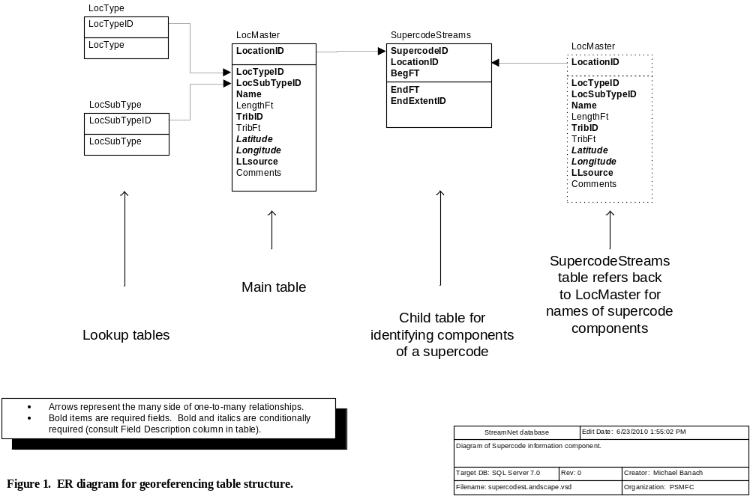

A1. LocMaster Table
This table houses the master list of all location codes used in StreamNet. Because they must all reside in this table, no two location codes can be the same, even if they represent different location types (stream; supercode; etc.). Use this table to submit new location information. It is not necessary to submit location codes that already exist in the StreamNet database. Datum for all locations is NAD83.
Field Name | Field Description | Data Type | Codes/Conventions for LocMaster Table
LocationID | The location code for the stream, lake, bay, reservoir, upland point, etc. See "LocationID" in the Glossary. | Text 13 | For dams and hatcheries the LocationID should be concatenated from the Longitude/Latitude or SiteLong/SiteLat fields from the Dam or Hatchery table.
LocationID |  | Text 13 | For Supercodes use the ranges shown at the right. | 10,000-19,999 = WDFW  20,000-29,999 = CRITFC  30,000-39,999 = USFWS | 40,000-49,999 = IDFG  50,000-59,999 = ODFW | 60,000-69,999 = PSMFC  70,000-79,999 = CDFG  80,000-89,999 = MFWP
LocTypeID | Defines the general type of location. | Byte | 1 = Watercourse (Lotic/flowing water body represented by arcs in a hydrography layer in GIS)  2 = Standing water (Lentic/flat water body represented by a polygon in GIS)  3 = PointID (Location represented by a point in GIS; best if long/lat used to make point code.)  4 = Nonstream arc (Roads, power lines, etc.)  5 = Polygon (Use only if Code 2 is not appropriate.)  6 = Spatially ambiguous, non-specific location that can not be accurately represented in a GIS. (Non-GIS location type.)  7 = Supercode
LocSubTypeID | Code for the subtype of location. This code must match the LocTypeID field. | Integer | For LocTypeID=1, acceptable values are:  100 = 100-k stream  110 = 100-k ditch or canal  111 = Possible 100-k ditch  119 = Mixed-scale watercourse (combined 100 and higher resolution geometry)  120 = 24-k (or higher resolution) stream  130 = 24-k (or higher resolution) ditch or canal  131 = Possible ditch / canal  For LocTypeID=2, acceptable values are:  200 = 100-k wetland  210 = 24-k (or higher resolution) wetland  220 = 100-k natural lake or pond  230 = 24-k (or higher resolution) natural lake or pond  240 = 100-k constructed lake, pond, or reservoir  250 = 24-k (or higher resolution) constructed lake, pond, or reservoir  260 = Bay / estuary  270 = Marine area  280 = Pacific Ocean  362 = Municipal water supply |  | For LocTypeID=3, acceptable values are:  300 = Ocean port  301 = Hatchery facility  302 = Dam  303 = Fish trap (other than a hatchery facility)  310 = Barrier  320 = Fish passage facility (e.g., ladder, screen)  330 = Culvert  340 = Bridge  350 = Mine / dredged site  360 = Spring  361 = Well  364 = Channel not in current hydrography scale  365 = Channel improperly represented at current hydrography scale  399 = Site temporarily not associated with hydrography [Use for temporary PointIDs that are to be replaced by better location coding]  (continued on next page)
 |  |  | For LocTypeID=4, acceptable values are:  400 = Road  401 = Power line  For LocTypeID=5, acceptable values are:  500 = Upland area  501 = Entire HUC (can be at any HUC field level)  502 = Entire catchment (entire watershed not represented by a defined HUC)  503 = Island |  | For LocTypeID=6, acceptable values are:  600 = Unknown location within a HUC (HUC known, exact location is not)  601 = Unspecified location within a HUC (useful for "fuzzing" known locations)  621 = Alaska location  622 = California location  623 = Idaho location  624 = Oregon location  625 = Washington location  626 = Montana location  629 = Undetermined body of water  640 = Outside StreamNet hydro coverage  650 = Stream terminatesFor LocTypeID=7, acceptable values are:  98 = N/A
Name | Name of the stream, lake, bay, reservoir, barrier, dam, hatchery, port, etc. | Text 100 | If unnamed, fill in this field using this pattern:  Unnamed stream [LocationID]  Unnamed dam [LocationID]  Unnamed pond [LocationID]  etc.  For unnamed features, in order to help data end users understand the location, enter the name in the form "X Creek (LocationID), trib to Y Creek (LocationID), trib to Z Creek (LocationID)". Include as many steps as necessary until the last creek listed is a named stream or other identifiable feature. For example, "Unnamed stream (1155232459921), trib to Unnamed stream (1155216459825), trib to Selway River".
LengthFt | Length of stream, in feet. | Long int | This field used only for streams.
TribID | LocationID for the water body this location (stream, lake, supercode, etc.) flows into. | Text 13 | TribID values must exist as a defined LocationID in the LocMaster table. For point locations, supercodes, other cases where a TribID is ambiguous or inappropriate, use one of the following codes as appropriate.  98 = Not applicable  6000 = Flows into Canada  6001 = Flows into California  6012 = Flows into Mexico  6002 = Flows into Nevada  6003 = Flows into Utah  6004 = Flows into Wyoming  6005 = (no outlet)  6006 = Flows into stream not represented in the regional hydrography  6013 = Flows into lake/pond/reservoir not represented in the regional hydrography  6030 = Flows into canal, ditch, or pipeline not represented in the regional hydrography |  | 6021 = Undetermined outlet in Alaska  6022 = Undetermined outlet in California  6023 = Undetermined outlet in Idaho  6026 = Undetermined outlet in Montana  6027 = Undetermined outlet in Nevada  6024 = Undetermined outlet in Oregon  6028 = Undetermined outlet in Utah  6025 = Undetermined outlet in Washington  6029 = Undetermined outlet in Wyoming  6032 = Undetermined canal/pipeline in California  6033 = Undetermined canal/pipeline in Idaho  6036 = Undetermined canal/pipeline in Montana  6037 = Undetermined canal/pipeline in Nevada  6034 = Undetermined canal/pipeline in Oregon  6035 = Undetermined canal/pipeline in Washington  Many more codes are already defined. Go to ftp://ftp.StreamNet.org/pub/StreamNet/ASCII_Data/LocMaster.zip for a complete list of locations with defined codes.
TribFt | The LocationID field (A) identifies the water body represented. The TribID field (B) identifies which water body the represented water body flows into. When B is a stream, this field is the measure from the mouth of B, in feet, to where A enters B. | Long int | Leave blank if TribID does not represent a routed stream.
Latitude | Latitude coordinate of point in decimal degrees (not degrees-minutes-seconds). Calculated using the 1983 North American Datum (NAD83).  Required for non-stream points (LocTypeID = 3). Not applicable for other location types. | Double | Use two digits left of the decimal point and at least four digits to the right of the decimal point. Up to six digits to the right of the decimal point are permitted.
Longitude | Longitude coordinate of point in decimal degrees (not degrees-minutes-seconds). Calculated using the 1983 North American Datum (NAD83).  Required for non-stream points (LocTypeID = 3). Not applicable for other location types. | Double | This is a negative number. Use three digits left of the decimal point and at least four digits to the right of the decimal point. Up to six digits to the right of the decimal point are permitted.
LLsource | Method by which the longitude and latitude values were determined.  Applies only to non-stream points (LocTypeID=3). Use N/A for other location types. | Text 3 | Only five options are possible:  GPS = Coordinates were determined by use of Global Positioning System, and datum is known to be NAD83.  DIG = Digitally-derived. Includes digitized coordinates, or those converted from other (non-GPS) projected data, and datum is known to be NAD83.  UNK = Unknown how lat/long values were determined, or datum = NAD83 cannot be confirmed.  CEN = Centroid coordinates derived from a feature that is represented as a polygon in StreamNet’s GIS.  N/A = Not applicable
Comments |  | Text 255

A2. SupercodeStreams Table
This table lists the individual component locations which, when combined, define a supercode. The records with common SupercodeID all belong to the same supercode.
Field Name | Field Description | Data Type | Codes/Conventions for SupercodeStreams Table
SupercodeID | Code which identifies a supercode. | Text 13 | For Supercode ranges see the LocationID field of the LocMaster table.
LocationID | The location code for the stream, lake, bay, upland point, etc. that is a component of the supercode. See "LocationID" in the Glossary. | Text 13
BegFt | If LocationID is for a stream, the downstream measure, in feet, of the stream section that defines the boundary of the reach. For other location types enter -1. | Long int | Use "-1" if LocationID does not represent a stream.
EndFt | If LocationID is for a stream, the upstream measure, in feet, of the stream section that defines the boundary of the reach. For other location types enter -1. | Long int | Use "-1" if LocationID does not represent a stream.
EndExtentID | EndFt values that are very near the top end of a stream or near a state border can be ambiguous. Is the EndFt meant to indicate the top end of the stream or the state border, or is there a deliberate reason the EndFt value falls short of the top of the stream, or just shy or just over a state border? This field answers that question. | Byte | 0 = EndFt value is not meant to represent the top end of stream or a state border  1 = EndFt value is meant to represent the top of the stream  2 = EndFt value is meant to represent the state border  97 = Not yet determined

An Explanation of "Supercodes"
The majority of the time series (trend) data that StreamNet collects are from surveys done on an individual stream reach. These time series are georeferenced in a straightforward manner in the Trend table with a LocationID to identify the stream, and BegFt and EndFt measures to identify the downstream and upstream ends of the sampling location on that stream. Other time series data sets, however, are not amenable to this system because sampling was not done on a single reach of a single stream. These more complex locations have been dubbed "supercodes" for the RRN codes that were originally assigned to them under the 1:250,000 scale PNW Reach system. Originally supercodes were multistream areas such as "Upper Columbia River basin" or "Clackamas River and tributaries." Other, non-stream types of locations such as lakes, points, and bays were later included in supercodes because of the similar problem they presented for data management.

A new database structure was later devised under the 1:100,000 scale system that allows for the specific definition of the geographic extents of supercodes and nonstream data. This higher level of precision allowed for more accurate display of the data and an enhanced ability to query the data. This system was revised again in version 2003.1 of this document, and this approach has been continued in the currently-used mixed-scale hydrography. The following is a brief description of this newest database structure as it relates to supercodes.

For supercode areas, a SupercodeID is assigned and this SupercodeID is entered in the LocationID field of the LocMaster table. The LocTypeID field in the LocMaster table identifies this code as a supercode, while the Name field is used to give a descriptive name to the supercode. To link the supercode to the several specific stream reaches, lakes, points, and other geographic features it represents, several entries are made in the SupercodeStreams table. For each entry, the SupercodeID is entered in the SupercodeID field, and the LocationID, BegFt, and EndFt fields identify an individual geographic component of the supercode. The LocationID field links back to the LocMaster table to identify an individual stream, lake, point, etc. As many entries are made in the SupercodeStreams table as are needed to include all the components of the supercode. Figure 1 illustrates the relationships between the tables discussed above.

A data management issue you will need to address is to ensure that duplicate supercodes are not defined for the exact same geographic extent. It is likely that your database management software will allow you to define more than one SupercodeID that relate to the same set of real-world reaches and lakes. An occasional review of your supercodes will help to find such duplicates and treat them appropriately.

B. Time series (trend) Information
These tables house much of the data in the StreamNet system. Data types include dam/weir counts, estimates of spawning populations, peak/other spawning counts, redd counts, spawner-recruit relationship estimates, freshwater harvest, saltwater harvest,, hatchery releases, and hatchery returns. All these data types share a common data structure within the Trend table. The Count table structures vary between data types.
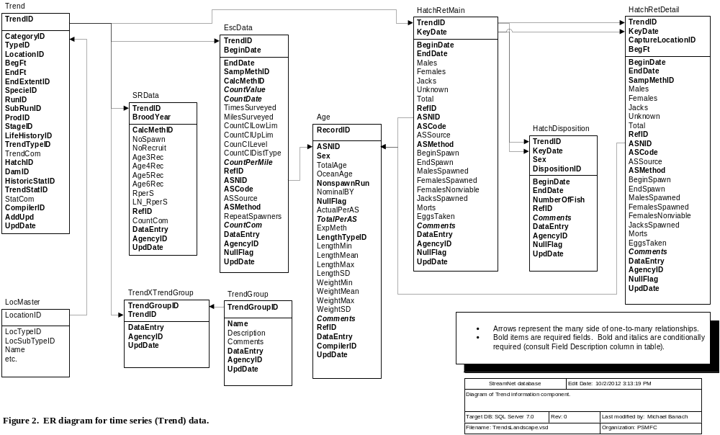

B1. Trend Table
This table contains the master records for time series data, including location, species / run / subrun of fish, data type, and general information about the trend. (The time-series records linked to these master records are found in the EscData, HatchRelData, HatchRetData, and SRData tables.)
Field Name | Field Description | Data Type | Codes/Conventions for Trend Table
TrendID | This field uniquely identifies each time series. Will be assigned by state data compilers or regional data assemblers as appropriate. | Long int | 10,000-19,999 = MFWP  20,000-29,999 = CRITFC  200,000-209,999 = CRITFC (Umatilla)  30,000-39,999 = USFWS  40,000-49,999 = IDFG  50,000-59,999; 500,000-599,999 = ODFW |  |  |  |  |  |  |  | 60,000-69,999 = PSMFC  70,000-89,999 = Not currently in use  90,000-99,999 = CDFG  100,000-199,999 = WDFW  300,000-399,999 = RMIS Hatchery Releases
CategoryID  (Refer to Appendix C for detailed instructions) | The code for the major data type. Data types not listed to the right are not appropriate for use in this table. This field along with TypeID define what was measured. | Byte | 1 = Spawner counts  2 = Freshwater / estuary harvest  3 = Marine harvest  4 = Dam / nonhatchery weir counts |  |  |  | 5 = Hatchery returns  6 = Hatchery releases  7 = Estimates of juvenile populations  8 = Estimates of spawning populations |  |  |  |  |  | 9 = Redd counts  12 = Spawner / recruit estimates  38 = Juvenile counts
TypeID | Code for the type of count in the trend. Answers the question, "what was counted?"  Links to Type table. | Integer | 99 = Unknown  101 = Redd count  102 = Redds per mile  103 = Peak redd count  104 = Total live fish  105 = Fish per mile  106 = Peak live fish  107 = Total live fish returned above hatchery  108 = Carcass  109 = Carcass per mile  110 = Peak carcass  111 = Fish days  112 = Spawner:recruit estimates  113 = Index of live fish  114 = Peak live & dead fish  115 = Resting hole count  116 = Total live and dead fish |  |  |  | 117 = Peak per mile  118 = Fish per pool  201 = Ocean troll  202 = Treaty troll  203 = Ocean sport  204 = Estuary sport  205 = Freshwater sport  206 = Freshwater treaty  207 = Freshwater sport release  208 = Ocean net  210 = Total sport, commercial & treaty  211 = Total net: commercial & treaty  212 = Freshwater commercial  213 = Agency test fishery  214 = Ocean sport (charter)  215 = Ocean sport (private)  216 = Estuary sport (jetty)  217 = Freshwater sport (snag) |  |  |  |  |  | 218 = Ocean troll (non-treaty)  219 = Ocean troll (day boat)  220 = Ocean troll (trip boat)  221 = Ocean (mixed net & seine)  222 = Ocean troll (treaty and non-treaty)  223 = Estuary sport (private)  224 = Estuary sport (charter)  225 = Coastal gillnet  301 = Off-site direct hatchery release  302 = Off-site volitional hatchery release  303 = On-site direct hatchery release  304 = On-site volitional hatchery release  305 = Non hatchery tag group release  306 = On-site hatchery release  401 = Parr density (#/100m2)  402 = Total parr abundance estimate  501 = Freshwater: ocean age
LocationID | The location code of the stream, lake, hatchery, dam, supercode, etc. See "LocationID" in the Glossary. | Text 13 | Note for hatchery returns trends:  Often a hatchery receives fish from other sources. LocationID in this table comes from the LocationID field of the Hatchery table. In the hatchery return details table the CaptureLocationID field conveys where the fish were captured, which is not always the hatchery indicated in the Trend table.
BegFt | If LocationID is for a stream, the downstream measure, in feet, of the stream section that defines the boundary of this trend. For other location types enter -1. | Long int | Enter -1 if LocationID does not represent a stream.
EndFt | If LocationID is for a stream, the upstream measure, in feet, of the stream section that defines the boundary of this trend. For other location types enter  -1. | Long int | Enter -1 if LocationID does not represent a stream.  For the "Dam / nonhatchery weir counts" data category, EndFt = BegFt.
EndExtentID | EndFt values that are very near the top end of a stream or near a state border can be ambiguous. Is the EndFt meant to indicate the top end of the stream or the state border, or is there a deliberate reason the EndFt value falls short of the top of the stream, or just shy or just over a state border? This field answers that question. | Byte | 0 = EndFt value is not meant to represent the top end of stream or a state border  1 = EndFt value is meant to represent the top of the stream  2 = EndFt value is meant to represent the state border  97 = Not yet determined
SpecieID | Code for the fish species | Integer | For a complete list of SpecieID codes please refer to the Specie table (downloadable at ftp://ftp.StreamNet.org/pub/StreamNet/ASCII_Data/Specie.txt). |  |  | Partial list:  1 = Chinook salmon  2 = Coho salmon  3 = Steelhead  4 = Sockeye salmon  5 = Chum salmon  6 = Pink salmon  39 = Mixed salmon  96 = Mixed anadromous salmonids  66 = Kokanee |  |  |  |  |  | 14 = Bull trout  10 = Brown trout  11 = Brook trout  9 = Rainbow trout  23 = Redband trout  111= Rainbow/redband/steelhead trout  17 = Coastal cutthroat trout  21 = Westslope cutthroat trout  8 = Cutthroat trout |  | 94 = Mixed lamprey  113 = Lamprey (unspecified)  122 = Pacific lamprey  120 = Western brook lamprey  15 = Lamprey: CODE DISCONTINUED  12 = White sturgeon  44 = Green sturgeon  98 = N/A  99 = Unknown
RunID | Code for the fish run.  For coastal cutthroat, use code 98. | Byte | 1 = Spring  2 = Summer  3 = Fall  4 = Winter | 12 = Odd year pink  13 = Even year pink  16 = Mixed |  |  |  | 17 = Spring/summer |  |  |  |  |  |  | 98 = N/A  99 = Unknown  If run not appropriate for the species, enter 98 = N/A.
SubRunID | Code for the fish subrun | Byte | 1 = A run  2 = B run  3 = S type - Early  4 = N type - Late |  |  | 5 = Tule  6 = Upriver bright  7 = S type & N type |  |  |  |  |  | 8 = Late run  9 = Early run  98 = N/A |  | 99 = Unknown  If subrun not appropriate for this species, enter 98 = N/A.
ProdID | Code for the production type of the fish. "Natural" in this database applies to stocks and situations that cannot be explicitly linked to a hatchery stock. For example, all redd counts are assumed to be natural stocks, even though some of the fish spawning may be of hatchery origin. | Byte | 1 = Hatchery  2 = Natural  3 = Mixed  99 = Unknown
StageID | Code for the life stage of the fish described in the trend.  For hatchery returns, always use code 29 (All stages) in this field. Differentiation into adults and jacks occurs in the HatcheryReturns table. | Byte | 1 = Egg (unspecified)  2 = Emergent fry or larvae  3 = Fed fry  4 = Fingerling  5 = Sub-yearling (age 0)  6 = Yearling (age 1)  7 = 2 year old migrant  8 = Jack or subadult |  | 9 = Adult  10 = Adults & jacks  11 = Egg (eyed)  12 = Egg (green)  13 = Fry (unspecified)  14 = Juvenile (unspecified)  16 = Smolt  17 = Carcass |  |  |  |  | 18 = Parr  19 = Presmolt  20 = Mini-jack (2 year old)  21 = Ages 1 and 2  22 = 2 year old  23 = Unfed fry  24 = Half-pounder  25 = Adults and half-pounders |  |  |  | 26 = Macroinvertebrate larva/nymph/naiad  27 = Pupa  28 = Sub-imago (dun)  29 = All stages  30 = Not specified  98 = N/A  99 = Unknown
LifeHistoryID | Code for the life history strategy(s) of the species in the indicated reach. | Byte | 1 = Anadromous  2 = Year-round resident  3 = Fluvial/adfluvial |  |  |  |  |  |  |  |  | 4 = Fluvial/adfluvial and year-round resident  5 = Anadromous and year-round resident  99 = Unknown
TrendTypeID | This field is used to describe the relative importance of a survey within a major category (refer to CategoryID above). Use code = 98 when CategoryID is not 1 or 8. Links to TrendType table. | Byte | 1 = Index - Areas that have been surveyed consistently over a long period of time, and are generally used to index abundance at some geographic scale.  2 = Random - Areas that may be used to index abundance, but the survey sites are selected randomly from the available species' distribution and therefore, may not be conducted every year.  3 = Supplemental - Surveys that are typically selected to fill specific localized information needs and may or may not be conducted year to year either due to management decisions or due to environmental conditions.  4 = Spot Check - Surveys that are identical to supplemental areas except only a subset of a given area is sampled (e.g. select gravel bars, every 5th fish observed, every other pool, etc.) and these subset counts are used to enumerate fish for the entire survey area.  5 = Incidental - Trend data that are derived from a survey targeting a different species than the one being reported (example: while conducting a steelhead redd count survey, 2 adult lamprey are noted in the comments - the lamprey count would be reported as an incidental trend).  6 = Exploratory - Used to determine presence/absence or distribution of fish or redds. Exploratory trends typically are used to determine where to establish long-term index trends.  98 = N/A - Use when CategoryID is not 1 or 8.  99 = Unknown
TrendCom | This field is used to describe general information which applies to all years in the trend. These include information such as local or colloquial names for the system which may not be part of the official reach designation, periods of closure to fishing during which no data are available, and specific run or stock details which may not be captured using the standard species/run/production categories. | Memo
HatchID | The code for the hatchery that the trend is related to, if applicable. | Integer | 98 = N/A  For assigned HatchID range series please refer to the Hatchery table information, or for a complete list of HatchID codes refer to the Hatchery table (downloadable at ftp://ftp.StreamNet.org/pub/StreamNet/ASCII_Data/Hatchery.txt).
DamID | The code for the dam that the trend is related to, if applicable. | Long int | 98 = N/A  For assigned DamID range series please refer to the Dam table information, or for a complete list of DamID codes refer to the Dam table (downloadable at ftp://ftp.StreamNet.org/pub/StreamNet/ASCII_Data/Dam.zip).
HistoricStatID | The code for the status of data entry for the Trend. Field is intended to assist in future updates of the database - it indicates whether all known historical data for the Trend are in the StreamNet database. | Byte | 1 = All available historical data currently in StreamNet.  2 = Earliest available data not yet in StreamNet.  3 = Earliest available data in StreamNet, but one or more gaps exist between oldest and newest data in StreamNet: these data known to exist.  4 = Earliest available data in StreamNet, but one or more gaps exist between oldest and newest data in StreamNet: unknown if these data exist.  99 = Unknown
TrendStatID | The code for the trend status. This field is intended to assist in future updates of database - it indicates whether data will be produced in the future to add to this Trend. This field indicates the status of the most recent years of data, while the HistoricStatID field indicates the status of the oldest data for the trend. | Byte | 1 = Data currently collected for Trend table  2 = No data currently collected, but data may be collected in future  3 = Run of fish still exists, but data collection has ceased  4 = Run of fish extinct, data collection ceased  5 = Inactive aggregate trend; current data in independent trends |  |  |  |  |  |  |  |  | 6 = Inactive independent trend; current data in aggregate trend  7 = Most recent data have been requested but are not yet ready for exchange  8 = Production of these fish stopped at this hatchery  9 = Facility closed or removed  10 = Data collection discontinued  99 = Unknown
StatCom | A comment field elaborating on the TrendStat | Memo | Comments on TrendStat (e.g., "Run declared extinct in 1982.")
CompilerID | The code for the agency that put the data into StreamNet format and sent it to StreamNet, and is responsible for updates. Links to the Compiler table. | Byte | 1 = Washington Department of Fish and Wildlife  2 = Columbia River Inter-Tribal Fish Commission  3 = U.S. Fish and Wildlife Service  4 = Idaho Department of Fish and Game  5 = Oregon Department of Fish and Wildlife  6 = Pacific States Marine Fisheries Commission |  |  |  |  |  | 7 = California Department of Fish and Game  8 = Montana Fish, Wildlife, and Parks  9 = Umatilla Confederated Tribes  10 = Nez Perce Tribe  11 = Shoshone-Bannock Tribes
AddUpd | Indicates whether a record has been added or updated. | Yes/No | 0 = False  -1 = True (default)
UpdDate | The date and time that the record was created or updated. For data obtained in electronic format from another source it can reflect the date and time of data capture or of conversion to StreamNet format. | Datetime | This can be the time a record was created, the last time it was edited, or the last time it was QCd.

B2. EscData Table
This table includes harvest data, and adult return indices (except for hatchery returns and spawner/recruit estimates). It has a many to one relationship with the Trend table.
Field Name | Field Description | Data Type | Codes/Conventions for EscData Table
TrendID | Identifier for the unique time series that this record is associated with. Refer to Trend table information. | Long int | Refer to Trend table information.
BeginDate | The starting date for the count, for calendar year results, usually Jan 1st of that year. For run year, actual date is reported. | Datetime | mm/dd/yyyy
EndDate | The ending date for the count, for calendar year results, usually Dec 31st of that year. For run year, actual cut off date is reported. | Datetime | mm/dd/yyyy
SampMethID | The method used to physically sample the fish.  Use 98 (N/A) when NullFlag = True. | Integer | 98 = N/A  99 = Unknown  101 = Fixed wing aerial  102 = Boat  103 = Dam  105 = Ground  106 = Helicopter  108 = Seine / electrofishing combination  109 = Hatchery rack / weir  110 = Rotary screw trap  111 = Weir / trap | 112 = Sonar  113 = In-stream PIT tag detector  114 = Snorkel  116 = Electrofishing  117 = Air / ground combination  201 = Commercial fish ticket  202 = Tribal fish ticket  203 = Punch card  204 = Postal survey  205 = Creel survey  206 = Air or lighthouse boat count  207 = Combination of methods |  | 208 = Gillnet  209 = Gaffing  210 = Hook and line  211 = Commercial & tribal fish tickets  212 = Punch card supplemented with creel survey statistics  213 = Aerial (unspecified aircraft)  214 = Boat and ground  215 = Sport fishing reward tags  216 = Seine  237 = See Comments
CalcMethID | The method by which the count was calculated.  Use 98 (N/A) when NullFlag = True.  Code 314 is often useful, and includes such straight-forward processes as addition, subtraction, multiplication, division, arithmetic mean, median, geometric mean, harmonic mean, weighted mean, mode, etc. | Integer | 98 = N/A  99 = Unknown  104 = Estimation - unknown type  115 = Estimation based on peak or redd count expansion  118 = Estimation based on dam count  119 = Weir count expansion  120 = Estimation based on juvenile population size  121 = Estimation based on spawning ground count  122 = Estimation based on carcass count expansion  123 = Estimation based on a combination of factors  124 = Estimation based on redd and carcass count expansions  301 = Weight derived estimate  302 = Book estimate |  | 303 = Mark-recapture: Petersen estimate  304 = Actual physical counts (No expansion)  305 = Mark-recapture -- unspecified type  306 = Mark-recapture: Shaefer method  307 = Mark-recapture: Jolly-Seber method  308 = Estimate based on historical data  309 = Mark-recapture: Ricker method  310 = Mark-recapture: Chapman method  311 = Mark-recapture: Bailey (1951) method  312 = Estimation based on creel survey expansion  313 = Depletion (regression) method  314 = Arithmetic calculation  315 = Run reconstruction  316 = Mark-recapture: Jolly-Dickson method
CountValue | Value of what was counted, as per the TypeID field of the Trend table.  - Required when NullFlag = False and CountPerMile is blank.  - Optional when NullFlag = False and CounPerMile is filled in.  - Must be null when NullFlag = True.  - If value is "Too many to count" then follow directions in Appendix A. | Single | (This value is used for age data when available. CountValue is the number of fish the age data apply to. For example if CountValue=300 but only 100 fish were aged, 300 will show up as both the number for the trend and as the number of fish the age data apply to. For this reason, age data should be associated with fish or carcass counts, not with such things as redd counts.)
CountDate | The count date is used to identify the specific date from which a peak count was derived (i.e., if several surveys were conducted over a period of time, and the peak count is recorded here, the date for that specific peak count would be entered as the count date).  Should be entered for any Peak type count. If the information does not exist for a peak count record, then leave this field blank and place whatever is known about dates in the CountCom field. | Datetime | mm/dd/yyyy
TimesSurveyed | The actual number of times the survey was conducted during the survey season. | Integer
MilesSurveyed | The actual miles surveyed. | Single | NOTE: Not be used for expansion counts.
CountCILowLim | The lower confidence limit (L₁) of the confidence interval (CI) of the value in the CountValue field. | Single | The fields CountCILowLim (this field) and CountCIUpLim define the confidence interval (CI) of the value in the CountValue field.
CountCIUpLim | The upper confidence limit (L₂) of the confidence interval (CI) of the value in the CountValue field. | Single | The fields CountCILowLim and CountCIUpLim (this field) define the confidence interval (CI) of the value in the CountValue field.
CountCILevel | The confidence level used to report the values in the CountCILowLim and CountCIUpLim fields. | Single | Expressed as a percentage in use, but stored here without the percent sign. Typical values for this field are 95 (for 95% confidence level) and 90 (for 90% confidence level). This value in this field is calculated as (100) (1 - α). [That is, 100 times the sum of 1 minus alpha.]
CountCIDistType | The type of distribution assumed when calculating the confidence interval for the CountValue field. | Text 30 | When used, most of the time the value in this field will be "Normal". However, any distribution type might appear that a biologist assumed when calculating the confidence interval. Also acceptable are entries such as "None assumed".
CountPerMile | The actual or computer-calculated count per mile for a survey area. This can be used for any “per mile” count (e.g. redds/mile, carcass/mile, etc.).  Required when NullFlag = False and CountValue is blank. See other rules in the CountValue field. | Single | NOTE: This would not be used for expansion counts.
RefID | The unique StreamNet reference ID number that identifies the source document or database from which the count was obtained. | Long int | Refer to Reference table information.
ASNID | Age Structure Number ID - Provides link to age structure data in the Age table. | Long int | Refer to the Age table for assigned ranges. Enter '98' if no age data are available. An ASNID value used in this table should not be used in the HatchRetMain or HatchRetDetail table.
ASCode | Age Structure Code. If age structure information exists, indicates whether it was derived by the group of fish represented by this record. | Byte | 1 = Age structure was derived from this group of fish.  2 = Age structure was derived from a different group of fish.  98 = No age data available.
ASSource | If ASCode = 2, this field indicates group of fish used to determine the age structure for this record. | Text 100 | Indicate group of fish that was source of the age structure information.  Leave null if ASCode = 1 or 98.  If ASCode=2, fill in this field if possible.
ASMethod | Method by which ages were derived.  Use codes 1/3/5/6 if traditional ring reading was used, code 4 if chemical marks were used.  Enter 98 if NullFlag = True, or if ASCode = 98. | Byte | 1 = Scales  2 = Length-frequency analysis  3 = Otoliths  4 = Marks (fin clips, brands, tags, chemical marks, etc.)  5 = Bones |  | 6 = Spines  7 = Standardized length classes applied  97 = Combination of methods  98 = N/A  99 = Unknown
RepeatSpawners | Number of repeat spawners included in CountValue. | Integer | This number is the (perhaps estimated) number of fish that were determined to be part of the total number reported in the CountValue field. The number in this field is already included in CountValue. So, for example, if 95 first-time spawners and 5 repeat spawners were counted for a total of 100 fish, then the value in CountValue is 100 (the total number of fish) and the number in RepeatSpawners is 5.
CountCom | This field is used to document unusual conditions which may affect a particular annual abundance record. Provide additional data which may complement this record, and report the page number on which the number appears in a published reference, etc. Required if NullFlag=True | Memo
DataEntry | Compiler's name. | Text 50 | The name of the person who entered the record.
AgencyID | Unique StreamNet ID for the agency that entered the record. Required for new data. | Integer | For AgencyID codes please refer to the Agency table. (Downloadable at ftp://ftp.StreamNet.org/pub/StreamNet/ASCII_Data/Agency.txt)
NullFlag | If true, this field indicates a null value for the defined time period: it is true that data were not collected. If set to true, enter in the CountCom field why data do not exist. | Yes/No | 0 = False (default)  -1 = True
UpdDate | The date and time that the record was created or updated. For data obtained in electronic format from another source it can reflect the date and time of data capture or of conversion to StreamNet format. | Datetime | This can be the time a record was created, the last time it was edited, or the last time it was QCd.

B3. HatchRetMain Table
This table contains hatchery return information and has a many to one relationship with the Trend table (via TrendID). This table houses information about the entire pool of fish coming to a hatchery for a year. The "pool" is defined by the hatchery, species, run, etc. in the Trend table, and includes all the fish from all capture locations. (Note about related age data: "Unknowns" in this table should equal the sum of "unknowns" in the Age table. Same for females. Males in the Age table should equal males+jacks here. Adding all the records in the Age table should equal the Total field here. Imperfect data will not match these expectations, but are allowable.)
Field Name | Field Description | Data Type | Codes/Conventions for HatchRetMain Table
TrendID | Refer to EscData table information. | Long int | Refer to Trend table information.
KeyDate | Earliest date fish are recorded or collection starts | Datetime | mm/dd/yyyy The key date is used to record the beginning of fish collection. Depending on the agency, this is either when the trap is opened or when the first fish is recorded.
BeginDate | Earliest date fish were recorded for the return year. | Datetime | mm/dd/yyyy
EndDate | Latest date fish were recorded for the return year. | Datetime | mm/dd/yyyy
Males | Number of adult males that arrived at the hatchery. Includes all fish from all capture locations. | Long int | If unknown, leave null.
Females | Number of adult females that arrived at the hatchery. Includes all fish from all capture locations. | Long int | If unknown, leave null. Includes Jennies.
Jacks | Number of jacks that arrived at the hatchery. Includes all fish from all capture locations. | Long int | If unknown, leave null.
Unknown | Number of unsexed fish that arrived at the hatchery. Includes all fish from all capture locations. | Long int | If unknown, leave null.
Total | Total number of fish that arrived at the hatchery. Includes all fish from all capture locations. | Long int | The sum of Males, Females, Jacks, Unknown. (The value in the Morts field is not added in here.) If Males, Females, Jacks, and Unknown are all zero, then enter zero here also. If unknown, leave null.  (This value is used for age data when available, and is the number of fish the age data apply to. For example if Total=300 but only 100 fish were aged, 300 will show up as both the number for the trend and as the number of fish the age data apply to.)
RefID | Refer to EscData table information. | Long int | Refer to Reference table information.
ASNID | Age Structure Number ID - Provides link to age structure data in the Age table. | Long int | Refer to the Age table for assigned ranges. Enter '98' if no age data are available. An ASNID value should generally be used in only one of the related tables (EscData, HatchRetMain, HatchRetDetail), though it is possible to be in both HatchRetMain and HatchRetDetail if all fish are from a single capture location.
ASCode | Age Structure Code. If age structure information exists, indicates whether it was derived by the group of fish represented by this record. | Byte | 1 = Age structure was derived from this group of fish.  2 = Age structure was derived from a different group of fish.  98 = No age data available.
ASSource | If ASCode = 2, this field indicates group of fish used to determine the age structure for this record. | Text 100 | Indicate group of fish that was source of the age structure information.  Leave null if ASCode = 1 or 98.  If ASCode=2, fill in this field if possible.
ASMethod | Method by which ages were derived.  Use codes 1/3/5/6 if traditional ring reading was used, code 4 if chemical marks were used.  Enter 98 if NullFlag = True, or if ASCode = 98. | Byte | 1 = Scales  2 = Length-frequency analysis  3 = Otoliths  4 = Marks (fin clips, brands, tags, etc.)  5 = Bones | 6 = Spines  7 = Standard length classes applied  97 = Combination of methods  98 = N/A  99 = Unknown
BeginSpawn | Earliest date fish were spawned. | Datetime | mm/dd/yyyy
EndSpawn | Latest date fish were spawned. | Datetime | mm/dd/yyyy
MalesSpawned | Number of adult males spawned. | Long int | This value is <= to the value in the Males field, unless the Males field is null or imperfect source data are available.
FemalesSpawned | Number of adult females spawned. | Long int | The value of FemalesSpawned + FemalesNonviable must be <= to the value in the Females field,  unless the Females field is null or imperfect source data are available.
FemalesNonviable | Number of adult females not spawned because nonviable. | Long int
JacksSpawned | Number of jacks spawned | Long int | This value must be <= to the value in the Jacks field, unless the Jacks field is null or imperfect source data are available.
Morts | Total morts | Long int | Because Morts indicates how many of the Total died, Morts must be <= the value in the Total field, unless the Total field is null or imperfect source data are available.
EggsTaken | Number of eggs taken | Long int | Total eggs collected from the spawned females, unless otherwise indicated. This is the number of eggs available for fertilizing, before culling, picking, eye-up, etc.
Comments | This field is used to document unusual conditions that may affect a particular hatchery return record. Provide additional data that may complement this record, and report the page number on which the number appears in a published reference, etc.  Required if NullFlag=True | Memo
DataEntry | Compiler's name. | Text 50 | The name of the person who entered the record.
AgencyID | Unique StreamNet ID for the agency that entered the record. Required for new data. | Integer | For AgencyID codes please refer to the Agency table. (Downloadable at ftp://ftp.StreamNet.org/pub/StreamNet/ASCII_Data/Agency.txt)
NullFlag | If true, this field indicates a null value for the defined time period: it is true that data were not collected. If set to true, enter in the Comments field why data do not exist. | Yes/No | 0 = False (default)  -1 = True
UpdDate | The date and time that the record was created or updated. For data obtained in electronic format from another source it can reflect the date and time of data capture or of conversion to StreamNet format. | Datetime | This can be the time a record was created, the last time it was edited, or the last time it was QCd.

B4. HatchRetDetail Table
This table contains hatchery return information and has a many to one relationship with the HatchRetMain table (via TrendID and KeyDate). This table houses information about fish coming to a hatchery from specific capture locations. In general you should use this table only if the fish coming to the hatchery (as listed in the HatchRetMain table) came from more than one location. (Notes about related age data: a) "Unknowns" in this table should equal the sum of "unknowns" in the Age table. Same for females. Males in the Age table should equal males+jacks here. Adding all the records in the Age table should equal the Total field here. Imperfect data will not match these expectations, but are allowable. b) Age data will only link to this table if age data specific to a capture site are available.)
Field Name | Field Description | Data Type | Codes/Conventions for HatchRetDetail Table
TrendID | Refer to EscData table information. | Long int | Refer to Trend table information.
KeyDate | Earliest date fish are recorded or collection starts | Datetime | mm/dd/yyyy The key date is used to record the beginning of fish collection. Depending on the agency, this is either when the trap is opened or when the first fish is recorded.
CaptureLocationID | Code for the location where fish were caught. Location code from LocMaster table for hatchery, trap, dam, or stream. Links to LocationID in LocMaster table. | Text 13 | Enter a Location ID.
BegFt | Used to indicate location on stream where fish were captured. Especially needed for long rivers such as the Columbia and Snake. | Long int | If CaptureLocationID represents a hatchery facility (fish swam into hatchery facility), then enter the BegFt value as recorded for that hatchery facility in the Hatchery table.  If CaptureLocationID represents a stream because fish were seined from a river, enter the distance from the mouth of the stream, in feet.  For captures at traps or dams enter -1.
BeginDate | Earliest date fish were recorded for the return year. | Datetime | mm/dd/yyyy
EndDate | Latest date fish were recorded for the return year. | Datetime | mm/dd/yyyy
SampMethID | The method used to capture the fish. | Integer | The full list of codes can be found in the EscData table. The codes that are most likely useful for hatchery returns are shown here: |  | 98 = N/A  99 = Unknown  109 = Hatchery rack / weir  111 = Weir / trap | 208 = Gillnet  209 = Gaffing  216 = Seine  237 = See Comments
Males | Number of adult males captured at the location. | Long int | If unknown, leave null.
Females | Number of adult females captured at the location. | Long int | If unknown, leave null. Includes Jennies.
Jacks | Number of jacks captured at the location. | Long int | If unknown, leave null.
Unknown | Number of unsexed fish captured at the location. | Long int | If unknown, leave null.
Total | Total number of live fish captured at the location. | Long int | The sum of Males, Females, Jacks, Unknown. (The value in the Morts field is not added in here.) If Males, Females, Jacks, and Unknown are all zero, then enter zero here also. If unknown, leave null.
RefID | Refer to EscData table information. | Long int | Refer to Reference table information.
ASNID | Age Structure Number ID - Provides link to age structure data in the Age table. | Long int | Refer to the Age table for assigned ranges. Enter '98' if no age data are available. An ASNID value should generally be used in only one of the related tables (EscData, HatchRetMain, HatchRetDetail), though it is possible to be in both HatchRetMain and HatchRetDetail if all fish are from a single capture location.
ASCode | Age Structure Code. If age structure information exists, indicates whether it was derived by the group of fish represented by this record. | Byte | 1 = Age structure was derived from this group of fish.  2 = Age structure was derived from a different group of fish.  98 = No age data available.
ASSource | If ASCode = 2 then indicate group of fish used to determine the age structure for this record. | Text 100 | Indicate group of fish that was source of the age structure information.  Leave null if ASCode = 1 or 98.  If ASCode=2, fill in this field if possible.
ASMethod | Method by which ages were derived.  Use code 1/3/5/6 if traditional ring reading was used, code 4 if chemical marks were used.  Enter 98 if NullFlag = True, or if ASCode = 98. | Byte | 1 = Scales  2 = Length-frequency analysis  3 = Otoliths  4 = Marks (fin clips, brands, tags, etc.)  5 = Bones | 6 = Spines  7 = Standard length classes applied  97 = Combination of methods  98 = N/A  99 = Unknown
BeginSpawn | Earliest date fish were spawned. | Datetime | mm/dd/yyyy
EndSpawn | Latest date fish were spawned. | Datetime | mm/dd/yyyy
MalesSpawned | Number of adult males spawned | Long int | This value is <= to the value in the Males field, unless the Males field is null or imperfect source data are available.
FemalesSpawned | Number of adult females spawned | Long int | The value of FemalesSpawned + FemalesNonviable must be <= to the value in the Females field,  unless the Females field is null or imperfect source data are available.
FemalesNonviable | Number of adult females not spawned because nonviable. | Long int
JacksSpawned | Number of jacks spawned | Long int | This value must be <= to the value in the Jacks field, unless the Jacks field is null or imperfect source data are available.
Morts | Total morts | Long int | Because Morts indicates how many of the Total died, Morts must be <= the value in the Total field, unless the Total field is null or imperfect source data are available.
EggsTaken | Number of eggs taken | Long int | Total eggs collected from the spawned females, unless otherwise indicated. This is the number of eggs available for fertilizing, before culling, picking, eye-up, etc.
Comments | This field is used to document unusual conditions that may affect a particular hatchery return record. Provide additional data that may complement this record, and report the page number on which the number appears in a published reference, etc.  Required if NullFlag=True | Memo
DataEntry | Compiler's name. | Text 50 | The name of the person who entered the record.
AgencyID | Unique StreamNet ID for the agency that entered the record. Required for new data. | Integer | For AgencyID codes please refer to the Agency table. (Downloadable at ftp://ftp.StreamNet.org/pub/StreamNet/ASCII_Data/Agency.txt)
NullFlag | If true, this field indicates a null value for the defined time period: it is true that data were not collected. If set to true, enter in the Comments field why data do not exist. | Yes/No | 0 = False (default)  -1 = True
UpdDate | The date and time that the record was created or updated. For data obtained in electronic format from another source it can reflect the date and time of data capture or of conversion to StreamNet format. | Datetime | This can be the time a record was created, the last time it was edited, or the last time it was QCd.

B5. HatchDisposition Table
This table designates the final disposition of fish bodies processed at hatchery facilities. This table has a many to one relationship with the HatchRetMain table via TrendID and KeyDate.
Field Name | Field Description | Data Type | Codes/Conventions for HatchDisposition Table
TrendID | Refer to EscData table information. | Long int | Refer to Trend table information.
KeyDate | Earliest date fish are recorded or collection starts | Datetime | mm/dd/yyyy The key date is used to record the beginning of fish collection. Depending on the agency, this is either when the trap is opened or when the first fish is recorded.
Sex | Sex of fish. | Byte | 1 = Male  2 = Female  3 = Male & Female | 4 = Jack  5 = Jenny  6 = Mini-Jack | 99 = Unknown
DispositionID | Code used to denote ultimate disposition of the fish. | Long int | 1 = Returned to water body dead - same stream (nutrient enhancement)  2 = Returned to water body dead - other stream (nutrient enhancement)  3 = Returned downstream live  4 = Returned upstream live  5 = Returned to water body live  6 = Disposal - buried  7 = Disposal - paid to haul away  8 = Disposal - processed  9 = Disposal - freezer  10 = Disposal - dump  11 = Disposal - general  12 = Transfer to tribe- ceremonial/subsistence  13 = Transfer to tribe - harvest agreement  14 = Sold to tribe | 15 = Sold non-tribal  16 = Sold unknown  17 = Donation to tribe  18 = Donation non-tribal  19 = Donation to food bank  20 = Donation unknown  21 = Donation to prisons  22 = Donation to research  23 = Donation to USFWS's Eagle Program  24 = Transfer - outside agency  25 = Transfer - within agency  26 = Transfer - unknown  27 = No carcass  28 = Other [specify in comment field if possible]  29 = Outreach / Education  99 = Unknown
BeginDate | Earliest date fish were recorded for disposition. | Datetime | mm/dd/yyyy
EndDate | Latest date fish were recorded for disposition. | Datetime | mm/dd/yyyy
NumberOfFish | Number of fish (live or dead) removed from the Hatchery. | Long int
RefID | Refer to EscData table information. | Long int | Refer to Reference table information.
Comments | This field is used to document unusual conditions that may affect a particular record. Provide additional data that may complement this record, and report the page number on which the number appears in a published reference, etc. Required if NullFlag=True | Memo
DataEntry | Compiler's name. | Text 50 | The name of the person who entered the record.
AgencyID | Unique StreamNet ID for the agency that entered the record. Required for new data. | Integer | For AgencyID codes please refer to the Agency table. (Downloadable at ftp://ftp.StreamNet.org/pub/StreamNet/ASCII_Data/Agency.txt)
NullFlag | If true, this field indicates a null value for the defined time period: it is true that data were not collected. If set to true, enter in the Comments field why data do not exist. | Yes/No | 0 = False (default)  -1 = True
UpdDate | The date and time that the record was created or updated. For data obtained in electronic format from another source it can reflect the date and time of data capture or of conversion to StreamNet format. | Datetime | This can be the time a record was created, the last time it was edited, or the last time it was QCd.

B6. SRData Table
This table contains spawner - recruit data. Originally housing only data from the PATH project from the 1990s, this table now houses spawner - recruit data from multiple sources.
Field Name | Field Description | Data Type | Codes/Conventions for SRData Table
TrendID | Refer to EscData table information. | Long int | Refer to Trend table information.
BroodYear | Brood year of the release. | Integer | The calendar year in which the majority of the parents of the cohort spawned.
CalcMethID | The method by which the count was calculated. | Integer | Refer to EscData table information.
NoSpawn | The estimated number of spawners (adults and jacks) during the year. | Double | Ideally, the NoSpawn, NoRecruit, and RperS fields should always be filled in. However, if some data are missing it may be useful to some people to record what is available.
NoRecruit | The estimated total number of recruits to the Columbia River mouth that were progeny of those spawners. | Double | Ideally, the NoSpawn, NoRecruit, and RperS fields should always be filled in. However, if some data are missing it may be useful to some people to record what is available.
Age3Rec | The estimated number of 3 year old (brood year + 3) recruits to the Columbia River mouth that were progeny of those spawners. | Double
Age4Rec | The estimated number of 4 year old (brood year + 4) recruits to the Columbia River mouth that were progeny of those spawners. | Double
Age5Rec | The estimated number of 5 year old (brood year + 5) recruits to the Columbia River mouth that were progeny of those spawners. | Double
Age6Rec | The estimated number of 6 year old (brood year + 6) recruits to the Columbia River mouth that were progeny of those spawners. | Double
RperS | Recruits divided by Spawners | Double | Ideally, the NoSpawn, NoRecruit, and RperS fields should always be filled in. However, if some data are missing it may be useful to some people to record what is available.
LN_RperS | The natural logarithm of Recruits divided by Spawners. | Double
RefID | Refer to EscData table information. | Long int | Refer to Reference table information.
CountCom | This field is used to document unusual conditions that may affect a particular spawner recruitment record. Provide additional data that may complement this record, and report the page number on which the number appears in a published reference, etc. | Memo
DataEntry | Compiler's name. | Text 50 | The name of the person who entered the record.
AgencyID | Unique StreamNet ID for the agency that entered the record. Required for new data. | Integer | For AgencyID codes please refer to the Agency table. (Downloadable at ftp://ftp.StreamNet.org/pub/StreamNet/ASCII_Data/Agency.txt)
UpdDate | The date and time that the record was created or updated. For data obtained in electronic format from another source it can reflect the date and time of data capture or of conversion to StreamNet format. | Datetime | This can be the time a record was created, the last time it was edited, or the last time it was QCd.

B7. Age Table
This table stores population-level age structure information. It is a child of the EscData, HatchRetMain, and HatchRetDetail tables, linking via ASNID. Because the rules for which fields can/should be filled change based on several factors, the key field is an arbitrary number rather than a meaningful combination of data fields.
(Notes: a) Including records that represent zero fish is OK. For example, if a sample has records for TotalAge=2, 4, and 5, then including a record for TotalAge=3 with ActualPerAS=0 and TotalPerAS=0 is OK, but not required. This extra record can help complete the data set so that users don't wonder if data are missing. b) We do not yet have the ability to record data about repeat steelhead and sea-run coastal cutthroat spawners.)
Field Name | Field Description | Data Type | Codes/Conventions for Age Table
RecordID | Key field for this table. | Long int | 1,000,000-1,999,999 = WDFW  2,000,000-2,999,999 = CRITFC |  |  |  | 3,000,000-3,999,999 = USFWS  4,000,000-4,999,999 = IDFG  5,000,000-5,999,999 = ODFW |  |  |  |  | 6,000,000-6,999,999 = PSMFC  7,000,000-7,999,999 = CDFG  8,000,000-8,999,999 = MFWP
ASNID | This field links the age data to the escapement / harvest / hatchery return data for a particular year.  An ASNID value should generally be used in only one of the related tables (EscData, HatchRetMain, HatchRetDetail), though it is possible to be in both HatchRetMain and HatchRetDetail if all fish are from a single capture location. | Long int | 98 = No age data available.  100,000-199,999 = WDFW  100,000,000-199,999,999 = WDFW  200,000-299,999 = CRITFC  200,000,000-299,999,999 = CRITFC |  |  |  | 300,000-399,999 = USFWS  300,000,000-399,999,999 = USFWS  400,000-499,999 = IDFG  400,000,000-499,999,999 = IDFG  500,000-599,999 = ODFW  500,000,000-599,999,999 = ODFW |  |  |  |  | 600,000-699,999 = PSMFC  600,000,000-699,999,999 = PSMFC  700,000-799,999 = CDFG  700,000,000-799,999,999 = CDFG  800,000-899,999 = MFWP  800,000,000-899,999,999 = MFWP
Sex | Sex of the fish aged.  Required unless NullFlag = True. | Byte | 1 = Male  2 = Female |  |  |  |  |  | 3 = Male & Female  98 = N/A  99 = Unknown
TotalAge | Total age of the fish. | Integer | If unknown, leave null. (Normally we use “99" for unknowns, but some species can be that old so let's avoid ambiguity.)  If NullFlag=True, leave null. (Normally we use "98" for these, but again some species make that ambiguous.)
OceanAge | Ocean age of fish.  Subtracting this number from the year when the fish was sampled should provide the year the fish smolted. | Integer | If unknown, leave null.  If fish has never entered ocean, leave null.  If NullFlag=True, leave null. |  |  |  |  | This field applies only to salmon, steelhead, coastal cutthroat trout, and perhaps Pacific lamprey that have already entered the ocean. For some anadromous species such as sturgeon, and for resident species, only a total age is recorded.
NonspawnRun | First annulus after entering salt water is a "half-pounder" annulus (for steelhead) or "feeding run" annulus (for coastal cutthroat). For fish with OceanAge = 0, "True" in this field indicates the fish was on it's "half-pounder" or "feeding run" when sampled. | Byte | 0 = False  1 = True  98 = N/A  99 = Unknown | Half-pounder steelhead only occur in Oregon and California.  ODFW and WDFW will use this code for searun coastal cutthroats.  For everyone else, this value will always be "98" for all records.
 |  |  |  | Examples:  A) Steelhead that has not been to the ocean  TotalAge=3  OceanAge=null  NonspawnRun=N/A  B) Steelhead on its half-pounder run  TotalAge=3  OceanAge=0  NonspawnRun=True |  |  |  |  |  | C) The fish from example B, one year later  TotalAge=4  OceanAge=1  NonspawnRun=True  D) A steelhead same age as example C that did not have a half-pounder run  TotalAge=4  OceanAge=1  NonspawnRun=False
NominalBY | Nominal brood year: the calendar year in which the bulk of the eggs of a generation were deposited.  The actual calendar year that a particular population spawns may not match this value. For example, coho generally spawn in the fall, but a few populations of the same run-year don't spawn until February. This field is the "nominal" year because it assigns a value based on major spawning time for a whole run, keeping run-years together. So the February spawning coho get the same value in this field as a population that spawns 3 months earlier in November. See the Codes/Convention field for more information. | Integer | This varies by spawning guild, and maybe by run. Follow these rules:  - When length-frequency analysis is used for adult anadromous fish, brood year is probably unknown. Leave this field null in those instances. (Applies to: any anadromous fish, but this is most common in the Snake River basin.)  - In some species, spawning for the run-year begins before January 1 and continues into the next calendar year.  - For steelhead and coastal cutthroat trout, the brood year is considered the later year (spring). So if a steelhead is sampled summer 2003 and has 3 annuli, enter "2000" here.  - For coho, chum, and fall Chinook the brood year is considered the earlier year (fall). Most spawning is done before January 1, but some populations don't spawn until as late as March. However, these are still part of the run-year with those fish that spawned the previous fall. So if a coho is sampled summer 2003 and has 3 annuli, enter "1999" here.  - For species whose eggs hatch the same calendar year they are laid, there are no inherent problems. However, if you encounter a term such as "4 year old" for a fish with 3 annuli that is "in its fourth year of life," you need to recognize this means a fish with 3 annuli sampled in summer 2003 has a brood year of 2000, not 1999. (Applies to: rainbow trout, cutthroat trout, smallmouth bass, bluegill, yellow perch, white sturgeon, most minnows, most lampreys.)  - For fall-spawning fish, where eggs hatch the calendar year after they are laid, pay attention to whether the "ages" you have use the year of egg deposition (fall) or egg hatching (spring) as the zero point. Usually the age for these is counted from hatching (spring), and in these cases subtracting the age from the year sampled will not give the correct brood year. For example, a bull trout with 3 annuli sampled in summer 2003 may be called a "3" or an "age 3" or a "3 year old," but the egg was laid in 1999. For this fish you would enter 1999 in this field. (Applies to: bull trout, brook trout, kokanee, maybe some Pacific lamprey.)
NullFlag | "True" indicates no age analysis was done for the defined time period, so there are no age data to capture: it is true that the fish were not aged. If set to true, enter in the Comments field why age data do not exist (if you know). | Yes/No | 0 = False (default)  -1 = True |  | Using "True" in this field means that the fish were not aged. That being the case, only a single record should be used for years when NullFlag = true, and the ActualPerAS and TotalPerAS fields for this single record should be null. (A value of 0 means no aged fish had that age, whereas null means no aging was done. Those are different concepts.)
ActualPerAS | Number of fish that were actually aged that match the Sex/TotalAge/OceanAge/NonspawnRun/NominalBY combination for the time period represented. | Integer | If 1000 fish are counted at a dam, and 200 of these are aged, and 50 match the sex/age combination for the record, and these 50 represent 250 of the original 1000, enter "50" in this field.
TotalPerAS | Number of fish of the whole population represented by this Sex/TotalAge/OceanAge/NonspawnRun/NominalBY combination for the time period represented.  Required unless NullFlag = True. | Long | If 1000 fish are counted at a dam, and 200 of these are aged, and 50 match the sex/age combination for the record, and these 50 represent 250 of the original 1000, enter "250" in this field.  When both AsCode=1 and weighted means are not used to apply ages back to the original 1000 fish, then adding all these up for a group should equal the value in EscData.CountValue or in HatchRetMain.Total.  When ASCode=2 or if the raw numbers are weighted when applied back to the original 1000 fish, then adding all these up for a group probably will not equal the value in EscData.CountValue or in HatchRetMain.Total. An entry in the Comments field may be appropriate to help the data user.
ExpMeth | Method used to expand the observed age data in the ActualPerAS field to create the value in the TotalPerAS field. | Text 30 | Describe how the value in the ActualPerAS field was used to calculate the value in the TotalPerAS field. Provide an entry such as "Straight proportion" or "Statistical model" or "Weighted by week". If all fish were aged and thus no expansion was needed, enter "N/A".
LengthTypeID | Type of lengths represented in the LengthMin, LengthMean, LengthMax, and LengthSD fields. | Byte | 1 = Total length  2 = Fork length |  |  | 3 = Mideye-hypural length  4 = Mideye-posterior scale (MEPS) length |  |  |  |  | 5 = Standard length  6 = Post-orbital to hypural (POH) length  98 = N/A
LengthMin | Minimum length recorded for the group. | Integer | All measured in millimeters.
LengthMean | Mean length recorded for the group. | Single
LengthMax | Maximum length recorded for the group. | Integer
LengthSD | Standard deviation of length recorded for the group. | Single
WeightMin | Minimum weight recorded for the group. | Long int | All measured in grams.
WeightMean | Mean weight recorded for the group. | Single
WeightMax | Maximum weight recorded for the group. | Long int
WeightSD | Standard deviation of weight recorded for the group. | Single
Comments | Additional information or comments.  Required if NullFlag=True | Memo
RefID | Refer to EscData table information | Long int | Refer to Reference table information.
DataEntry | Who originally put the data into electronic format. This is not necessarily a StreamNet person. This field can include more information also, to describe not only who entered the data, but who edited or reviewed data or transformed them into a usable format. This field helps with future QC. | Text 50
CompilerID | The code for the agency that put the data into StreamNet format and sent it to StreamNet, and is responsible for updates. Links to the Compiler table. | Byte | The compiling agency is one of the small group of agencies related to StreamNet. In instances where the person sending data to StreamNet is employed by one agency but functions within a different agency (common for PSMFC staff), the CompilerID reflects the agency the person functions within. See Trend table for codes.
UpdDate | The date and time that the record was created or updated. For data obtained in electronic format from another source it can reflect the date and time of data capture or of conversion to StreamNet format. | Datetime | This can be the time a record was created, the last time it was edited, or the last time it was QCd.

B8. TrendGroup Table
This table defines a group of related trends. It has a one to many relationship to the TrendXTrendGroup table via TrendGroupID.
Field Name | Field Description | Data Type | Codes/Conventions for TrendGroup Table
TrendGroupID | Code to uniquely identifies each trend group. | Long int | Assigned ranges are the same as for TrendID. See the Trend table for the assigned ranges.
Name | Short name for the Trend Group. Give a brief description that will be good for displaying online. | Text 255
Description | Greater detail about the Trend Group, if needed. | Memo
Comments | Comments about the Trend Group that are not the name nor the longer description, but may be useful. | Memo
DataEntry | Compiler's name. | Text 50 | The name of the person who entered the record.
AgencyID | Unique StreamNet ID for the agency that entered the record. Required for new data. | Integer | For AgencyID codes please refer to the Agency table. (Downloadable at ftp://ftp.StreamNet.org/pub/StreamNet/ASCII_Data/Agency.txt)
UpdDate | The date and time that the record was created or updated. For data obtained in electronic format from another source it can reflect the date and time of data capture or of conversion to StreamNet format. | Datetime | This can be the time a record was created, the last time it was edited, or the last time it was QCd.

B8. TrendXTrendGroup Table
This table defines which trends are in a Trend Group. It has a many to one relationship to the Trend table via TrendID, and a many to one relationship to the TrendGroup table via TrendGroupID. By using this cross table we get a many to many relationship between Trend and TrendGroup, so that a TrendGroup can contain many trends, but also a single trend can belong to many TrendGroups.
Field Name | Field Description | Data Type | Codes/Conventions for TrendXTrendGroup Table
TrendGroupID | Foreign key to TrendGroup table. | Long Int
TrendID | Foreign key to Trend table. | Long int
DataEntry | Compiler's name. | Text 50 | The name of the person who entered the record.
AgencyID | Unique StreamNet ID for the agency that entered the record. Required for new data. | Integer | For AgencyID codes please refer to the Agency table. (Downloadable at ftp://ftp.StreamNet.org/pub/StreamNet/ASCII_Data/Agency.txt)
UpdDate | The date and time that the record was created or updated. For data obtained in electronic format from another source it can reflect the date and time of data capture or of conversion to StreamNet format. | Datetime | This can be the time a record was created, the last time it was edited, or the last time it was QCd.

C. Fish Distribution Information
This section details tables for fish distributions. The ER diagram for fish distribution is shown in the following figure.

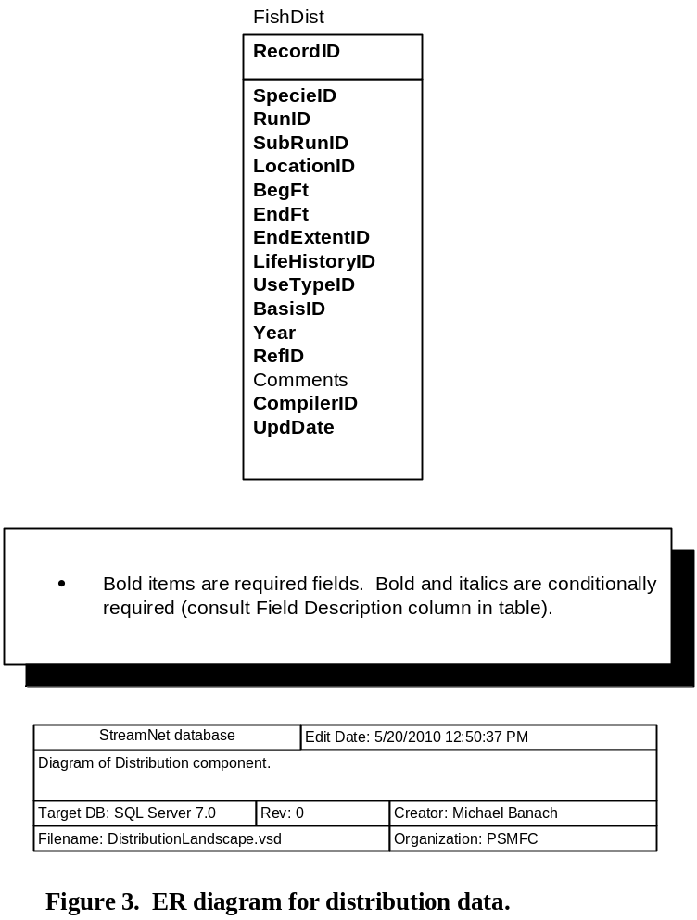

C1. FishDist Table
As used here, the definition of generalized fish distribution is "areas of suitable habitat currently believed to be used by wild, hatchery, or naturalized fish populations, based on sampling and/or best biological judgment." "Current" is defined by each data-providing agency according to their own policies. The locations recorded in this table are extrapolations based on observing organisms at specific points; these extrapolations are specific to a taxon and life history. This table is for where species are found, but does not address where species are not found -- lack of a record does not imply that the species does not exist in a given reach.

Records in this table should not overlap spatially within a species/run/subrun/life history/basis combination. For example, if spawning and rearing occur for the same species/run/subrun/life history combination from 300 feet to 1000 feet from the stream mouth, and rearing and migration occur from the mouth to 300 feet, the data would appear as two records though both have "rearing" as a component of the use types:
1) UseType=Rearing and migration/BegFt=0/EndFt=300; and
2) UseType=Spawning and rearing/BegFt=300/EndFt=1000.
Field Name | Field Description | Data Type | Codes/Conventions for FishDist Table
RecordID | Arbitrary number to identify the record. | Long int | 1,000,000-1,999,999 = WDFW  2,000,000-2,999,999 = CRITFC | 3,000,000-3,999,999 = USFWS  4,000,000-4,999,999 = IDFG  5,000,000-5,999,999 = ODFW |  |  | 6,000,000-6,999,999 = PSMFC  7,000,000-7,999,999 = CDFG  8,000,000-8,999,999 = MFWP
SpecieID | Code for the fish species. | Integer | Refer to Trend table information.
RunID | Code for the fish run. | Byte | If run not appropriate for this species, enter 98 = N/A. Refer to the Trend table for other codes.
SubRunID | Code for the fish subrun. | Byte | If subrun not appropriate for this species, enter 98 = N/A. Refer to the Trend table for other codes.
LocationID | The location code of the stream, lake, etc. See "LocationID" in the Glossary. | Text 13
BegFt | The downstream measure in FEET of the presence of the species/run/subrun/life history in a stream. | Long int | Enter -1 if LocationID does not represent a stream.
EndFt | The upstream measure in FEET of the presence of the species/run/subrun/life history in a stream. | Long int | Enter -1 if LocationID does not represent a stream.
EndExtentID | EndFt values that are very near the top end of a stream or near a state border can be ambiguous. Is the EndFt meant to indicate the top end of the stream or the state border, or is there a deliberate reason the EndFt value falls short of the top of the stream, or just shy or just over a state border? This field answers that question. | Byte | 0 = EndFt value is not meant to represent the top end of stream or a state border  1 = EndFt value is meant to represent the top of the stream  2 = EndFt value is meant to represent the state border  97 = Not yet determined
LifeHistoryID | Code for the life history strategy(s) of the species in the indicated reach. | Byte | 1 = Anadromous  2 = Year-round resident  3 = Fluvial/adfluvial |  | 4 = Fluvial/adfluvial and year-round resident  5 = Anadromous and year-round resident  99 = Unknown
UseTypeID | Description of how fish use the indicated stream segment. | Byte | 1 = Spawning and rearing  2 = Rearing and migration  3 = Migration only  4 = Year-round use |  | 5 = Foraging  6 = Nodal (adult residence)  7 = Pioneer spawning (marginal habitat where fish may spawn but successful reproduction is deemed unlikely)  99 = Unknown
BasisID | Code for the basis upon which the extrapolated distribution information in this record rests. | Byte | 1 = Extrapolated from multiple surveys / observations  2 = Extrapolated from a single survey / observation  3 = Professional judgement |  |  | 4 = Anecdotal  99 = Unknown
Year | Year this record was last updated. | Integer | Enter 4-digit year.
RefID | Code for the reference in the StreamNet library. | Long int | Refer to Reference table information.
Comments |  | Memo
CompilerID | The code for the agency that put the data into StreamNet format and sent it to StreamNet, and is responsible for updates. Links to the Compiler table. | Byte | The compiling agency is one of the small group of agencies related to StreamNet. In instances where the person sending data to StreamNet is employed by one agency but functions within a different agency (common for PSMFC staff), the CompilerID reflects the agency the person functions within. See Trend table for codes.
UpdDate | The date and time that the record was created or updated. For data obtained in electronic format from another source it can reflect the date and time of data capture or of conversion to StreamNet format. | Datetime | This can be the time a record was created, the last time it was edited, or the last time it was QCd.

D. Barrier Information
This section details tables for fish barriers. The ER diagram for fish barrier data is shown in the following figure.
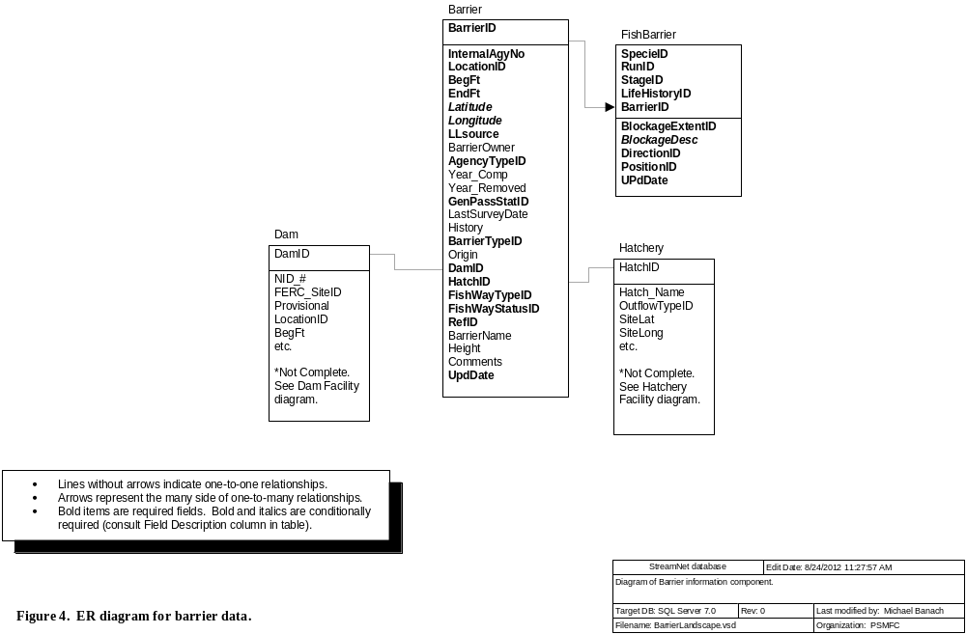

D1. Barrier Table
This table houses a list of barriers, and information about each barrier. Some "barriers" have artificial fishways or have otherwise been corrected, and now all fish are able to pass the barrier. At other times the severity may be unknown and a feature may not even be a barrier (i.e., is only a "potential barrier" and thus GenPassStatID=99). Tracking this information is important for people who will use these data. Therefore DO submit records for "barriers" that once blocked fish but no longer do, and for "potential barriers".
Field Name | Field Description | Data Type | Codes/Conventions for Barrier Table
BarrierID | This field uniquely identifies a barrier identified by a particular agency | Long int | 98 = N/A  101-50,000 = IDFG |  | 50,001-100,000 = ODFW  100,001-150,000 = WDFW |  | 150,001-200,000 = MFWP  200,001-250,000 = CRITFC  700,000-799,999 = CDFG
InternalAgyNo | Identifies a barrier in the database of the agency that provided the data to StreamNet -- i.e., the internal barrier identifier for WDFW, ODFW, CDFG, etc. This field ensures database updates are performed correctly, and lets data users communicate more clearly with the agencies providing the data. | Text 20
LocationID | The location code of the stream the barrier is on. See "LocationID" in the Glossary. | Text 13 | In general, a code for location types other than streams probably make no sense and should not be used. Points, however, may be useful if barriers have not yet been tied to streams.
BegFt | The beginning measure of the barrier in feet | Long int | Enter -1 if LocationID does not represent a stream.
EndFt | The ending measure of the barrier in feet | Long int | Enter -1 if LocationID does not represent a stream.
Latitude | Latitude coordinate of barrier in decimal degrees. Calculated using NAD83.  Required if LocationID does not represent a stream. | Double | Use two digits left of the decimal point and at least four digits to the right of the decimal point. Up to six digits to the right of the decimal point are permitted.
Longitude | Longitude coordinate of barrier in decimal degrees. Calculated using NAD83.  Required if LocationID does not represent a stream. | Double | This is a negative number. Use three digits left of the decimal point and at least four digits to the right of the decimal point. Up to six digits to the right of the decimal point are permitted.
LLsource | Method by which the longitude and latitude values were determined.  Required if LocationID does not represent a stream. | Text 3 | Only three options are possible:  GPS = Coordinates were determined by use of Global Positioning System, and datum is known to be NAD83.  DIG = Digitally-derived. Includes digitized coordinates, or those converted from other (non-GPS) projected data, and datum is known to be NAD83.  UNK = Unknown how lat/long values were determined, or datum = NAD83 cannot be confirmed.  N/A = Not applicable
BarrierOwner | The barrier owner | Text 100 | The owner of a barrier, and the owner of the land where a barrier sits, can be different. Up through version 2006.1 of this document we did not explicitly state which is expected here. Beginning with version 2009.1 this field is specifically for the owner of the barrier. So if an irrigation district owns a diversion on a stream on US Forest Service land, this field should contain the name of the irrigation district, not the US Forest Service.
AgencyTypeID | Code for the institutional status of the land owner (private, federal, state, etc.). Links to the AgencyType table. | Byte | 1 = Watershed council  2 = State government agency  3 = Local government agency  4 = Federal government agency  5 = Private landowner - corporate  6 = Private landowner - noncorporate  7 = Conservation group  8 = Other  9 = Soil and water conservation district  10 = Sporting group  11 = Job or volunteer program |  | 12 = Tribe or tribal organization  13 = Private contractor  14 = Private consultant  15 = Professional society  16 = College or university  17 = Primary or secondary school  18 = Natural Resource Commission  19 = Canadian national government  20 = Public utility  21 = Private |  | 22 = City  23 = County  24 = Water or irrigation district  25 = Sewer district  26 = Port district  27 = Park or recreation district  28 = Multiple / mixed  30 = Nonprofit organization  98 = N/A  99 = Unknown
Year_Comp | The year the barrier was completed. | Integer
Year_Removed | Year the barrier was removed (if applicable) | Integer
GenPassStatID | General status of severity of the barrier in terms of whether this barrier blocks movement of all the fish in the stream. | Byte | 1 = Is a complete passage barrier to all fishes at all times. (Example is 100-foot waterfall.)  2 = Is a barrier to at least some fish at some time.  3 = Passable -- not currently a barrier to any fish. (This includes past barriers that have since been corrected.)  99 = Unknown
LastSurveyDate | The most recent date on which the status of the barrier was evaluated. | Datetime | If the barrier has never been evaluated then leave this field null.
History | This field records information about the history of changes to the barrier. It may also include information about planned changes to the barrier. | Memo
BarrierTypeID | Code for the type of barrier | Byte | 1 = Dam  2 = Culvert  3 = Insufficient flow  4 = Water diversion  5 = Hatchery facility-related structure  6 = Falls |  | 7 = Cascades / gradient / velocity  8 = Debris jam  9 = Temperature  10 = Tidal gate  11 = Poor water quality  12 = Water diversion: screened |  | 13 = Water diversion: unscreened  14 = Utility crossing  15 = Flow measurement weir  16 = Grade control structure (sill)  97 = Other  99 = Unknown
Origin | Code for whether the barrier is natural, human-caused, etc. | Byte | 1 = Natural  2 = Human-caused  3 = Mixed |  |  | 98 = N/A  99 = Unknown
DamID | The DamID code for BarrierTypeID = 1. | Long int | 98 = N/A  For assigned DamID range series please refer to the Dam table information, or for a complete list of DamID codes refer to the Dam table (downloadable at ftp://ftp.StreamNet.org/pub/StreamNet/ASCII_Data/Dam.zip).
HatchID | The HatcheryID code for BarrierTypeID = 5. | Integer | The HatchID from the Hatchery table for BarrierTypeID=5.  98 = N/A  For a complete list of HatchID codes please refer to the Hatchery table (downloadable at ftp://ftp.StreamNet.org/pub/StreamNet/ASCII_Data/Hatchery.txt).
FishWayTypeID | Code for the type of fishway present to help fish pass the barrier.  Note about regular round culverts: In this database, regular round culverts are not considered a type of fishway. Use code 201, 205, or 210 when appropriate. Use code 101 for unmitigated round culverts. | Byte | 99 = Unknown  (Use "Unknown" when you don't know whether a fishway exists for the barrier)  101 = None  (Used when fishway known to be absent)  32 = Denil (Includes: Denil fishway; Alaska steeppass)  72 = Vertical slot  201 = Pool and weir  (Includes:  Pool and weir without orifice;  Pool and weir with orifice;  Pool and weir below culvert)  205 = Roughened channel  (Includes: Rock ramp; Artificial rapids; Roughened chute; Engineered steepened stream channel; Newberry riffles; Newberry weirs) | 207 = Mechanical / Trap and haul  (Includes:  Fish lift [same as elevator?];  Brail [what's that?];  Fish elevator;  Fish lock;  Hauling / trucking / barging;  Borland lock;  Borland fishpass;  Pumps)  210 = Culvert is designed for fish passage  (Includes:  Culvert with baffles, or otherwise designed for improved fish passage;  Culvert has roughened channel designed inside) |  | 211 = Climbing pass  (Includes:  Elver pass [for young eels, which we don't have in our part of the world);  Lamprey pass [is there such a thing?])  212 = Downstream bypass system  (Includes:  Guidance net;  Turbine intake screen;  Louvers [at turbine intake];  Bar racks [at turbine intake];  Bypass pipe / channel / chute / sluiceway;  Surface collector;  Diversion return pipe or channel) |  | 213 = Hybrid or multiple types  (Hybrid fishways are often a combination of weir and pool, vertical slot, or roughened channel fishways)  214 = Unspecified fishway  (Something is there, but we don't know what)  51 = Other  98 = N/A
FishWayStatusID | Code for the presence of fish passage facilities. | Byte | 1 = Barrier has no known fishway  2 = Fishway present and functioning  3 = Fishway present but needs work  4 = Fishway not wanted, conflicts with hatchery program  5 = Fishway not wanted, unspecified reason  6 = No fishway - mitigated by hatchery program |  |  | 7 = No fishway - mitigated by trap and haul  8 = No fishway - mitigation unspecified  9 = Abandoned fishway - no longer needed  10 = Present, status unknown  99 = Unknown
RefID | The primary reference number for the barrier | Long int | Refer to Reference table information.
BarrierName | Name of barrier, if applicable | Text 100
Height | Height of barrier in feet. | Single | For a culvert, height is measured from the stream surface below the culvert to the surface of the water at the outlet of the culvert. This varies by season, so if possible record in the Comments when the measure was made (base flow; a month; a season; etc.).
Comments | Special purposes, special conditions, etc. | Memo
UpdDate | The date and time that the record was created or updated. For data obtained in electronic format from another source it can reflect the date and time of data capture or of conversion to StreamNet format. | Datetime | This can be the time a record was created, the last time it was edited, or the last time it was QCd.

D2. FishBarrier Table
This table lists specific fish species/run/stages (SRS) whose migration is blocked by each barrier. Only species of management interest need be entered, though including all species is fine if desired. Enter a record for each SRS that is blocked by a barrier, or for which passage ability is unknown. Separate records should be used when passage differs between life stages within a species. For some barriers, a SRS of interest may be able to pass what is a barrier to other fish. In such cases, enter a record for the SRS that is blocked, using BlockageExtentID=1 or 2 or 99. Then if you wish you may enter records for those SRSs that are able to pass the barrier. Do not create "passable" records for a barrier unless there is also at least one record with BlockExtentID = 1 or 2 or 99.
Field Name | Field Description | Data Type | Codes/Conventions for FishBarrier Table
SpecieID | Code for the fish species blocked by the barrier. | Integer | Refer to Trend table information. Create records in this table only for specific taxa. That is, do not use codes such as 55 ("Miscellaneous freshwater species"), 93 ("Not specified"), 98("N/A"), 99 ("Unknown"), or 125 ("Other").
RunID | Code for the fish run blocked by the barrier. | Byte | If run not appropriate for this species, enter 98 = N/A. Refer to the Trend table for other codes.
StageID | Code for the life stage of the fish blocked by the barrier. | Byte | In this table, use only the following stages: | 9 = Adult  14 = Juvenile (unspecified) |  | 29 = All stages  30 = Not specified
LifeHistoryID | Code for the life history strategy(s) of the species in the indicated reach. | Byte | 1 = Anadromous  2 = Year-round resident  3 = Fluvial/adfluvial |  | 4 = Fluvial/adfluvial and year-round resident  5 = Anadromous and year-round resident  99 = Unknown
BarrierID | Links to specific barrier in Barrier table if BarrierID > 100. | Long int | Refer to Barrier table for ranges.
BlockageExtentID | Code describing the extent of the blockage for the particular species/run. | Byte | 1 = Complete barrier (Allows NO passage of the species/run/stage at ALL times. Example is a 50-foot waterfall.)  2 = Partial barrier (If used, the BlockageDesc field must be filled in to tell what is meant by "partial.")  3 = Passable -- not a barrier (This code is used when: the species/run/stage for the current record can pass, but blockage extent is complete or partial or unknown for another species/run/stage. For example, a waterfall may be a complete barrier to fall Chinook (code 1), but be completely passable to winter steelhead (code 3) because the water level is higher during the winter.  99 = Unknown/undetermined
BlockageDesc | Use this field to describe what "partial" means. You can also use it to provide further information about complete barriers, or about barriers above the current distribution of the species. Be as explicit as possible.  Required if BlockageExtentID=2. | Memo | Try to use consistent language between records with the same applicable conditions.
DirectionID | Direction of travel impeded by the barrier. | Byte | 1 = Upstream  2 = Downstream  3 = Upstream and downstream  99 = Unknown
PositionID | Location of barrier in relation to species/run distribution. | Byte | 1 = Upstream of current distribution of species/run  2 = Defines upstream end of species/run in the stream.  3 = Within species/run distribution.  4 = Defines downstream end of species/run in the stream.  5 = Downstream of current distribution of species/run  99 = Unknown |  | Code #1 is used to identify barriers upstream from current distribution. Whether to identify such barriers at all, and if so then for how far upstream, is up to each state to decide. The purpose of records with PositionID=1 is to help with modeling the effects of barrier removal. Such records should be limited to the reasonable future distribution. Identifying the next barrier(s) upstream may be a good general rule.
UpdDate | The date and time that the record was created or updated. For data obtained in electronic format from another source it can reflect the date and time of data capture or of conversion to StreamNet format. | Datetime | This can be the time a record was created, the last time it was edited, or the last time it was QCd.

E. Map Catalog and Photograph Data
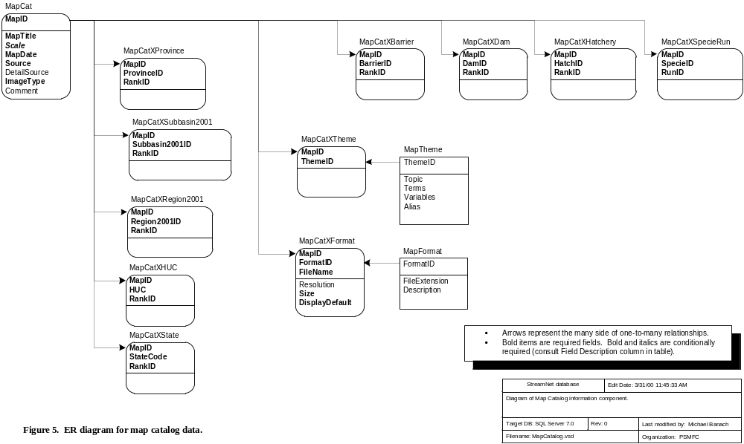

E1. MapCat Table
This table contains information on static map holdings as well as digital photographs and other images.
Field Name | Field Description | Data Type | Codes/Conventions for MapCat Table
MapID | This field uniquely identifies a map or digital image. | Long int | Assigned ranges:  10,000-19,999 = BPA  20,000 - 29,999; 200,000 - 299,999 = CRITFC  30,000 - 39,999; 300,000 - 399,999 = USFWS  40,000 - 49,999; 400000 - 499,999 = IDFG | 80,000 - 89,999; 800000 - 899,999 = MFWP  50,000 - 59,999; 500000 - 599,999 = ODFW  60,000 - 69,999; 600000 - 699,999 = PSMFC  100,000 - 199,999 = WDFW
MapTitle | The title of the plot as it appears on the map or the title description of the photograph. | Text 255
Scale | The map scale.  Not required for photos. Required for all other images. | Text 10 | 1:100,000  1:250,000  etc.
MapDate | The date the plot was produced or the date the photo was taken. | Datetime
Source | The agency that produced the image. | Text 50
DetailSource | Additional contact information about the image source, if available. | Text 255
ImageType | Code for the image type | Byte | 1 = Static Map  2 = Digital photograph or image
Comment | Any comments pertaining to the image | Memo

E2. MapCatXBarrier Table
Many to one relationship with the MapCat table. Contains one record for EACH image of a barrier.
Field Name | Field Description | Data Type | Codes/Conventions for MapCatXBarrier Table
MapID | Uniquely identifies a map or digital image. | Long int | Refer to MapCat table information.
BarrierID | This field uniquely identifies a barrier identified by a particular agency | Long int | For BarrierID codes please refer to the Barrier table (downloadable at ftp://ftp.StreamNet.org/pub/StreamNet/ASCII_Data/Barrier.zip).
RankID | The rank describing the geographic scope of the map relative to the particular barrier. Links to MapRank table. | Byte | Refer to MapCatXDam table information.

E3. MapCatXDam Table
Many to one relationship with the MapCat table. Contains one record for EACH dam on the map.
Field Name | Field Description | Data Type | Codes/Conventions for MapCatXDam Table
MapID | Uniquely identifies a map or digital image. | Long int | Refer to MapCat table information.
DamID | The DamID from the Dam table. | Long int | For a complete list of DamID codes refer to the Dam table (downloadable at ftp://ftp.StreamNet.org/pub/StreamNet/ASCII_Data/Dam.zip).
RankID | The rank describing the geographic scope of the image relative to the particular dam. Links to MapRank table. | Byte | 1 = Exactly to scale  2 = Aggregated  3 = Subset  99 = Unknown

E4. MapCatXFormat Table
Many to one relationship with the MapCat table. Contains one record for EACH format a particular plot is available in.
Field Name | Field Description | Data Type | Codes/Conventions for MapCatXFormat Table
MapID | Uniquely identifies a map or digital image. | Long int | Refer to MapCat table information.
FormatID | The ID field describing the format of the image file. | Byte | 1 = GIF image  2 = JPEG image  3 = Encapsulated Postscript File (Compressed) | 4 = Arc/Info graphics file (Compressed)  5 = Bitmap
FileName | The complete filename of the file. | Text 50
Resolution | Resolution of the image, in pixels. | Text 50 | The values most commonly used so far are: "1024 x 1536", "128 x 192", "2048 x 3072", "256 x 384" and "512 x 768". These are listed here as examples, not as .the only valid values.
Size | The size of the file in kilobytes | Long int
DisplayDefault | For MapIDs with multiple images, this field selects the one image to display by default. Exactly one FileName per MapID must = "T". | Text 1 | T = This FileName is the display default  F = This FileName is not the display default

E5. MapCatXHatchery Table
Many to one relationship with the MapCat table. Contains one record for EACH hatchery that appears on the map.
Field Name | Field Description | Data Type | Codes/Conventions for MapCatXHatchery Table
MapID | Uniquely identifies a map or digital image. | Long int | Refer to MapCat table information.
HatchID | The ID from the Hatchery table for the hatchery. | Integer | For a complete list of HatchID codes please refer to the Hatchery table (downloadable at ftp://ftp.StreamNet.org/pub/StreamNet/ASCII_Data/Hatchery.txt).
RankID | The rank describing the geographic scope of the image relative to the particular hatchery. Links to MapRank table. | Byte | Refer to MapCatXDam table information.

E6. MapCatXHUC Table
Many to one relationship with the MapCat table. Contains one record for EACH 4th-level Hydrologic Unit Code represented on the image for drainage specific images ONLY.
Field Name | Field Description | Data Type | Codes/Conventions for MapCatXHUC Table
MapID | Uniquely identifies a map or digital image. | Long int | Refer to MapCat table information.
HUC | The 8 digit hydrologic unit code (HUC) for each HUC represented on the image. | Text 8
RankID | Rank describing the geographic scope of the image relative to the particular hydrologic unit. Links to MapRank table. | Byte | Refer to MapCatXDam table information.

E7. MapCatXProvince Table
Many to one relationship with the MapCat table. Contains one record for EACH NWPCC-defined province represented on the image.
Field Name | Field Description | Data Type | Codes/Conventions for MapCatXProvince Table
MapID | Uniquely identifies a map or digital image. | Long int | Refer to MapCat table information.
ProvinceID | The code for the Province defined by the NWPCC for subbasin planning in 2001. | Byte | 1 = Columbia River Estuary  2 = Lower Columbia  3 = Columbia Gorge  4 = Columbia Plateau  5 = Columbia Cascade | 6 = Intermountain  7 = Mountain Columbia  8 = Blue Mountain  9 = Mountain Snake | 10 = Middle Snake  11 = Upper Snake  98 = Outside the Columbia basin  99 = Unknown
RankID | Rank describing the geographic scope of the image relative to the particular province. Links to MapRank table. | Byte | Refer to MapCatXDam table information.

E8. MapCatXSubbasin2001 Table
Many to one relationship with the MapCat table. Contains one record for EACH NWPCC-defined subbasin represented on the image. (Note: If a record exists in this table, there should be a corresponding record in the MapCatXProvince table.)
Field Name | Field Description | Data Type | Codes/Conventions for MapCatXSubbasin2001 Table
MapID | Uniquely identifies a map or digital image. | Long int | Refer to MapCat table information.
Subbasin2001ID | The code for the Subbasin defined by the NWPCC for subbasin planning in 2001. | Byte | 11 = Columbia estuary  12 = Grays  13 = Elochoman  21 = Cowlitz  22 = Kalama  23 = Lewis  24 = Columbia lower  25 = Willamette  26 = Washougal  27 = Sandy  31 = Columbia Gorge  32 = Wind  33 = Little White Salmon  34 = Big White Salmon  35 = Hood  36 = Klickitat | 37 = Fifteenmile  40 = Columbia lower middle  41 = Deschutes  42 = John Day  43 = Umatilla  44 = Walla Walla  45 = Snake lower  46 = Palouse  47 = Tucannon  48 = Yakima  49 = Crab  51 = Columbia upper middle  52 = Wenatchee  53 = Entiat  54 = Lake Chelan  55 = Methow | 56 = Okanogan  61 = Columbia upper  62 = Sanpoil  63 = Spokane  64 = Pend Oreille  65 = Coeur D'Alene  71 = Clark Fork  72 = Bitterroot  73 = Blackfoot  74 = Flathead  75 = Kootenai  81 = Snake Hells Canyon  82 = Asotin  83 = Grande Ronde  84 = Imnaha  91 = Clearwater | 92 = Salmon  98 = Outside Columbia Basin  100 = Snake lower middle  101 = Powder  102 = Burnt  103 = Weiser  104 = Snake upper middle  105 = Payette  106 = Malheur  107 = Boise  108 = Owyhee  109 = Bruneau  111 = Snake upper  112 = Snake headwaters  113 = Snake upper closed basin
RankID | Rank describing the geographic scope of the image relative to the particular province. Links to MapRank table. | Byte | Refer to MapCatXDam table information.

E9. MapCatXRegion2001 Table
Many to one relationship with the MapCat table. Contains one record for EACH StreamNet Region represented on the image.
Field Name | Field Description | Data Type | Codes/Conventions for MapCatXRegion2001 Table
MapID | Uniquely identifies a map or digital image. | Long int | Refer to MapCat table information.
Region2001ID | The ID field for the StreamNet Region | Byte | 9 = North Oregon coast  10 = Northern California  14 = Puget Sound | 15 = South Oregon coast  17 = Southern California  18 = Washington coast | 21 = Great Basin  22 = Oregon closed basin  24 = Columbia River basin  28 = Bear River (Great Basin)
RankID | The rank describing the geographic scope of the map relative to the particular Region. Links to MapRank table. | Byte | Refer to MapCatXDam table information.

E10. MapCatXSpecieRun Table
Many to one relationship with the MapCat table. Contains one record for EACH species/run combination represented on the image (if applicable).
Field Name | Field Description | Data Type | Codes/Conventions for MapCatXSpecieRun Table
MapID | Uniquely identifies a map or digital image. | Long int | Refer to MapCat table information.
SpecieID | Code for the fish species | Integer | Refer to Trend table information.
RunID | Code for the fish run | Byte | If run not appropriate for this species, enter 98 = N/A. Refer to the Trend table for other codes.

E11. MapCatXState Table
Many to one relationship with the MapCat table. Contains one record for EACH State represented on the image.
Field Name | Field Description | Data Type | Codes/Conventions for MapCatXState Table
MapID | Uniquely identifies a map or digital image. | Long int | Refer to MapCat table information.
StateCode | ANSI code for the state represented on the image. | Text 2 | Refer to Hatchery table information. (State ANSI codes are the same as the state FIPS codes.)
RankID | The rank describing the geographic scope of the map relative to the particular state. Links to MapRank table. | Byte | Refer to MapCatXDam table information.

E12. MapCatXTheme Table
Many to one relationship with the MapCat table. Contains one record for EACH different theme represented on the image.
Field Name | Field Description | Data Type | Codes/Conventions for MapCatXTheme Table
MapID | Uniquely identifies a map or digital image. | Long int | Refer to MapCat table information.
ThemeID | The ID field describing the theme present on the image. | Integer | The following codes have been used or are currently marked as for use in StreamNet data. However the full list is much longer and any of those entries can be used. To see the full list refer to the MapTheme table in the full database download.  429 = Exotic species  430 = Fish distribution  432 = Indigenous species  447 = Evolutionarily significant units (ESUs)  448 = FEMAT boundary  449 = HUC boundary  450 = Marbled murrelet range  451 = Spotted owl range  483 = Aquaculture (hatcheries)  485 = BPA project sites  490 = Dam location  498 = Industrialization/urbanization  499 = Irrigation  500 = Land ownership  501 = Land use  504 = Oil spill  506 = Pollution  507 = Reforestation | 508 = Habitat restoration  511 = Urbanization (cities)  534 = Floodplain/flooding  536 = Forest  556 = Riparian/stream habitat  666 = Sediment  719 = Drainage  725 = Lakes  728 = Rivers  765 = Water quality  873 = Upwelling  886 = Estuary  912 = Wetland  1021 = Zooplankton  1537 = ESA review species  1538 = Fish blockages  1539 = Fish identification  1541 = Shellfish identification  1564 = Hatchery facility | 1565 = Hatchery operations  1566 = Fish sampling  1567 = Fish tagging  1568 = Habitat destruction  1569 = Fisheries (commercial/recreational/tribal)  1570 = Fish ladder  1571 = Fish screens, and juvenile bypass facilities  1572 = Water diversion  1573 = Marine organisms  1574 = Salmon spawning/redds  1575 = Salmonid development/life cycle  1576 = Historical photo  1577 = Water/nutrient cycling  1578 = Education/community involvement  1579 = Juvenile stranding  1580 = PIT-tagging equipment/facilities  1581 = CWT-coded wire tagging information  1582 = Barging/trucking juvenile salmon smolts Columbia River  1583 = Angling/recreation

F. Reference Information

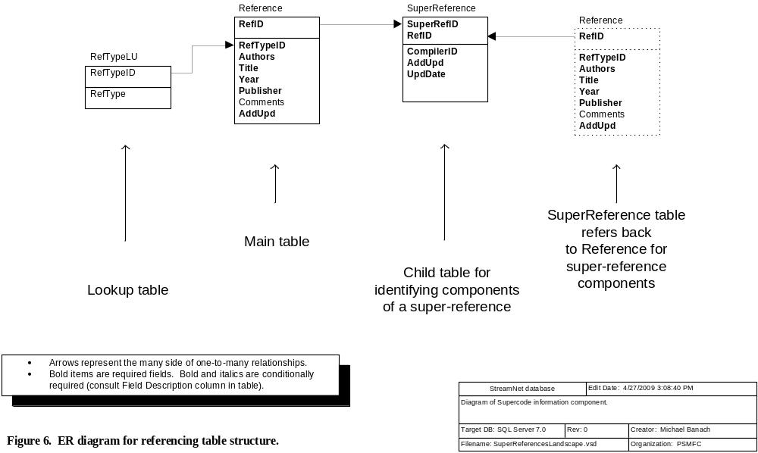

F1. Reference Table
This table stores information about reference documents used to develop the StreamNet database.
Field Name | Field Description | Data Type | Codes/Conventions for Reference Table
RefID | Unique StreamNet reference ID number | Long int | Pre-Data Exchange - 0 - 1,000  WDFW = 10,000-19,999; 100,000-199,999  CRITFC = 20,000-29,999; 200,000-299,999  USFWS = 30,000-39,999; 300,000-399,999  IDFG = 40,000-49,999; 400,000-499,999  ODFW = 50,000-59,999; 500,000-599,999  PSMFC = 60,000-69,999; 600,000-699,999  MFWP = 70,000-89,999; 700,000-799,999  CDFG = 90,000-99,999; 800,000-899,999
RefTypeID | Indicates whether the reference is a single document or multiple documents. | Byte | 1 = Single reference document  2 = Multiple reference documents | If RefTypeID = 2, then:  - the RefID for this record must be used at least twice in the SuperReference table  - Suggested entries for the Authors, Title, Year, and Publisher fields are shown below.
Authors | Author(s) | Memo | Example: Anderson, Duane A.  For SuperReferences (RefTypeID=2), simply entering "Multiple" in this field is suggested.
Title | Title | Memo | Full title of document  For SuperReferences (RefTypeID=2), simply entering "Multiple titles" in this field is suggested.
Year | Year published, year of draft, year data source was created or updated, year communication took place, etc. | Text 40 | Ideally, this is the year a document was published or a personal communication occurred. If unknown, give the best approximate year available and point out the uncertainty in the Comments field.  For SuperReferences (RefTypeID=2), do one of the following:  - enter the year of the most recent item document  - enter the range of years of the document (e.g., "1996-2001")  - enter "Multiple"
Publisher | Publisher | Memo | Document printer. e.g.: Bonneville Power Administration, Portland, OR;  Washington Department of Fish and Wildlife, Olympia, WA  For SuperReferences (RefTypeID=2), simply entering "Multiple" in this field is suggested.
Comments |  | Memo | Any pertinent comments about the reference.
AddUpd | Indicates whether a record has been added or updated. | Yes/No | 0 = False  -1 = True (default)

F2. SuperReference Table
This table lists the individual component references which, when combined, define a superreference. The records with common SuperRefID all belong to the same superreference.
Field Name | Field Description | Data Type | Codes/Conventions for SuperReference Table
SuperRefID | Code which identifies a superreference. | Long int | See Reference table for code ranges. Use the same range for SuperRefID as you use for RefID.  Though a special kind, a "SuperReference" is a reference. Also, this table is a child table of the Reference table. Therefore, every SuperRefID used in this table must first be used in the RefID field of the Reference table.
RefID | Unique StreamNet reference ID number | Long int | See Reference table for code ranges.
CompilerID | The code for the agency that put the data into StreamNet format and sent it to StreamNet, and is responsible for updates. Links to the Compiler table. | Byte | The compiling agency is one of the small group of agencies related to StreamNet. In instances where the person sending data to StreamNet is employed by one agency but functions within a different agency (common for PSMFC staff), the CompilerID reflects the agency the person functions within. See Trend table for codes.
AddUpd | Indicates whether a record has been added or updated. | Yes/No | 0 = False  -1 = True (default)
UpdDate | The date and time that the record was created or updated. For data obtained in electronic format from another source it can reflect the date and time of data capture or of conversion to StreamNet format. | Datetime | This can be the time a record was created, the last time it was edited, or the last time it was QCd.

G. Habitat Restoration / Improvement Projects Data
This section details tables for habitat restoration / habitat improvement projects.
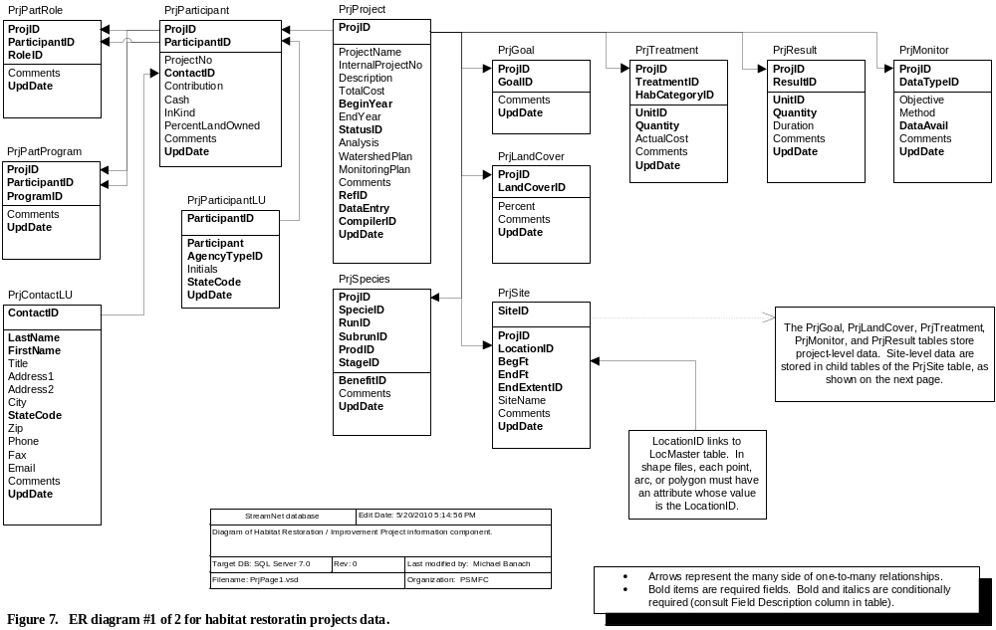
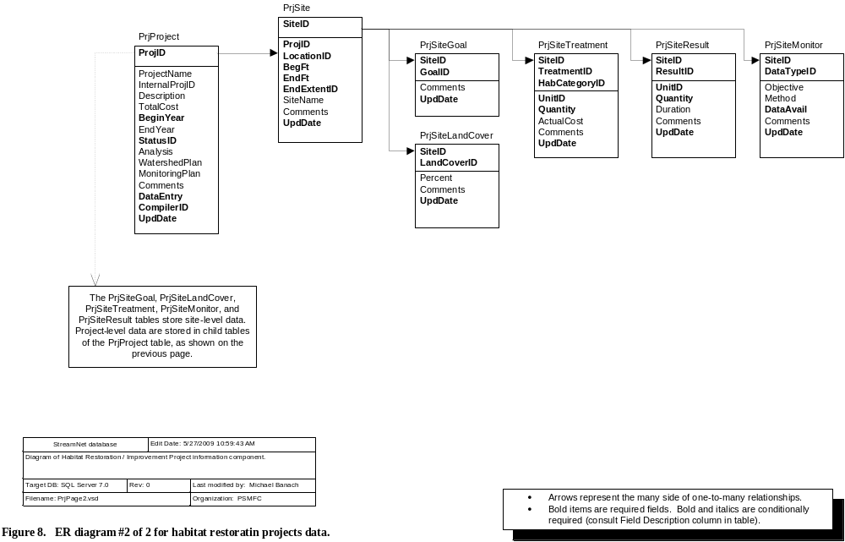
These tables store data about activities that have occurred on the ground in order to improve fish habitat. These activities, grouped into "projects," are known as "habitat restoration projects," "habitat improvement projects," "habitat enhancement projects," "stream habitat projects," "mitigation projects," "habitat creation projects," "habitat replacement projects," "habitat rehabilitation projects," "habitat reclamation projects," or by other names. They may be stand-alone projects, or may be mitigation measures undertaken as part of other land management actions. They may even be things that were not done, such as leaving extra trees in a riparian zone that otherwise would have been harvested during a logging operation. In this database we make no judgements as to the usefulness or appropriateness of actions -- this database is used to document actions taken with the stated purpose of helping fish habitat, and to guide data users to people who can answer further questions about specific projects.

The scope of the this database is limited in the following ways:
1) First, it houses data only for projects that have already produced on the ground results. It does not cover proposed actions, nor does it try to capture real-time information on projects in progress. It can be used to capture early-year data about long-term projects.
2) Second, it is limited to projects done with the stated purpose of helping fish and fish habitat. Projects done purely to help wildlife or vegetation are not covered at this time, nor are projects that manipulate fish populations but not fish habitat.
3) Third, the geographic extent is limited to that area covered in the extended StreamNet sphere. Within the bounds of this scope, we intend this database to include information from all data sources possible: local and state and tribal and federal governments, watershed councils, private companies, etc.

The general outlay and purposes of these tables is as follows:
The PrjProject table is the central table, and each project is identified by one record in this table.
Agencies and other entities that participated in carrying out the project (government agencies, timber companies, private individuals etc.), either through funding or on the ground implementation or other means, are listed in the PrjParticipant table.
The role(s) each of these project participants fulfilled (providing funding, on the ground implementation, etc.) is listed in the PrjPartRole table.
If a project was done under an existing program (e.g., USFWS's "Partners" program) then this information is captured in the PrjPartProgram table.
The goals of the project are captured in the PrjGoal table.
The species affected by the project are captured in the PrjSpecies table.
Land cover before project implementation is captured in the PrjLandCover table. (There is no after-project land cover table.)
Treatments -- that is, the on the ground activities that were carried out -- are recorded in the PrjTreatment table.
The PrjResult table provides codes for recording results of the treatments.
If project effectiveness monitoring is conducted then the PrjMonitor table permits capture of that information.
The PrjSite table records the locations where project treatments occurred.
Finally, the PrjSiteGoal, PrjSiteLandCover, PrjSiteTreatment, PrjSiteResult, and PrjSiteMonitor tables are tables that record site-specific information. These tables are parallel to their project-level counterparts. Project-level, site-level, or both sets of these tables may be filled in.

G1. PrjProject Table
This is the central table for restoration projects data. It contains the core field (ProjID) for organizing the other tables related to habitat restoration/improvement projects, and also contains general information about each project.
Field Name | Field Description | Data Type | Codes/Conventions for PrjProject Table
ProjID | StreamNet primary key for the restoration projects database that uniquely identifies a project. | Long int | 100,000-199,999 = WDFW  200,000-299,999 = CRITFC  300,000-399,999 = USFWS | 400,000-499,999 = IDFG  500,000-599,999 = ODFW  600,000-699,999 = PSMFC |  | 700,000-799,999 = CDFG  800,000-899,999 = MFWP
ProjectName | Official name of project | Text 255
InternalProjectNo | Identifies a project in the database of the agency that provided the data to StreamNet -- i.e., the internal project identifier for CRITFC, WDFW, PRISM, OWEB, CDFG, IRDA, etc. This field ensures database updates are performed correctly, and is included because some data providers are not StreamNet partners and thus do not track ProjID numbers. | Text 50
Description | General statement regarding the primary purpose(s) and general description of the project.. | Memo | The expected benefits of the project should be included here.
TotalCost | Total cost of the project, summed over all participants and all years.. | Currency | This field houses total project cost. Because the Cash and InKind fields of the PrjParticipant table may not always be filled in, this field may be greater than the records in PrjParticipant indicate, but this field should never be lower.
BeginYear | Year project implementation began. | Integer | Project start year must be >1800 and consist of four digits, e.g., '2001'. If begin year is not known, provide an estimate here and describe the uncertainty in the Comments field. We want to be able to indicate newer vs. older vs. very old projects.
EndYear | Year project implementation was or will be completed. | Integer | Project end year must be >1800 and consist of four digits, e.g., '2001' and be ≥ BeginYear.
StatusID | The status of the project. Links to the LuStatus table. | Byte | 1 = Completed  2 = Ongoing  99 = Unknown |  | Code 3, "Planned," is not used because this data set covers only projects that have already been done on the ground.
Analysis | Things that facilitated, complicated, or would help the project. | Memo
WatershedPlan | Name of the watershed assessment or plan which this project addresses, if any. | Text 255 | If this project was done specifically to address actions identified in a watershed plan or watershed assessment, enter the name of the plan or assessment.
MonitoringPlan | Name of the comprehensive monitoring strategy or program used to evaluate this project, if any. | Text 255 | If this project was or will be evaluated under a monitoring program, enter the name of that program here.
Comments | Additional information or comments. | Memo
RefID | RefID for the project data source(s) | Long int | Refer to Reference table information.
DataEntry | Who originally put the data into electronic format. This is not necessarily a StreamNet person. This field can include more information also, to describe not only who entered the data, but who edited or reviewed data or transformed them into a usable format. This field helps with future QC. | Text 50
CompilerID | The code for the agency that put the data into StreamNet format and sent it to StreamNet, and is responsible for updates. Links to the Compiler table. | Byte | The compiling agency is one of the small group of agencies related to StreamNet. In instances where the person sending data to StreamNet is employed by one agency but functions within a different agency (common for PSMFC staff), the CompilerID reflects the agency the person functions within. See Trend table for codes.
UpdDate | The date and time that the record was created or updated. For data obtained in electronic format from another source it can reflect the date and time of data capture or of conversion to StreamNet format. | Datetime | This can be the time a record was created, the last time it was edited, or the last time it was QCd.

G2. PrjParticipant Table
This table stores information about who participated in conducting a project. "Participation" can mean funding the project, providing in-kind services or labor or materials or machinery, providing expertise or administrative support, or performing the project on the ground. This table has a many to one relationship with the PrjProject table via ProjID.
Field Name | Field Description | Data Type | Codes/Conventions for PrjParticipant Table
ProjID | StreamNet project ID. | Long int | Refer to PrjProject table for assigned ranges.
ParticipantID | Unique StreamNet codes for agency and non-agency participants. | Long int | Refer to PrjParticipantLU table.
ProjectNo | Agency number associated with the project (if any). | Text 50 | Agency project number
ContactID | Code for participant's contact or project manager.  Cross reference to PrjContactLU table. | Integer | 99 = Unknown  Other codes shown in the PrjContactLU table.
Contribution | Dollar value of cash plus in-kind contributions made by the participant. | Currency | If information is available for the Cash and InKind fields, then Cash + InKind should equal this value.
Cash | Amount of money provided by this participant | Currency | Rounded to dollars. Enter 0 if it is known that no funds were provided by this participant. If Cash > 0 then a record should be created in the PrjPartRole table indicating this participant is a funder.
InKind | Value of in-kind contribution provided by this participant. "In-kind" means somebody provided support for a project, but not actual money. If not for this support, the project would otherwise have had to pay for the same service. Common in-kind services are free labor, lending use of heavy machinery, or providing materials such as fencing or trees for planting. Because they were provided free they were not a cash contribution, but they were as good as one. Thus, "In kind." | Currency | Rounded to dollars. Enter 0 if it is known that no in-kind contributions were made by this participant.  In-kind contributions are a type of project funding, so if Inkind > 0 then a record should be created in the PrjPartRole table indicating this participant is a funder.
PercentLandOwned | Percentage of project site owned | Byte | Round to whole number from 0 to 100. This number is a percentage of the whole project's land area, not just for a specific site.
Comments | Additional information or comments. | Memo
UpdDate | The date and time that the record was created or updated. For data obtained in electronic format from another source it can reflect the date and time of data capture or of conversion to StreamNet format. | Datetime | This can be the time a record was created, the last time it was edited, or the last time it was QCd.

G3. PrjParticipantLU Table
This is the lookup table for project participants. It has a many to one relationship with the PrjParticipant table via ParticipantID. This table exists (rather than using the Agency table) because of the large number of entries this table will have. We don't want this large number of entries to interfere with the smaller and more focused Agency table.
Field Name | Field Description | Data Type | Codes/Conventions for PrjParticipantLU Table
ParticipantID | Unique StreamNet codes for agency and non-agency participants. | Long int | Refer to the StreamNet PrjParticipantLU table: ftp://ftp.StreamNet.org/pub/StreamNet/ASCII_Data/PrjParticipantLU.txt.  0 = All project participants [Useful in some tables, not in others.)  1-999 = ODFW  1,000-1,999 = BPA |  | 2,000-2,999 = CRITFC  3,000-3,999 = USFWS  4,000-4,999 = IDFG  5,000-5,999 = SHOBAN  6,000-6,999 = PSMFC  8,000-8,999 = MFWP  9,000-9,999; 90,000-99,999 = CDFG  10,000-10,999 = WDFW
Participant | Name of participant. For example, "Idaho Department of Fish and Game." | Text 255 | For private participants that request information not be shared, it was agreed that data providers would censor such data rather than passing to PSMFC. Thus, PSMFC will not filter out "anonymous" records as was done in the previous version of this database. It is preferred that you include private anonymous parties in the table in an appropriate way, rather than leaving their information out. It is also acceptable to pool anonymous private parties into a single record in whatever fashion desired.
AgencyTypeID | Code for the institution type of the participant (private, federal, state, etc.). Links to the AgencyType table. | Byte | Refer to the Barrier table for codes.
Initials | Initials for the participant, when appropriate. For example, enter "IDFG" for Idaho Department of Fish and Game. | Text 20 | Often not applicable for private or business participants. For subdivisions of an agency you can enter either the initials for the whole agency, or for that subdivision. For example, the Nez Perce National Forest could be entered as NPNF or as USFS or as USFS-NPNF or as USDA-FS. Specific is preferred. Consistency is desirable.
StateCode | If a participant occurs in only one state, enter the ANSI code for the state. This becomes useful when similar or identical names are used by different entities in different states. Schools and volunteer groups are good examples. This is also useful when data compilers get an updated lookup code list, so they can know which apply to their state. | Text 2 | 06 = California  16 = Idaho  41 = Oregon | 53 = Washington  30 = Montana  00 = N/A  99 = Unknown |  | (State ANSI codes are the same as the state FIPS codes.)
UpdDate | The date and time that the record was created or updated. For data obtained in electronic format from another source it can reflect the date and time of data capture or of conversion to StreamNet format. | Datetime | This can be the time a record was created, the last time it was edited, or the last time it was QCd.

G4. PrjPartRole Table
This table is used to identify the role(s) that a participant filled for a project. If a participant had more than one role, then enter a record for each role the participant filled. It has a many to one relationship with the PrjParticipant table via ProjID and ParticipantID.
Field Name | Field Description | Data Type | Codes/Conventions for PrjPartRole Table
ProjID | StreamNet project ID. | Long int | Refer to PrjProject table for assigned ranges.
ParticipantID | Unique StreamNet codes for agency and non-agency participants. | Long int | Refer to PrjParticipantLU table.
RoleID | Code for the role played by the participant in the execution of the project. | Byte | 1 = Funder  2 = On-ground implementor  3 = Land owner  4 = Administrator (e.g., middle-man like PSMFC)  5 = Provided technical advice or products  6 = Primary project coordinator  7 = Data source (provided the data being viewed)  99 = Unknown | Note that code 7 "Data source" does not refer to a StreamNet person entering data, but rather to an agency that provided the data in hard copy or electronic format. A StreamNet person entering data gets recorded in the DateEntry field of the PrjProject table, not here.
Comments | Additional information or comments. | Memo
UpdDate | The date and time that the record was created or updated. For data obtained in electronic format from another source it can reflect the date and time of data capture or of conversion to StreamNet format. | Datetime | This can be the time a record was created, the last time it was edited, or the last time it was QCd.

G5. PrjPartProgram Table
This table is used to identify programs under which a participant provided funding or did the work. It has a many to one relationship with the PrjParticipant table via ProjID and ParticipantID.
Field Name | Field Description | Data Type | Codes/Conventions for PrjPartProgram Table
ProjID | StreamNet project ID. | Long int | Refer to PrjProject table for assigned ranges.
ParticipantID | Unique StreamNet codes for agency and non-agency participants. | Long int | Refer to PrjParticipantLU table.
ProgramID | Code for the program the project is a part of. Links to PrjProgramLU table. | Integer | 98 = N/A  99 = Unknown  0-50 = BPA  51-70 = CRITFC | 71-90 = IDFG  91-110 (except 98 and 99) = ODFW  111-130 = SHOBAN  131-150 = USFWS | 151-170 = WDFW  1001-1300 = CDFG  191-210 = MFWP  211-230 = PSMFC
Comments | Additional information or comments. | Memo
UpdDate | The date and time that the record was created or updated. For data obtained in electronic format from another source it can reflect the date and time of data capture or of conversion to StreamNet format. | Datetime | This can be the time a record was created, the last time it was edited, or the last time it was QCd.

G6. PrjContactLU Table
This table is the lookup table for ContactID field in the PrjParticipant table. It houses the person who should be contacted for further information about the project. This table has a many to one relationship with the PrjParticipant table via ContactID.
Field Name | Field Description | Data Type | Codes/Conventions for PrjContactLU Table
ContactID | Code for participant's contact or project manager. | Integer | For existing codes refer to the StreamNet PrjContactLU table: ftp://ftp.StreamNet.org/pub/StreamNet/ASCII_Data/PrjContactLU.txt. Contact PSMFC to assign new code ranges as needed.  Assigned ranges:  99 = Unknown  1-2,999 = WDFW (except 99="Unknown") | 3,000-5,999 = CRITFC  6,000-8,999 = USFWS  9,000-11,999 = IDFG  12,000-14,999 = ODFW  15,000-17,999 = PSMFC  18,000-20,999, 30,000-32,767 = CDFG  21,000-23,999 = MFWP
LastName | Family name of contact person. | Text 20
FirstName | Given name of contact person. | Text 20
Title | Job title of contact person. | Text 80
Address1 | Mailing address line 1 for contact. | Text 255
Address2 | Mailing address line 2 for contact. | Text 255
City | The town where mail is received. | Text 20
StateCode | Cross reference to State table. | Text 2 | Refer to PrjParticipantLU table information. (State ANSI codes are the same as the state FIPS codes.)
Zip | The zip code. | Text 10
Phone | Phone number(s) of contact. | Text 50 | (area code) prefix-number
Fax | Fax number(s) of contact. | Text 50 | (area code) prefix-number
Email | E-mail address(es) of contact. | Text 50
Comments | Additional information or comments. | Memo
UpdDate | The date and time that the record was created or updated. For data obtained in electronic format from another source it can reflect the date and time of data capture or of conversion to StreamNet format. | Datetime | This can be the time a record was created, the last time it was edited, or the last time it was QCd.

G7. PrjSpecies Table
This table holds information about the species affected by a project, whether it is the target species or a secondarily-affected species. The table has a many to one relationship with the PrjProject table via ProjID.
Field Name | Field Description | Data Type | Codes/Conventions for PrjSpecies Table
ProjID | StreamNet project ID. | Long int | Refer to PrjProject table for assigned ranges.
SpecieID | Species code for affected species | Integer | Refer to Trend table information.
RunID | Run code for affected run | Byte | If run not appropriate for this species, enter 98 = N/A. Refer to the Trend table for other codes.
SubrunID | The subrun of the target species | Byte | If subrun not appropriate for this species, enter 98 = N/A. Refer to the Trend table for other codes.
ProdID | Code for the production type of the fish. Natural in this database applies to stocks and situations that cannot be explicitly linked to a hatchery stock. For example, all redd counts are assumed to be Natural stocks, even though some of the fish spawning may be of hatchery origin. | Byte | 1 = Hatchery  2 = Natural  3 = Mixed  99 = Unknown
StageID | Code for the life stage of the fish targeted by the project. | Byte | Use code 30 (Not specified) unless specific information indicates otherwise. The codes most likely to be used for this table are shown at right. See Trend table for full list of codes. |  | 1 = Egg (unspecified)  10 = Adults & jacks  14 = Juvenile (unspecified) | 16 = Smolt  18 = Parr  29 = All stages  30 = Not specified
BenefitID | Is species a primary or secondary beneficiary of the project, or will the project inadvertently negatively affect the species?  Links to PrjBenefitLU table. | Byte | Often one or two species are the true targets of a project, and other species present in the area are listed only as afterthoughts or as additional justification for funding a project. Judgement will be needed during data entry to assign "primary" and "secondary" codes to the species. | 1 = Primary target species  2 = Secondarily affected species: positive effect  3 = Secondarily affected species: detrimental effect
Comments | Additional information or comments. | Memo
UpdDate | The date and time that the record was created or updated. For data obtained in electronic format from another source it can reflect the date and time of data capture or of conversion to StreamNet format. | Datetime | This can be the time a record was created, the last time it was edited, or the last time it was QCd.

G8. PrjLandCover Table
This table houses information about the land cover at the project site as a whole. It has a many to one relationship to the PrjProject table via ProjID. To record land cover information about a single site of a multiple-site project, use the PrjSiteLandCover table.
Field Name | Field Description | Data Type | Codes/Conventions for PrjLandCover Table
ProjID | StreamNet project ID. | Long int | Refer to PrjProject table for assigned ranges.
LandCoverID | Dominant land cover of the project area before the project began. | Byte | Codes 1-5 may be difficult to define consistently, especially across ecoregions. | 1 = Young forest  2 = Second growth forest  3 = Large timber  4 = Mature forest  5 = Old growth  6 = Active harvest  7 = Partially cut forest | 8 = Cropland  9 = Pasture  10 = Ungrazed grasslands  11 = Shrub  12 = Wetland  13 = Barren  14 = Urban | 15 = Other  16 = Forest - unknown age  17 = Rural residential  18 = Urban industrial / commercial  19 = Urban residential  20 = Residential  21 = Mine  99 = Unknown
Percent | Percentage of project area of the indicated land cover. | Byte | Not required, but very useful.  Round to whole number from 0 to 100. This number is a percentage of the whole project's land area, not just for a specific site.
Comments | Additional information or comments. | Memo
UpdDate | The date and time that the record was created or updated. For data obtained in electronic format from another source it can reflect the date and time of data capture or of conversion to StreamNet format. | Datetime | This can be the time a record was created, the last time it was edited, or the last time it was QCd.

G9. PrjGoal Table
This table houses the goals identified for the project. Sometimes "limiting factors" or similar wording is used rather than "goals." Filling in this table sometimes requires interpreting such things as "limiting factors" in order to determine which goals to assign. This table has a many to one relationship with the PrjProject table via ProjID. To record goal information about a single site of a multiple-site project, use the PrjSiteGoal table.
Field Name | Field Description | Data Type | Codes/Conventions for PrjGoal Table
ProjID | StreamNet project ID. | Long int | Refer to PrjProject table for assigned ranges.
GoalID | StreamNet habitat restoration projects goal ID. | Integer | 1 = Stream habitat integrity/complexity protection or improvement [This one often used along with other goals.]  2 = Riparian or floodplain function protection or improvement  3 = Wetland habitat protection, creation or improvement  4 = Estuary habitat protection, creation or improvement  5 = Upland habitat protection or improvement  6 = Stream sediment reduction  7 = Water quality improvement (chemical or nutrients)  8 = Water quality improvement (temperature)  9 = Stream flow improvement  10 = Reduce entrainment of fish into diversion  11 = Fish passage improvement  12 = Reservoir or lake habitat protection, creation or improvement  13 = Increase food resources for fish  14 = Spawning habitat protection, creation, or improvement  15 = Marine habitat protection, creation, or improvement  97 = Other goal  99 = Unknown
GoalID | StreamNet habitat restoration projects goal ID. | Integer | These codes are currently used only by CDFG for CalFish site:  1001 = Research  1002 = Education, training  1004 = Organizational support  1005 = Monitoring | 1006 = Habitat restoration project maintenance or repair  1007 = Planning or watershed assessment  1008 = Land/water right acquisition  1009 = Fish rescue  1010 = Fish rearing and release
Comments | Additional information or comments. | Memo
UpdDate | The date and time that the record was created or updated. For data obtained in electronic format from another source it can reflect the date and time of data capture or of conversion to StreamNet format. | Datetime | This can be the time a record was created, the last time it was edited, or the last time it was QCd.

G10. PrjTreatment Table
This table contains information about the treatments performed during the project. It has a many to one relationship with the PrjProject table via ProjID. To record information about treatments at a single site of a multiple-site project, use the PrjSiteTreatment table.
Field Name | Field Description | Data Type |  | Codes/Conventions for PrjTreatment Table
ProjID | StreamNet project ID. | Long int |  | Refer to PrjProject table for assigned ranges.
TreatmentID | Treatment type details.  Links to PrjTreatmentLU table. | Integer |  | Codes are arranged below into nine groups. The groups are meant only to help find codes of interest. They should not be interpreted as a restriction on which codes can be used for data entry in any particular case.
TreatmentID | FISH PASSAGE:  14 = Fish ladder installed  23 = Fish ladder improved  15 = Fish screen installed  13 = Fishway created [if it's a ladder, use code 14]  20 = Pushup dam permanently removed  21 = Fish barrier (type unknown) removed  22 = Fish barrier installed (type unknown)  602 = Tidegate altered / removed  56 = Log jam removed |  | ROAD / STREAM CROSSINGS:  40 = Culvert or other stream crossing removed and not replaced  33 = Improve ford (low-water traffic crossing)  34 = Culvert replaced with bridge  35 = Culvert replaced with open-bottom arch culvert  36 = Culvert replaced with closed-bottom culvert (round or pipe-arch)  37 = Culvert retrofitted with baffles or weirs  38 = Weir installed below culvert outlet to raise pool level and provide passage through culvert  39 = Bridge installed  62 = Culvert replaced with box culvert  63 = Culvert replaced with open-bottom box culvert  64 = Culvert replaced with closed-bottom box culvert  66 = Culvert replaced [use other code if possible]  124 = Culvert or bridge upgraded (unknown method) |  |  |  |  | ROADS:  201 = Road modified to reduce impacts to streams  206 = Road decommissioned / obliterated  202 = Road ditch and drainage culvert maintenance (removing debris)  203 = Road drainage culvert installed / replaced / improved
TreatmentID | IN-STREAM / ON-BANK ACTIVITIES  503 = Repair/maintenance of existing restoration project structure (non-dam) [use code 58 for fence maintenance; use 202 for culverts and ditches]  29 = Loosened/cleaned spawning gravels (with bulldozer)  119 = Sediment removed from stream  55 = Carcasses or other nutrients added to stream / bank  8 = Boulders placed in stream  9 = Brush bundle placed in stream  1 = Large wood anchored in place (log, rootwad, etc.)  47 = Large wood placement (log, rootwad, etc. Not anchored, or not known if anchored.)  4 = Log weir installed (not below culvert)  11 = Rock weir installed (not below culvert)  31 = Concrete weir installed (not below culvert)  48 = Weir installed (unknown type, not below culvert)  118 = Sediment-trap dam installed  16 = Spawning gravel placed in stream  17 = Stream bank stabilized: rock gabion installed  116 = Stream bank stabilized: riprap (rock revetment) installed  49 = Stream bank stabilized: log revetment installed  50 = Stream bank stabilized: rock and log revetment installed  51 = Stream bank stabilized: bioengineering (living building materials) [this is not simple planting]  7 = Stream bank stabilized: unknown method  120 = Stream bank stabilized: stream bank resloped  12 = Flow deflector installed: type unspecified  52 = Flow deflector installed: log  53 = Flow deflector installed: rock / boulder  401 = Dike breached  10 = Off-channel habitat created (alcove, side channel, pond, etc.)  24 = Off-channel habitat reconnected or access improved (alcove, side channel, etc.)  32 = Main stream channel modified / created (can include reconnecting historical channel)  5 = Pool created (unknown method)  54 = Pool excavated or blasted  122 = Flow deflector installed: rock and log  123 = Pool scour structure installed |  | VEGETATION:  102 = Hardwood stand converted to conifers  42 = Planting (unknown type)  41 = Trees planted (unknown type)  101 = Conifers planted  105 = Hardwoods planted  121 = Shrubs or herbaceous vegetation planted  115 = Grass planted  407 = Wetland vegetation planted  303 = Upland vegetation management changed  65 = Invasive plant control |  |  |  |  | OTHER LAND MANAGEMENT CODES:  103 = Livestock rotation  306 = Agricultural or grazing practices modified  106 = Fencing / livestock exclusion  58 = Fence maintenance  107 = Livestock off-channel watering facility developed  59 = Livestock stream access/crossing created or improved  304 = Irrigation system improved  209 = Mine site restoration  60 = Voluntary riparian tree retention (extra trees left during harvest beyond law requirements) [as part of logging, riparian zone trees that otherwise would have been cut were left standing for stream habitat purposes beyond what was required by law.]  28 = Water management (storage and release timing)  61 = Irrigation water recycled (tailwater recaptured)  104 = Beavers introduced  30011 = Wildlife management, trapping, transport (except beaver introduction)  302 = Upland erosion control  501 = Land purchased, leased, or easement acquired  502 = Water right purchased or leased
TreatmentID | WETLAND:  404 = Existing wetland improved  403 = Previously filled or drained wetland restored  402 = Wetland created |  | ESTUARY:  603 = Previously-filled or drained estuary restored  601 = Estuarine area created  604 = Freshwater flow in estuary increased |  |  |  |  | OTHER CODES:  112 = Dam repaired  57 = Dam removed  113 = Riparian restoration [use other code if possible]  97 = Other treatment [be sure to enter further information in comments]  99 = Unknown
TreatmentID | These codes are currently used only by CDFG:  10001 = Restoration project effectiveness monitoring  10002 = Organizational support  30000 = Research |  | 30003 = Education, training, workshops conducted  30005 = Educational video, display, interpretive facilities created  30007 = Fish rearing and release |  |  |  |  | 30008 = Planning or watershed assessment  30013 = Watershed or fisheries monitoring  30014 = Fish rescue
HabCategoryID | Code for the general category of habitat where the work was done.  Links to the LuHabCategory table. | Byte |  | 1 = In-stream  2 = Riparian  3 = Upland |  | 24 = Wetland  25 = Estuary  26 = Road |  |  |  | 27 = Marine  28 = Mixed  98 = N/A  99 = Unknown
UnitID | Unit of measure in Quantity field. Used in tandem with Quantity field.  Links to LuUnit table. | Byte |  | 1 = acre  2 = acre-foot  3 = baffle  4 = bale  5 = barrier  6 = board  7 = board-foot | 8 = boulder  9 = bridge  10 = cfs  11 = crossing  12 = cubic foot  13 = cubic yard  14 = cubic yards / year |  | 15 = culvert  16 = dam  17 = each  18 = foot  19 = kilometer  20 = log  21 = meter |  | 22 = mile  23 = pool  24 = pound  25 = screen  26 = seedling  27 = site  28 = square foot  29 = square meter |  | 30 = square mile  31 = square yard  32 = structure  33 = ton  34 = tree  35 = yard  36 = Percent  99 = Quantity unknown
Quantity | Quantity or measure of treatment identified in the TreatmentID field. Used in tandem with Units field. | Single |  | If UnitID = 99 (quantity unknown) then enter zero in this field.
ActualCost | Cost of performing the treatment, including such things as materials, equipment use, personnel, in-kind contributions, etc. | Currency |  | Rounded to dollars. If the Quantity field is >1 then this field should record the cost of doing all the treatments indicated by the record. For example, if two log weirs were installed then this field will record the total cost to install both log weirs, not the per-weir cost.
Comments | Additional information or comments. | Memo
UpdDate | The date and time that the record was created or updated. For data obtained in electronic format from another source it can reflect the date and time of data capture or of conversion to StreamNet format. | Datetime |  | This can be the time a record was created, the last time it was edited, or the last time it was QCd.

G11. PrjResult Table
This table is for recording general measures of project accomplishments that cannot be captured in the PrjTreatment table. For example, one record in the PrjTreatment table may say that 1/2 mile of riparian zone was fenced and another record says 1/2 mile of riparian zone had trees planted. But the PrjTreatment table does not indicate whether those records refer to the same 1/2 mile of stream, a partial overlap, or entirely different areas. This table permits recording measures of what was affected by the project overall. This table has a many to one relationship with the PrjProject table via ProjID. When selecting codes from this table, adhere to these definitions: "Protected" means put into protected status so further degradation is less likely; "Treated" means where on-the-ground work was done; "Benefited" means the total length of stream benefited by the treatment(s). Note that the stream length "benefited" can be longer than the length of stream actually treated -- for example, the benefits of lowered stream temperatures or lowered sediment can extend downstream from the project area. To record information about results from work at a single site of a multiple-site project, use the PrjSiteResult table.
Field Name | Field Description | Data Type | Codes/Conventions for PrjResult Table
ProjID | StreamNet project ID. | Long int | Refer to PrjProject table for assigned ranges.
ResultID | Code for the physical result the project produced. The "results" listed here may also be called "performance measures" or "accomplishments" or some other term. | Byte | 1 = Stream length protected by acquisition, easement, lease, or agreement  2 = Stream length treated  3 = Stream length benefited  4 = Stream length opened for fish passage  5 = Sediment prevented from entering stream  6 = Sediment removed from stream  7 = Riparian or floodplain area protected by acquisition, easement, lease, or agreement  8 = Riparian or floodplain area treated  9 = Wetland area protected by acquisition, easement, lease, or agreement  10 = Wetland area created or treated | 11 = Estuarine area protected by acquisition, easement, lease, or agreement  12 = Estuarine area created or treated  13 = Upland area protected by acquisition, easement, lease, or agreement  14 = Upland area treated  15 = Water flow acquired  16 = Water flow protected by screens  17 = Area opened up that is presumed spawning habitat  18 = Area opened up that is presumed rearing habitat  19 = Area protected by acquisition, easement, lease, or agreement  20 = Area treated
UnitID | Unit of measure in Quantity field. Used in tandem with Quantity field.  Links to LuUnit table. | Byte | See PrjTreatment table for codes.
Quantity | Quantity or measure identified in the ResultID field. | Single | Use in tandem with Units field.
Duration | Length of time the Result will apply, or date through which it will be in force. | Text 40 | This field is intended for use when ResultID = 1, 7, 9, 11, 13, and 15. A specific date is preferred, but an entry such as "3 years" is also acceptable.  For codes 1, 7, 9, 11 and 13: Easements, leases, and agreements generally apply for a specific period of time, so indicating the duration or the ending date is useful.  For code 15 it is sometimes appropriate to include both the sunset information (the ending date) and the time of year or the number of months for which the acquired flow applies.
Comments | Additional information or comments. | Memo
UpdDate | The date and time that the record was created or updated. For data obtained in electronic format from another source it can reflect the date and time of data capture or of conversion to StreamNet format. | Datetime | This can be the time a record was created, the last time it was edited, or the last time it was QCd.

G12. PrjMonitor Table
This table holds information about effectiveness monitoring data that exist to help evaluate the project. At this time we are not seeking to capture the monitoring data. Instead we are assuming that the person(s) identified as contacts in the ContactID field of the PrjParticipant table can be contacted for monitoring data. This table has a many to one relationship with the PrjProject table via ProjID. To record information about monitoring at a single site of a multiple-site project, use the PrjSiteMonitor table. (Implementation monitoring is outside the scope of this database because the StreamNet habitat restoration/improvement database only contains data for projects which have already been conducted.)
Field Name | Field Description | Data Type | Codes/Conventions for PrjMonitor Table
ProjID | StreamNet project ID. | Long int | Refer to PrjProject table for assigned ranges.
DataTypeID | Classification of general monitoring type conducted to evaluate project effectiveness.  Links to DataType table. | Byte | 0 = No monitoring done (indicates certainty none was conducted)  Biological  13 = Fish passage effectiveness  1 = Fish counts  2 = Macroinvertebrate sampling  8 = Upland vegetation  9 = Riparian vegetation  18 = Aquatic vegetation  20 = Other aquatic or terrestrial species | Water  17 = Water quantity / flow  19 = Water quality  3 = Water temperature  12 = Suspended sediment  (A water quality measure. Substrate sediment levels are code 7.)  11 = Fecal coliform  10 = Dissolved oxygen  16 = Water pH  6 = Salinity |  | Physical  15 = Livestock exclusion effectiveness  7 = Physical instream habitat  (Includes measures of substrate sediment levels. Water quality sediment levels are code 12.)  4 = Air temperature  5 = Soils  14 = Culvert function  Other codes  21 = Photographs  97 = Other  99 = Unknown
Objective | Objectives of the monitoring effort. | Memo
Method | Primary methods used for monitoring activity. | Memo | You can use this field to supply details about the method(s) used to monitor the item indicated by the MonitorID field.
DataAvail | Are monitoring data available for evaluating the effectiveness of the project? (Not necessarily currently in StreamNet database.) | Byte | Because records in this table are specific to a monitoring type, as shown in the DataTypeID field, this field should be filled in for the type of data indicated by DataTypeID. |  | 0 = False  1 = True  99 = Unknown
Comments | Additional information or comments. | Memo
UpdDate | The date and time that the record was created or updated. For data obtained in electronic format from another source it can reflect the date and time of data capture or of conversion to StreamNet format. | Datetime | This can be the time a record was created, the last time it was edited, or the last time it was QCd.

G13. PrjSite Table
This table records locations at which work was done. It has a many to one relationship with the PrjProject table via ProjID. This table also is the parent table for the PrjSiteGoal, PrjSiteLandCover, PrjSiteTreatment, PrjSiteResult, and PrjSiteMonitor tables. Those five tables mirror their project-level counterparts, but the data they hold are specific to a single site.
Field Name | Field Description | Data Type | Codes/Conventions for PrjSite Table
SiteID | Unique code that identifies a site. | Long int | Each location gets a SiteID number that is unique for the whole database. This number is specific to a ProjID, so a single on-the-ground location can be represented by more than one SiteID if more than one project occurred at that location. | 1,000,000-1,999,999 = WDFW  2,000,000-2,999,999 = CRITFC  3,000,000-3,999,999 = USFWS  4,000,000-4,999,999 = IDFG | 5,000,000-5,999,999 = ODFW  6,000,000-6,999,999 = PSMFC  7,000,000-7,999,999 = CDFG  8,000,000-8,999,999 = MFWP
ProjID | StreamNet project ID. | Long int | Refer to PrjProject table for assigned ranges.
LocationID | The location code of the stream, lake, HUC, dam, supercode, polygon, etc. See "LocationID" in the Glossary. | Text 13 | This data category uses more types of location coding than the other data categories. It is also the only data category that can involve sending shape files. For this reason extra instruction is provided here.  Refer to the first section of this document, "Location coding," for general information for filling in this field.  There are two issues to consider regarding location codes.  1) Does a code already exist?  2) What type of location is being described?  Stream or riparian location  Standing water location (i.e., lake, reservoir, wetland, pond, marine area)  Upland point location (not on a stream)  Line location that is not a stream (e.g. a road)  Polygon location  Where location codes already exist:  -- Where in-stream or riparian work was done for a stream already in the hydrography GIS layer, this field will be filled in with an existing LocationID for the stream.  -- For work done in a standing water already in the GIS layer, this field will be filled in with an existing LocationID for the standing water body.  -- For other existing location codes, refer to ftp://ftp.StreamNet.org/pub/StreamNet/Projman_files/ExchangeFormat/CurrentDraft/LocMaster.txt.  -- For instances where a site's exact location is not known, use a code such as "Unresolved location in HUC 17010201" or even "Restoration Project in Montana not yet located." These codes already exist and can be found at ftp://ftp.StreamNet.org/pub/StreamNet/Projman_files/ExchangeFormat/CurrentDraft/LocMaster.txt.  When existing location codes don't work, you will have to create a new one.  -- Streams. If you need to add a stream, contact a StreamNet GIS specialist to discuss how to do this.  -- For other types of locations, new LocationIDs must be created and then submitted using the LocMaster and perhaps the SupercodeStreams table.  -- For upland points, create a new LocationID by concatenating Longitude and Latitude (in NAD83), each accurate to 4 decimal places, then remove the decimal points. For example, a point with longitude = -123.45678 and latitude = 45.67801 would get a LocationID of 1234568456780. (Do not create a point code if you can instead use a stream code.)  -- For non-stream lines, create an arc shape file and provide metadata defining datum and projection. The attribute file for the shape file must have fields for SiteID and LocationID. Each arc (line) you make must have a SiteID and LocationID value assigned. The SiteID and LocationID values must match the appropriate record in the PrjSite table. To create LocationIDs, we suggest using the concatenated long/lat of the starting point of the arc. If you think it appropriate, multiple arcs can share a single SiteID and LocationID.  -- For polygons, create a polygon shape file and provide metadata defining datum and projection. The attribute file for the shape file must have fields for SiteID and LocationID. Each polygon you make must have a SiteID and LocationID value assigned. Create LocationIDs following the methods described in the "Location Coding" section of this document. The SiteID and LocationID values must match the appropriate record in the PrjSite table. To create LocationIDs, we suggest using the concatenated long/lat of the centroid of the polygon. If you think it appropriate, multiple polygons can share a single SiteID and LocationID.  -- For all new LocationID codes you create, fill out a record in the LocMaster table and submit it with your restoration projects data submission.  -- If you find something for which the existing LocSubTypeID choices in LocMaster do not seem adequate, contact StreamNet to discuss your need.
BegFt | If LocationID is for a stream, the downstream measure, in feet, of the stream section that defines the boundary of the site. For other location types enter -1. | Long int | Enter -1 if LocationID does not represent a stream.
EndFt | If LocationID is for a stream, the upstream measure, in feet, of the stream section that defines the boundary of the site. For other location types enter -1 | Long int | Enter -1 if LocationID does not represent a stream.
EndExtentID | EndFt values that are very near the top end of a stream or near a state border can be ambiguous. Is the EndFt meant to indicate the top end of the stream or the state border, or is there a deliberate reason the EndFt value falls short of the top of the stream, or just shy or just over a state border? This field answers that question. | Byte | 0 = EndFt value is not meant to represent the top end of stream or a state border  1 = EndFt value is meant to represent the top of the stream  2 = EndFt value is meant to represent the state border  97 = Not yet determined
SiteName | Name used by project to identify the site | Text 255
Comments | Additional information or comments. | Memo
UpdDate | The date and time that the record was created or updated. For data obtained in electronic format from another source it can reflect the date and time of data capture or of conversion to StreamNet format. | Datetime | This can be the time a record was created, the last time it was edited, or the last time it was QCd.

G14. PrjSiteLandCover Table
This table mirrors the PrjLandCover table, but is for site-level information rather than project-level. This table houses information about the pre-project land cover at a specific site. It has a many to one relationship to the PrjSite table via SiteID. To record land cover information about the whole project, use the PrjLandCover table.
Field Name | Field Description | Data Type | Codes/Conventions for PrjSiteLandCover Table
SiteID | SiteID from the PrjSite table. | Long int | Refer to PrjSite table for assigned ranges.
LandCoverID | Dominant land cover of the site before the project began. | Byte | Refer to PrjLandCover table for codes.
Percent | Percentage of site of the indicated land cover. | Byte | Not required, but very useful.  Round to whole number from 0 to 100. This number is a percentage of the specific site's land area, not for the whole project.
Comments | Additional information or comments. | Memo
UpdDate | The date and time that the record was created or updated. For data obtained in electronic format from another source it can reflect the date and time of data capture or of conversion to StreamNet format. | Datetime | This can be the time a record was created, the last time it was edited, or the last time it was QCd.

G15. PrjSiteGoal Table
This table mirrors the PrjGoal table, but is for site-level information rather than project-level. This table houses the goals identified for a specific site. Sometimes "limiting factors" or similar wording is used rather than "goals." Filling in this table sometimes requires interpreting such things as "limiting factors" in order to determine which goals to assign. This table has a many to one relationship with the PrjSite table via SiteID. To record goal information about the whole project, use the PrjGoal table.
Field Name | Field Description | Data Type | Codes/Conventions for PrjSiteGoal Table
SiteID | SiteID from the PrjSite table. | Long int | Refer to PrjSite table for assigned ranges.
GoalID | StreamNet habitat restoration projects goal ID. | Byte | Refer to PrjGoal table for codes.
Comments | Additional information or comments. | Memo
UpdDate | The date and time that the record was created or updated. For data obtained in electronic format from another source it can reflect the date and time of data capture or of conversion to StreamNet format. | Datetime | This can be the time a record was created, the last time it was edited, or the last time it was QCd.

G16. PrjSiteTreatment Table
This table mirrors the PrjTreatment table, but is for site-level information rather than project-level. This table contains information about the treatments performed at a specific site. It has a many to one relationship with the PrjSite table via SiteID. To record information about treatments for a whole project, use the PrjTreatment table.
Field Name | Field Description | Data Type | Codes/Conventions for PrjSiteTreatment Table
SiteID | SiteID from the PrjSite table. | Long int | Refer to PrjSite table for assigned ranges.
TreatmentID | Treatment type details.  Links to PrjTreatmentLU table. | Integer | Refer to PrjTreatment table for codes.
HabCategoryID | Code for the general category of habitat where the work was done.  Links to the LuHabCategory table. | Byte | Refer to PrjTreatment table for codes.
UnitID | Unit of measure in Quantity field. Used in tandem with Quantity field.  Links to LuUnit table. | Byte | Refer to PrjTreatment table for codes.
Quantity | Quantity or measure of treatment identified in the TreatmentID field. Used in tandem with Units field. | Single | If UnitID = 99 (quantity unknown) then enter zero in this field.
ActualCost | Cost of performing the treatment, including such things as materials, equipment use, personnel, in-kind contributions, etc. | Currency | Rounded to dollars. If the Quantity field is >1 then this field should record the cost of doing all the treatments indicated by the record. For example, if two log weirs were installed then this field will record the total cost to install both log weirs, not the per-weir cost.
Comments | Additional information or comments. | Memo
UpdDate | The date and time that the record was created or updated. For data obtained in electronic format from another source it can reflect the date and time of data capture or of conversion to StreamNet format. | Datetime | This can be the time a record was created, the last time it was edited, or the last time it was QCd.

G17. PrjSiteResult Table
This table mirrors the PrjResult table, but is for site-level information rather than project-level. This table is for recording general measures of accomplishments at a site that cannot be captured in the PrjSiteTreatment table. Because this table is specific to a site, no ambiguity exists for locations and so some codes used in the project-level PrjResult table are not used here. Codes applicable to this table are shown below. This table has a many to one relationship with the PrjSiteProject table via SiteID. When selecting codes from this table, adhere to the definitions for "Protected" and "Treated" and "Benefited" as shown for the PrjResult table. To record information about results for the whole project, use the PrjResult table.
Field Name | Field Description | Data Type | Codes/Conventions for PrjSiteResult Table
SiteID | SiteID from the PrjSite table. | Long int | Refer to PrjSite table for assigned ranges.
ResultID | Code for the physical result the project produced. The "results" listed here may also be called "performance measures" or "accomplishments" or some other term. | Byte | Some codes listed in the PrjResult table are not applicable here, and so are not shown. | 3 = Stream length benefited  4 = Stream length opened for fish passage  5 = Sediment prevented from entering stream  15 = Water flow acquired  16 = Water flow protected by screens
UnitID | Unit of measure in Quantity field. Used in tandem with Quantity field.  Links to LuUnit table. | Byte | See PrjTreatment table for codes.
Quantity | Quantity or measure identified in the ResultID field. | Single | Use in tandem with Units field.
Duration | Length of time the Result will apply, or date through which it will be in force. | Text 40 | Refer to PrjResult table.
Comments | Additional information or comments. | Memo
UpdDate | The date and time that the record was created or updated. For data obtained in electronic format from another source it can reflect the date and time of data capture or of conversion to StreamNet format. | Datetime | This can be the time a record was created, the last time it was edited, or the last time it was QCd.

G18. PrjSiteMonitor Table
This table mirrors the PrjMonitor table, but is for site-level information rather than project-level. This table holds information about effectiveness monitoring data that exist to help evaluate the project. At this time we are not seeking to capture the monitoring data. Instead we are assuming that the person(s) identified as contacts in the ContactID field of the PrjParticipant table can be contacted for monitoring data. This table has a many to one relationship with the PrjSite table via SiteID. To record information about monitoring for the whole project, use the PrjMonitor table. (Implementation monitoring is outside the scope of this database because the StreamNet habitat restoration/improvement database only contains data for projects which have already been conducted.)
Field Name | Field Description | Data Type | Codes/Conventions for PrjMonitor Table
SiteID | SiteID from the PrjSite table. | Long int | Refer to PrjSite table for assigned ranges.
DataTypeID | Classification of general monitoring type conducted to evaluate project effectiveness.  Links to DataType table. | Byte | Refer to PrjMonitor table for codes.
Objective | Objectives of the monitoring effort. | Memo
Method | Primary methods used for monitoring activity. | Memo | You can use this field to supply details about the method(s) used to monitor the item indicated by the MonitorID field.
DataAvail | Are monitoring data available for evaluating the effectiveness of the project? (Not necessarily currently in StreamNet database.) | Byte | Because records in this table are specific to a monitoring type, as shown in the MonitorID field, this field should be filled in for the type of data indicated by MonitorID. | 0 = False  1 = True  99 = Unknown
Comments | Additional information or comments. | Memo
UpdDate | The date and time that the record was created or updated. For data obtained in electronic format from another source it can reflect the date and time of data capture or of conversion to StreamNet format. | Datetime | This can be the time a record was created, the last time it was edited, or the last time it was QCd.

H. Hatchery Facility Data
This data category includes information about existing hatchery facilities.
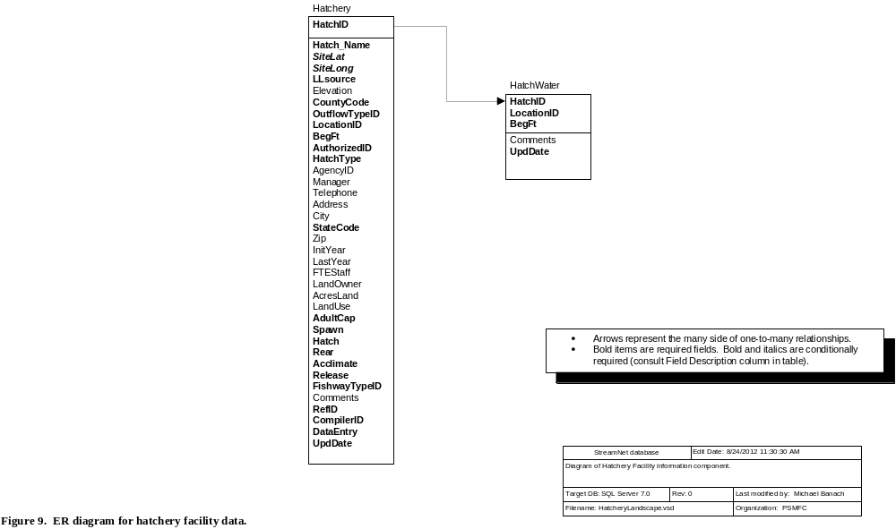

H1. Hatchery Table
This table contains information about hatchery facilities. It also houses codes used in the HatchRelData and HatchRetData tables. "Facility" is defined as an immobile, permanent or semi-permanent fish culture station. (Note: Due to overlapping geographic responsibilities, state, federal, and tribal agencies must coordinate to prevent duplicate entries. The StreamNet regional database manager must ensure that deleted records are replaced appropriately.)
Field Name | Field Description | Data Type | Codes/Conventions for Hatchery Table
HatchID | The unique hatchery ID number for the facility. | Integer | 98 = N/A  2,000-2,999 = CRITFC  Codes 4000-4999 reserved for IDFG.  Codes 610-709 reserved for WDFW.  Codes 558-599, 5000-5999 reserved for ODFW.  Codes 710-729, 800-899 reserved for MFWP.  Codes 730-769 reserved for CDFG.  For a complete list of HatchID codes please refer to the Hatchery table (downloadable at ftp://ftp.StreamNet.org/pub/StreamNet/ASCII_Data/Hatchery.txt).
Hatch_Name | The name of the hatchery | Text 100
SiteLat | Latitude of the hatchery site in decimal degrees (not degrees-minutes-seconds). Calculated using the 1983 North American Datum (NAD83).  Required unless OutflowTypeID=98. | Double | Use two digits left of the decimal point and at least four digits to the right of the decimal point. Up to six digits to the right of the decimal point are permitted.
SiteLong | Longitude of the hatchery site in decimal degrees (not degrees-minutes-seconds). Calculated using the 1983 North American Datum (NAD83).  Required unless OutflowTypeID=98. | Double | This is a negative number. Use three digits left of the decimal point and at least four digits to the right of the decimal point. Up to six digits to the right of the decimal point are permitted.
LLsource | Method by which the longitude and latitude values were determined.  Required for non-stream points (LocTypeID=3). Not applicable for other location types. | Text 3 | Only three options are possible:  GPS = Coordinates were determined by use of Global Positioning System, and datum is known to be NAD83.  DIG = Digitally-derived. Includes digitized coordinates, or those converted from other (non-GPS) projected data, and datum is known to be NAD83.  UNK = Unknown how lat/long values were determined, or datum = NAD83 cannot be confirmed.  CEN = Centroid coordinates derived from a feature that is represented as a polygon in StreamNet’s GIS.  N/A = Not applicable
Elevation | Elevation of the hatchery in feet | Integer
CountyCode | Concatenated ANSI state code plus ANSI county code for the county where the hatchery is located. For example: ANSI state code for California=06 and ANSI county code for Inyo County is 027, so "06027" would be used in StreamNet for this county. | Text 5 | For state ANSI codes see the StateCode field further down in this table. For county ANSI codes refer to www.census.gov/geo/www/ansi/countylookup.html. (State and county ANSI codes are the same as the state and county FIPS codes.)  XX000 = N/A [where XX = StateCode]  XX999 = Unkonwn [where XX = StateCode]
OutflowTypeID | Code for the water body class to which the hatchery's water is primarily discharged. | Byte | 4 = No outflow to any fresh or marine water body.  8 = Outflow to stream  9 = Outflow to standing water  98 = N/A. Use when HatchID represents N/A or a collection of facilities (98, 347, 603, or similar).  99 = Unknown
LocationID | Usually the LocationID of the stream the hatchery is on, but see the Codes/Conventions column for further information. | Text 13 | Contact regional data manager for various codes for "Unknown"  If OutflowTypeID = 4 or 98:  LocationID =Null;  BegFt = Null;  If OutflowTypeID = 8:  LocationID = The appropriate code for the stream;  BegFt = Measure in feet from the mouth of the stream identified in the LocationID field to the main hatchery outflow;  If OutflowTypeID = 9:  LocationID = The appropriate code for the lake/reservoir/etc.;  BegFt = -1
BegFt | Required if OutFlowTypeID=1, 2, or 6. | Long int | Refer to notes under LocationID field above for conventions for filling in this field.
AuthorizedID | The legislation or program that authorized the hatchery construction  Links to the Authorized table. | Byte | 1 = Mitchell Act  2 = Northwest Power Act / Fish & Wildlife Program of the NPPC  3 = LSRCP (Lower Snake River Compensation Plan)  4 = Federal Power Act / FERC mitigation  5 = State statute or program  6 = Tribal statute or program |  | 7 = Dingle-Johnson  8 = Grand Coulee Mitigation  9 = Other federal statute or program  10 = Other  11 = Idaho Power Mitigation  98 = N/A  99 = Unknown
HatchType | The general life-history pattern of species raised at this hatchery as of Spring 1999 | Integer | 1 = Anadromous fish  2 = Resident fish |  | 3 = Both resident and anadromous  98 - N/A  99 = Unknown
AgencyID | Code for the management agency responsible for the hatchery. Cross reference to Agency lookup table. | Integer | For AgencyID codes please refer to the Agency table. (Downloadable at ftp://ftp.StreamNet.org/pub/StreamNet/ASCII_Data/Agency.txt)
Manager | The name of the hatchery manager | Text 30
Telephone | Phone number for hatchery | Text 12 | Preferred format is this pattern: "503-595-3100".
Address | Mailing address of the hatchery | Text 50
City | The town where mail is received | Text 20
StateCode | ANSI state code for the mailing address of the facility. | Text 2 | 06 = California  16 = Idaho  41 = Oregon | 53 = Washington  30 = Montana  00 = N/A  99 = Unknown |  | (State ANSI codes are the same as the state FIPS codes.)
Zip | The zip code | Text 10
InitYear | The year the hatchery went into operation | Integer | "Operated" is defined as water flowing through the facility for fish culture purposes
LastYear | If not currently in operation, the last year the hatchery operated | Integer | "Operated" is defined as water flowing through the facility for fish culture purposes
FTEStaff | The number of Full Time Equivalent (FTE) staff on location | Single
LandOwner | Owner of the land where the hatchery is located | Text 100
AcresLand | The total acreage owned and available for hatchery use (not only the acres in use) | Single
LandUse | Percentage of acres actually in use by the hatchery | Single
AdultCap | Does this facility have the infrastructure for capturing adults? | Byte | 0 = False  1 = True  99 = Unknown
Spawn | Does this facility have the infrastructure for adult spawning (egg collection)? | Byte | 0 = False  1 = True  99 = Unknown
Hatch | Does this facility have the infrastructure for holding eggs until hatching? | Byte | 0 = False  1 = True  99 = Unknown
Rear | Does this facility have the infrastructure for rearing fish? | Byte | 0 = False  1 = True  99 = Unknown
Acclimate | Does this facility have the infrastructure for prerelease acclimation? | Byte | 0 = False  1 = True  99 = Unknown  (This field should contain "False" if "Release" field contains "False." Also, this item refers to relatively short-term holding of fish, unlike the essentially unlimited time suggested in the "Rear" field.)
Release | Does this facility have the infrastructure for directly releasing fish to a natural water body? | Byte | 0 = False  1 = True  99 = Unknown
FishWayTypeID | Code describing the type of fishway. | Byte | Refer to Barrier table.
Comments | Special purposes, special conditions, etc. | Memo | Comments are helpful when OutflowTypeID = 5, 6, or 7, or if outflow is to more than one stream.
RefID | The primary reference number for the source of the hatchery information | Long int | Refer to Reference table information.
CompilerID | The code for the agency that put the data into StreamNet format and sent it to StreamNet, and is responsible for updates. Links to the Compiler table. | Byte | The compiling agency is one of the small group of agencies related to StreamNet. In instances where the person sending data to StreamNet is employed by one agency but functions within a different agency (common for PSMFC staff), the CompilerID reflects the agency the person functions within. See Trend table for codes.
DataEntry | Who originally put the data into electronic format. This is not necessarily a StreamNet person. This field can include more information also, to describe not only who entered the data, but who edited or reviewed data or transformed them into a usable format. This field helps with future QC. | Text 50
UpdDate | The date and time that the record was created or updated. For data obtained in electronic format from another source it can reflect the date and time of data capture or of conversion to StreamNet format. | Datetime | This can be the time a record was created, the last time it was edited, or the last time it was QCd.

H2. HatchWater Table
This table links to the Hatchery table via the HatchID field and holds the hatchery water source data. It has a many to one relationship with the Hatchery table.
Field Name | Field Description | Data Type | Codes/Conventions for HatchWater Table
HatchID | The ID number of the hatchery. Cross reference to Hatchery table | Integer | For a complete list of HatchID codes please refer to the Hatchery table (downloadable at ftp://ftp.StreamNet.org/pub/StreamNet/ASCII_Data/Hatchery.txt).
LocationID | The code for the water body or other water source that is a water supply for the hatchery.  See "LocationID" in the Glossary for further notes. | Text 13 | A LocationID is used even for such water sources as wells and municipal water supplies. Create a PointID for such sources and submit them in the LocMaster table.
BegFt | Distance in feet from the mouth of the stream | Long int | If the LocationID field does not represent a stream, then enter -1.
Comments | Enter any appropriate comments about the water supply. | Memo
UpdDate | The date and time that the record was created or updated. For data obtained in electronic format from another source it can reflect the date and time of data capture or of conversion to StreamNet format. | Datetime | This can be the time a record was created, the last time it was edited, or the last time it was QCd.

I. Dam Facility Data
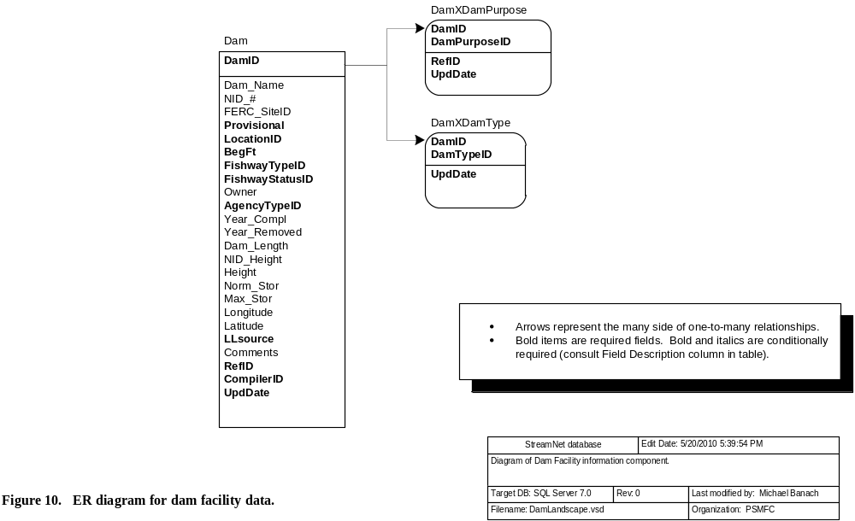

I1. Dam Table
This table contains information about dams in the Pacific Northwest.
Field Name | Field Description | Data Type | Codes/Conventions for Dam Table
DamID | The DamID number for the dam  The mailing address of the dam determines which state is responsible for updates. | Long int | 98 = N/A  0 - 9,999 = National Inventory of Dams  10,000-19,999 = WDFW  20,000-29,999 = CRITFC  30,000-39,999 = USFWS | 40,000-49,999 = IDFG  50,000-69,999 = ODFW  70,000-79,999 = MFWP  90,000-99,999 = CDFG | For a complete list of DamID codes please refer to the Dam table. (Downloadable at ftp://ftp.StreamNet.org/pub/StreamNet/ASCII_Data/Dam.zip)
Dam_Name | The name of the dam | Text 65
NID_# | National Inventory of Dams ID number | Text 7
FERC_SiteID | Federal Energy Regulatory Commission number authorizing the dam. | Text 12
Provisional | If yes, indicates the assigned measure along the stream may not be the exact location of the dam. | Yes/No | 0 = False  -1 = True
LocationID | The LocationID of the stream the dam is on, or the point representing the dam location.  See "LocationID" in the Glossary for further notes. | Text 13
BegFt | Distance of the dam from the mouth of the stream (in feet). | Long int | Enter -1 if LocationID does not represent a stream.
FishwayTypeID | Code describing the type of fishway. | Byte | Refer to Barrier table.
FishwayStatusID | Code describing presence or status of fish passage facilities at dam | Byte | Refer to Barrier table for codes.
Owner | The dam owner | Text 100
AgencyTypeID | Code for the institutional status of the dam owner (Private, Federal, State, etc.). Links to the AgencyType table. | Byte | Refer to the Barrier table for codes.
Year_Compl | The year the dam was completed | Integer
Year_Removed | Year the dam was removed (if applicable) | Integer
Dam_Length | Dam crest length in feet (length of dam along stream surface) | Single
NID_Height | The maximum of dam, structure, or hydraulic height in feet from the National Inventory of Dams. | Single
Height | Height of dam in feet from a source other than the National Inventory of Dams. | Integer
Norm_Stor | The normal storage capacity of the reservoir in acre feet | Single
Max_Stor | The maximum storage capacity of the reservoir in acre feet | Single
Longitude | Longitude of the project in decimal degrees (not degrees-minutes-seconds). Calculated using the 1983 North American Datum (NAD83). | Double | This is a negative number. Use three digits left of the decimal point and at least four digits to the right of the decimal point. Up to six digits to the right of the decimal point are permitted.
Latitude | Latitude of the project in decimal degrees (not degrees-minutes-seconds). Calculated using the 1983 North American Datum (NAD83). | Double | Use two digits left of the decimal point and at least four digits to the right of the decimal point. Up to six digits to the right of the decimal point are permitted.
LLsource | Method by which the longitude and latitude values were determined.  Required for non-stream points (LocTypeID=3). Not applicable for other location types. | Text 3 | Only three options are possible:  GPS = Coordinates were determined by use of Global Positioning System, and datum is known to be NAD83.  DIG = Digitally-derived. Includes digitized coordinates, or those converted from other (non-GPS) projected data, and datum is known to be NAD83.  UNK = Unknown how lat/long values were determined, or datum = NAD83 cannot be confirmed.  CEN = Centroid coordinates derived from a feature that is represented as a polygon in StreamNet’s GIS.  N/A = Not applicable
Comments | Comments related to the dam | Memo
RefID | The primary reference number for the source of the Dam information | Long int | Refer to Reference table information.
CompilerID | The code for the agency that put the data into StreamNet format and sent it to StreamNet, and is responsible for updates. Links to the Compiler table. | Byte | The compiling agency is one of the small group of agencies related to StreamNet. In instances where the person sending data to StreamNet is employed by one agency but functions within a different agency (common for PSMFC staff), the CompilerID reflects the agency the person functions within. See Trend table for codes.
UpdDate | The date and time that the record was created or updated. For data obtained in electronic format from another source it can reflect the date and time of data capture or of conversion to StreamNet format. | Datetime | This can be the time a record was created, the last time it was edited, or the last time it was QCd.

I2. DamXDamPurpose Table
This table contains information about the defined purposes of the dam. There is a many to one relationship with the Dam table via the DamID field. There should be at least one record in this table for each record in the Dam table, if possible.
Field Name | Field Description | Data Type | Codes/Conventions for DamXDamPurpose Table
DamID | The DamID number for the dam | Long int | 98 = N/A  For assigned DamID range series please refer to the Dam table information, or for a complete list of DamID codes refer to the Dam table. (Downloadable at ftp://ftp.StreamNet.org/pub/StreamNet/ASCII_Data/Dam.zip)
DamPurposeID | The uses or purposes of the project (hydropower, water supply, recreation, etc.) | Byte | 1 = Irrigation  2 = Hydroelectric  3 = Flood control and storm water management  4 = Navigation | 5 = Water supply  6 = Recreation  7 = Fire protection, stock, or small farm pond  8 = Fish And wildlife pond | 9 = Debris control  10 = Tailings  11 = Other  12 = Water quality  99 = Unknown
RefID | The primary reference number for the source of the Dam information | Long int | Refer to Reference table information.
UpdDate | The date and time that the record was created or updated. For data obtained in electronic format from another source it can reflect the date and time of data capture or of conversion to StreamNet format. | Datetime | This can be the time a record was created, the last time it was edited, or the last time it was QCd.

I3. DamXDamType Table
This table contains information about the defined types of the dam. There is a many to one relationship with the Dam table via the DamID field. There should be at least one record in this table for each record in the Dam table, if possible.
Field Name | Field Description | Data Type | Codes/Conventions for DamXDamType Table
DamID | The DamID number for the dam | Long int | 98 = N/A  For assigned DamID range series please refer to the Dam table information, or for a complete list of DamID codes refer to the Dam table. (Downloadable at ftp://ftp.StreamNet.org/pub/StreamNet/ASCII_Data/Dam.zip)
DamTypeID | The dam type (earth, rockfill/gravity, arch, etc.) | Byte | 1 = Buttress  2 = Concrete gravity  3 = Concrete  4 = Rockfill | 6 = Masonry  7 = Multi-arch  8 = Non required  9 = Other | 10 = Gravity  11 = Rolled concrete  12 = Earth  13 = Stone | 14 = Timber crib  15 = Arch  99 = Unknown
UpdDate | The date and time that the record was created or updated. For data obtained in electronic format from another source it can reflect the date and time of data capture or of conversion to StreamNet format. | Datetime | This can be the time a record was created, the last time it was edited, or the last time it was QCd.

III. Trend Data Compiler Decision Tree

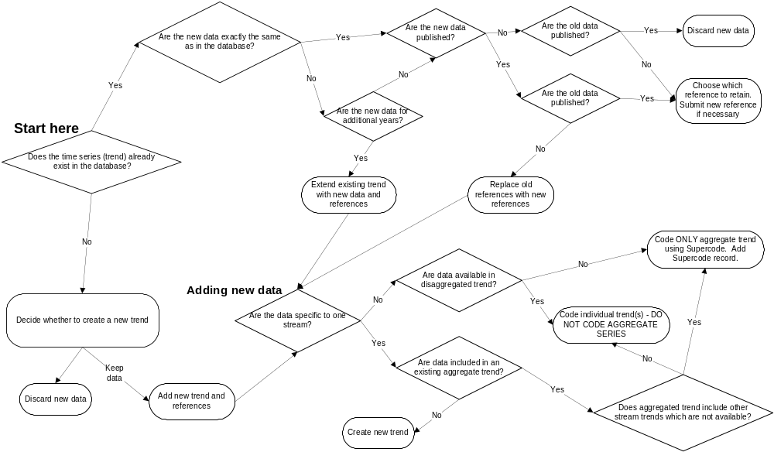

Appendix A. "Too Many To Count" in the EscData table
Sometimes, the results of a survey may be that there were too many fish or redds to effectively count them. In such instances, there may be no real estimate reported, but instead something like "Too many to count" or an equivalent phrase is used to characterize the number of fish or redds. This statement may (or may not) be accompanied by a wild guess/informal estimate of the actual number that the author doesn't feel confident about. This circumstance presents us with a special problem, because while the survey was done and did produce results, the result will not fit into our numeric CountValue field. In such cases, do the following in the EscData table:
- NullFlag is "False" (because the survey was done);
- CountValue is null (because you don't have a number to report);
- CountPerMile is null (because you don't have a number to report);
- In CountCom, very briefly explain why there is no value available. This explanation should include the sampling year or date, and must be immediately preceded and followed by the six characters "[TMTC]" (without the quotation marks). This explanation can be at the beginning, end, or middle of CountCom. Keep it short, because it will be displayed on graphs by the query system. For example, the CountCom might contain the following text, and will produce the graph shown:
Weather was blah blah blah. [TMTC]Too many redds to count in 1971 because high returns resulted in superimposed redds.[TMTC] More blah blah blah.

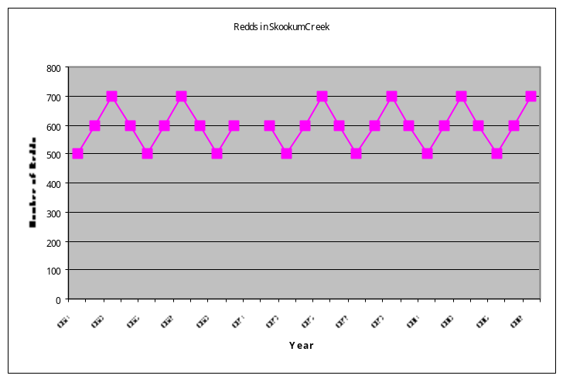
?
?Too many redds to count in 1971 because high
returns resulted in superimposed redds.

Equivalent directions for other tables have not been developed. If you encounter this need for other tables, contact the DEF document editor.

Appendix B. Draft tables
Draft tables are no longer housed in this document. To view the draft tables, refer to the companion document entitled Exchange Format Documentation - Version 2010.1. Volume II: Draft Tables
(file name is StreamNetExchangeFormat2010-1Volume2.doc).

Appendix C. Additional Instructions for CategoryID Field
The CategoryID field found in the Trend table requires some additional clarification and usage guidance. CategoryID is used as the major data category in the StreamNet database and on-line query system. Code definitions and usage guidelines are shown in Table Appendix C1.

Table Appendix C-1. CategoryID Code Usage Guidelines
Code Definition | Code Usage Guideline
1 = Spawner counts | Apply to peak type counts, to indexes, and to other spawner counts that are simple counts and not actual population estimates. A "peak count" is defined as either a one time spawning ground survey done at the presumed peak of the run, or the highest value recorded over multiple surveys. (While these are actually quite different, because of differences in usage around the Northwest we group them here.) These counts are NOT estimates of total spawner abundance. Sampling method is often "Ground"; count type is often "Peak live & dead fish."
9 = Redd Counts | Apply to any type of redd count. Sampling method is usually "Ground" or by boat or from the air; count type is always "Redd count" or "Peak redd count" or "Redds per mile."
8 = Estimate of spawning population | Apply to estimates of spawning populations. Sampling methods are varied and often combinations of methods; count type should always be Total Live Fish.
2 = Freshwater / estuary harvest | Apply to all freshwater and estuary harvest trends. Sampling method is often "Punch card" or "Postal survey" for sport harvest and "Commercial fish ticket" for commercial harvest; count type is usually "Freshwater sport" for sport harvest and "Freshwater commercial" for commercial harvest.
3 = Marine harvest | Apply to all marine harvest trends. Sampling method is often "Postal survey" or "Punch card" for sport harvest and "Commercial fish ticket" for commercial harvest; count type is quite varied.
4 = Dam / nonhatchery weir counts | Apply to a dam count or weir count that is not part of a hatchery operation. Sampling method is either "Dam" or "Weir/trap"; count type is usually "Total live fish" or "Index of live fish." For this data category, which is counts of fish at a particular point in a stream, the value of Trend.EndFt should equal Trend.BegFt.
5 = Hatchery returns | Apply to all hatchery return trends. Sampling method is not used; count type is usually "Total live fish."
6 = Hatchery releases | (This data type is not currently done by StreamNet. If done in the future, the directions will be as follows: Apply to all hatchery release trends. Sampling method is "N/A"; count type is one of codes 301 through 306.)
38 = Juvenile counts | As for CategoryID #1, this data category is for raw counts and for density estimates that are not actual estimates of the number of fish in an entire population.
7 = Estimates of juvenile populations | This data category is for estimates of population sizes, not for simple counts or density estimates.
12 = Spawner/Recruit Estimates | Sampling method is not used; count type is always "Spawner:recruit estimates."

Appendix D. Glossary

Aggregate trend: Data collection methods sometimes change, with the same basic information collected with two different levels of detail at different times. An aggregated trend is defined for such an occurrence, and is the trend with less detailed information. For example, redds may initially be counted for an entire stream. In later years the count may be split into two separate numbers, perhaps above and below a tributary. In this example, the aggregate trend is for the entire stream, while "independent trends" are defined for the reaches above and below the tributary.

Independent trend: A regular trend. Compare to "aggregate trend."

LocationID: A standard and unique code, usually 13 digits, that identifies an individual stream, point, standing water body, supercode, hatchery, dam, or some other location. LocationID values for hatcheries should be made by concatenating the SiteLong and SiteLat fields (each to 4 decimal places, longitude in front, using NAD83), and for dams should be made by concatenating the Longitude and Latitude fields (4 decimal places, longitude in front, using NAD83). LocationID codes are unique: only one stream, flat water, supercode, point, hatchery, or dam can be represented by a LocationID. That is, two locations cannot share a LocationID even if they are of different location types.

PointID: A standard and unique 13-digit code that identifies a point location that is not associated with a stream. These are often upland points not associated with any stream, or a location on a stream that has not yet tied to the hydrography. PointIDs are not created when data can instead be tied to a stream or lake or marine water body. To create a PointID, concatenate the decimal-degree longitude and latitude of the point (each to four decimal places, longitude in front, using NAD83), then remove negative signs and decimal points. For example, a point at 47.923685 latitude and -118.089256 longitude would be assigned a PointID of "1180892479236".

Appendix E. Updating This StreamNet Data Exchange Format Document

The purpose of this document is to serve as a guide to data managers and data entry personnel associated with the StreamNet project. Items in this document which represent changes from the previous version must be implemented in the databases and associated tools of data submitters, and of the regional StreamNet database managers. A number of tasks must be completed to fully implement a change to this document. A general, non-exhaustive outline of the tasks and procedures necessary for proposing and implementing changes to this document is shown in a companion document (.pdf format) entitled StreamNet Data Exchange Format: Development/Revision Procedure. This document is distributed with this exchange format, and is also available at ftp://ftp.StreamNet.org/pub/StreamNet/Projman_files/ExchangeFormat/CurrentDraft. The file name is 'DEF-Change-Process.pdf.'

Appendix F. SQL Server 2005 Data Types and MS-Access 2000 Equivalents

SQL Server Data Type | Definition | Use | SQL Server  Numeric Range | SQL Server  Bytes Required | MS-Access 2000 Equivalent
Bit | Boolean | Indicates whether a condition is true or false | 0=No, 1=Yes | 1 | Yes/No  0=No, -1=Yes
Char | Character | Fixed-length alpha-numeric up to 8000 characters in length. | N/A - Max Wid field shows set record length | 1 byte per character declared regardless of number of characters in record | Text
Datetime;  SmallDatetime | Date and time | Dates and times | Datetime: 1/1/1753 - 12/31/9999; millisecond precision. SmallDatetime: 1/1/1900 - 6/6/2079; minute precision. | Datetime: 8  SmallDatetime: 4 | Date/Time
Decimal | Exact numeric values | Numbers where exact precision is required - generally not used in StreamNet | 10-38 to 1038, with precision up to 38 digits | 2-7 | Number  (Decimal  1(1028-1) to (1028-1))
Float | Approximate numeric values | Numbers where exact precision is not required but increased decimal precision is | 2.23⁻³⁰⁸ through 1.79³⁰⁸ for positive numbers;  -2.23⁻³⁰⁸ through -1.79³⁰⁸ for negative numbers. 15 digit precision | 8 | Number  (Double)
Int | Integer | Non fraction numbers | –2,147,483,648 through 2,147,483,647 | 4 | Number  (Long Integer)
Money | Monetary data | Used for monetary data | -922,337,203,685,477.5808 through +922,337,203,685,477.5807 | 8 | Currency
Nvarchar | Variable unicode (2-byte) characters | Allows for special characters. Variable-length alpha-numeric up to 4000 characters in length. | N/A. Max Wid field shows maximum allowed record length | 2 bytes per character used | None.  (Access 2000 will permit)
Real | Approximate numeric values | Numbers where exact precision is not required | 1.18⁻³⁸ through 3.40³⁸ for positive numbers; -1.18⁻³⁸ through -3.40³⁸ for negative numbers. 7 digit precision | 4 | Number  (Single)
Smallint | Small integer | Whole numbers | -32,768 through 32,767 | 2 | Number  (Integer)
Text | Text | Variable length alpha-numeric fields with over 255 characters | N/A - up to 2,147,483,647 characters per record | Non-null records have 16-byte pointer, data are stored in 8 KB pages. | Memo  (up to 64,000 characters)
Tinyint | Tiny integer | Whole numbers | 0 through 255 | 1 | Number (Byte)
Varchar | Variable character | Variable-length alpha-numeric up to 8000 characters in length. | N/A. Max Wid field shows maximum allowed record length | 1 byte per character used | Text  (up to 255 characters)  Memo  (256-64,000 characters)

Saunders, Kimberly M., 1992. The Relational Database Advisor: Elements of PC Database Design. Windcrest Books.

